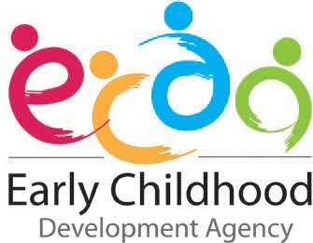
PROSPECTUS 2026

Contents
ONE@ECDA .............................................................................................. 4
Skills Framework for Early Childhood 5
“GROW ME” Resource ..……………………………………………………..6
Modes of Professional Development 7
Funding Models for CPD Courses ...........................................................8
Information on CPD Courses ..................................................................9
List of CPD Courses Excel Sheet……………………………..………….….13
Information on Modular Courses ...........................................................14
Annex A – Step-By-Step Registration Guides for ONE@ECDA.............15
Annex B – Occupation Descriptors ........................................................16
Annex C – Individual Professional Development Map ........................18
The information in this Prospectus is accurate as of 10 April 2026.

Foreword
Dear Educators,
You are key to determining the quality of education received by young children. On-going professional development plays an important role in enhancing your knowledge, skills, and practices.

In our Prospectus 2026 April update, we continue to provide you with a range of Continuing Professional Development (CPD) courses which would deepen your skills and competencies.

If you are starting on your CPD journey, we hope that the Prospectus will help you identify the key courses to begin your career development and growth.

To help you focus your search and selection of courses, we have updated the prospectus with the following features:
- The revised Occupational Titles (OTs) and Technical Skills and Competencies (TSCs) are reflected throughout the Prospectus and Course Listings.
- Separate tabs have been added in the Excel format of the listing of courses.
- Instructions on searching for your desired course.
- Courses in all languages are listed in the ‘Course Listing’ tab.
- Modular Courses
- Inclusion of:
- Focus Areas for each course.
- Link to each course’s respective pages from SSG’s MySkillsFuture Portal (where applicable)

We would like to encourage you to participate actively in the various professional development opportunities provided.

We hope that you will find the Prospectus a useful resource and guide to plan your professional development. Please note that this Prospectus is also available for download under 

in ONE@ECDA. Click on to see all the files available for download.

ONE@ECDA

ONE@ECDA is an online system that has been developed to make it easier for Early Childhood (EC) educators to manage their CPD activities.

EC educators can access and apply for CPD courses and maintain your CPD portfolio directly through ONE@ECDA. The system facilitates and streamlines the training administration process from registration of CPD courses to the issuing of e-certificates.

To help you in applying for courses via ONE@ECDA, we have provided a step-by-step registration guide in Annex A.

For Early Intervention (EI) Educators and Learning Support Educators (LSEds), ECDA is the process of enhancing the One@ECDA system, so that you could access similar features. We will inform the EI sector when the system is ready.

In the meantime, please register with the respective training providers directly, for the CPD courses which you may be interested to attend.

Skills Framework for Early Childhood (SFw EC)

The SFw EC articulates the existing, emerging, and future skills for pivotal occupations in the EC sector, as well as career pathways available to EC, LSeds and EI educators.

With the refreshed Skills Framework launched at the ECDA Early Childhood Conference (ECC) 2021, we have updated the career pathways to support educators’ development and progression choices.

Career Pathways
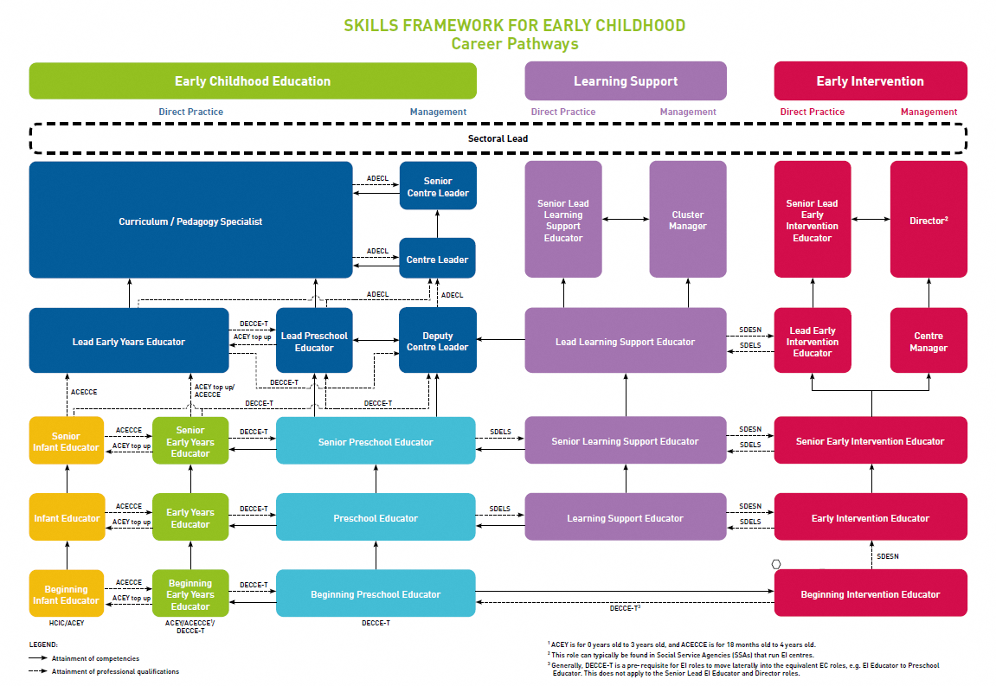

For more information about the occupational titles/job roles in each track, please refer to Annex B.

You can refer to the SFw EC to understand the knowledge and skills required in your current position and identify areas to increase your knowledge and deepen your skills.

“GROW ME” Resource
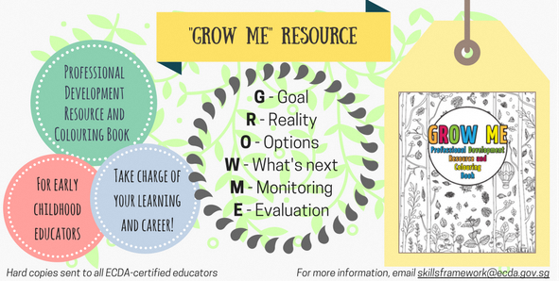

The “GROW ME” Professional Development Resource and Colouring Book aims to help Early Childhood educators take charge of their learning and chart their career growth. Hard copies of the “GROW ME” resource have been sent out to all centres. We encourage you to use this resource together with the Skills Framework for Early Childhood, the CPD Prospectus and ONE@ECDA. You may refer to this website for a softcopy of the “GROW ME” resource.

Modes of Professional Development (PD)

PD is an on-going process and planned to optimise learning for your development and growth in performing your professional role. CPD can take a variety of forms, such as:
- Conferences, seminars, courses, workshops
- E-learning/web-based learning
- Practitioner Inquiry
- Professional learning communities
- Networked learning communities
- Peer sharing
- Professional readings
- Research
- Structured on-the-job training (e.g. Induction and Mentoring)
- Study trips
- Learning journeys
- Work attachments
- Qualification programmes
- Centre-based PD activities

Note: The list above is not exhaustive. Any of these modes can be counted towards CPD hours for ECDA-certified educators.
You are encouraged to conduct an individual learning needs analysis to identify your level of competence in specific learning areas, using the SFw EC.

We have identified “Key Courses” that aim to build fundamental skills and competencies required for each Occupational Track. To help you plan your professional development needs, you can search for these “Key Courses” under the column “Course Remarks” of the Course Listing. You would need to ensure that the identified individual learning needs are aligned to your centre’s priorities and goals. You can then draw up an Individual PD Map (Annex C) that would help you address training gaps in the knowledge and skills identified. You can also use it to track your progress.

Funding Models for CPD Courses
Funding for the CPD courses in this Prospectus falls under one of these categories:

- Funding from SkillsFuture Singapore (SSG), previously known as Workforce Development Agency (WDA).
- ECDA subsidy of course fees for non-SCPRs
- Fully subsidised by ECDA

SSG Funding

Course Fee Funding and Absentee Payroll Funding may be available for courses that are under SSG funding.

Staff must be either a Singapore Citizen, Permanent Resident or a Long-Term Visit Pass-Plus (LTVP+) Holder to be eligible for the funding.

For more information, please refer to SSG’s website. Alternatively, you may contact SSG at Tel: 6785 5785 or their feedback portal.

ECDA Funding

ECDA course fee subsidy is only available* for EC educators who are Non-Singapore Citizens, Non-Permanent Residents (Non-SCPRs¹), at 40% of course fees (without GST), capped at $140 per ECDA-endorsed course.

*Subject to the availability of funds and unless otherwise indicated on the One@ECDA portal

Information on CPD Courses for EC Educators
General Course Information:
- Only ECDA-certified educators, with the relevant Letter of Notification (LON) and tagged to the occupational titles required for the specific course listed in this prospectus will be able to register for courses via ONE@ECDA.

- We strongly encourage EC Educators to attain at least 20 hours of CPD per year. CPD includes any form of PD activities/programmes that contribute to your development and growth in performing your professional role as an educator. Some examples of the different modes of PD that you can undertake as part of your CPD can be found on Page 7.

- EC Educators should write to their respective centre leaders if they wish to clarify how many CPD hours they are to attain each year.

- EC Educators who conduct training (e.g., to fellow educators in the centre) following the attainment of skills from participation of a CPD course, will be allowed to clock in double the hours. The additional hours will take into consideration preparation time required for the training session.

- Please note that withdrawals will not be allowed once registration for a course has been confirmed. Any participant who is unable to attend the course after receiving the course confirmation will need to provide a replacement who meets the intended participant criteria (e.g., relevant LON certification status and occupational title) of the specific course.

- If a participant is absent without a valid reason, the centre may be charged the full fee of the course at the non-subsidised rate. For participants with a valid reason for absence, documentary proof (e.g., medical certificate) must be submitted to the respective training provider or organiser, for fee waiver considerations. If the minimum class size is not met, the class will not commence, and applicants will be informed of the next available date(s).

- EC Educatorscan document your learning in your CPD Portfolio after attending an ECDA-endorsed CPD course by completing a Post-Course Reflection in ONE@ECDA. Upon completion, you will receive your e-certificate.

Information on Intended Participant Criteria

We have listed courses for the Infant Educator Track, Early Years Educator Track, Preschool Educator Track and Leader/Curriculum Specialist Track.
For ease of reference, we have colour-coded all the courses in the Prospectus.
Kindly note the following colour-coding used:
Courses for Infant Educator Track
Courses for Early Years Educator Track
Courses for Preschool Educator Track
Courses for Leader/Curriculum Specialist Track
Courses for Learning Support Track
Courses for Early Intervention Track

For more information about the occupational titles/job roles in each track, please refer to Annex B.

Overview of Technical Skills and Competencies (TSCs)

To support educators in developing the Technical Skills and Competencies (TSCs) required at different stages of their respective job roles, information on courses which are aligned to each of the TSCs are reflected within the List of Courses document on Page 13. This information may be utilised to identify courses which will deepen their proficiencies in the relevant TSCs.

You may refer to the CPD Roadmaps, for more information on the progression of TSCs across the various occupational tracks and job roles, as well as to guide you in prioritising the TSCs that you wish to develop within your current job role. The links to the respective CPD roadmaps are provided below:
- EC CPD Roadmap
- EI CPD Roadmap

Overview of Focus Areas for EC Educators

In addition to the courses which EC educators may undertake for their respective job roles, there are 6 focus areas which have been identified for EC educators to develop and deepen their knowledge and skills in progressively. These 6 focus areas are as follows:

Focus Area | Definition of Focus Area
Classroom Management | Classroom management refers to the skills and techniques that an educator uses in managing and guiding children’s behaviour to facilitate the delivery of learning activities and meaningful participation
Early Years (Birth to 3) | The Early Years (Birth to 3) is often referred as the critical window of opportunity where children’s brains form neural connections at unparalleled rates. It is thus exceedingly important to optimise children’s learning and development during the period through providing quality care, interaction and experiences
Inclusive Practice | Inclusive practice recognises the diversity of children and applies strategies to enable meaningful participation for each child across different early childhood settings
Outdoor Learning | Outdoor learning refers to outdoor experiences intentionally provided to support children’s play, exploration and discovery in natural or urban outdoor spaces
Parent Engagement | Parent engagement is a shared responsibility in which schools, organisations and community agencies recognise the central role of the family in every child’s life and develop strategies for family engagement, nurturing trust and rapport to enhance children’s developmental outcomes
Social and Emotional Development | Social and emotional development refers to the soft skills that are responsible for children’s personal and social well-being. It also increases children’s capacity to learn and help them prepare for life beyond school.

Along with the launch of the updated EC CPD Roadmap in October 2023, information on courses which cover each focus area may be found within the List of Courses document on Page 13.

Courses associated with each focus area will be categorised as follows:
- Level 1 courses: For educators who are starting out their journey in a specific focus area and would like to gain more insights in this area.
- Level 2 courses: For educators who would like to further hone their skills in a specific focus area.

ECDA will be progressively adding new courses within each level, of the respective focus areas, to support educators in acquiring and enhancing their knowledge and skills in these areas of priority.
Please refer to the Excel sheet to view our updated listing of CPD courses for 2026.



Note: To register for courses by the National Institute of Early Childhood Development (NIEC) commencing from 1 June 2026 onwards, please refer to NIEC’s website

Information on Modular Courses for EC Educators

ECDA has worked with Institutes of Higher Learning (IHLs) to provide skills-based modular courses for EC educators, which are flexible, bite-sized and targeted learning options. Through these courses, EC educators can acquire and deepen skills and knowledge, and customise learning according to theirneeds and interests. Credits from some of these courses can be considered as part of an early childhood-related qualification, e.g. Specialist Diploma, Advanced Diploma or Degree.

Please refer to the respective institutions’ websites for application procedures for the Modular courses:

National Institute of Early Childhood Development (NIEC)

Singapore University of Social Sciences (SUSS)

To facilitate EC educators’ professional development planning, we have included the application period throughout the year for the modular courses. For modular courses where the application period has closed this year, educators may wish to consider applying for next year’s intake.

Singapore Citizens (SCs) enrolled in SkillsFuture skills-based modular courses will receive subsidies from the Government of Singapore. With the SkillsFuture Mid-Career Enhanced Subsidy, SCs aged 40 and above will enjoy higher subsidies for these courses.

For more information on available subsidies and financial assistance schemes, applicants may approach the institutions that they are enrolled in.

Please refer to the Prospectus Course Listing Excel sheet to view the skills-based modular courses.

Annex A: Quick Guides – Educator
For more assistance on registration queries, please refer to the following documents:

Quick Guide – Educator


e-Learning Quick Guide – Educator



Annex B- Occupation Descriptors
Occupation | Occupation Descriptors
Beginning Infant Educator | - Builds relationships with infants and toddlers and looks out for their developmental needs and milestones so as to be able to respond to their needs appropriately  - Contributes to the creation of a secure environment for infants and toddlers through nurturing respectful, responsive and reciprocal relationships  - Executes the required curricula and programmes, and creates a quality learning environment  - Provides holistic care for infants and toddlers by establishing relationships and partnerships with different stakeholders  Engages in professional development and reflective practice, under the guidance of his/her leaders
Infant Educator | - Responsive to the needs of infants and toddlers  - Creates a secure environment for infants and toddlers through nurturing respectful, responsive and reciprocal relationships with them  - Creates a quality learning environment through implementing developmentally appropriate curricula and programmes  - Builds trusting and respectful relationships and partnerships with stakeholders by actively engaging the children's family and community  - Engages in ongoing professional development and reflective practice  Contributes to fostering a culture of collaboration and collegiality with relevant stakeholders
Senior Infant Educator | - Active role as a mentor to the Infant Educator team  - Takes responsibility for coaching and leading the infant care team in the Centre.  - Designs and implements developmentally appropriate curricula and programmes for the day-to-day developmental and caregiving tasks for infants.  - Leads the building of relationships and partnerships with stakeholders.  Designs and implements family and community programmes, and contributes to the Centre’s culture of continuous learning, collaboration and collegiality, in line with its vision, mission and goals
Beginning Early Years Educator | - Responsive to the needs of young children  - Creates a secure environment for young children through nurturing respectful, responsive and reciprocal relationships with them  - Creates a quality learning environment by implementing developmentally appropriate curricula and programmes through the observation and assessment of the children's needs and developmental milestones  - Provides a holistic development for the children by forging trusting and respectful relationships and partnerships with families  - Actively carries out the Centre's initiatives and supports its collaborative efforts with the community  Engages in continuous learning and development
Early Years Educator | - Guides in responding to the needs of young children.  - Guides junior educators in creating a secure and quality learning environment for children, and models respectful, responsive and reciprocal relationships with them  - Proficient in designing and implementing developmentally appropriate curricula and programmes to support the learning and developmental needs of the children  - Establishes relationships and partnerships with families and community stakeholders to provide a holistic care and development for young children  Engages in ongoing professional development and reflective practice, and contributes to fostering a culture of collaboration and collegiality with relevant stakeholders
Senior Early Years Educator | - Plays an active role as a mentor to the team  - Provides leadership in the design and set up of a secure and quality learning environment for young children  - Guides the team in nurturing respectful, responsive and reciprocal relationships with them  - Leads in the design and implementation of developmentally appropriate curricula and programmes, and develops structures for sustained collaborative relationships and partnerships with families and community stakeholders  - Works with their team to design and implement family and community programmes, and contribute to the Centre’s culture of continuous learning, collaboration and collegiality
Beginning Preschool Educator | - Creates a secure and quality learning environment for children through fostering meaningful relationships with them  - Supports the holistic development of children by:  - Implementing a developmentally and culturally appropriate curricula  - Nurturing trusting and respectful relationships with the children  - Builds partnerships with parents and families, and actively engages in Centre initiatives to support its collaborative efforts with the community  - Works closely with colleagues and contributes to a culture of collaboration and collegiality.  Participates in professional development and service quality improvement activities
Preschool Educator | - Creates a secure and quality learning environment for the children through nurturing trusting and respectful relationships with them  - Enriches children’s learning by:  - Co-designing and implementing a developmentally and culturally appropriate curricula  - Effectively integrating innovative teaching and learning practices  - Is proactive and intentional in strengthening partnerships with families and the community, and co-designs collaborative efforts with colleagues and stakeholders  - Guides the junior educators in enhancing their professional practice  Provides suggestions and ideas to improve professional development in the Centre, while also contributing to the Centre’s culture of collaboration and collegiality
Senior Preschool Educator | - Mentors team to enhance their teaching practice including the nurturing of trusting and respectful relationships with children  - Utilises in-depth knowledge of Early Childhood education and pedagogical expertise to:  - Design and implement a developmentally and culturally appropriate curricula for children  - Contributes to innovations in teaching and learning practices  - Oversees the design and set up of secure and quality learning environment for children  - Mentors the other educators in preparing the learning experiences and environment for the children in line with Centres' philosophy and curricula goals  - Develops structures for sustained collaborative partnerships with families and communities  Supports in fostering a culture of continuous learning, collaboration and collegiality within the Centre
Lead Early Years Educator | - Leads their team and drives the learning and development of children within the Centre  - Responsible for the overall learning curricula, programmes and teaching designs for children between 2 months and 4 years old in the Centre  - Strategises the building of relationships and partnerships with families and community stakeholders  - Develops and evaluates the Centre's programmes to ensure they cater to children of different levels and ensures a smooth transition for young children between levels
Lead Preschool Educator | - Provides leadership for the development of teaching and learning practices at the Centre  - Ensures that the curricula goals are sound and progressive  - Mentors and provides leadership in designing and implementing a holistic curriculum  - Regularly conducts inquiry into the emerging trends and latest developmental approaches to introduce new teaching and learning methods, tools and assistive technologies  Fosters a culture of continuous learning and professionalism, and develops and leads in partnerships and sustained collaborations with stakeholders
Deputy Centre Leader | - Assists in the development of the Centre's strategic plans  - Supports efforts to foster a culture of care and trust, mentoring, collaborative professionalism and continuous development within the Centre  - Oversees management and optimisation of Centre resources and the implementation of specific Centre programmes, initiatives and events  - Ensures the quality of the curricula and pedagogies within the Centre  - Works with senior educators to set the direction for parent partnership, community engagement and talent management within the Centre  - Able to build and leverage effective relationships with stakeholders  Coaches colleagues on their personal and professional development within the Centre
Centre Leader | - Leads in developing strategic plans and structures to foster a culture of care and trust, mentoring, collaborative professionalism and continuous learning within the Centre  - Is responsible for managing and enhancing Centre operations while adhering to industry regulations  - Drives operational and programme excellence by developing strong processes in strategic areas such as governance, partnerships, continuous development, curriculum and pedagogy  - Develops frameworks for sustained collaborative partnerships with stakeholders, possesses strong communication skills and is highly influential  Leads in modelling the Centre’s mission, vision and values, and oversees the well-being of all staff in the Centre
Senior Centre Leader | - Oversees and leads a Cluster of Centres  - Mentors juniors, guiding them in the development of strategic plans and structures to ensure that the Centres they lead deliver high quality programmes and lessons for the children  - Advances professionalism and organisation excellence through mentoring Centre Leaders on Centre operations management, process improvements and governance across Centres  - Possesses strong leadership skills and is able to build and leverage effective relationships with stakeholders  - Drives the conceptualisation of Cluster wide networking plans to establish and sustain collaborative partnerships with stakeholders
Curriculum/  Pedagogy Specialist | - Has a span of influence over professional matters beyond the Centre level  - Provides leadership in the review, design and implementation of a holistic curriculum and drives the development of teaching and learning practices beyond the Centre  - Works with the organisation's leadership team to ensure alignment of curricula goals and teaching practices across the Centres  - Inculcates a strong culture of collaboration and promotes professionalism across Centres
Learning Support Educator | - Provides learning support to children in helping them develop academic, behavioural social and communication skills  - Assesses children’s learning, develops plans and progress reports  - Supports the management of children in a classroom setting  - Works to identify children who require low levels of support through use of standardised assessments and other relevant information  - Works closely with Early Childhood educators and families of the children to further guide them in develop the children ‘s learning needs
Senior Learning Support Educator | - Guides colleagues on identifying children who require low levels of support through the use of standardised assessments and other relevant information.  - Looks into complex cases which require deeper observations and analysis  - Helps establish the developmental needs of the child and works with colleagues to develop the abilities of the child  - Develops relationships with key stakeholders and families of the children to drive awareness of the interventions
Lead Learning Support Educator | - Guides the team on the calibration of assessment on children’s learning needs, especially on more complex cases which require deeper observations and analysis  - Oversees, develops and reviews appropriate intervention plans that are in line with the children’s individual education plan  - Monitors the progress of his/her team in implementing interventions  - Supports and mentors his/her colleagues and participates in their resourcing
Senior Lead Learning Support Educator | - Plans and drives the overall level of Learning Support provided to children across Centres  - Drives delivery of Learning Support tailored to the needs of children in the Centre  - Continually oversees support on teaching and classroom management strategies provided to Early Childhood educators  - Leads stakeholder partnerships and drives Centre and community initiatives  - Responsible for performing and presenting research in Learning Support teaching to the wider community
Cluster Manager | - Oversees the daily operations in the deployment of the team across Centres and ensures the team operates in compliance in all policies  - Manages manpower resources, which includes onboarding and staff development  - Possesses strong leadership skills and able to build and leverage effective relationships with stakeholders  - Drives overall initiatives for cross-Centre programmes, curricula and quality of learning
Beginning Early Intervention Educator | - Develops lesson plans and teaching materials and delivers lessons for children under supervision  - Enriches children’s learning through implementing curriculum and adopting developmentally appropriate teaching and classroom management strategies  - Creates quality natural learning environment and facilitates children’s development and learning  - Coordinates class-based activities with families, caregivers and other professionals  - Supports the delivery of Centre initiatives, programmes and services  - Assists in identifying new intervention methods, tools and technologies to improve Centre services
Early Intervention Educator | - Integrates a range of teaching and learning approaches and identifies new approaches to conduct lessons for children  - Enriches children’s learning through implementing curriculum, as well as adapting and integrating developmentally appropriate teaching and classroom management strategies  - Creates quality natural learning environment and facilitates children’s development and learning  - Partners with families and caregivers and coordinates with community stakeholders, volunteers and social service providers to support the delivery of Centre initiatives, programmes and services  - Carries out data collection for inquiry projects
Senior Early Intervention Educator | - Oversees individual and group classes in coordination with other social service professionals  - Designs and sets up quality natural learning environment  - Leads the review of the children’s learning progress and improves teaching and learning approaches to meet the development goals of children.  - Supports the design and evaluation of Centre-wide curriculum, programmes and teaching practices to improve learning outcomes  - Develops outreach activities to promote the Centre programmes and services, as well as collaborates with community stakeholders, volunteers and social service providers to deliver programmes and services  - Conducts workshops for knowledge sharing, provides guidance to junior staff, supports the conceptualisation of relevant inquiry projects and carries out data collection
Lead Early Intervention Educator | - Leads the development and implementation of Centre-wide curriculum, programmes and teaching practices  - Develops the procedures and processes for the delivery of programmes, intervention methods and teaching practices  - Coordinates cross-Centre and cross-sector programmes with other social service organisations, institutions, corporate and community stakeholders  - Oversees engagements with families to facilitate exchange of information and resources  - Conducts trainings on evidence-based practices and provides supervision and mentorship to Early Intervention educators  - Conceptualises and carries out relevant inquiry work
Senior Lead Early Intervention Educator | - Provides leadership in the design, evaluation and implementation of Centre-wide curriculum, programmes and teaching practices.  - Drives cross-Centre collaborations with other social service organisations, institutions as well as corporate and community stakeholders to deliver programmes and services  - Leads the implementation of new intervention methods and practices to improve service delivery, and in relevant inquiry work  - Oversees the professional training and quality aspects for Early Intervention educators  - Provides supervision and mentorship to junior staff
Centre Manager | - Responsible for managing Centre operations and provides leadership in strategic and operational planning  - Leads the development of Centre initiatives and improvements in systems, processes and operations for the effective delivery and quality of Centre programmes and services  - Drives the development and implementation of policies, procedures and standards, as well as risk management frameworks to ensure quality teaching, curriculum development and student well-being  - Oversees staff professional development, student enrolment and manpower requirements for the Centre.
Director | - Responsible for providing leadership in strategic and operational planning across Centres.  - Drives development of cross-Centre partnerships, initiatives and improvements for the effective delivery and quality of Centre programmes and services  - Establishes and oversees implementation of policies, procedures and standards as well as risk management frameworks to ensure quality teaching, curriculum development and student well-being across Centres  - Drives staff professional development, student enrolment and manpower requirements across the Centres

Annex C- INDIVIDUAL PROFESSIONAL DEVELOPMENT MAP (IPDM)

INDIVIDUAL PROFESSIONAL DEVELOPMENT MAP (IPDM)
1. Fill in how you will carry out your CPD activities
2. Track your progress
Name of Educator: Occupational Title:
Plan |  |  |  |  |  |  |  | Log
S/N | What competencies do I want to work on? |  |  | What do I want to learn? | Type of CPD | When do I do this? | What resources are needed? | CPD Date(s) | CPD Hours Completed  or Reason(s) for not completing | Learning & Application
S/N | TSC Category | TSC | TSC Proficiency Levels | Learning Goals | CPD Activity^ | Month/Year | (E.g. Funding Support, Approval etc) | CPD Date(s) | CPD Hours Completed  or Reason(s) for not completing | Learning & Application
1

2
Signature of Educator and Date |  |  |  |  |  |  |  | Signature of Principal and Date
^ CPD activity may include course based and non-course-based training.

Does not include Long Term Visit Pass Plus (LTVP+) Holders, as they are eligible for SSG funding w.e.f. 1 October 2021
Occupations in the Infant Educator Track include Beginning Infant Educator, Infant Educator, Senior Infant Educator.
Occupations in the Early Years Educator Track include Beginning Early Years Educator, Early Years Educator and Senior Early Years Educator.
Occupations in the Preschool Educator Track include Beginning Preschool Educator, Preschool Educator, Senior Preschool Educator.
Occupations in the Leader/Curriculum Specialist Track include Lead Early Years Educator, Lead Preschool Educator, Deputy Centre Leader, Centre Leader, Senior Centre Leader, Curriculum/Pedagogy Specialist.
Occupations in the Learning Support Track include Learning Support Educators, Senior Learning Support Educators, Lead Learning Support Educators, Senior Lead Learning Support Educators, Cluster Managers
Occupations in the Early Intervention Track include Beginning Early Intervention Educator, Early Intervention Educator, Senior Early Intervention Educator, Lead Early Intervention Educator, Senior Lead Early Intervention Educator, Centre Manager, Director
Except for the following CPD courses conducted by NIEC until further notice: (1) Overview of Early Years Development Framework (EYDF) 2023 (English and Chinese versions); (2) Overview of Early Years Development Framework (EYDF) 2023 and Putting EYDF 2023 into Practice (English and Chinese versions); (3) Overview of NEL Framework 2022; (4) Overview of NEL Framework 2022 and Putting NEL Framework 2022 into Practice

