INSTRUCTION

The Qualified Person appointed for the supervision of CD shelter works shall submit this CD shelter inspection report in respect of the completed household shelter (“HS”) for the Project (“Report”) to the Commissioner of Building Control (“CBC”) pursuant to regulation 43(3)(d) or 42(2)(g) of the Building Control Regulations 2003 (“BC Regs”) for the purposes of obtaining a temporary occupation permit or a certificate of statutory completion (as the case may be) from the CBC in relation to the Project.

SECTION 1: PROJECT INFORMATION

Project Reference No.
Project Title
House Unit No.
List of Approved BP/CD Plans & Date
List of Approved ST/CS Plans & Date
SCDF Waiver (if any) & Date | Please tick:  ☐ Yes  ☐ No  Date and description of waiver granted (if “Yes” is ticked):  NIL
HS Position | Please tick where relevant to the project development:  ☐ Reinforced concrete roof/clay tiled roof within setback distance  ☐ Metal roof within setback distance  ☐ Skylight within setback distance  ☐ Air well within setback distance  ☐ Reinforced concrete staircase within setback distance  ☐ Metal/timber staircase within setback distance  ☐ Glass/metal lift core within setback distance  ☐ Shielding wall within setback distance

SECTION 2: INSPECTION OF CD SHELTER WORKS
This section shall be deemed to illustrate the compliance of completed household shelter(s) within the project development. Photos shall be provided for each unique HS layout where applicable.

S/No | Please Tick | Description | Photo
A |  | Readiness Condition of HS
1 | ☐ | Building for the development must be near completion stage for TOP.
2 | ☐ | Household Shelter (HS) must be completed (see attached photo) in compliance with technical requirements.  (E.g. Setback distance, services, CD door, ventilation sleeves, internal/external floor finish level and no plastering on the internal wall, completed with final coat of painting.)
B |  | Ventilation Sleeves
1 | ☐ | Both external and internal face of ventilation sleeve shall be cleared and free of cement grout and paint.
2 | ☐ | Screw threaded holes on the internal flange of ventilation sleeve shall be cleared and free of cement grout.
3 | ☐ | The inner flange of ventilation sleeve shall be flushed with internal face of the HS wall.
4 | ☐ | Ventilation sleeves (inside HS) shall be positioned such that the centre of the sleeves shall be:  - minimum 300 mm from any surrounding wall and ceiling slab.  - minimum 1900 mm above HS finished floor level.  - minimum 1000 mm apart.  - Minimum 700 mm from any internal structural element.  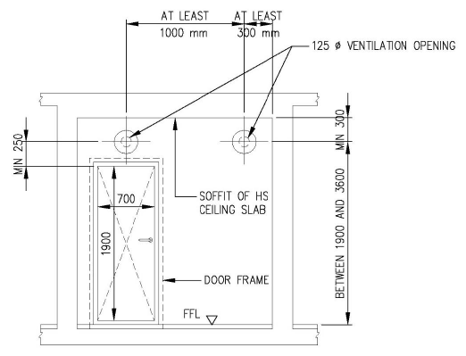  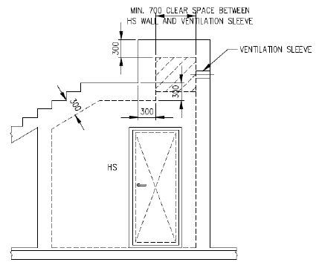
5 | ☐ | For ventilation sleeve above false ceiling (outside HS wall), access opening shall be covered by perforated panel of 600 mm X 600 mm.  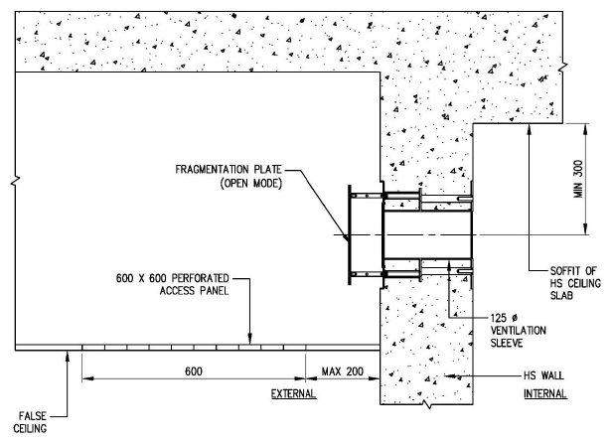
6 | ☐ | Fragmentation plate of the ventilation sleeve above false ceiling (outside HS wall) must be able to close and open without obstruction.
7 | ☐ | False ceiling (outside HS) fronting the ventilation sleeves shall have a minimum clear distance of 500 mm away from the fragmentation plate in open position.  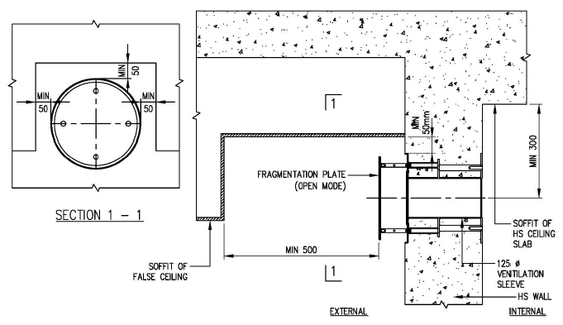
C |  | HS Door and Frame
1 | ☐ | PLS label and HS door notice shall be pasted on the door and door frame.  (Note: Closeup photo showing unmasked serial number of PLS label shall be provided.)
2 | ☐ | HS door and door frame shall be completed with final painting.  (Note: Rubber gasket, door hinges, locking pins and shear pins shall not be painted over.)
2 | ☐ | HS door shall be able to close and lock in CD mode as shown in the door notice.
2 | ☐ | External floor finish shall be clear from the bottom edge of the HS door to ensure unimpeded opening of HS door.
2 | ☐ | There shall be a minimum 150mm reinforced concrete nib next to the nearest vertical edge of the door frame.  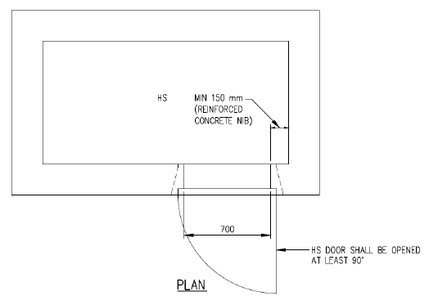
3 | ☐ | The locking pin and the pin hole on the door frame shall be aligned so that the door can be engaged in CD mode easily. Handle shall be secured properly such that it is not loose or jammed from turning.  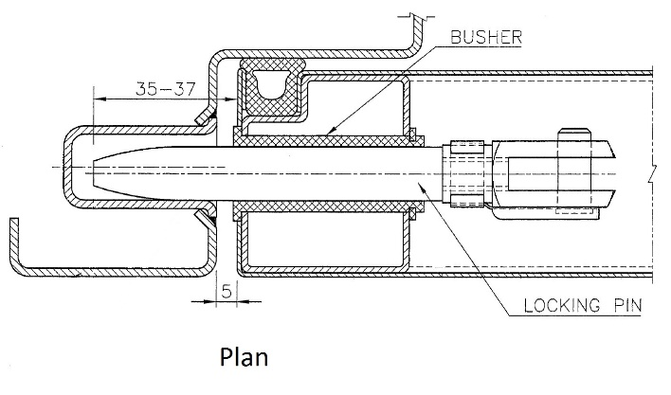  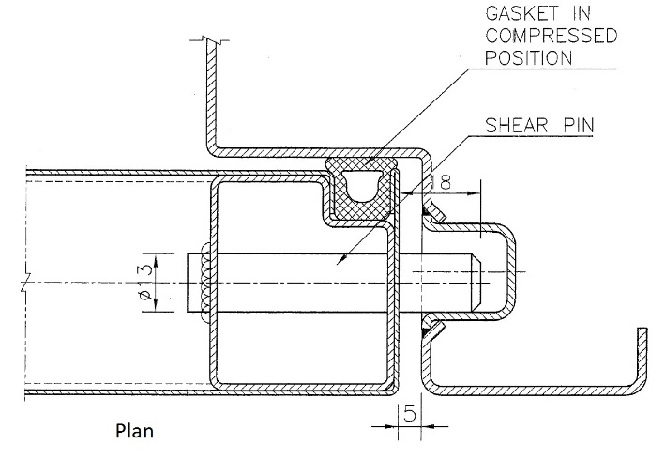
4 | ☐ | The design gap between the door and door frame is 5 mm. The maximum gap shall not be more than:  - 6mm along door with hinges and  - 7mm along door with locking pins.  Maximum total gap (hinges side + locking pin side) shall not exceed 13mm.
5 | ☐ | Rubber gasket shall be fully secured into the recess along the sides of the door panel.
D |  | Services
1 | ☐ | Socket outlet/fixtures for Lighting switch, Telephony (RJ45) and Power point (2nos or twin) shall be installed inside HS.
2 | ☐ | Galvanised steel encasement for Telephony, power point and lighting switch shall be placed within 40 mm measured from internal surface.  (Note: Closeup measurement shall be provided.)  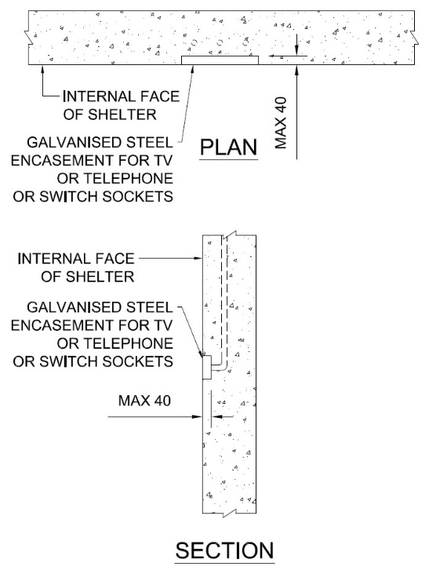
3 | ☐ | All open ends of conduit at internal and external of HS shall be sealed with sealant to a minimum depth of 100mm.  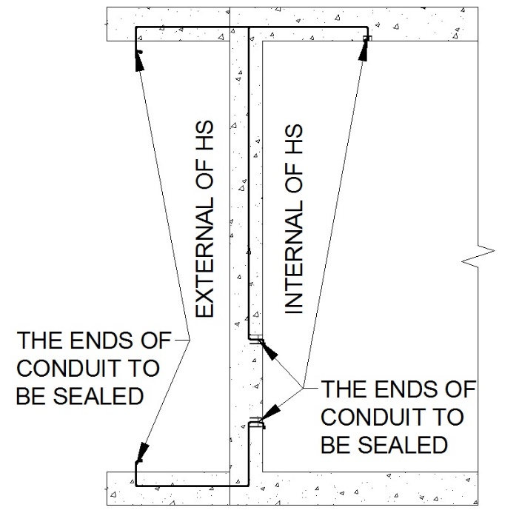

SECTION 3: COMMISSIONING TESTS
This section shall be deemed to illustrate the compliance of household shelter(s) selected for commissioning tests.

Door Supplier
(E.g. Nam Lee, Prefab, Yong Tai Loong, etc.)

Attendance List
Attendees who attended and witnessed the commissioning tests shall be recorded.
QP’s representative shall be architect or engineer in civil engineering discipline.

S/No | Name | Company | Role  (E.g. QP, QP’s representative, Builder, Competent tester, etc.)
1 |  |  | QP / QP’s representative
2 |  |  | Builder
3 |  |  | Competent tester
4 |  |  | Door supplier

Group Photo of Attendees (Mandatory)
Group photo showing attendees in front of the completed building shall be provided.

Results of Commissioning Tests
Videos of commissioning tests for each commissioned unit shall be endorsed and submitted as supporting evidence.

Commissioning Test | Result
- Light penetration test  The test is considered to have passed if no light could be seen from the inside of HS. | Passed / Failed
- Chalk mark test  The test is considered to have passed if there is an unbroken and uniform transfer of the chalk markings onto the door seal when the door is closed and re-opened. | Passed / Failed
- Air-tightness test  The HS is pressurised by pumping air into the HS such that there is a pressure difference of 250 Pa* between inside and outside of HS. The HS is considered to have passed the test if the pressure gauge shows more than or equal to 50 Pa after 45 seconds.  *The pressure gauge used should have a dial size with a scale of 0 to 50mm or 0 to 500Pa. (Note: 1 mm = 10 Pa). | Passed / Failed  Start pressure : ? mm  End pressure : ? mm  Pressure drop : ? mm

SECTION 4: AS-BUILT HS SETBACK DIMENSION
This section shall be deemed to illustrate the compliance of completed household shelter(s) within the project development. Photos of HS setback dimension shall be provided for each unique HS layout where applicable.

S/No | Plans / Photographs / Measurements
1 | Approved Plans
1 | Setback Distance of HS Wall with HS Door  Approved setback distance =  Measured setback distance =
1 | Overall View of HS
1 | Lookup View at Ceiling Slab

S/No | Plans / Photographs / Measurements
2 | Approved Plans
2 | Setback Distance of HS Wall without HS Door  Approved setback distance =  Measured setback distance =
2 | Overall View of HS
2 | Lookup View at Ceiling Slab

S/No | Plans / Photographs / Measurements
3 | Approved Plans
3 | Setback Distance of HS Wall without HS Door  Approved setback distance =  Measured setback distance =
3 | Overall View of HS
3 | Lookup View at Ceiling Slab

S/No | Plans / Photographs / Measurements
4 | Approved Plans
4 | Setback Distance of HS Wall without HS Door  Approved setback distance =  Measured setback distance =
4 | Overall View of HS
4 | Lookup View at Ceiling Slab

S/No | Others
5 | Please provide photos with descriptions where applicable.

SECTION 5: DECLARATIONS AND CERTIFICATIONS BY QUALIFIED PERSON

- I declare that I have been appointed as the Qualified Person under section 8 or 11 of the Building Control Act 1989 (“BC Act”) to supervise the carrying out of the building works in relation to the HS.

- I declare and certify that I have supervised the carrying out of the building works in respect of the HS.

- I declare and certify that the building works in respect of the HS are completed based on my inspection of the completion HS on ____________(date). I declare and certify that the building works in respect of the HS are carried out and completed in accordance with:-

- the provisions of the BC Act and BC Regs;
- the plans approved by the CBC in respect of the HS and the conditions under which the plans have been approved by the CBC;
- the provisions of the Civil Defence Shelter Act 1997; and
- the provisions of the “Technical Requirements for Household Shelters” issued under the Civil Defence Shelter Act 1997.

- I understand and acknowledge that the CBC will be relying on my declarations and certifications, as set out herein, when assessing whether to grant approvals, permits and issue any other documents under the Building Control Act 1989 and building regulations in respect of the building works for the HS. I declare that the information stated in this Report, including any accompanying documents and/or information, are true, complete and correct and are based on facts and information that are true and accurate.

Submitted by:

________________________ ____________________
Name and Signature of QP Date

