
ADMINISTRATIVE LIST OF COLLABORATIVE PRESCRIBING PRACTITIONERS
SN | Name of Collaborative Prescriber | Pharmacist/  SNB Registration Number | Institution | CPA Formulary | Phone Number
 | Liau Wei Fong | N9616515H | Bukit Batok Polyclinic | Prescriptions by prescriber are for internal dispensing only | 69082222
 | Natasha Teo Hui Ling | N9717715F | Choa Chu Kang Polyclinic | Prescriptions by prescriber are for internal dispensing only | 67673479
 | Kng Kwee Keng | P01536I | TTSH |  | 62566011
 | Kng Kwee Keng | P01536I | NNI (TTSH) | 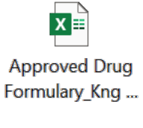 | 63306363
 | Jiang Yan | N9717760A | TTSH | 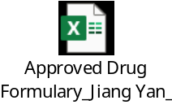 | 62566011
 | Wong Yee May | P01253Z | TTSH |  | 62566011
 | Chan Shu Zhen Debra | P02521F | TTSH |  | 62566011
 | Yee Sow Ling | N9414496G | SGH | Prescriptions by prescriber are for internal dispensing only | 62223322
 | Wee Li-Phing Clarice | N0732154J | NTFGH | Prescriptions by prescriber are for internal dispensing only | 67162000
 | Saw Yik Chuen | P01695J | NTFGH |  | 67162000
 | Oh Wan Lin | P02288H | Tampines Polyclinic | Prescriptions by prescriber are for internal dispensing only | 66436969
 | Ang Kim Wai | N8509783G | Tampines Polyclinic | Prescriptions by prescriber are for internal dispensing only | 66436969
 | Xu Xuelian | N9819107H | KKWCH | 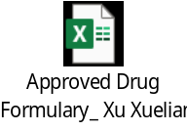 | 62255554
 | Kee Hwei Min | N0021112E | KKWCH |  | 62255554
 | Li Wei | N9616887D | NNI (TTSH) | Prescriptions by prescriber are for internal dispensing only | 63306363
 | Zhou Wentao | N97177778D | NNI (TTSH) | Prescriptions by prescriber are for internal dispensing only | 63306363
 | Lim Paik Shia | P01677B | SGH | Prescriptions by prescriber are for internal dispensing only | 62223322
 | Ong Soo Im | P01118E | Woodlands Polyclinic | Prescriptions by prescriber are for internal dispensing only | 63553000
 | Lee Cai Feng Michelle | N0325883J | Ang Mo Kio Polyclinic | Prescriptions by prescriber are for internal dispensing only | 63553000
 | Lim Teong Guan | P01324B | SGH | Prescriptions by prescriber are for internal dispensing only | 62223322
 | Hon Jin Shing | P01510E | NHCS |  | 67048000
 | Lian Xia | N9920450A | TTSH | 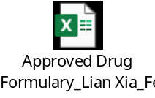 | 62566011
 | Wong Yoke Poh Audrey | N0021305  E | TTSH |  | 62566011
 | Choo Chor Hui | P01705A | TTSH |  | 62566011
 | Lim Shu Fang | P02266G | TTSH | 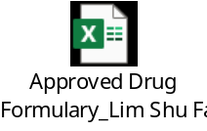 | 62566011
 | Koh Sei Keng | P01025I | SGH | Prescriptions by prescriber are for internal dispensing only | 62223322
 | Wang Na | N0325782F | Queenstown Polyclinic | Prescriptions by prescriber are for internal dispensing only | 63553000
 | Shera Wong See Ah | P01838D | NHCS |  | 67048000
 | Ong Wan Chee | P02094Z | SGH | Prescriptions by prescriber are for internal dispensing only | 62223322
 | Nancy Yong Mei Ling | P00655F | NUH | Prescriptions by prescriber are for internal dispensing only | 67795555
 | Fan Siew Wai | P01966F | NUH | Prescriptions by prescriber are for internal dispensing only | 67795555
 | Priscilla How | P01120G | NUH |  | 67795555
 | Khee Giat Yeng | P02091E | SGH | Prescriptions by prescriber are for internal dispensing only | 62223322
 | Karen Koh Wei Ling | N0021767J | NUH |  | 67795555
 | Juvena Gan Chew Huang | N0122738B | NUH | 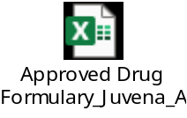 | 67795555
 | Lo Chew Yong | N9414498C | NUH | 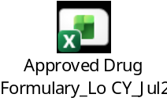 | 67795555
 | Heng Boon Ling | N9414517C | NUH |  | 67795555
 | Ngo Lay Poh Ednajoy | N9616546H | NUH | 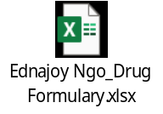 | 67795555
 | Elena Lee Mei Shan | P01587C | CGH |  | 67888833
 | Elena Lee Mei Shan | P01587C | SGH | Prescriptions by prescriber are for internal dispensing only | 62223322
 | Cheong Kah Mun | P02476G | CGH |  | 67888833
 | Cheong Kah Mun | P02476G | SGH | Prescriptions by prescriber are for internal dispensing only | 62223322
 | Lim An Qi Agnes | P02111C | CGH |  | 67888833
 | Lim An Qi Agnes | P02111C | SGH | Prescriptions by prescriber are for internal dispensing only | 62223322
 | Goh Leng Chuan | P02964E | CGH |  | 67888833
 | Goh Leng Chuan | P02964E | SGH | Prescriptions by prescriber are for internal dispensing only | 62223322
 | Hwang Chung Cheng | N9920142A | SGH | Prescriptions by prescriber are for internal dispensing only | 62223322
 | Lissa Vazhayil Joseph | N0427507G | SGH | Prescriptions by prescriber are for internal dispensing only | 62223322
 | Yang Jumei | N9920000Z | SGH | Prescriptions by prescriber are for internal dispensing only | 62223322
 | Tan May Leng Mabel | N9213529A | NCCS | Prescriptions by prescriber are for internal dispensing only | 64368091
 | Cheng Shuhua | N9717797J | CGH |  | 67888833
 | Tan Poh Choo | N9213178D | CGH | 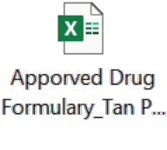 | 67888833
 | Sri Rahayu Binte Masjum | N8610434E | CGH | Prescriptions by prescriber are for internal dispensing only | 67888833
 | De Roza Jacqueline Giovanna | N0122472C | Geylang Polyclinic | Prescriptions by prescriber are for internal dispensing only | 65476456
 | Lim Yu Ling Cheryl | P02498Z | SGH | Prescriptions by prescriber are for internal dispensing only | 62223322
 | Goh Si Han | P02658A | Tampines Polyclinic | Prescriptions by prescriber are for internal dispensing only | 66436969
 | Goh Si Han | P02658A | Tampines North Polyclinic | Prescriptions by prescriber are for internal dispensing only | 66436969
 | Wong Pang Nee Frida | N9414560B | Sengkang Polyclinic | Prescriptions by prescriber are for internal dispensing only | 66436969
 | Yeo Hui Ing Fiona | P02687E | SGH | Prescriptions by prescriber are for internal dispensing only | 62223322
 | Dewi Azura Binte Hussain | P03060J | CGH |  | 67888833
 | Sim Jun Long Marvin | P02970Z | Jurong Polyclinic | Prescriptions by prescriber are for internal dispensing only | 63553000
 | Woo Jia Xiang | P02271C | Pioneer Polyclinic | Prescriptions by prescriber are for internal dispensing only | 63553000
 | Yeo Yan Ting | P02301I | SGH | Prescriptions by prescriber are for internal dispensing only | 62223322
 | Sim Mui Hian | P02311F | SGH | Prescriptions by prescriber are for internal dispensing only | 62223322
 | Zulidiah Mohd Mohtar | N8811016G | Pasir Ris Polyclinic | Prescriptions by prescriber are for internal dispensing only | 66436969
 | Chua Yen Nee Sophia | N9920090E | CGH | 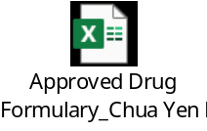 | 67888833
 | Him Ai Ling | N9717546C | CGH |  | 67888833
 | Blessy Koottappal Mathew | N0326875E | Toa Payoh Polyclinic | Prescriptions by prescriber are for internal dispensing only | 63553000
 | Chen Birong | N0427829G | IMH | 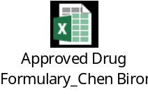 | 63892000
 | Qu Yuanrong | N0529248F | IMH | 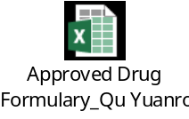 | 63892000
 | Rita Tan Kheng Siew | N9515379F | IMH |  | 63892000
 | Wong Chui Ping | N9515346Z | IMH |  | 63892000
 | Xu Changqing | N0122770F | IMH |  | 63892000
 | Ng Boon Tat | P01502D | IMH |  | 63892000
 | Liew Kai Suen Emily | P01135E | IMH |  | 63892000
 | Leo Wen Ling Amy | P01893G | IMH |  | 63892000
 | Loh Guek Leng | P03397I | NTFGH |  | 67162000
 | Chang Shu-wen Grace | P01932A | KTPH | 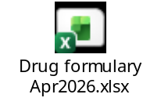 | 65558000
 | Low Suat Fern | P01098G | KTPH | 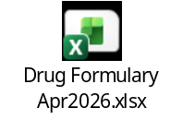 | 65558000
 | Cynthia Goh Ee Mei | P01526A | TTSH | 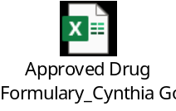 | 62566011
 | Ong Wan Qin | P03274C | TTSH |  | 62566011
 | Ow Yong Pu En | P03336G | CGH |  | 67888833
 | Sun Tao | N9920655E | TTSH |  | 62566011
 | Low Peik Ching | P02178D | NUH | 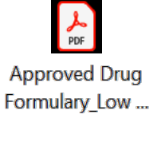 | 67795555
 | Saw Yashi | P01721C | NUH | 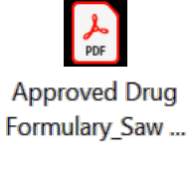 | 67795555
 | Lim Chi Ching | N1042346G | NUH | 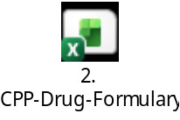 | 67795555
 | Tay Lay Eng Lucinda | N0733263A | NUH | 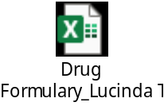 | 67795555
 | Yeo Hui Xian Celine | N0939242Aa | NUH | 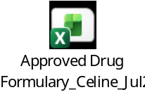 | 67795555
 | Wang Qingli | N0325734F | Hougang Polyclinic | Prescriptions by prescriber are for internal dispensing only | 63553000
 | Chua Bee Ling Xanthe | N9515525Z | TTSH |  | 62566011
 | Wang Zhizhen Golda | P02611E | AH | Prescriptions by prescriber are for internal dispensing only | 64722000
 | Loo Yu Jen | N0224250J | NHCS | 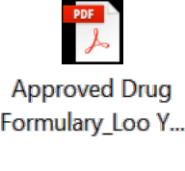 | 67048000
 | Ng Swee Ling Elaine | N9515326E | NHCS | 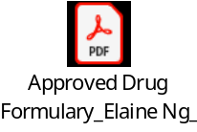 | 67048000
 | Fun Sharon Nne | N9414519Z | KTPH | 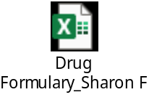 | 65558000
 | Fun Sharon Nne | N9414519Z | Admiralty Medical Centre |  | 68078000
 | Chua Chin Lian | N9515552G | KTPH | 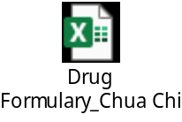 | 65558000
 | Chua Chin Lian | N9515552G | Admiralty Medical Centre |  | 68078000
 | Goh Soon Pang | N0529321J | KTPH | Prescriptions by prescriber are for internal dispensing only | 65558000
 | Ong Kai Xin | P01879A | TTSH |  | 62566011
 | Lee Yanqun Evonne | P01610A | Jurong Polyclinic | Prescriptions by prescriber are for internal dispensing only | 63553000
 | Lim Pei Qi | P02703J | TTSH | 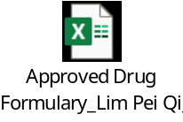 | 62566011
 | Wang Xiaona | N0630703C | TTSH | 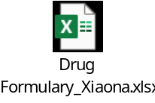 | 62566011
 | Julia Eng Chui Lee | N9515596I | KKWCH | 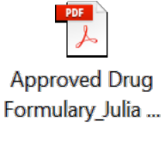 | 62255554
 | Huang Fang | N9819121C | KKWCH | 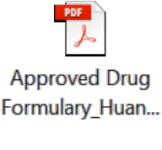 | 62255554
 | Wu Yiping | N0529190J | KKWCH | 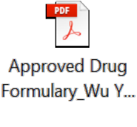 | 62255554
 | Zhang Xinrong | N0122795A | KKWCH | 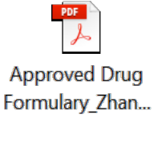 | 62255554
 | Sim Peizhen Charmaine | N0223618G | NUH | 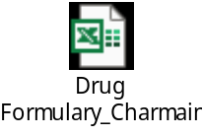 | 67795555
 | Lim Mei Siew | N9919947H | NUH | 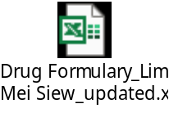 | 67795555
 | Chua Hsu Fung Cindy | N9818946D | NUH | 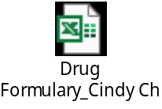 | 67795555
 | Ting Kit Cheng | N9414512B | NUH |  | 67795555
 | Quek Karmen | P03151H | CGH |  | 67888833
 | Kelly Chng Bee Ling | P01336F | NHCS |  | 67048000
 | Chen Liping | P01927E | NHCS |  | 67048000
 | Sarah Ho-Lim Su Tin | N0021749B | NUH | 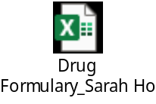 | 67795555
 | Oh Jing Wen | P02093A | KTPH |  | 65558000
 | Stephenie Lim Sheue Fen | P02853C | WHC | 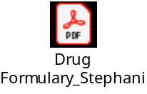 | 63633000​
 | Ngoh Soh Heng Agnes | N8509818C | Bedok Polyclinic | Prescriptions by prescriber are for internal dispensing only | 66436969
 | Wang Xue Fei | N9819165E | Outram Polyclinic | Prescriptions by prescriber are for internal dispensing only | 66436969
 | Zhang Qinyi | N9819094B | Eunos Polyclinic | Prescriptions by prescriber are for internal dispensing only | 66436969
 | Michelle Low Pei Qi | P02535F | Punggol Polyclinic | Prescriptions by prescriber are for internal dispensing only | 66436969
 | Wong Qian Hong | P02324H | Bedok Polyclinic | Prescriptions by prescriber are for internal dispensing only | 66436969
 | Cheryl Tan Wei Yan | P02678F | Kallang Polyclinic | Prescriptions by prescriber are for internal dispensing only | 63553000
 | Cheryl Tan Wei Yan | P02678F | Toa Payoh Polyclinic | Prescriptions by prescriber are for internal dispensing only | 63553000
 | Cheryl Tan Wei Yan | P02678F | Khatib Polyclinic | Prescriptions by prescriber are for internal dispensing only | 63553000
 | Fu Wing Hang | P02088E | SKGH | Prescriptions by prescriber are for internal dispensing only | 69305000
 | Ng Hong Yen | P01453B | SGH | Prescriptions by prescriber are for internal dispensing only | 62223322
 | Ng Vin Cci | P01733G | SGH | Prescriptions by prescriber are for internal dispensing only | 62223322
 | Ng Vin Cci | P01733G | NCCS | Prescriptions by prescriber are for internal dispensing only | 64368091
 | Samuel Ho Shan Wei | P03266B | KTPH | 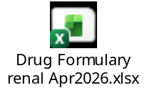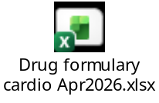 | 65558000
 | See Toh Wei Yann | P02536D | TTSH |  | 62566011
 | Jessie Tan Joon Cheen | N9314139I | KTPH | 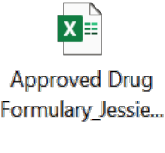 | 65558000
 | Wang Xiqin | N0325735D | CGH | 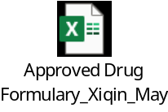 | 67888833
 | Raudhah Binte Haji Mohamad Mascuri | N9314183F | CGH | 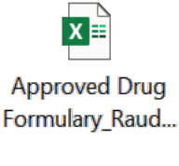 | 67888833
 | Mu Wei Ling | N9920010G | CGH | 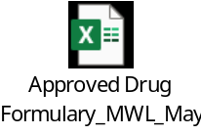 | 67888833
 | Serena Koh Ee Ling | N9818895F | CGH | 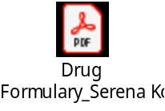 | 67888833
 | Sim Aishah Binte Mohammed | N0122451J | CGH | 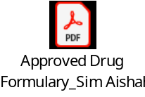 | 67888833
 | Tan Beng Le | N9819551J | Assisi Hospice | 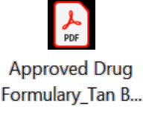 | 68322650
 | Cassandra Chang Wee Ting | P01602J | SGH | Prescriptions by prescriber are for internal dispensing only | 62223322
 | Tan Su Ching | P01999B | NUH |  | 67795555
 | Elaine Lo | P03508D | NUH | 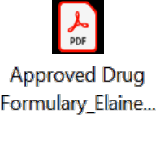 | 67795555
 | Hsu Pei Chi | N9819679G | KTPH | 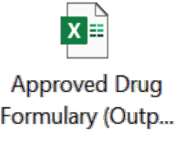 | 65558000
 | Bian Li | N0325723J | Bukit Batok Polyclinic | Prescriptions by prescriber are for internal dispensing only | 68962094
 | Sin Irene | N0529956A | SGH | Prescriptions by prescriber are for internal dispensing only | 62223322
 | Chan Yoke Ling | N9616185C | SGH | Prescriptions by prescriber are for internal dispensing only | 62223322
 | Tan Poh Ching | P02395G | Geylang Polyclinic | Prescriptions by prescriber are for internal dispensing only | 63553000
 | Tan Poh Ching | P02395G | Serangoon Polyclinic | Prescriptions by prescriber are for internal dispensing only | 63553000
 | Chia Hui Shan | P02034F | Yishun Polyclinic | Prescriptions by prescriber are for internal dispensing only | 63553000
 | Sumathi D/O M.Govindan | N0938395C | KTPH | 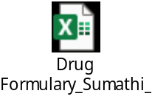 | 65558000
 | Sumathi D/O M.Govindan | N0938395C | Admiralty Medical Centre |  | 68078000
 | Mariana Binte Mahadi | N0529166H | KTPH | 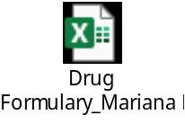 | 65558000
 | Mariana Binte Mahadi | N0529166H | Admiralty Medical Centre |  | 68078000
 | Woo Sook Fan Amy | N0224557G | NUH | Prescriptions by prescriber are for internal dispensing only | 67795555
 | Lee Kim Hua | N9919977Z | NUH |  | 67795555
 | Lee Choy Yee | N0428221I | NUH |  | 67795555
 | Cheong Yuiin Ling | N0021133H | NUH |  | 67795555
 | Song Ge | N0122752H | NUH | 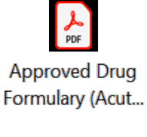 | 67795555
 | Raveen Dev Ram Dev | N0122768D | IMH | 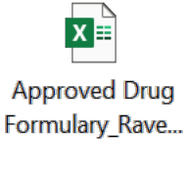 | 63892000
 | Saralla D/O Arunasalam | N9819696G | IMH | 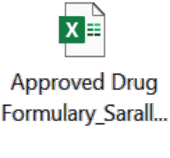 | 63892000
 | Lim Tien Joo | N9920496Z | IMH | 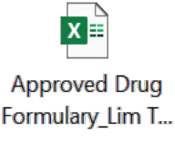 | 63892000
 | Li Jie | N0732921E | IMH | 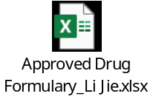 | 63892000
 | Gao Ziwen | N0732918E | IMH | 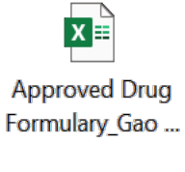 | 63892000
 | Ang Bee Hwee | P02261F | TTSH | 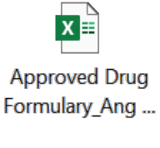 | 62566011
 | Law Hwa Lin | P01116I | TTSH | 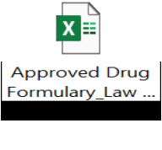 | 62566011
 | Ng Giok Qin | P03648Z | TTSH |  | 62566011
 | Selina Cheong Ting Ting | P02264J | TTSH |  | 62566011
 | Li Lihong | N0427586G | TTSH | 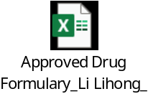 | 62566011
 | Jamie Lim Chuen | N9112567I | TTSH | 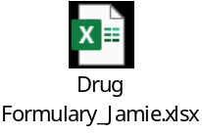 | 62566011
 | Jennifer Wong Chee Mei | N9213196B | TTSH |  | 62566011
 | Kang Sin Ee Jasmine | N9919970B | TTSH |  | 62566011
 | Tan Siok Bee | N8510147H | SGH | Prescriptions by prescriber are for internal dispensing only | 62223322
 | Usanee Chotphoksap | N0325781H | SGH | Prescriptions by prescriber are for internal dispensing only | 62223322
 | Chong Yu Hooi | N0733245C | NTFGH | 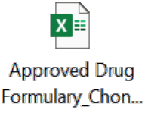 | 67162000
 | Chong Hui Ping | P03030I | NUH | 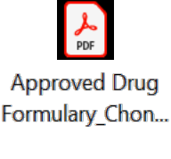 | 67795555
 | Tan Su-Yin Doreen | P01023E | NUH | 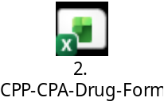 | 67795555
 | Lim Hui Ning | P02492I | NUH | 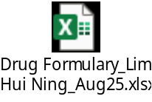 | 67795555
 | Yao Yao | P02490B | NUH | 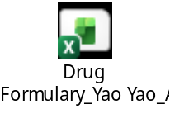 | 67795555
 | Yong Huey Shyan | P01834A | NHCS |  | 67048000
 | Lim Kiat Wee | P01302A | SGH | Prescriptions by prescriber are for internal dispensing only | 62223322
 | Lim Yan Jiun | P01842B | SGH | Prescriptions by prescriber are for internal dispensing only | 62223322
 | Larissa Tan Yi Ying | P03044I | KTPH |  | 65558000
 | Charlene Ng Kai Yi | P03587D | KTPH | 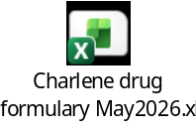 | 65558000
 | Chia Gerk Sin | N0939256A | TTSH |  | 62566011
 | Yow Chunru Fionna | N0529427F | TTSH |  | 62566011
 | Zhuo Guoshuang | N0835134B | TTSH |  | 62566011
 | Serene Tan Leong Hwee | N9919996F | TTSH |  | 62566011
 | Ng Suan Gek | N0021027G | NNI (TTSH) | Prescriptions by prescriber are for internal dispensing only | 63306363
 | Ng Suan Gek | N0021027G | SGH | Prescriptions by prescriber are for internal dispensing only | 62223322
 | Melissa Chow Mee Yin | P01877E | SGH | Prescriptions by prescriber are for internal dispensing only | 62223322
 | Yap Hui Rei | P01882A | Ang Mo Kio Polyclinic | Prescriptions by prescriber are for internal dispensing only | 63553000
 | Tan Shu Ying | P03676E | TTSH |  | 62566011
 | Yong Ying Bing | N0732644E | NUH | Prescriptions by prescriber are for internal dispensing only | 67795555
 | Tsen Li Mee Marie | N9616461E | AH | Prescriptions by prescriber are for internal dispensing only | 64722000
 | Ng Li Choo | N9717584F | SGH | Prescriptions by prescriber are for internal dispensing only | 62223322
 | Maslinna Binte Abdul Rahman | N0529351B | SGH | Prescriptions by prescriber are for internal dispensing only | 62223322
 | Daphne Tan Soo Chieng | P01460E | Bukit Merah Polyclinic | Prescriptions by prescriber are for internal dispensing only | 66436969
 | Lim Hui Shien | P02439B | Punggol Polyclinic | Prescriptions by prescriber are for internal dispensing only | 66436969
 | Chan Shi Mun | P03619F | AH |  | 64722000
 | Sim Kwang Han | P02502Z | Marine Parade Polyclinic | Prescriptions by prescriber are for internal dispensing only | 66436969
 | Lam Miao Hui | P03782F | WHC | 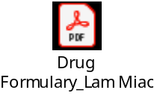 | 63633000
 | Clara Wong Su Ying | P02632H | NTFGH | 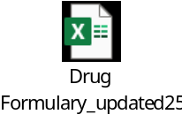 | 67162000
 | Jiang He | P03259Z | NUH | 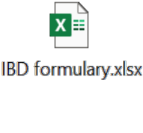 | 67795555
 | Xiong ShuJuan | P02280B | AH | 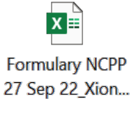 | 64722000
 | Ong Shu Fen | N1249096B | KTPH | Prescriptions by prescriber are for internal dispensing only | 65558000
 | Ho Li Fen Carol | N1042339D | NUH |  | 67795555
 | Chee Rei Yen | N1145452D | NUH |  | 67795555
 | Pang Shu Kuan | N0631215J | NUH | 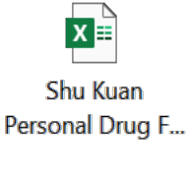 | 67795555
 | Tan Min Yuan | N1042364E | NUH |  | 67795555
 | Yang Jing Hui | N0021087J | NUH | 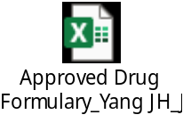 | 67795555
 | Lee Suhui | N1249095D | KTPH |  | 65558000
 | Lim Shimin Cher | N0835184I | SGH | Prescriptions by prescriber are for internal dispensing only | 62223322
 | Rajashulakshana D/O Rajaram | N0326912C | SGH | Prescriptions by prescriber are for internal dispensing only | 62223322
 | Lin Lilin | N0529090D | SGH | Prescriptions by prescriber are for internal dispensing only | 62223322
 | Wen Jing | N0733474Z | SGH | Prescriptions by prescriber are for internal dispensing only | 62223322
 | Lim Jia Hui | P02531C | TTSH | 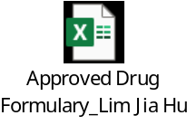 | 62566011
 | Ng Wai May | N9515637Z | NNI (SGH) | Prescriptions by prescriber are for internal dispensing only | 62223322
 | Ng Wai May | N9515637Z | NNI (TTSH) | Prescriptions by prescriber are for internal dispensing only | 62566011
 | Janis Tye Siew Noi | N9616671E | SGH | Prescriptions by prescriber are for internal dispensing only | 62223322
 | Janis Tye Siew Noi | N9616671E | NNI (TTSH) | Prescriptions by prescriber are for internal dispensing only | 62566011
 | Tan Il Fan | N0325778H | NNI (SGH) | Prescriptions by prescriber are for internal dispensing only | 62223322
 | Alice Chua Foong Sin | N9616507G | SGH | Prescriptions by prescriber are for internal dispensing only | 62223322
 | Alice Chua Foong Sin | N9616507G | NCCS | Prescriptions by prescriber are for internal dispensing only | 64368091
 | Hong Yanqi | N1042377G | NCCS | Prescriptions by prescriber are for internal dispensing only | 64368091
 | Koh Poh Geok Suzanne | N9213444I | NCCS | Prescriptions by prescriber are for internal dispensing only | 64368091
 | Ma Yuet Ting | P02126A | Toa Payoh Polyclinic | Prescriptions by prescriber are for internal dispensing only | 63553000
 | Sandra Xu | P02109A | Hougang Polyclinic | Prescriptions by prescriber are for internal dispensing only | 63553000
 | Loh Chai-Li Jeffrey | N0325790G | AH | 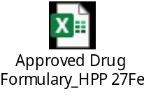 | 64722000
 | Wang Chunyan | N9920163D | Woodlands Polyclinic | Prescriptions by prescriber are for internal dispensing only | 63553000
 | Wang Chunyan | N9920163D | Khatib Polyclinic | Prescriptions by prescriber are for internal dispensing only | 63553000
 | Wang Chunyan | N9920163D | Sembawang Polyclinic | Prescriptions by prescriber are for internal dispensing only | 63553000
 | Goh Shixu | P03664A | NTFGH | Prescriptions by prescriber are for internal dispensing only | 67162000
 | Chew Jing Si | N0733614I | SGH | Prescriptions by prescriber are for internal dispensing only | 62223322
 | Goh Ai Sze Cheryl | N0224507J | IMH | 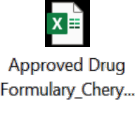 | 63892000
 | M Bindthu Sukumaran Nair | N9515225J | IMH | 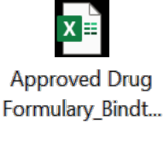 | 63892000
 | Tan Peck Lan Frieda | N0529929D | IMH | 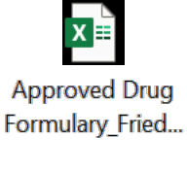 | 63892000
 | Tan Yen Li Wendy | N104196B | IMH | 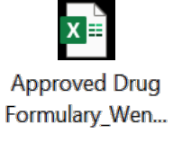 | 63892000
 | Yip Wan Ting Shanel | N0835756A | IMH | 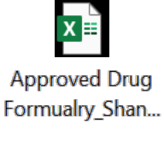 | 63892000
 | Zhang Ling | N9919871D | IMH | 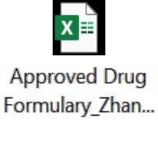 | 63892000
 | Zhou Zhenyu | N0325951I | IMH | 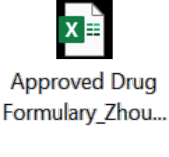 | 63892000
 | Ng Porlin | P03381B | NUH | 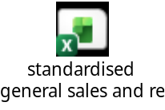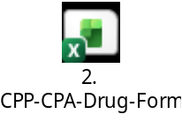 | 67795555
 | Tan Hongyun | N1042339D | WHC | 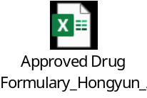 | 63633000​
 | Tan Mei Hong | N1453897C | NTFGH | 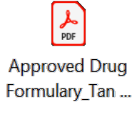 | 67162000
 | Lee Yee Mei | N9213338H | NUH |  | 67795555
 | Wang Hwee Yi Stella | N9717871C | SKGH | Prescriptions by prescriber are for internal dispensing only | 69305000
 | Wong Yoke Hui | N0630768H | SKGH | Prescriptions by prescriber are for internal dispensing only | 69305000
 | Chan Zhi Yao | P02981E | NUH |  | 67795555
 | Wang Wei | N0529100E | SGH | Prescriptions by prescriber are for internal dispensing only | 62223322
 | Adele Woon Pei Ning | N1351806I | NCCS | Prescriptions by prescriber are for internal dispensing only | 64368091
 | Yau Sew Peng | N0122942C | KTPH | Prescriptions by prescriber are for internal dispensing only | 65558000
 | Sim Wee Sern Glen | N0835907F | SKGH | Prescriptions by prescriber are for internal dispensing only | 69305000
 | Myat Myint Myint Kyaing | N0325814H | Pioneer Polyclinic | Prescriptions by prescriber are for internal dispensing only | 63553000
 | Meng Chunli | N0529059I | CGH | 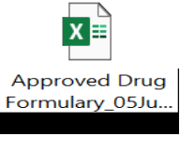 | 67888833
 | Jia Lina | N0427527A | CGH | 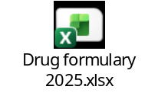 | 67888833
 | Marnie Tamayo Gutierrez | N0223726D | CGH |  | 67888833
 | Chua Xing Rong Annabel | P03790G | TTSH |  | 62566011
 | Cheng Hong | N0224068J | TTSH | 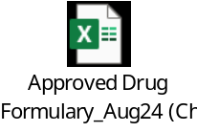 | 62566011
 | Lim Kelly | N0630615J | TTSH |  | 62566011
 | Tan Beng Li | P01888J | Bukit Batok Polyclinic | Prescriptions by prescriber are for internal dispensing only | 68962094
 | Lee Chern Yih | P02318C | AH | Prescriptions by prescriber are for internal dispensing only | 64722000
 | Veronica Margaret Loh Peixia | N0733262C | AH | Prescriptions by prescriber are for internal dispensing only | 64722000
 | Lee Siok Ying | P01663B | KTPH |  | 65558000
 | Xie Meijiao | N0938564F | Yishun Polyclinic | Prescriptions by prescriber are for internal dispensing only | 63553000
 | Yu Rubing | N0021249J | Punggol Polyclinic | Prescriptions by prescriber are for internal dispensing only | 66436969
 | Chieng Ying Jia Shermin | N1145431A | Bukit Panjang Polyclinic | Prescriptions by prescriber are for internal dispensing only | 69082222
 | Jiang Lina | N0021239C | CGH | Prescriptions by prescriber are for internal dispensing only | 67888833
 | Lim Soo Ting Joyce | N9818810G | KKWCH | Prescriptions by prescriber are for internal dispensing only | 62255554
 | Dong Shuqin | N9819204Z | CGH | Prescriptions by prescriber are for internal dispensing only | 67888833
 | Wang Yutao | N0732783B | CGH |  | 67888833
 | Liao Suyue | N0630632J | CGH | 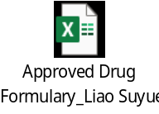 | 67888833
 | Eronica Lim Seok Ping | P04181E | CGH |  | 67888833
 | Eronica Lim Seok Ping | P04181E | SGH | Prescriptions by prescriber are for internal dispensing only | 62223322
 | Tan Ying Lin Cheryl | P03010D | SGH | Prescriptions by prescriber are for internal dispensing only | 62223322
 | Wang Ting | N1041578B | IMH |  | 63892000
 | Li Yao | N0529136F | NUH | 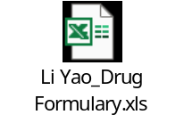 | 67795555
 | Koh Mei Jiao | N0122728E | NUH |  | 67795555
 | Foong Li Li | N9213624G | NUH | 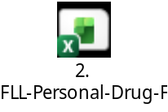 | 67795555
 | Tay Yee Kian | N9213265I | NUHS RHSO | Prescriptions by prescriber are for internal dispensing only | 67795555
 | Yeo Ai Wah | N9515572A | NUHS RHSO | Prescriptions by prescriber are for internal dispensing only | 67795555
 | Amanda Wong Shi Yi | P03268I | SGH | Prescriptions by prescriber are for internal dispensing only | 62223322
 | Catherine Teo Pai Pai | N9515555A | St. Andrew Nursing Home (Taman Jurong, Buangkok, Henderson, Queenstown, St-John’s St Margaret) | Prescriptions by prescriber are for internal dispensing only | 6586 1000
 | Lee Chen Na | N0427436D | SGH | Prescriptions by prescriber are for internal dispensing only | 62223322
 | Leong Ee Won | N0938208F | SGH | Prescriptions by prescriber are for internal dispensing only | 62223322
 | Lew Sook Fui Claire | P03880F | TTSH |  | 62566011
 | Varsha Ramakrishnan | P03598Z | TTSH |  | 62566011
 | Fiona Chen Shaomei | N0122747A | NUH | 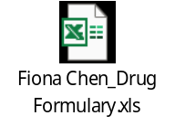 | 67795555
 | Paa Jenniffer Aileen Gonzales | N0732912F | NUH | 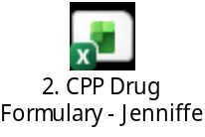 | 67795555
 | Doreen Chew Mei Leng | N0021101Z | NUH |  | 67795555
 | Jedidah Lieow Leng Meng | N0122745E | NUH |  | 67795555
 | Lee Li Jia Tiffany | N1145706Z | NUH |  | 67795555
 | Yang Dongli | N0224263B | NTFGH | Prescriptions by prescriber are for internal dispensing only | 67162000
 | Tan Bee Ling | N0630836F | NNI (TTSH) | Prescriptions by prescriber are for internal dispensing only | 63306363
 | Emily Ang Liling | N9414774E | NNI (TTSH) | Prescriptions by prescriber are for internal dispensing only | 63306363
 | Lim Mei Yoke | P03388Z | NTFGH | 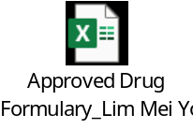 | 67162000
 | Chen Siyun Cassandra | N1453945G | KTPH | Prescriptions by prescriber are for internal dispensing only | 65558000
 | Ong Keng Boon | N9616261B | IMH |  | 63892000
 | Regina Lua Tuan Liang @ Mrs Regina Lua Ubana | N0021359D | IMH |  | 63892000
 | Huang Zhihua | N0733456A | SGH | Prescriptions by prescriber are for internal dispensing only | 62223322
 | Soon Yu Ming | P03717F | NHCS |  | 67048000
 | Hobart Owen Ng Tsai | P02923H | KTPH |  | 65558000
 | Toh Wen Ya | N0938339B | NTFGH | Prescriptions by prescriber are for internal dispensing only | 67162000
 | Zhang Di | N9819219H | SKGH | Prescriptions by prescriber are for internal dispensing only | 69305000
 | Sivagame Maniya | N9616465H | SKGH | Prescriptions by prescriber are for internal dispensing only | 69305000
 | Lin Xueli | N0427657Z | SKGH | Prescriptions by prescriber are for internal dispensing only | 69305000
 | Gan Peiying | N0427417H | SKGH | Prescriptions by prescriber are for internal dispensing only | 69305000
 | Mok Wen Qi | N1351798D | KTPH | Prescriptions by prescriber are for internal dispensing only | 65558000
 | To Hiu Kwan | N0529430F | SGH | Prescriptions by prescriber are for internal dispensing only | 62223322
 | Fam Su Rong | N0529307E | NNI (TTSH) | Prescriptions by prescriber are for internal dispensing only | 62566011
 | Leo Siyan | N0835185G | NNI (TTSH) | Prescriptions by prescriber are for internal dispensing only | 62566011
 | Siti Rohaida Binte Rahmat | N0937831C | NNI (TTSH) | Prescriptions by prescriber are for internal dispensing only | 62566011
 | Siti Rohaida Binte Rahmat | N0937831C | SGH | Prescriptions by prescriber are for internal dispensing only | 62223322
 | Teo Lee Wah | N8509923F | NHCS |  | 67048000
 | Xu Shuhui | N0834834A | KTPH |  | 65558000
 | Aw Fung Chee | N8718568Z | SGH | Prescriptions by prescriber are for internal dispensing only | 62223322
 | Chiang Patsy | N8509705E | NHCS | 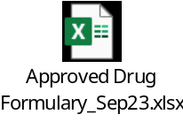 | 67048000
 | Yap Yen Ping | N8911460Z | NHCS | 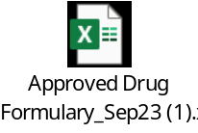 | 67048000
 | Quek Imm Pin | N9818832H | Sembawang Polyclinic | Prescriptions by prescriber are for internal dispensing only | 63553000
 | Quek Imm Pin | N9818832H | Yishun Polyclinic | Prescriptions by prescriber are for internal dispensing only | 63553000
 | Quek Imm Pin | N9818832H | Woodlands Polyclinic | Prescriptions by prescriber are for internal dispensing only | 63553000
 | Ong Yu Jing | N0835024I | KTPH | Prescriptions by prescriber are for internal dispensing only | 65558000
 | Azrina Imran Tan | P04044D | TTSH |  | 62566011
 | Ng Wan Ring | N1144333F | TTSH |  | 62566011
 | Cheok Poh Gek | N0938203E | SGH | Prescriptions by prescriber are for internal dispensing only | 62223322
 | Aw Wei Long Fabian | P02962I | WHC |  | 63633000​
 | Ang Kwang Hwee | N0122600I | SKGH | Prescriptions by prescriber are for internal dispensing only | 69305000
 | Rachel Marie Towle | N9717662A | SGH | Prescriptions by prescriber are for internal dispensing only | 62223322
 | Ng Chang Chyi Celine | P01642Z | CGH |  | 67888833
 | Ng Chang Chyi Celine | P01642Z | SGH | Prescriptions by prescriber are for internal dispensing only | 62223322
 | Ho Ying Shi | P02308F | SGH | Prescriptions by prescriber are for internal dispensing only | 62223322
 | Ho Ying Shi | P02308F | NCCS | Prescriptions by prescriber are for internal dispensing only | 64368091
 | Frena Lee Jia Sy | N1351825E | Jurong Polyclinic | Prescriptions by prescriber are for internal dispensing only | 63553000
 | Lim Qian Ru | N06321288F | CGH | Prescriptions by prescriber are for internal dispensing only | 67888833
 | Tay Xin Ying | P03220D | SGH | Prescriptions by prescriber are for internal dispensing only | 62223322
 | Yan Peng | N0834784A | CGH | Prescriptions by prescriber are for internal dispensing only | 67888833
 | Wang Liyun | N0325816D | CGH | Prescriptions by prescriber are for internal dispensing only | 67888833
 | Chen Xiaojuan | N04277492E | AH | Prescriptions by prescriber are for internal dispensing only | 64722000
 | Tham Wei Ping Vivien | P02974B | SGH | Prescriptions by prescriber are for internal dispensing only | 62223322
 | Nazurah Loh Binte Mohd Ridwan Loh | N0938522J | SNEC | Prescriptions by prescriber are for internal dispensing only | 62277255
 | Daniel Benjamin Fletcher | P02563A | CGH |  | 67888833
 | Felicia Tan Zi Ying | P03607B | CGH |  | 67888833
 | Lee Zhao Yuan | N0835624G | SGH | Prescriptions by prescriber are for internal dispensing only | 62223322
 | Sun Qiuxiang | N0630587A | IMH |  | 63892000
 | Winnie Poh Siew Huay | N9515337J | Kallang Polyclinic | Prescriptions by prescriber are for internal dispensing only | 63553000
 | Winnie Poh Siew Huay | N9515337J | Ang Mo Kio Polyclinic | Prescriptions by prescriber are for internal dispensing only | 63553000
 | Melissa Tan Jia Hui | P03460F | SKGH | Prescriptions by prescriber are for internal dispensing only | 69305000
 | Lee Ting Yee | P02317E | Pioneer Polyclinic | Prescriptions by prescriber are for internal dispensing only | 63553000
 | Claudia Tan Yan Hua | N1145422B | NUH |  | 67795555
 | Koh Pei Si | N0835264J | NUH | 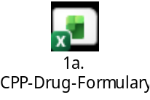 | 67795555
 | Kok Hui Qi | P04091F | SKGH | Prescriptions by prescriber are for internal dispensing only | 69305000
 | Ang Yun Ling | N0529239G | IMH | 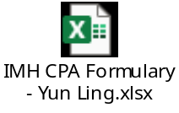 | 63892000
 | Hu Chuanlei | N0835480E | IMH | 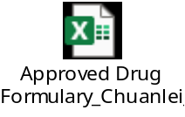 | 63892000
 | Sang Jie | N1350913B | IMH | 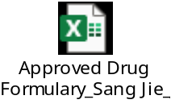 | 63892000
 | Elaine Neoh Geok Lin | P02605J | CGH |  | 67888833
 | Paul Heng Wei Min | P03986A | NHCS |  | 67048000
 | Joey Tan Jia Yi | P04427Z | TTSH |  | 62566011
 | Krystle Tang Huey Weng | N0630961C | NTFGH | Prescriptions by prescriber are for internal dispensing only | 67162000
 | Tang Ee Fhong | P03810E | SGH | Prescriptions by prescriber are for internal dispensing only | 62223322
 | Sim Zuo Heng | P04326E | AH | Prescriptions by prescriber are for internal dispensing only | 64722000
 | Wang Yu Yan | N0939234J | NSC | 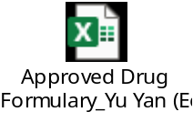 | 62534455
 | Wang Yu Yan | N0939234J | DSC Clinic @ Kelantan Lane | 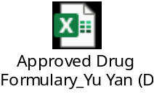 | 62952944
 | Wang Yu Yan | N0939234J | DSC Clinic @ NSC |  | 62534455
 | Helen Law Fung Lun | N0733124D | SGH | Prescriptions by prescriber are for internal dispensing only | 62223322
 | Tee Ning | N0530142F | SGH | Prescriptions by prescriber are for internal dispensing only | 62223322
 | Chua Wei Hsin | N0938441J | Bukit Merah Polyclinic | Prescriptions by prescriber are for internal dispensing only | 66436969
 | Nadiah Erniyanti Binte Maliki | N0529410A | Bedok Polyclinic | Prescriptions by prescriber are for internal dispensing only | 66436969
 | Lim Su Ying Jasmine | N0938341D | NTFGH | Prescriptions by prescriber are for internal dispensing only | 67162000
 | Chia Hoon Woon Audrey | N1144636Z | NTFGH | Prescriptions by prescriber are for internal dispensing only | 67162000
 | Chen Shuo | N1502602F | SGH | Prescriptions by prescriber are for internal dispensing only | 62223322
 | Kassandra Joan D/O Saritharan | N1452908G | IMH |  | 63892000
 | Karine Sim | N0835648D | SGH | Prescriptions by prescriber are for internal dispensing only | 62223322
 | Too Ai Ling Irene | N8911433B | SGH | Prescriptions by prescriber are for internal dispensing only | 62223322
 | Chong Hui Ling, Joanne | N0939233B | SGH | Prescriptions by prescriber are for internal dispensing only | 62223322
 | Michelle Segal-James | N08359938F | WHC | Prescriptions by prescriber are for internal dispensing only | 63633000
 | Chua Leslie | P03850D | TTSH | 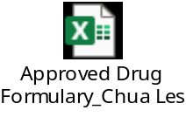 | 62566011
 | Rion Kudo | N1501225D | SKGH | Prescriptions by prescriber are for internal dispensing only | 69305000
 | Phone Ko Joanna | N0939231F | SGH | Prescriptions by prescriber are for internal dispensing only | 62223322
 | Tan Hui Li | N0122576B | SGH | Prescriptions by prescriber are for internal dispensing only | 62223322
 | Lew Sing Hui Veronica | N1248932H | SGH | Prescriptions by prescriber are for internal dispensing only | 62223322
 | Lim Wen Ting | N0325711G | SGH | Prescriptions by prescriber are for internal dispensing only | 62223322
 | Ng Pei Fu | N0529039D | CGH | Prescriptions by prescriber are for internal dispensing only | 67888833
 | Tian Yuan | N0529062I | CGH | Prescriptions by prescriber are for internal dispensing only | 67888833
 | Teo Wei Ling | P04346Z | NHCS | 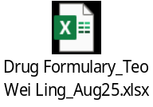 | 67048000
 | Vincent See | P03600E | WHC | 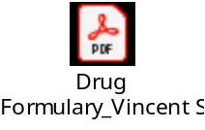 | 63633000
 | Pay Jin Yu | N0020991J | NUHS RHSO |   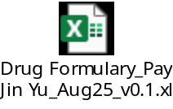 | 67795555
 | Ng Qi Wen | N1248929H | NUHS RHSO | 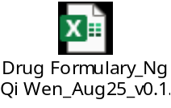 | 67795555
 | Ong Zi Yuan | P04375C | SGH | Prescriptions by prescriber are for internal dispensing only | 62223322
 | Ng Kian Hong | P03597A | CGH |  | 67888833
 | Oo Fiona Aisis | N0835639E | SGH | Prescriptions by prescriber are for internal dispensing only | 62223322
 | Shao Yanli | N0020877I | WHC | Prescriptions by prescriber are for internal dispensing only | 63633000
 | Zhou Yuanpei | N1041194I | NUH | Prescriptions by prescriber are for internal dispensing only | 67795555
 | Lim Peck Kee | N1144391C | NNI (TTSH) | Prescriptions by prescriber are for internal dispensing only | 63306363
 | Lim Peck Kee | N1144391C | SGH | Prescriptions by prescriber are for internal dispensing only | 62223322
 | He Hui | N0224274H | SGH | Prescriptions by prescriber are for internal dispensing only | 62223322
 | Samuel Soon Guo Yu | N1453998H | TTSH | 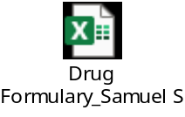 | 62566011
 | Rina Ng | N1453950C | TTSH | 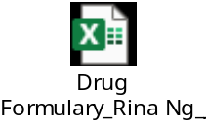 | 62566011
 | Su Meizhen Elsa | N0834756F | TTSH | 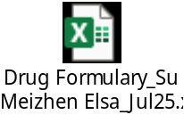 | 62566011
 | Wang Xiaxia | N0732797B | TTSH | 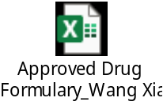 | 62566011
 | Loo Seow Chein | N1144770F | TTSH |  | 62566011
 | Nicholas Chan Xiang Xuan | P03277H | NUH | Prescriptions by prescriber are for internal dispensing only | 67795555
 | Genevieve Suseno Subur | P02569J | SGH | Prescriptions by prescriber are for internal dispensing only | 62223322
- y | Chong Wooi Fuon Christina | N9515574H | NUH | Prescriptions by prescriber are for internal dispensing only | 67795555
 | Goh Kang Wei Desmond | N0835971H | NUH | Prescriptions by prescriber are for internal dispensing only | 67795555
 | Tan Su Lin | N0631106E | NUH | Prescriptions by prescriber are for internal dispensing only | 67795555
 | Ng Yu An Genevieve Marie | N0732755G | SGH | Prescriptions by prescriber are for internal dispensing only | 62223322
 | Lee Ang Yun | N1453867A | NUH | 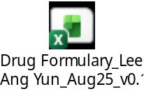 | 67795555
 | Liaw Yi Qi | N1502624G | NUH | Prescriptions by prescriber are for internal dispensing only | 67795555
 | Qi Hong Juan | N0835052D | NUH | Prescriptions by prescriber are for internal dispensing only | 67795555
 | Hwang Yi Ping Faith | N1042363G | TTSH | Prescriptions by prescriber are for internal dispensing only | 62566011
 | Pereira Fiona Lyn | N1041759I | TTSH | Prescriptions by prescriber are for internal dispensing only | 62566011
 | Tan Yihua | P04288I | SGH | Prescriptions by prescriber are for internal dispensing only | 62223322
 | Nathalie Grace Sy Chua | P02307H | SGH | Prescriptions by prescriber are for internal dispensing only | 62223322
 | Narendran S/O Koomanan | P02691C | SGH | Prescriptions by prescriber are for internal dispensing only | 62223322
 | Aline Teh Hooi Ming | N9213324H | SGH | Prescriptions by prescriber are for internal dispensing only | 62223322
 | Teo Wei Qin | N1145477Z | SGH | Prescriptions by prescriber are for internal dispensing only | 62223322
 | Kam Tsz Yan | N0938368F | SGH | Prescriptions by prescriber are for internal dispensing only | 62223322
 | Liu Huiying | N0631094H | NTFGH | Prescriptions by prescriber are for internal dispensing only | 67162000
 | Eliana Luo Jing Ting | N1041329A | Clementi Polyclinic | Prescriptions by prescriber are for internal dispensing only | 63553000
 | Xiao Li | N9920035B | NHCS | Prescriptions by prescriber are for internal dispensing only | 67048000
 | Wee Hwei Li Gillian | N9819684C | NHCS | Prescriptions by prescriber are for internal dispensing only | 67048000
 | Cai Jiana Alice | N0224343D | NHCS | Prescriptions by prescriber are for internal dispensing only | 67048000
 | Zhang Xiaoxia | N0224599B | NHCS | 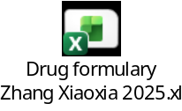 | 67048000
 | Debra Chua Su Fang | P04275G | NHCS | 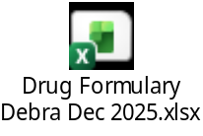 | 67048000
 | Yong Hui Yan Joy | P02152J | NUH | Prescriptions by prescriber are for internal dispensing only | 67795555
 | Xie Qingxiao | P03835J | NUH | Prescriptions by prescriber are for internal dispensing only | 67795555
 | Wang Chunmei | N0224397C | SKGH | Prescriptions by prescriber are for internal dispensing only | 69305000
 | Ng Lit Soo | N0021768I | SGH | Prescriptions by prescriber are for internal dispensing only | 62223322
 | Sutha d/o Wasudevan | N1246774Z | SGH | Prescriptions by prescriber are for internal dispensing only | 62223322
 | Tan Lee Han Shanly | N1249105E | SGH | Prescriptions by prescriber are for internal dispensing only | 62223322
 | Zhang Huimin | N0835328J | NUH | Prescriptions by prescriber are for internal dispensing only | 67795555
 | Chin Hui Shan | N1502521F | SGH | Prescriptions by prescriber are for internal dispensing only | 62223322
 | Kweh Jia Rong | P04287J | Eunos Polyclinic | Prescriptions by prescriber are for internal dispensing only | 66436969
 | Koh Shi Yi | P02954H | Tampines Polyclinic | Prescriptions by prescriber are for internal dispensing only | 66436969
 | Jasmine Tang Vun Jar | P03339A | Sengkang Polyclinic | Prescriptions by prescriber are for internal dispensing only | 66436969
 | Shum Mun Lee Angela | N1351840I | NUH | Prescriptions by prescriber are for internal dispensing only | 67795555
 | Lee Xin Yu Jasmine | N1145441I | NUH | 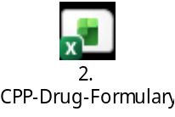 | 67795555
 | Wu Xueting | N0834799Z | NUH | Prescriptions by prescriber are for internal dispensing only | 67795555
 | Tay Yu Ning Tiffany | N1041030F | TTSH |  | 62566011
 | Priscilla Tay | N0834969J | CGH | Prescriptions by prescriber are for internal dispensing only | 67888833
 | Cham Swss Qynn Grace | N0938414C | NUH | Prescriptions by prescriber are for internal dispensing only | 67795555
 | Wong Shi Yin Vivian | P02044C | SGH | Prescriptions by prescriber are for internal dispensing only | 62223322
 | Kuo En Yi | P03701Z | SGH | Prescriptions by prescriber are for internal dispensing only | 62223322
 | Koh Xue Qi | P04157B | SGH | Prescriptions by prescriber are for internal dispensing only | 62223322
 | Cheong Yue Ning | N0733304B | SGH | Prescriptions by prescriber are for internal dispensing only | 62223322
 | Lim Xin Ling | N1247863F | NTFGH | Prescriptions by prescriber are for internal dispensing only | 67162000
 | Tay Yuki | P04591H | TTSH |  | 62566011
 | Lee Hwei Khien | P01127D | TTSH |  | 62566011
 | Chan Lok See Joyce | P04580B | TTSH |  | 62566011
 | Ang Jun Hao | P04243I | TTSH |  | 62566011
 | Eunice Tay | N0326000B | TTSH |  | 62566011
 | Lee Queennie | N1351811E | TTSH |  | 62566011
 | Jennifer Li Yuan | N9717775Z | TTSH |  | 62566011
 | Hou Rui Yu | N0427393G | TTSH | 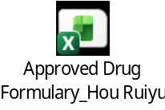 | 62566011
 | Alyssa Chua Xing En | N0835694H | TTSH |  | 62566011
 | Marissa Chin Su Yuen | P03991H | Choa Chu Kang Polyclinic | Prescriptions by prescriber are for internal dispensing only | 67673479
 | Waseemah Begam D/O Abdul Azeez | P03668D | Clementi Polyclinic | Prescriptions by prescriber are for internal dispensing only | 63553000
 | Thinesh Edward Balasingam | N0530105A | SGH | Prescriptions by prescriber are for internal dispensing only | 62223322
 | Lin Mei | N0937950F | SGH | Prescriptions by prescriber are for internal dispensing only | 62223322
 | Woo Guan Yi | N0630853F | SKGH | Prescriptions by prescriber are for internal dispensing only | 69305000
 | Jie Rosi | N1601911I | KTPH | 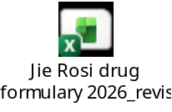 | 65558000
 | Tan Ling Lynn | N1042358J | KTPH | 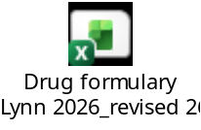 | 65558000
 | Yap Suk Foon | N9717276F | KTPH | 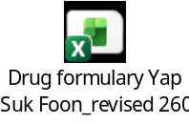 | 65558000
 | Jessica Kong Ci Wan | N1351803D | NTFGH | 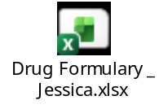 | 67162000
 | Chua Chin Wee Dennis | P02720J | Clementi Polyclinic | Prescriptions by prescriber are for internal dispensing only | 63553000
Last updated on 6 August 2026

