Electronic Signing Solutions

- The following methods may be used for both intra-Government and external facing transactions except where specifically indicated. Please note that the list of OES methods listed in this Annex is not exhaustive.
OES Signing Solutions
OES | Description | Notes
In-system approval | Common examples include (not exhaustive):  - The signatory clicking on an “I accept” or “I agree” checkbox in a system or website; or  - Signing with a pointing device (such as stylus, mouse, finger on a touch screen) in an e-service; or  - At the end of a digital form, with authentication via (i) integration with Singpass or (ii) field to type out form-filler’s name, and verification via email/SMS OTP. | e.g. FormSG is not considered as OES on its own, but an e-service. A signature of “I accept” or “I agree” on FormSG is needed for the transaction to be an OES.  Refer to the pictorial example of an OES in-system approval on FormSG
Email method | The signatory sends an email to the recipient to communicate the notice, agreement or transaction, with the relevant text in the email body or as an attached document. The signatory types his name as the signature or appends his signature. | Must be sent from an official email address. For added assurance, it is strongly encouraged for the electronically executed document to be sent from an official email address of the signatory himself.

Example of OES In-system approval on FormSG:
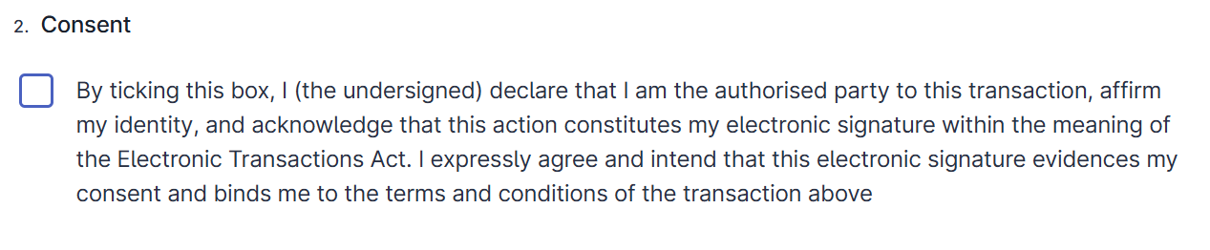
2. If Agencies are unable to use in-system approval or email methods, they can consider using the other OES methods detailed below:
OES | Description | Notes
WOG Signing Certificate method (for officers with GSIB* computers) [*Government Standard Image Build – i.e. Government issued work laptops] | Among the OES solutions, the WOG Signing Certificate method has a tamper-proof feature that provides added assurance of the integrity of the document The signatory digitally signs the document in Adobe Acrobat (using the “Certificates” function) or in Word (using the “Digital Signing” function), before the document is emailed to the recipient. | Only for use for intra Government transactions (i.e. within or between Agencies).  This does not apply to documents that have already been signed. The WOG Signing Certificate was first developed for intra-Government transactions under Finance Circular Minute M9/2019. Subsequently, to support Agencies in the use of electronic signatures during the mandatory work-from-home period, we took a risk-based approach by having the WOG Signing Certificate as one of the OES solutions for external-facing transactions under PMO(SNDGO) Circular Minute 2/2020. While existing security features were sufficient for temporary use, they are not adequate to protect against more sophisticated cyber attackers.]
Image signature method | The signatory embeds a signature image onto the document using any software, before the document is emailed to the recipient. | Refer to Risk Mitigation Measures.
PDF signature method | The signatory digitally draws a signature onto the document, using Adobe Acrobat “Fill and Sign” function or other similar software, before the document is emailed to the recipient. | Refer to Risk Mitigation Measures. Refer to the pictorial example of an OES PDF Signature Method on FormSG
Example of drawn Signature method on FormSG:
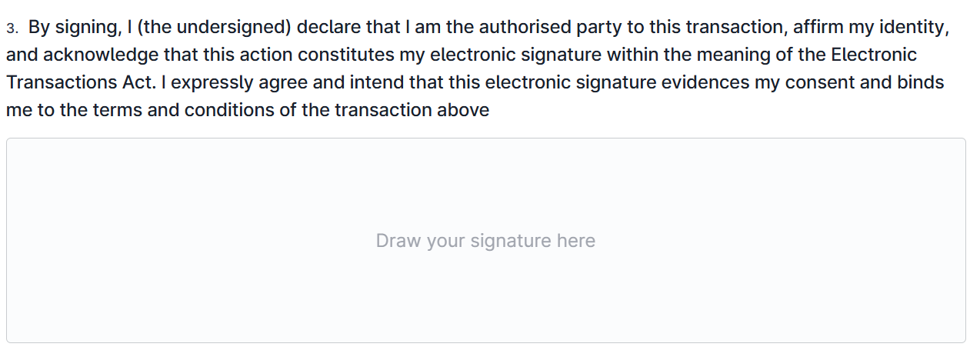
Secure Electronic Signature (“SES”)
3. Where Agencies have assessed that OES does not meet their needs and SES is required, they should use Sign with Singpass signatures. Sign with Singpass signatures are based on Public Key Infrastructure (“PKI”) and are thus tamper-proof, i.e. cannot be modified after signing except to add more PKI-based signatures.
SES | Description | Notes
Sign with Singpass | Agencies may directly integrate with the Sign with Singpass API, or approach one of the Digital Signing Application Providers (“DSAP”) who have integrated with Sign with Singpass.  Agencies may also use Signify (Sign with Singpass) or DocCentral (Sign with Singpass) | A current list of DSAPs integrated with Sign with Singpass can be found at docs.sign.singpass.gov.sg
Digital signatures produced using certificates issued by an accredited certification authority | Where Agencies need to accept SES-level documents from signatories who do not have Sign with Singpass signatures (i.e. foreigners who do not hold a work pass or long-term pass), they may accept digital signatures from Certificate Authorities accredited or recognised by the Electronic Transactions Act. | A current list of accredited certification authorities can be found at https://www.imda.gov.sg/regulations-and-licensing-listing/electronic-transactions-act-and-regulations/controller-of-certification-authorities/accredited-cas-in-singapore

