Sungei Buloh Wetland Reserve marks 30 years with community programmes, new lookout platform
by Jean Iau on 26 November 2023
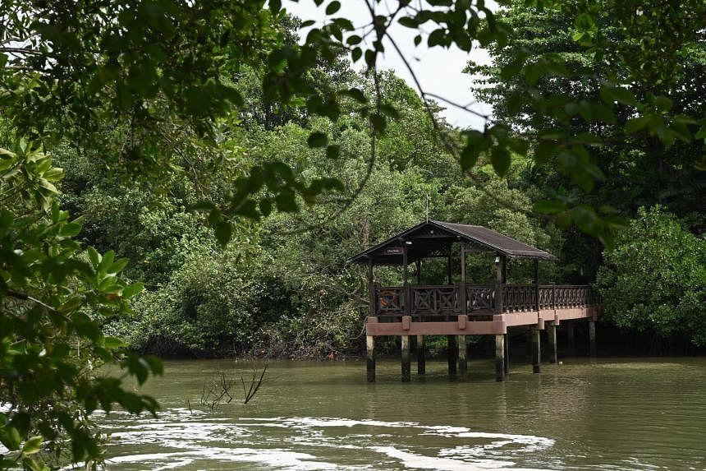The former Main Bridge at the wetland reserve that has been converted to feature a new lookout platform. ST PHOTO: SHINTARO TAY
SINGAPORE – Nature lovers will be able to enjoy free programmes and a new lookout point at Singapore’s only wetland reserve as it celebrates 30 years of conservation.
The Sungei Buloh Wetland Reserve, home to mainland Singapore’s largest mangrove forest, opened the new lookout platform on Nov 25. It was converted from the original main bridge in line with suggestions from the community.
The platform, which is accessible from the wetland centre in Neo Tiew Crescent, offers visitors a panoramic view of Sungei Buloh Besar and a prime vantage point for birdwatching.
As part of the 30th anniversary celebrations, visitors can also register for programmes such as photography classes and guided walks at the reconstructed Cashin House located in Lim Chu Kang Nature Park. Access to the colonial-era house and the 18ha nature park are only for those who sign up for programmes.
Speaking during the celebrations on Nov 25, Mr Desmond Lee, Minister for National Development and Minister-in-charge of Social Services Integration, noted that the wetland reserve’s beginnings are rooted in community initiatives.
Avid birdwatchers in the 1980s discovered that Sungei Buloh’s ponds and mudflats served as key resting and feeding sites for migratory shorebirds.
This group initiated a collaborative community effort to conserve the area, which culminated in the opening of Sungei Buloh Nature Park on Dec 6, 1993, the minister said.
The area was gazetted as a nature reserve in 2002 and was renamed the Sungei Buloh Wetland Reserve.
Mr Lee said volunteers have played a crucial role in conservation efforts in the area over the years.
“It is only through the strong, steady support of the community that we have been able to transform Sungei Buloh into one of the region’s most important and premier wetland reserves,” he told some 200 volunteers as well as corporate and community partners at the wetland reserve’s visitor centre.
Similarly, National Parks Board (NParks) celebrated 30 years of community stewardship since its volunteer programme began with the wetland reserve in 1994.
The Sungei Buloh volunteer programme was formally established in 1997 and involved the recruitment, training and development of volunteers to facilitate public participation in conservation activities.
The programme at Sungei Buloh now has more than 300 active volunteers. In total, NParks’ volunteer base islandwide has grown to more than 60,000.
It has also extended into the Friends of the Parks initiative, which has grown to 12 communities with thousands of volunteers.
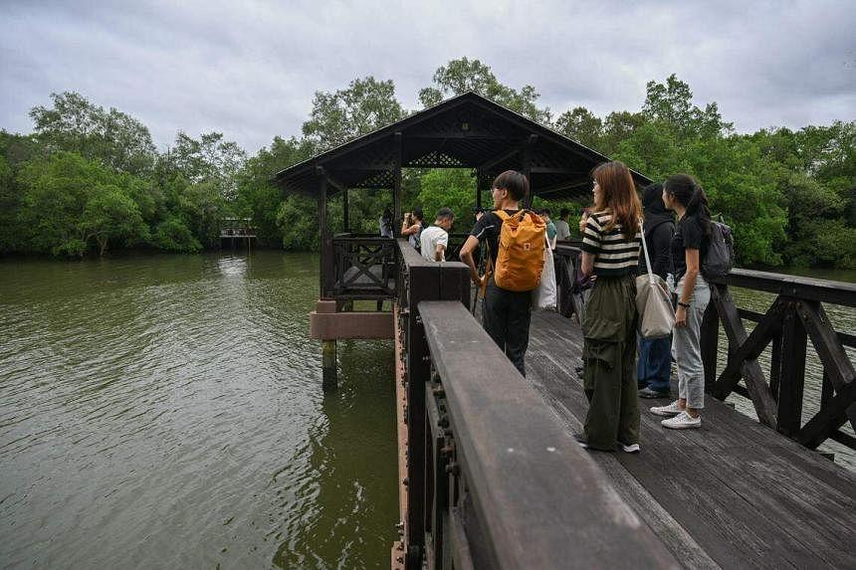Visitors looking at the former Main Bridge at the wetland reserve that has been converted to feature a new lookout platform. ST PHOTO: SHINTARO TAY
One of the volunteers at Sungei Buloh, Mr Bernard Seah, said that he has been volunteering over the past 11 years to help educate the public on wildlife.
Mr Seah, who is the new chairman of Friends of Sungei Buloh Wetland Reserve, said: “My biggest motivation for being a volunteer is outreach; I like to share what I’ve learnt.”
The 54-year-old believes it is important for Singaporeans to better understand nature to be able to coexist with wildlife.
To help protect the area’s wetland biodiversity, NParks said it has conserved several ecologically important sites around the reserve over the years, including the 31ha wetland reserve extension and Kranji Marshes, which opened in 2014 and 2018 respectively.
The Sungei Buloh Nature Park Network, which is more than triple the size of the wetland reserve, was established in 2020.
It includes the Mandai Mangrove and Mudflat, Kranji Marshes and Lim Chu Kang Nature Park.
NParks said: “These green buffers protect the wetland reserve from edge effects and abutting developments, and enhance ecological connectivity for its biodiversity, which includes rare waterbirds such as the lesser adjutant (Leptoptilos javanicus) and great-billed heron (Ardea sumatrana).”
In 2014, NParks unveiled plans for the sensitive enhancement of the western extension to Sungei Buloh Wetland Reserve to strengthen the conservation of the area’s biodiversity.
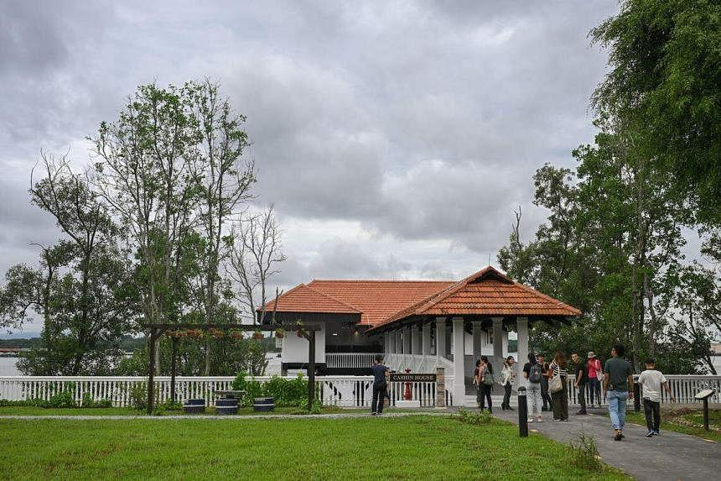Cashin House at the Lim Chu Kang Nature Park is accessible only through special programmes and activities that the public can sign up for. ST PHOTO: SHINTARO TAY
This extension was earmarked in 2020 for conservation as Lim Chu Kang Nature Park, which encompasses Cashin House. Habitat restoration is ongoing at the nature park, which also features intertidal mangroves and mudflats.
Cashin House, originally built in 1921, overlooks the Johor Strait, and its pier is known for being one of the sites where the Japanese Imperial Army landed on the north-western coastline on Feb 8, 1942.
The reconstructed 160 sq m house retains elements of its original colonial architecture, such as the metal gate, clay roof and terrazzo tiles. It houses a gallery, a space for workshops and a terrace overlooking mangroves and mudflats.
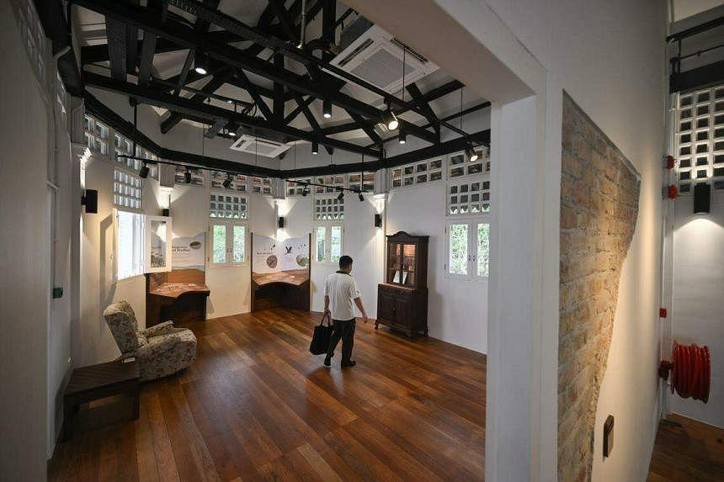Cashin House houses a gallery, a space for workshops and a terrace overlooking mangroves and mudflats ST PHOTO: SHINTARO TAY
Programmes offered at Cashin House and Lim Chu Kang Nature Park include guided walks, wildlife and sunset photography, nature journaling and tree planting.
Members of the public can go to www.go.gov.sg/sbwr30 to view and sign up for the programmes.

Link to article: https://www.straitstimes.com/singapore/sungei-buloh-wetland-reserve-marks-30-years-with-community-programmes-new-lookout-platform

Discussion Questions:
What is Sungei Buloh’s importance to Singapore?
What consequences do you think might arise if green spaces like Sungei Buloh are mismanaged?

