Tapping mangroves a focus of study on protecting Singapore's north-western coast against sea-level rise
by Ng Keng Gene on 15 August 2021
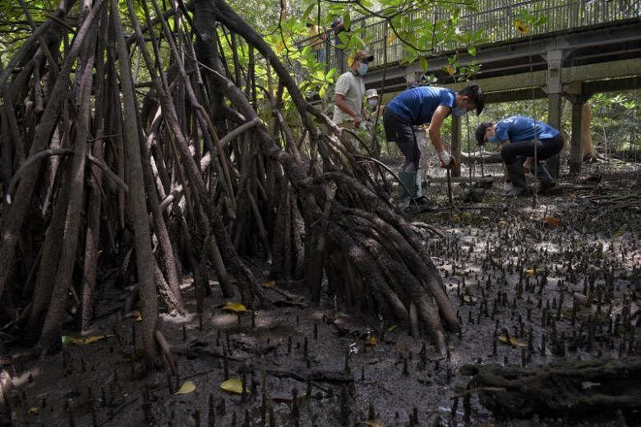
Mangroves are often considered a nature-based solution to counter coastal flooding. ST PHOTO: MARK CHEONG
SINGAPORE - Mangroves can help cushion the impact of climate change and Singapore is now exploring how best to harness this natural defensive weapon against sea-level rise in the north-west.
National water agency PUB called a tender in July for a study, whose findings will help plan and implement coastal protection measures along a 24km stretch between Tuas Checkpoint and Lim Chu Kang jetty.
Key infrastructure within the area includes four reservoirs operated by PUB - Tengeh, Poyan, Murai and Sarimbun - as well as military bases and farms.
Currently, this stretch comprises mainly dams and dykes that form coastal reservoirs, as well as some mangrove habitats.
A 2019 scientific paper by Singapore-based researchers found that pockets of mangroves line the stretch, especially the coastline near Murai and Sarimbun reservoirs.
The upcoming study comes amid heightened alert about how human-caused climate change could worsen the impacts of sea-level rise.
A landmark report by the United Nations' Intergovernmental Panel on Climate Change (IPCC), released on Aug 9, raised alarm bells about the speed at which such change is occurring.
The scientists warned of the possibility of extreme sea level events becoming more frequent. These refer to situations with a low probability of happening but can be very damaging when they do.
Mangroves, which trap sediment from tides in their root systems, are often considered a nature-based solution to counter coastal flooding as they can, to an extent, keep pace with sea-level rise.
National University of Singapore (NUS) mangrove expert Dan Friess said: "Mangroves in Singapore are able to reduce storm wave heights by more than 75 per cent, and mangroves can potentially increase their surface elevations and keep pace with some rates of sea-level rise if there is adequate sediment supply in surrounding waters."
Associate Professor Friess, who is with NUS' Geography Department, said nature-based solutions provide other benefits that do not come with engineered structures.
For instance, mangroves can soak up a lot more of the planet-warming carbon dioxide that is driving climate change than other tropical forest habitats.
But Prof Friess said that while such solutions should be a key component of any coastal management strategy, they have limitations.
"There will be situations where a mangrove alone will not be able to fully reduce the coastal hazard risk to landward assets, in which case mangroves could be incorporated into hybrid engineering solutions," said Prof Friess, who is also the deputy director of the NUS Centre for Nature-based Climate Solutions.
Ms Hazel Khoo, director of PUB's Coastal Protection Department, told The Straits Times that besides looking into the potential of preserving existing mangroves, the study will also explore hybrid approaches.
The latter will combine natural elements and hard engineering solutions.
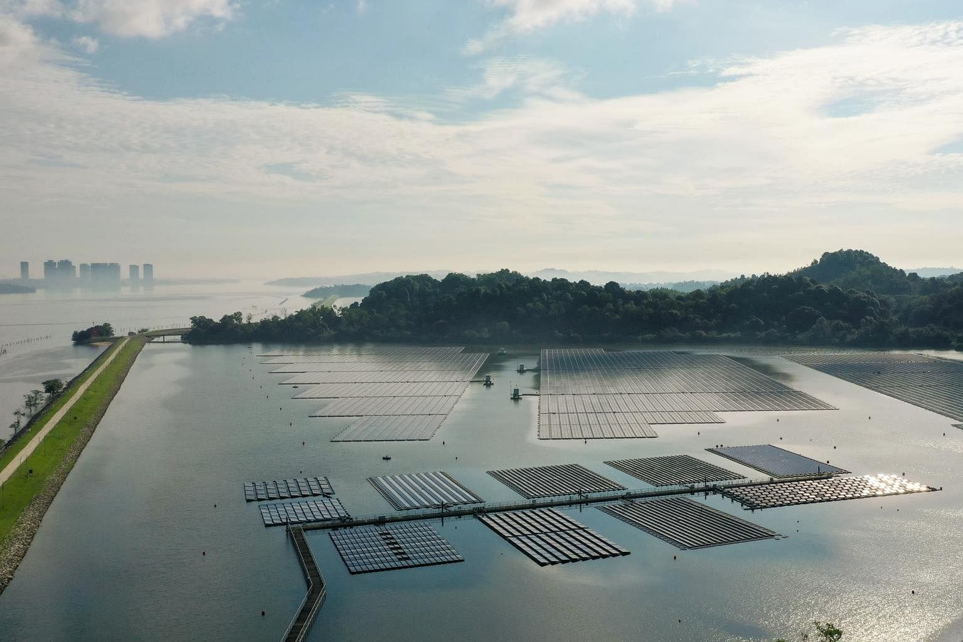
The 24km stretch between Tuas Checkpoint and Lim Chu Kang jetty includes four reservoirs operated by PUB. ST PHOTO: LIM YAOHUI
As flooding can be caused by sea-level rise, as well as bouts of heavier rainfall inland, PUB would consider the twin impacts in the country's adaptation strategy, said Ms Khoo.
She added that PUB will continually review and update Singapore's long-term coastal protection plans, including tapping projections from the IPCC and the country's third national climate change study, expected to be published at the end of 2022.
The tender for the latest study, which is expected to be awarded early next year, is the third site-specific study commissioned by the authorities.
The first two to be called were for the city-east coast stretch of coastline and around Jurong Island.
A tender for the fourth study that covers the other portion of the north-west coast, which includes Sungei Kadut and Woodlands Checkpoint, will be called next year.
All four studies are expected to be completed by 2030.
At Budget 2020, Deputy Prime Minister Heng Swee Keat announced the setting up of a Coastal and Flood Protection Fund, with an initial injection of $5 billion. The fund will finance coastal protection measures and drainage infrastructure to enhance Singapore's flood resilience.
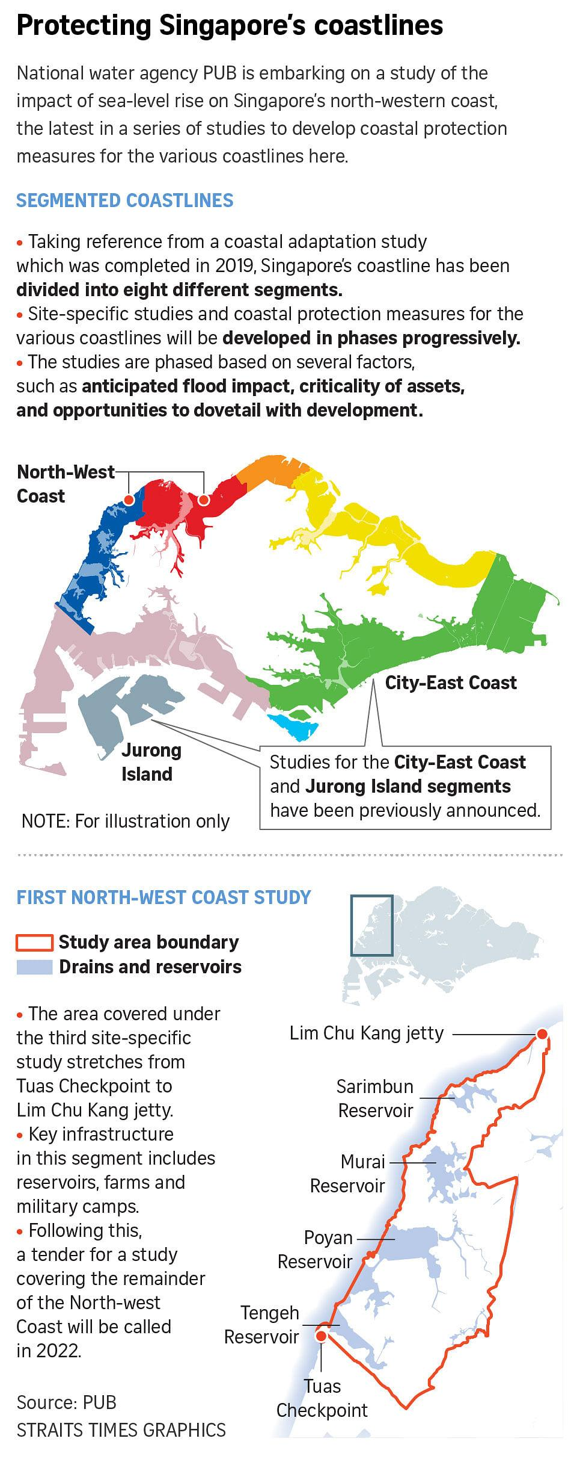
Source: https://www.straitstimes.com/singapore/environment/tapping-mangroves-a-focus-of-study-on-protecting-singapores-north-western
Discussion Questions:
Besides coastal protection, how else are mangroves important?
What can you do to support mangrove conservation efforts?

