Mangrove park to be opened in Pulau Ubin in 2026 with around 8,000 trees
by Gena Soh on 31 October 2022
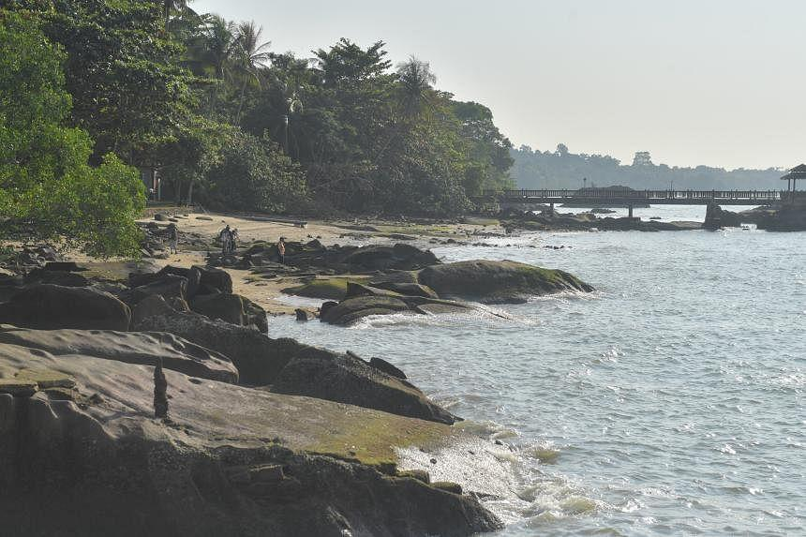The plans are part of a partnership between NParks and OCBC Bank to increase Singapore’s capacity for carbon storage. ST PHOTO: ALPHONSUS CHERN
SINGAPORE - Plans to naturally establish 8,000 mangrove trees in abandoned aquaculture ponds in Pulau Ubin were announced on Saturday, as part of a partnership between the National Parks Board (NParks) and OCBC Bank to increase Singapore’s capacity for carbon storage.
These trees will be located in the ponds of Sungei Durian – with a total area of 4ha – along the southern coast of the island, and the site will eventually be known as OCBC Mangrove Park.
Work is expected to be completed by 2026, and recreational opportunities at the site are expected to be available to the public.
OCBC will also grow an additional 1,000 saplings along the coastline as the park is being developed.
The total of 9,000 mangrove trees are expected to collectively capture and store up to 30 million kg of carbon dioxide in their lifetimes.
At the launch of the project on Saturday, National Development Minister Desmond Lee said the park will complement other nature-based solutions implemented by NParks to tackle climate change.
Examples include a coastal protection and mangrove restoration project on Pulau Tekong and the creation of a coastal belt in Kranji Coastal Nature Park.
Mr Lee said: “These solutions are important in mitigating climate change, and offer additional habitats for our biodiversity.”
Associate Professor Daniel Friess from the National University of Singapore said the mangroves at the OCBC Mangrove Park will take root via the Ecological Mangrove Restoration (EMR) method.
This involves filling the pond with sediment to increase its elevation base to allow mangrove propagules to settle in the soil, and creating “streams” to facilitate these seedlings flowing further inland.
This is important because the ponds now are completely flooded regardless of tide level, he said.
Prof Friess, who is a member of the Restore Ubin Mangroves Initiative, a group that advocates the restoration of mangrove sites on the island, added: “Everyone assumes that mangroves love the sea, that they need it, but it is actually a really stressful place… They’ve evolved over tens of millions of years just to tolerate the flooding.”
“What we are trying to do (with EMR) is create an environment where mangroves are above water just enough, right within their conditions where salt water is just within their tolerance,” he said.
Mr Lim Liang Jim, group director of conservation at NParks, said that apart from functioning as carbon sinks and coastal shields, the restored mangrove fields contribute to the protection of wildlife that reside within these habitats.
“Having a high biodiversity provides a full suite of elements that provide resilience against the impacts of climate change,” he said.
Source: https://www.straitstimes.com/singapore/environment/mangrove-park-to-be-opened-in-pulau-ubin-in-2026-with-around-8000-trees
Discussion Questions:
What are the benefits of developing a mangrove park?
How would the various stakeholders benefit from the development of this mangrove park?

