Singapore's last surviving village

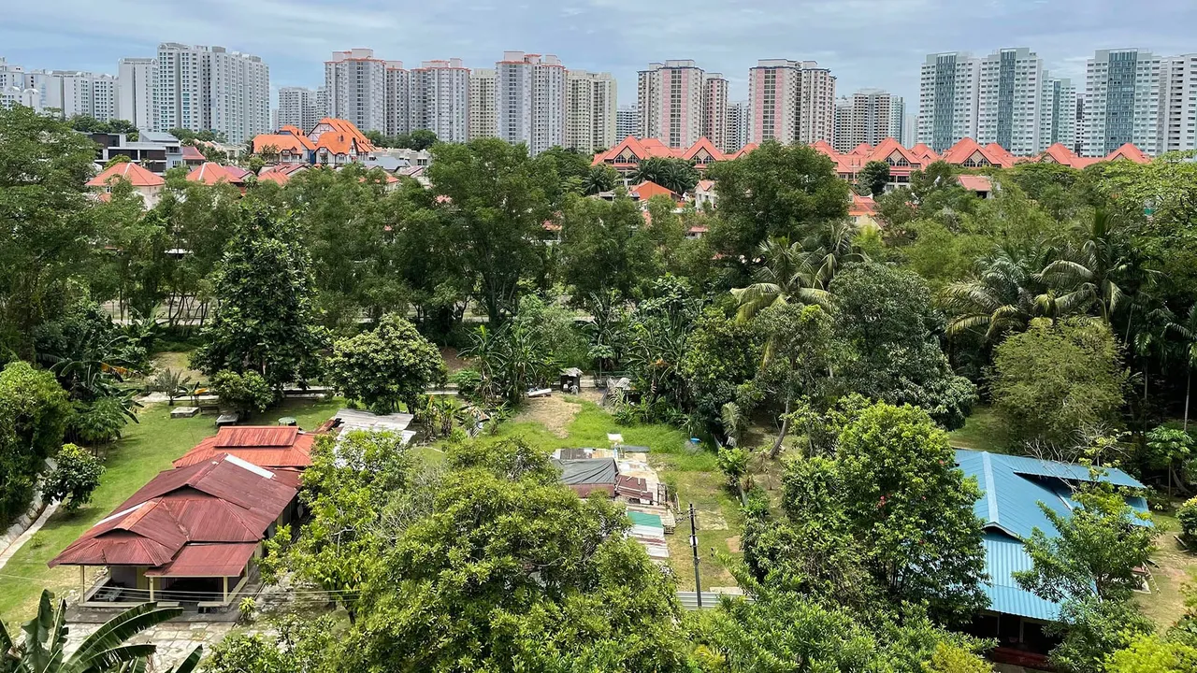
By Samantha HuiQi Yow 27th May 2021

Away from its soaring skyscrapers and urban sprawl, one rural oasis shows how Singapore used to look.
If you turn off the busy Yio Chu Kang road in north-eastern Singapore and follow a long, earthen path that winds and snakes for about 300m, you will find something of a time capsule. Nestled here, on three acres of verdant land, is Kampong Lorong Buangkok, Singapore's last surviving village, where remnants of the 1960s are alive and well. Little resembles modern-day Singapore's panorama of slick skyscrapers. Instead, the cluster of squat bungalows looks like a vintage postcard of the city's yesteryear.

The cluster of squat bungalows looks like a vintage postcard of the city's yesteryear

The kampong – which means "village" in Malay – is a rural oasis in a city-state synonymous with urban sprawl. Roughly 25 archetypal wooden, single-storey dwellings with tin roofs are spread around a surau (small mosque). Forgotten flora that once covered Singapore before all the concrete – like the ketapang, a native coastal tree – grow freely. Nearby, power cables hang overhead, a rare sight since most have gone underground in the rest of the city. Elderly residents sit out on their verandas; chickens in their coops cluck endlessly away; and the chorus of chirping crickets and crowing roosters – the sounds of a bygone era – drown out the city's noise pollution and provide a soothing, bucolic soundtrack.

Nestled among Singapore's modern urban sprawl, Kampong Lorong Buangkok is the city-state's last rural village (Credit: Samantha HuiQi Yow)

Rustic idyll isn't what usually comes to mind when most people think of Singapore today. Rather, it's the boat-shaped Marina Bay Sands towers, the soaring skyline, or the colourful and futuristic Gardens by the Bay. Yet, until the early 1970s, kampongs like Lorong Buangkok were ubiquitous across Singapore, with researchers from the National University of Singapore estimating there were as many as 220 scattered across the eponymous island. Today, while a few still exist on surrounding islands, Lorong Buangkok is the last of its kind on the mainland.
A young nation with international aspirations, Singapore rapidly urbanised in the 1980s and quickly transitioned from an agricultural to industrial economy. Overcrowded shophouses were replaced with high-rise flats and sprawling skyscrapers, ushering in the so-called "era of expressways" that saw small roads replaced with multi-lane highways across the city-state. With land at a premium on the island, the rural kampongs had to give way.
And so hundreds of traditional villages were bulldozed, the native flora stripped, earthen paths levelled and livelihoods razed to the ground as part of a government-wide resettlement programme. Village residents – some reluctant to give up their valuable real estate; others eager to swap countryside living for flushing toilets and running water – were herded into government-built subsidised flats erected atop their old homes. Today, more than 80% of Singaporeans live in these structures.
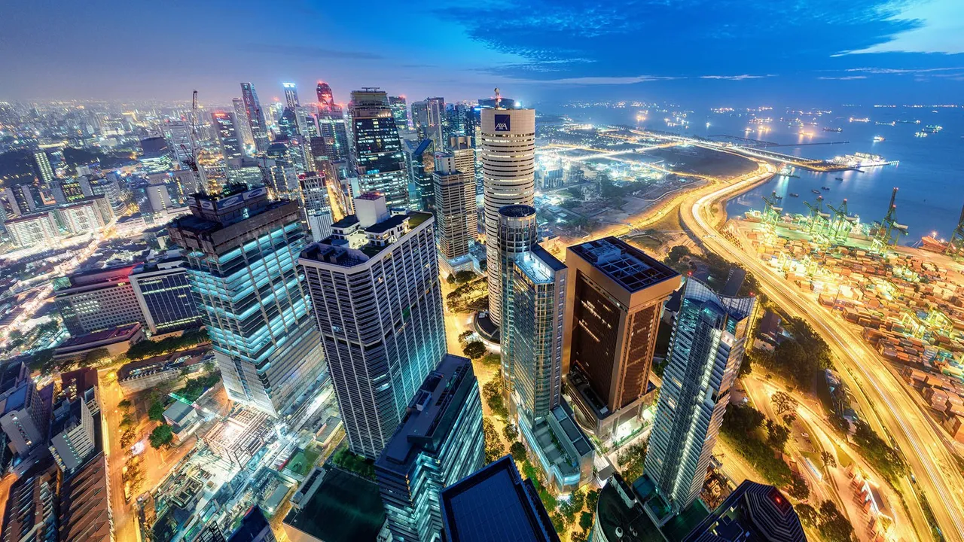Singapore rapidly urbanised in the 1980s and it is now one of the world's most-densely populated countries (Credit: Jonathan Chiang/Scintt/Getty Images)

With the rural villages' demolition also went the famed "kampong spirit", a term used by Singaporeans to describe the culture of camaraderie, trust and generosity that existed within them. In kampongs, residents didn't need to lock their doors and families welcomed neighbours, who often stopped by unannounced to borrow whatever they needed. It's a way of life that the government has tried to recreate in its apartment blocks by increasing the number of shared communal spaces to encourage social interaction.
In 2017, Singapore's Housing & Development Board partnered with the Singapore University of Technology and Design to develop a framework for urban kampongs, a high-tech approach that uses motion sensors and shared Wi-Fi spaces to encourage camaraderie among neighbours. Lawrence Wong, the then-minister for national development said one of the goals was to "strengthen the kampong spirit in our high-rise apartments". But communal living isn't the only ingredient to foster this friendly spirit; the environment matters, too.
One reason Lorong Buangkok has managed to escape the fate that befell other kampongs is because the surrounding area wasn't as desirable for commercial, industrial and residential development as elsewhere in Singapore – though that has slowly changed. Once surrounded by a forest clearing and farms, it is now flanked by an enclave of private gated housing and a cluster of flats that overlooks the low-rise settlement.
Another reason became obvious once I met the village's landlady: a headstrong woman with a resolute commitment to preserve Singapore's sole surviving kampong.
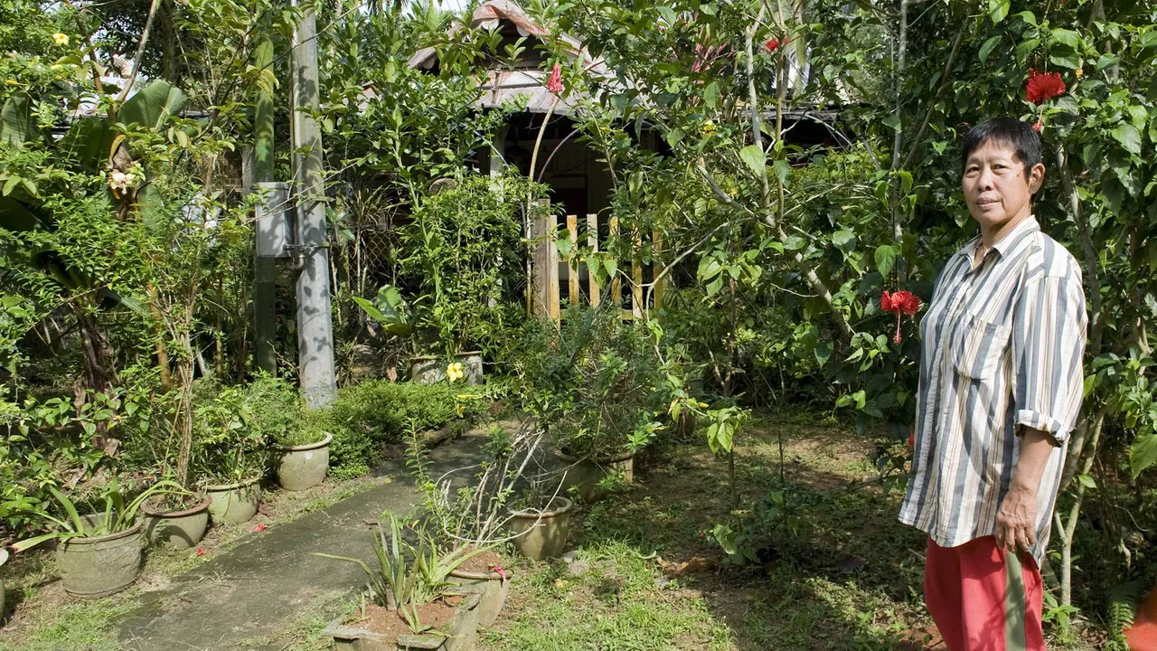Sng Mui Hong is the village's landlady and has lived here since before Singapore was its own country (Credit: AFP Stringer/Getty Images)

Approaching 70, Sng Mui Hong, has lived nearly her whole life in the village. She is the youngest of four siblings, and only one who has stayed here. Her late father, a traditional Chinese medicine seller, purchased the land in 1956, the same year the village was created and nine years before Singapore gained independence.
According to local guide Kyanta Yap, who leads tours through the kampong, the majority of the plots were leased out to workers from the nearby hospital and rubber plantation – many of whose descendants still reside here. Back then, monthly rent for each house was between S$4.50 and S$30 (£2.40-16.20). Today, Sng still charges Lorong Buangkok's 25 families more or less the same rate. By contrast, renting a room that's roughly one-tenth the size of a kampong house in an adjacent government-built block might cost about 20 times that amount. And the houses across the dividing canal can sell for upward of a few million Singaporean dollars.
While the village has arguably the most affordable housing in Singapore, no new occupants have moved in since the 1990s, and there's a slim chance there will be any in the near future. As Yap told me, residency is conditional: someone generally has to move out or pass away for a home to open up, and then only those with a connection to either past and present tenants or Sng's family are considered.
Since Singapore emerged from lockdown last June, Yap has noticed an increasing interest in Lorong Buangkok and his weekend tours now quickly fill to capacity.
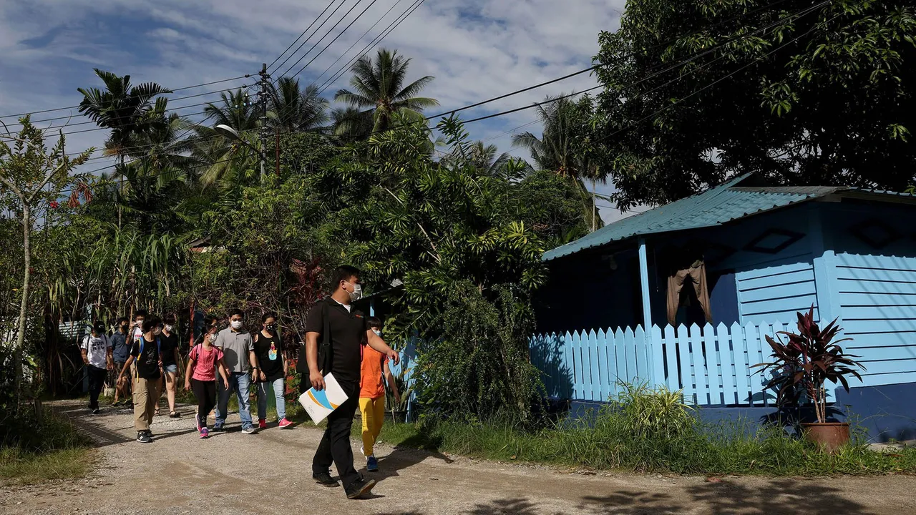Yap, who leads tours through the kampong, has noticed an increase in visitors in the past year (Credit: Edgar Su/Alamy)

It's not that surprising since no-one can travel, and this is a unique local tourist spot," he said. "There are also many who visit on their own; the general public, bikers, joggers and even groups organised on Meetup." Yap said most come to take a serene walk through the kampong, snapping photos of a rare green oasis tucked away in one of the world's most-densely populated and urbanised countries.
Yap added that the secluded, tight-knit community of 25 households who live in the kampong have now grown used to the steady stream of curious passersby.

The village is rare green oasis in one of the world's most-densely populated and urbanised countries

Though Lorong Buangkok may represent an intriguing time capsule for many Singaporeans, it represents something much more for Sng. She recalled following her father around as a child while he tended to this land. It was from him that she picked up the knowledge of traditional Chinese medicine that she now shares with her neighbours. Leaves from the village's henna plants, for example, can be used to soothe open wounds and burns, and they are also believed to protect against intestinal ulcers when ingested.
Sng knows she's sitting on hot property. In a country so starved of space, there has been no shortage of developers hoping to purchase the village. But no offer will ever be attractive enough for her to retract a promise she made to her dying father – to preserve Lorong Buangkok. She reiterated a stance she's defended for decades, and one her siblings, who frequently come back to visit, fiercely share: for as long as she can help it, this land is not up for sale.

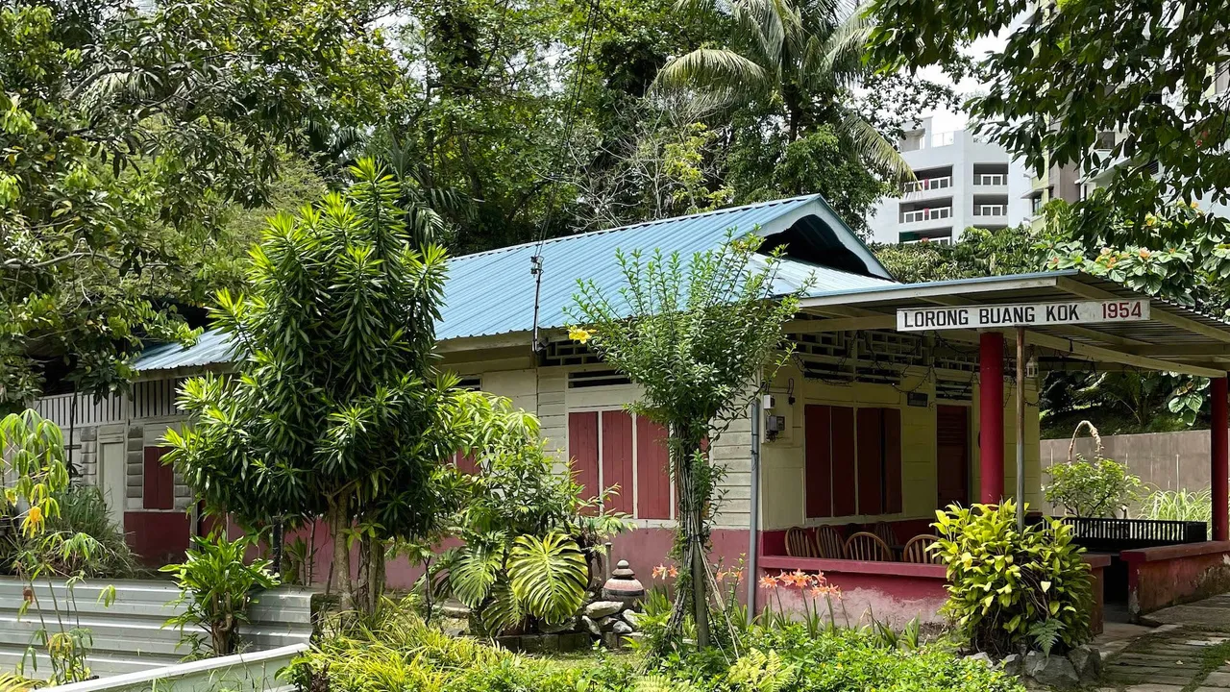
Sng promised her dying father that she would preserve Lorong Buangkok and not sell the land (Credit: Samantha HuiQi Yow)

In 2014, there was a proposal to raze the village and replace it with a highway, two schools and a public park. Though the government may still consider the plan, the Minister for National Development, Desmond Lee, has also stated that there is “no intention to implement these developments in the near future”.
Many Singaporeans have voiced their objections to the proposed plan. Others have even pushed for the village to be included as a Unesco World Heritage site. But while kampongs were once widely regarded as "deplorable" by the Singapore government, there's now a newfound appreciation by officials for these rural relics and the culture they foster.
"Lorong Buangkok could be retained as part of the schools for outdoor learning activities for example, or integrated into future parks or playgrounds," explained Dr Intan Mokhtar, a former politician and current assistant professor in policy and leadership at Singapore Institute of Technology. "Most [residents] have lived there for more than half of their lives, and they treat one another as family."

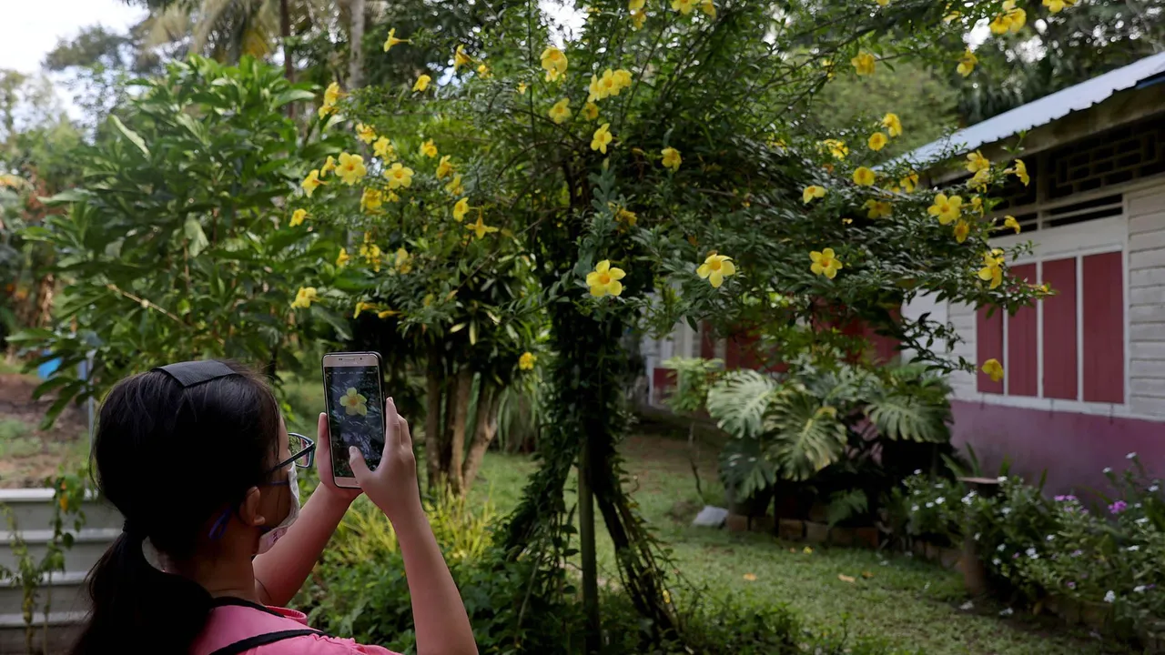
Many Singaporeans now feel a newfound appreciation for this rural relic and the “kampong spirit” (Credit Edgar Su/Alamy)

At the very least, Singaporeans have the government's word that it will approach the matter thoughtfully. "When the time comes for us to finalise our plans for the entire area, the government should work closely with relevant stakeholders to ensure developments are carried out in a holistic and coherent way," Lee has said. "This must involve deep engagement with the kampong families living there at that time, to understand and consider their needs and interests."

We came from these humble huts

One of the kampong's residents, Nassim, told me that, "It's good the government now sees the importance of our kampong."
"You need to leave something behind that reminds our young of how this country came about. We came from these humble huts." Nassim added that it's also a good thing that Sng, once much more reclusive, now welcomes the public to her land. "It helps them understand us and understand why Lorong Buangkok needs to be preserved."
In Singapore, where land is a precious commodity, there will always be tension between keeping the old and developing the new. While the future of Lorong Buangkok remains uncertain, saving it means safekeeping a glimpse of the nation's roots, culture and heritage for future generations – something that's necessary even for a country as young as Singapore.
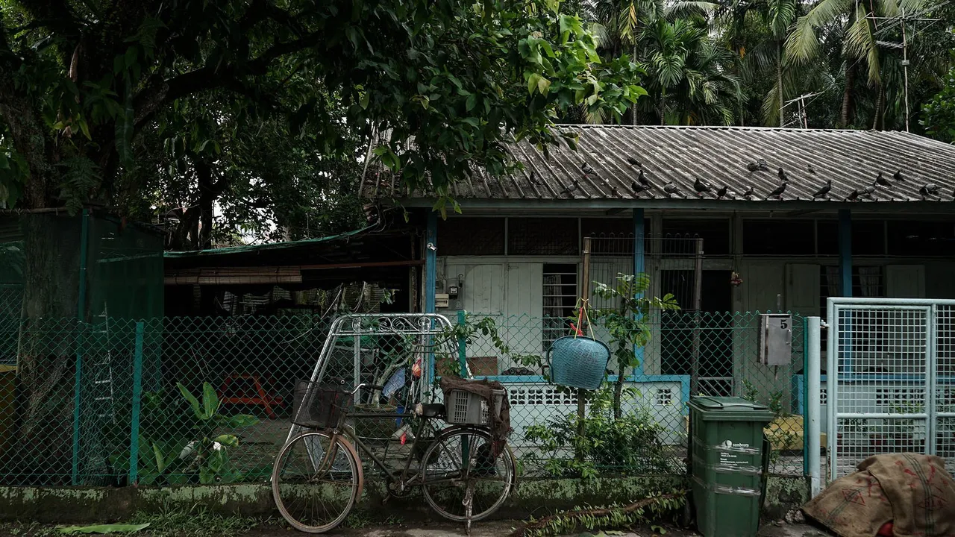
“You need to leave something behind that reminds our young of how this country came about" (Credit: NurPhoto/Getty Images)

Source: BBC Travel
https://www.bbc.com/travel/article/20210525-singapores-last-surviving-village

Discussion Questions:

Why do people choose to live in Lorong Buangkok instead of developed estates?

What role can Lorong Buangkok play in Singapore’s development as a nation?

With respect to Singapore’s land scarcity, what are some trade-offs that must be made in the process of preserving Lorong Buangkok?

