Punggol Waterfront BTO project wins BCA award for inclusive design

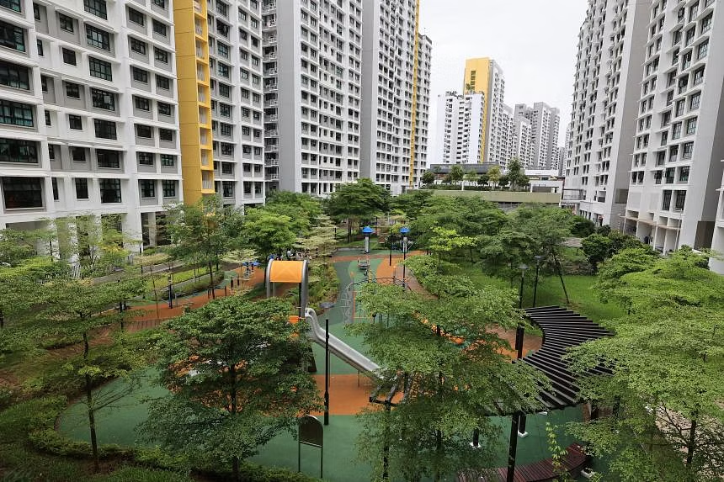The Housing Board’s Build-To-Order project Waterfront I & II @ Northshore in Punggol is one of four winning projects. PHOTO: LIANHE ZAOBAO

Isabelle Liew
PUBLISHED NOV 10, 2022, 6:00 PM SGT

SINGAPORE - Barrier-free communal spaces and linkways to the neighbourhood centre and transport nodes provide residents at Waterfront I & II @ Northshore with seafront living without having to give up comfort or accessibility.
These features helped the project clinch the Building and Construction Authority’s (BCA) Universal Design Excellence Award.
The Housing Board’s Build-To-Order project in Punggol is one of four winning projects, all of which obtained the highest possible universal design index rating, the authority announced on Thursday.
The winners showcased universal design principles to create a more accessible and inclusive environment for people with disabilities, the elderly and young children, BCA said.
Mr Clement Tseng, BCA’s group director for building plan and management, said: “We are glad to celebrate the achievements of these exemplary developers and architects who have incorporated thoughtful designs so that users, regardless of their needs and abilities, can enjoy a common experience.”
This award replaces BCA’s previous Universal Design Mark Award, for which industry players were required to apply.
Now, BCA shortlists projects based on their universal design index, a self-assessment checklist on the firms’ part, before the authority does its own assessment.
At Waterfront I & II, which was completed in 2021, barrier-free pavements connect facilities such as the senior care centre, childcare centre and three-generation playgrounds.
To allow more residents access to the seafront, a wheelchair-accessible promenade and viewing deck with railings were built with safety in mind.

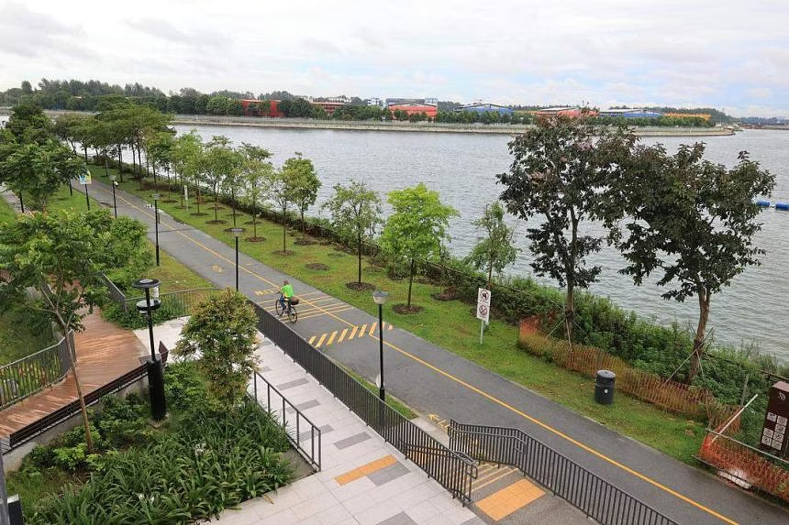A continuous barrier-free seafront promenade runs along the length of the Waterfront I & II development. PHOTO: LIANHE ZAOBAO

Residents can access facilities, communal spaces and the neighbourhood centre – which houses 52 shops – via sheltered linkways on the first and second storey. A second-storey path connecting the development north to south allows residents to reach bus stops and the Samudera LRT station conveniently.
Royalgreen in Bukit Timah, a condominium by Allgreen Properties, also won the award for its facilities that promote social interaction. This includes an indoor play area furnished with flexible play furniture and a projector screen.

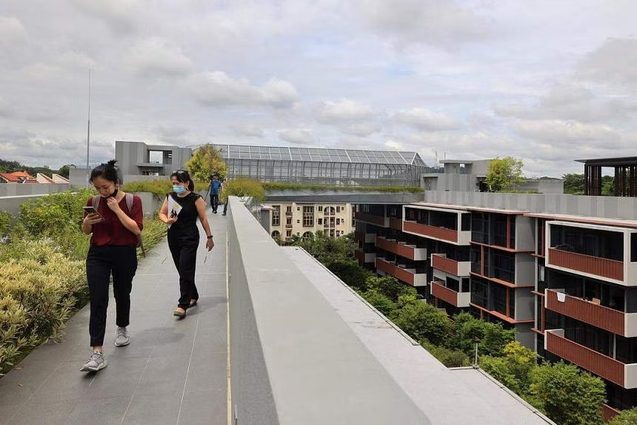The Roof Garden at Royalgreen, with various landscape facilities, is linked across all blocks, providing inter-connectivity above ground. PHOTO: LIANHE ZAOBAO

Another award winner, Fernvale Community Club in Sengkang, has a child-friendly activity level on its fifth storey, complete with a childcare centre, children’s activity rooms and jogging track.
Kallang Polyclinic and Long-Term Care Facility also won the award for its eldercare friendly design. Its counters are equipped with a hearing enhancement system to allow staff members to better communicate with patients.

Source: The Straits Times
https://www.straitstimes.com/singapore/housing/punggol-waterfront-bto-project-wins-bca-award-for-inclusive-design

Discussion Questions:

Why is it important to ensure that housing in Singapore is inclusive?
What other aspects of inclusive housing can be included and suggest methods through which they can be realised.

