$1.56 billion in Enhanced CPF Housing Grants given out to nearly 50,000 households since 2019: HDB

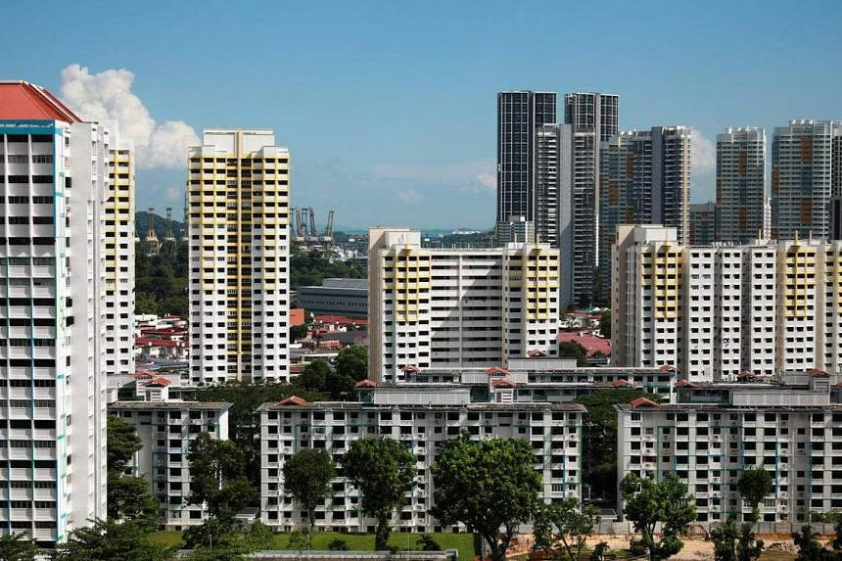
HDB said 49,500 households buying their first flat have benefited from Enhanced CPF Housing Grants since September 2019. ST PHOTO: RYAN CHIONG

Sarah Koh
UPDATED MAY 18, 2023, 5.34 AM SGT

SINGAPORE - The Housing Board gave out $564 million in Enhanced CPF Housing Grants (EHG) to 18,000 households in 2022, with a total of $1.56 billion disbursed since the grant was introduced in 2019.
Providing an update on the grant on Wednesday , HDB said 49,500 households buying their first flat have benefited from it since September 2019.
The number of households and grant amount given out have increased each year since, in line with more flats being sold and a rising number of buyers eligible for the EHG, said HDB in a statement.
From September to December 2019, about 1,500 households received $42 million in EHG, which provides up to $80,000 to lower- and middle-income families buying their first new or resale flat.
In 2020, 14,000 households received $454 million in total, and 16,000 households got $499 million in 2021.
“The EHG is part of a suite of support that the Government provides to ensure HDB flats remain affordable amid the strong demand,” said HDB.
The update comes as the affordability of HDB flats remains a hot-button issue, after resale prices climbed during the Covid-19 pandemic.
The issue has been raised on multiple occasions, including in Parliament where ministers sought to address concerns, including by announcing an increase in the Central Provident Fund (CPF) Housing Grant to help first-timers buying a resale flat.
HDB resale prices increased by 1 per cent in the first quarter of 2023, marking the smallest quarterly increase in the past 10 quarters, or 2½ years.
On Wednesday, HDB said that of the 49,500 first-timer households that have received the EHG, 28,400 bought a flat through its various modes of sale such as Build-To-Order (BTO), Sale of Balance Flats and open booking.
The other 21,100 bought a resale flat, it added.
For Mrs Chloe Leong and her husband, the $60,000 in EHG they received for their five-room resale executive flat helped offset the amount they had to put down as a deposit.
“We found that the grant was very helpful, because we used the entire amount when we were paying the flat’s deposit,” said the 29-year-old psychologist, who bought her Punggol flat in December 2021 for about $580,000.
“We needed to top up only another $1,800 in cash (to cover the deposit).”
HDB also said that with the EHG and market discounts for BTO flats, about 90 per cent of flat buyers who got the keys to their new homes in non-mature estates in 2022 use a quarter or less of their monthly incomes to pay their housing loans.
The figure was more than 80 per cent for those who got the keys to their new flats in mature estates, it added.
“This means that they can service their HDB loans using their monthly CPF contributions, with little or no cash outlay,” said HDB.
It noted that those looking to buy resale flats can tap the Proximity Housing Grant, which provides up to $30,000 and $15,000, respectively, for families and singles who are looking to buy a resale flat to live with – or within 4km of – their parents or children.
Families getting a two- to four-room resale flat can also get $80,000 from the CPF Housing Grant, while those buying a five-room or larger flat can get $50,000.

Close to 50,000 households have bought their first homes with the support of the Enhanced CPF Housing Grant since its…

Posted by Desmond Lee on Tuesday, May 16, 2023

With the various housing grants, almost 80 per cent of first-timer families who collected the keys to their resale flats in 2022 used a quarter or less of their monthly household income to service their HDB loans, said HDB.
Flat buyers will also have an easier time purchasing their homes after HDB streamlined the process by introducing the HDB Flat Eligibility (HFE) letter on May 9.
The HFE replaces the HDB Loan Eligibility letter, and informs potential flat buyers upfront if they are eligible to buy a new or resale flat, the amount of CPF housing grants, and the amount in HDB housing loan they qualify for.
For second-time flat buyers, the HFE letter will also provide information on the resale levy or premium that buyers have to pay upon purchase of another subsidised flat from HDB.
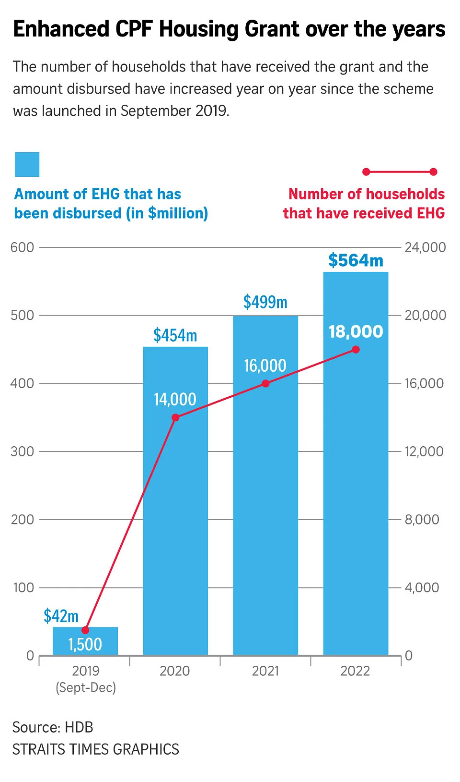

Source: The Straits Times
https://www.straitstimes.com/singapore/156-billion-in-enhanced-cpf-housing-grant-given-out-to-nearly-50000-households-since-2019-hdb

Discussion Questions:

Why is it important that HDB flats remain affordable?

What other measures can be taken to ensure the affordability of HDB flats for Singaporeans?

