Billionaire Adani gets final nod to revamp famous Mumbai slum

Published Sat, Jul 15, 2023 · 2:22 pm

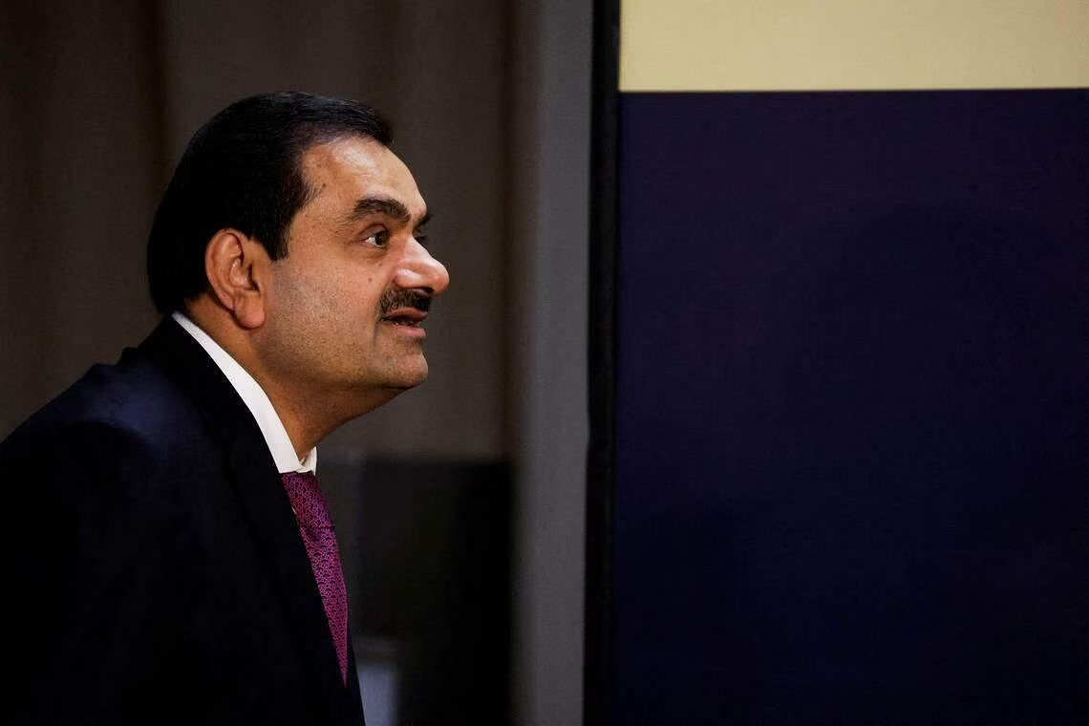
Though Adani’s plans for Dharavi are still opaque, he may transform the slum into modern apartments, offices and malls, extending his foothold in India’s financial capital, where he already runs one of the country’s busiest airports. PHOTO: REUTERS

BILLIONAIRE Gautam Adani’s real estate unit received final approval to start the redevelopment of Dharavi, one of Asia’s largest slums that sits in the heart of Mumbai.
A representative of the Mumbai Metropolitan Region Development Authority, which oversees the project, on Saturday (Jul 15) confirmed it was given the go-ahead by the Maharashtra state government. A spokesperson for Adani Group declined to comment.
Adani won the project with a bid of 50.7 billion rupees (S$815.5 million) late last year. The slum is spread over roughly 620 acres (250 hectares) of potentially prime real estate in the financial capital, which is home to more than 20 million people.
Dharavi, made famous by the film Slumdog Millionaire, neighbours the Bandra Kurla Complex, an upmarket district of shopping malls, embassies and banks, including offices of JPMorgan Chase & Co.
Mumbai’s administrators have struggled for decades to modernise the neighbourhood, because of the difficulty of acquiring large tracts of land, attracting investors to a place without stable utilities, and resettling an estimated one million people.
Though Adani’s plans for Dharavi are still opaque, he may transform the slum into modern apartments, offices and malls, extending his foothold in India’s financial capital, where he already runs one of the country’s busiest airports.
His involvement has been met with protests from local inhabitants, who are concerned that homes and businesses will be relocated far from the city centre. Others fear they’ll be shunted into tiny apartments with poor amenities.
Adani’s ability to find the estimated US$3 billion needed for the project has also been questioned. The group has worked for months to try to repair the damage caused by the January report from short-seller Hindenburg Research that at one point erased more than US$150 billion from the conglomerate’s market value. Adani has denied any wrongdoing.

Source: Business Times
https://www.businesstimes.com.sg/property/billionaire-adani-gets-final-nod-revamp-famous-mumbai-slum

Discussion Questions:

Why are people protesting the revamp of Dharavi?

What are the trade-offs that must be made by local authorities in slum relocation?

Should slum dwellers have a say in cities’ development plans?

