Singapore’s Changi Airport fully reopens Terminal 2 following dramatic makeover

By Karla Cripps, CNN

4 minute read | Updated 6:01 AM EDT, Fri November 3, 2023

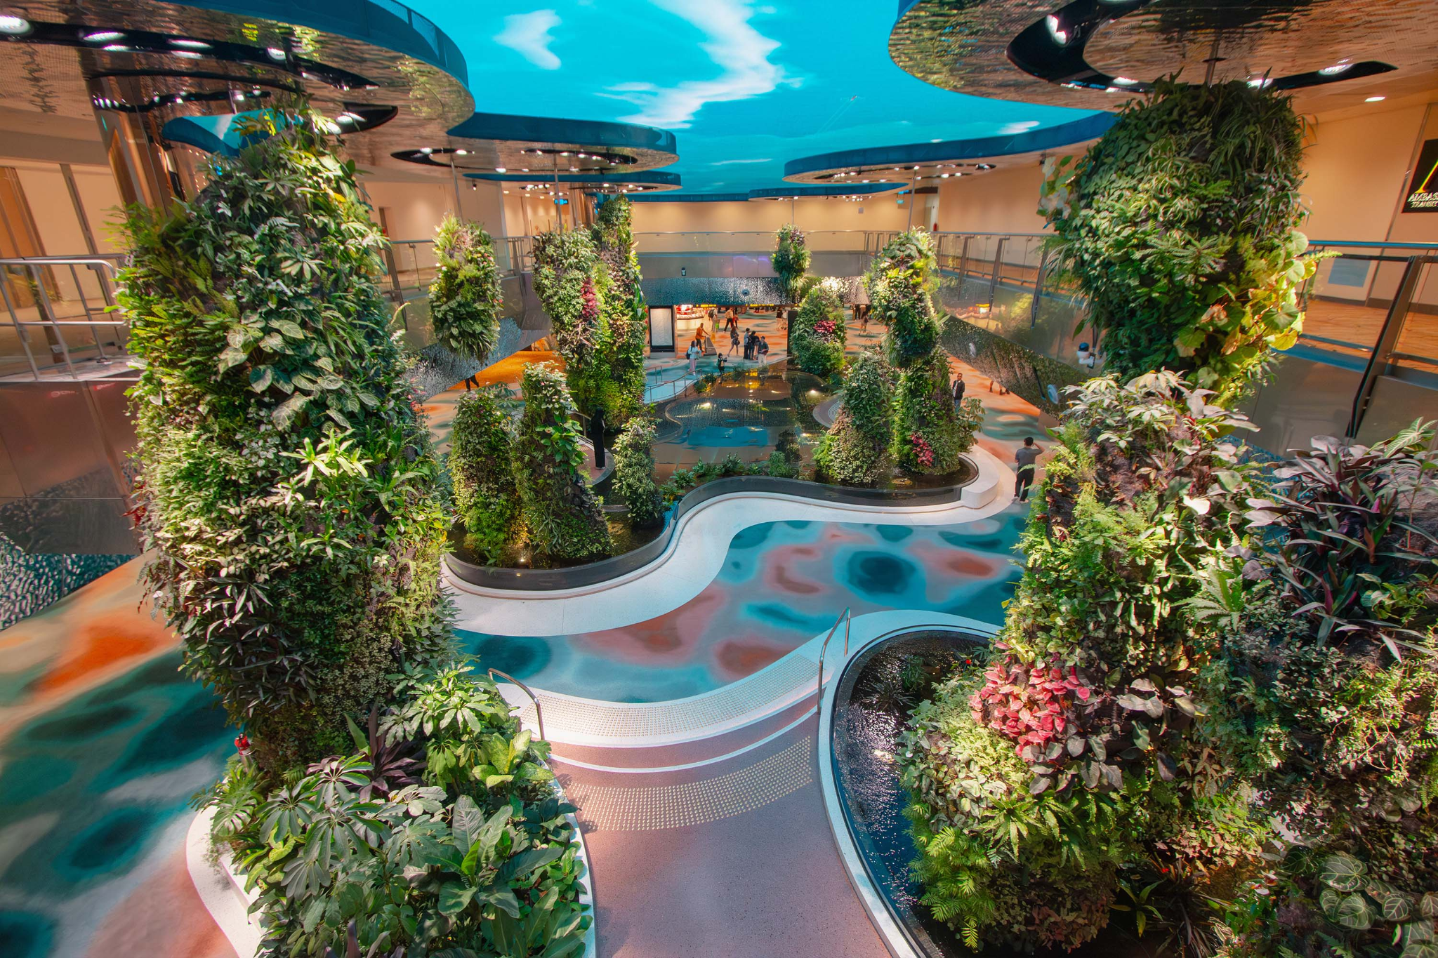
Dreamscape: Following a 2.5-year makeover, Singapore's Changi Airport has fully reopened Terminal 2 to travelers. Visual highlights include "Dreamscape," a garden brought alive by a "digital sky" that changes colors depending on the time of day and reflective ponds that can be walked on.

(CNN) — Singapore’s Changi Airport has fully reopened Terminal 2 following a massive 3.5-year expansion project.
And given it was voted the world’s best airport in the 2023 Skytrax Airport Awards, it should come as little surprise this was no ordinary makeover.
Around 21,000 square meters (226,000 square feet) have been added to the original terminal building, providing additional infrastructure, new systems and more shopping and dining offerings.
Nature is the overriding design theme in the refreshed T2, with one of the star attractions being a 14-meter-high digital waterfall display. Surrounded by a vertical garden, “The Wonderfall” is located in the departure hall and cascades over megalithic boulders.
Keeping with the nature theme, over in the departure transit area travelers can take in the new Dreamscape garden, which features an array of plants, all brought alive by a “digital sky” that changes colors depending on the time of day.
Meanwhile, vintage travel fans will want to check out Flap Pix, an art installation that takes inspiration from the classic mechanical split-flap flight information boards that were once the norm in airports. According to Changi, 1,080 split-flaps were repurposed to create it.

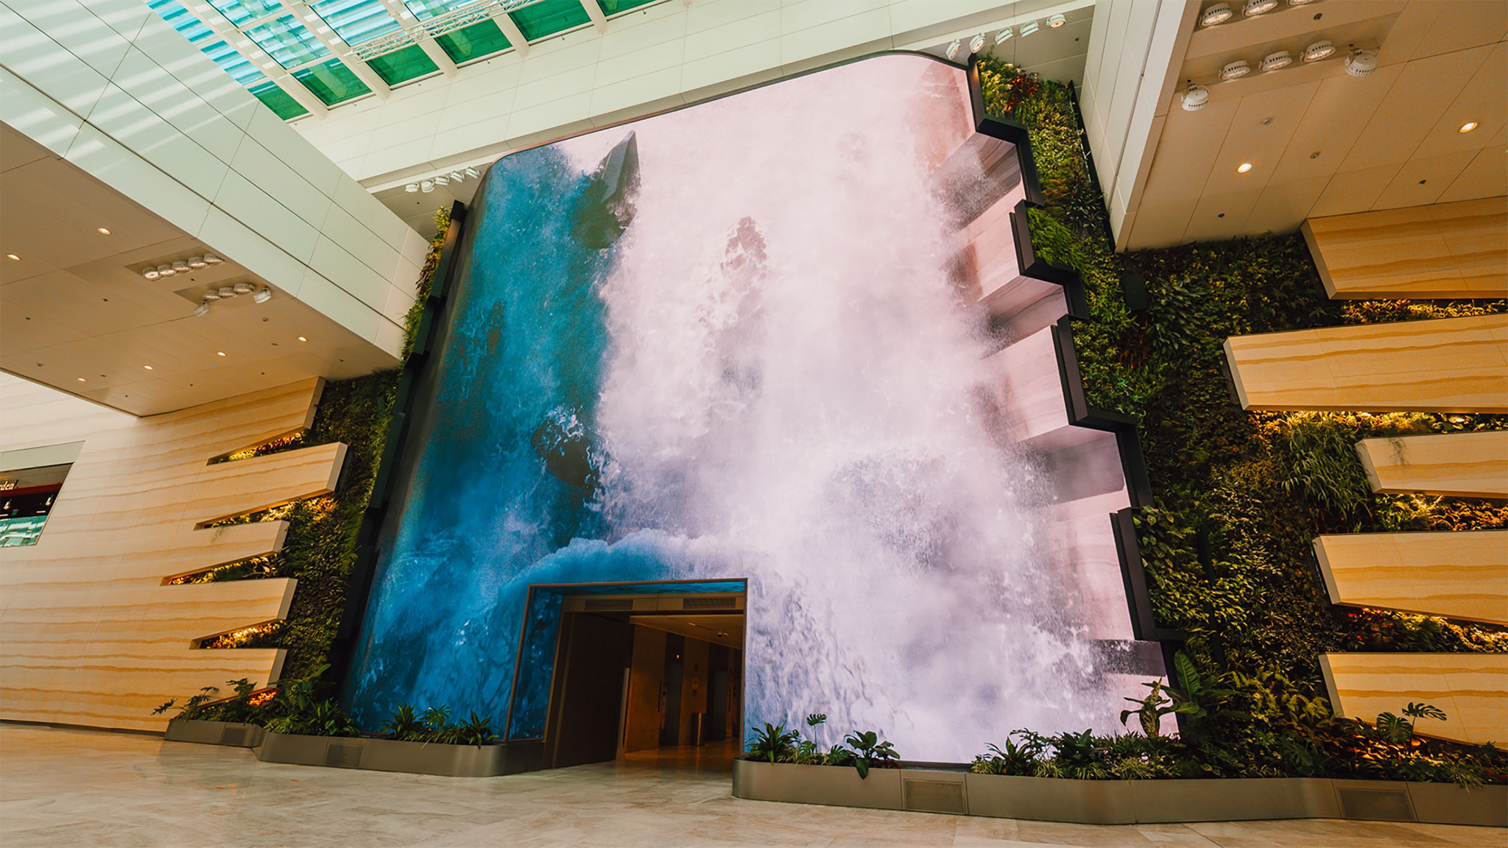Changi T2's new 'Wonderfall" features 892 flat and flexi-curved tiles.

“With T2, we sought to enhance the passenger experience, bringing together a modern terminal inspired by nature, with immersive digital experiences, innovative technology, as well as transformative retail and dining concepts that create a sense of place,” said Lye Teck, Changi Airport Group’s program director for the Terminal 2 expansion project, in a statement.
Among the new retail and dining experiences is the two-story Lotte Duty Free Wine & Spirits, which has its own robot bartender. Above the bar, there’s a 30-meter LED ring depicting a moon reflected in a lake, which Changi’s team says is an homage to Tang dynasty poet Li Bai’s famous work, ”Drinking Alone Under the Moon”.
On the upper level is the Forest of Li Bai, a luxury lounge offering 18 choices of whiskey under an LED ceiling. There’s also a smart selfie mirror visitors can use to take photos with famous K-pop artists.
In terms of dining, new additions include Gourmet Garden, which offers views of the airport’s apron and Singaporean flavors including Satay Club by Harry’s and Wee Nam Kee Chicken Rice.
According to a statement issued by the airport, the T2 expansion project, which kicked off in January 2020, boosts Changi’s passenger capacity by 5 million, bringing its total handling capacity to 95 million passengers per year.
Sixteen airlines operate out of the terminal, connecting Singapore to 40 cities.

What makes the ‘best’ airport so great?

Singapore Changi Airport topped Skytrax’s list of best airports for eight years in a row, but in 2021 and 2022 dropped a couple of spots down the list as passenger numbers fell during the pandemic, with Hamad International Airport in Doha, Qatar, taking the top spot instead. Changi took the crown back during this year’s awards, which were announced in March.
Indeed, it has come a long way since it first opened in 1981, replacing the single-runway Paya Lebar airport.
By 1986, construction had already begun on Terminal 2 – a response to the increasing influx of passengers – with the new facility opening to travelers in 1991.
But it was the introduction of some previously unheard-of amenities that really got the world’s travelers to take notice.
For instance, the world’s first transit-area swimming pool‎ was added to Changi in 1995, kicking off a series of additions that would further deepen the chasm between it and other world airports.
Among these were the addition of a news hub, a movie theater and a sports arena in 1998.
Changi Airport Terminal 3 – which now has a 12-meter-high mega slide and a butterfly garden – entered the picture in 2008. Terminal 4 followed, opening in 2017.
Next up: Changi Jewel, which opened in 2019, giving locals with no plans to travel reason to head to the airport.
Featuring a dramatic, doughnut-shaped exterior framed in steel and glass, the 135,700-square-meter space is a multi-use complex that connects three of Changi Airport’s four terminals.
The star attraction here is the 40-meter-tall HSBC Rain Vortex, which cascades through a huge oculus in the middle of the structure and is billed as the world’s tallest indoor waterfall.
There’s also an 11-cinema IMAX theater and Shiseido Forest Valley, a four-story garden filled with walking trails, all surrounding the Vortex waterfall.
So what’s next for the famous airport? Starting in 2024, officials say Changi will introduce automated immigration clearance, allowing passengers to depart the city-state without passports, using only biometric data.
Meanwhile, airport officials have already revealed plans for Terminal 5, which is expected to open to travelers in the mid-2030s. More details on that project here.

Source: CNN
https://edition.cnn.com/travel/singapore-changi-airport-terminal-2-expansion/index.html

Discussion Questions:

Why does Singapore invest so extensively in airport infrastructure?

