Rail before road? The task of modernizing Germany's transport infrastructure

Natalie Carney in Berlin

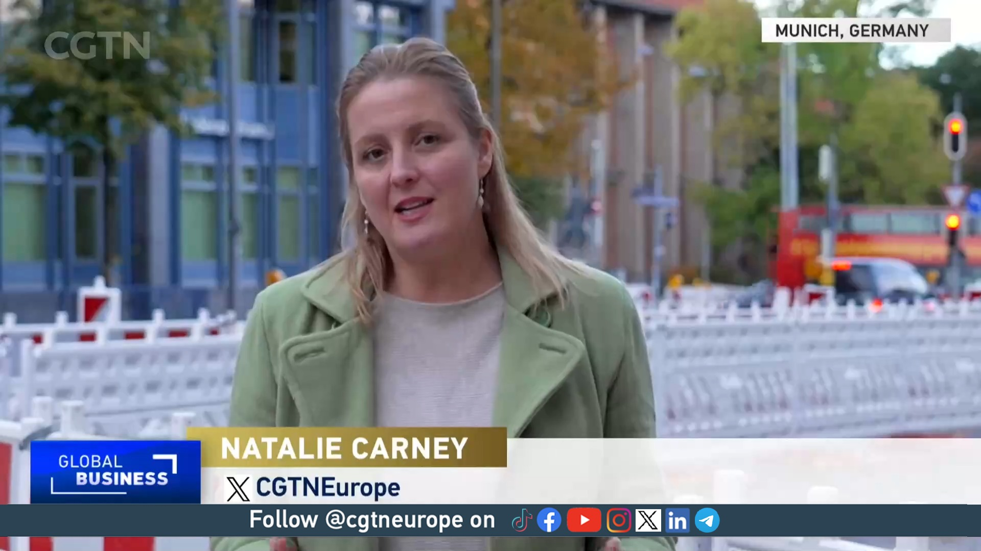

There was once a time when Germany's infrastructure, from roads to rail, were the pride of the country and admired by many. But those days seem increasingly distant as cracks in its maintenance begin to appear.
Years of under-investment, along with increased traffic, has led to crowded road networks and inconsistent rail travel.
According to Dr. Urs Maier, Project Manager Energy and Infrastructure at Agora Transport Transformation, Germany's highways have seen an increase of 30 percent of cars and trucks since 1990. Maier told CGTN: "With the lack of investment, public money and maintenance, we have a lot of bridges on the highway network that need to be maintained and some of them even need to be replaced."
Maier stresses that planning must prioritize "rail before road" and "maintenance before expanding."
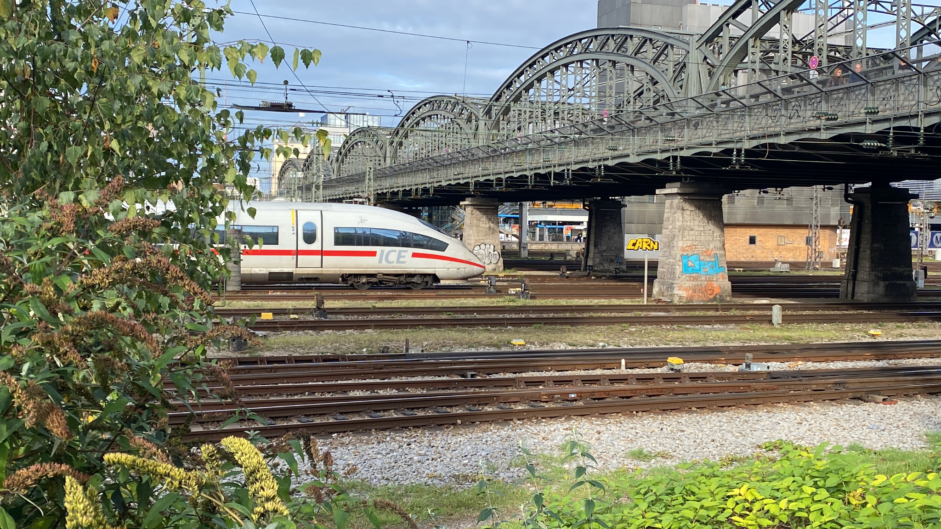Federal passenger association Pro Bahn says rail has been deprioritized. /CGTN

Federal passenger association Pro Bahn argues that the country's national rail company Deutsche Bahn has been pushed aside to make way for "glamorous" road projects for years.
Marco Kragulji, Pro Bahn vice chairman for the Bavarian branch, told CGTN the "problem with the German railway infrastructure goes back years, adding: "We have concentrated for far too long on further expanding our road system and becoming one of the best road systems. The railway has always been running on the side."
Deutsche Bahn has seen its punctuality quota fall year-by-year, reaching a new record low in 2022 with only 65.2 percent of trains reaching their destination on time. "The money has simply been spent on prestigious projects, not trains," lamented Kragulji.
The federal government has recognized its need to modernize the country's infrastructure by allocating $USD 285 billion to the 2030 Federal Transport Infrastructure Plan. However, Berlin must consider that historic inflation has increased the price for many of the materials and, as Maier points out, many projects within the plan are driven by what is "predicted" rather than the "green transport system" it should be working towards for the future.
"Planners and the government should look at the transport system that we want to have in 2045 when we are going to be climate neutral and then build the infrastructure respectively," he said, adding that more roads are being designed, not what is necessarily needed.
"Green transport means way less private cars, less individual mobility and more public transport, more rail," he said.
Pro Bahn is in agreement. "The best solution for the future is to recover our tracks," states Kragulji. "Then we want to build new tracks that we then can add more services to. We want to build a network that is fit for the future, not just fit for now."
Many agree that modernizing the country's infrastructure means modernizing the federal transport infrastructure plan. What's not agreed is how best to do so.

Source: CGTN
https://newseu.cgtn.com/news/2023-11-01/Rail-or-road-Modernizing-Germany-s-transport-infrastructure-1omtKs5JvTa/index.html

Discussion Questions:

Why do you think rail transport in Germany has been deprioritised?

What is the role of public transport in countries’ climate goals?

What is the distinction between expansion and modernisation of transport infrastructure? Which do you think is more important in different countries?

