How road pricing is tackling congestion and pollution in cities like London and Singapore

Dec 21, 2021

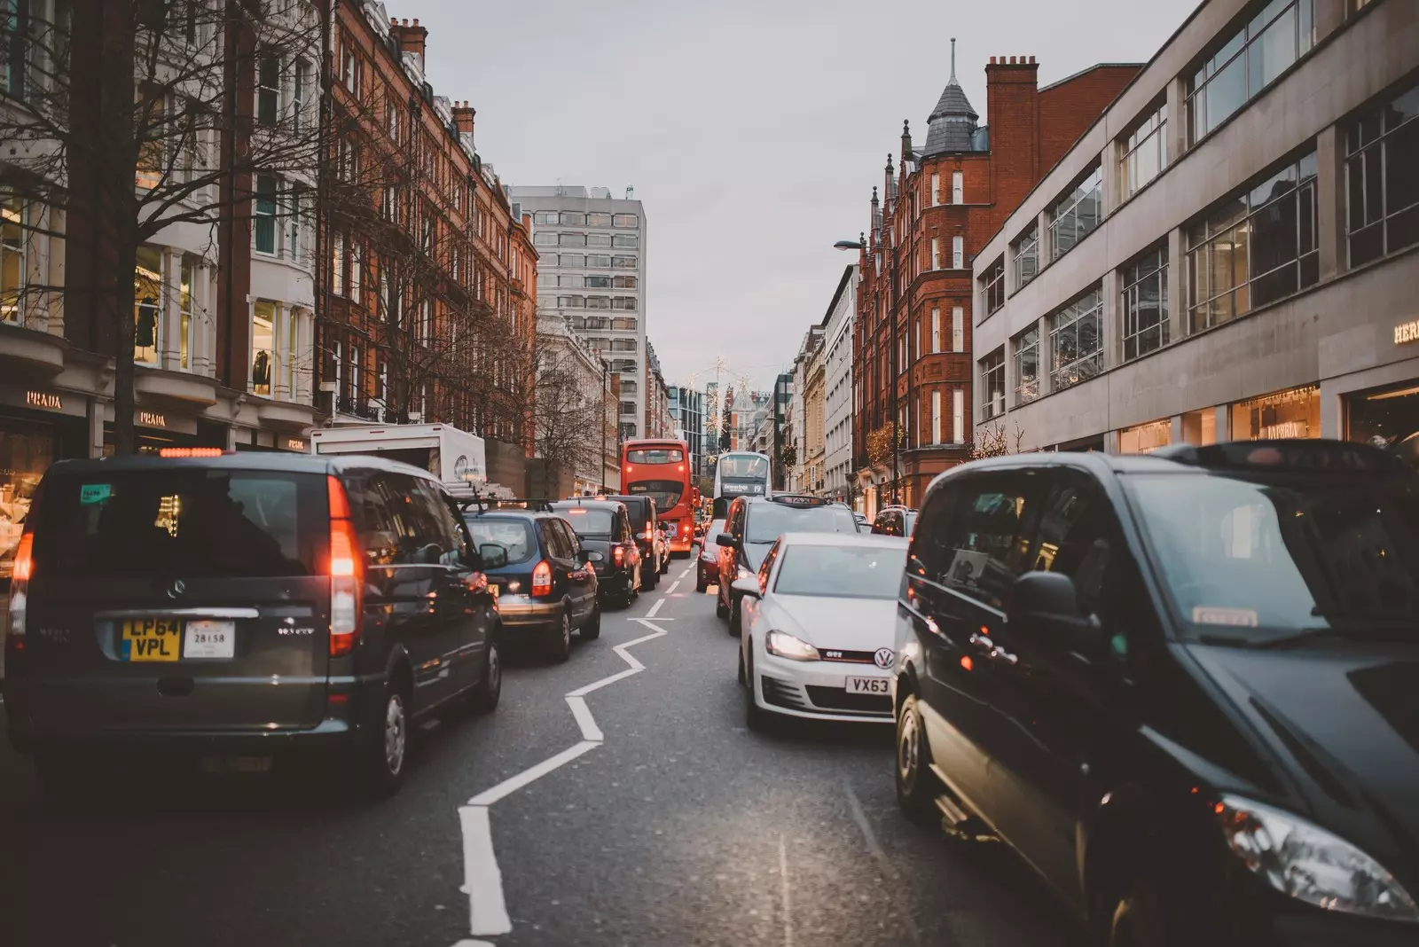New smart solutions can improve road pricing in cities.

- Private vehicle traffic is skyrocketing – bringing with it more traffic jams, longer travel times and worsening air quality.
- Modifying road pricing can play a pivotal role in solving these challenges as well as transitioning to sustainable urban mobility.
- A new white paper Sustainable Road Transport and Pricing evaluates road pricing mechanisms and calls for a sustainable future of road mobility.

Singapore and London may be located in different hemispheres but both cities are global leaders in innovative approaches that reduce the congestion, emissions and pollution caused by road traffic. They’re among a growing number of cities with roads surpassing or nearing pre-pandemic traffic counts. Cities around the world are considering road pricing as part of multi-pronged suite of solutions to improve their transport systems and answer the question: “How can city transport be safer, healthier and more sustainable?”
Changing pricing will change traffic patterns, free up public space, incentivize zero emission mobility and support investment in alternatives like public transport, cycling, scooting and walking. If carefully and thoughtfully redesigned and implemented with community input, revised road pricing that considers direct and indirect costs could lead to a clean, equitable and financially resilient, sustainable future of road mobility.

What are the hidden costs of transport?

Driving a private car into a city centre incurs various types of costs that can be classified as direct, or visible, and indirect, or hidden. Direct costs are associated with the physical assets your car travels across – or what your car occupies and consumes – like building and maintaining the road infrastructure and parking. Indirect costs reflect the societal effect of your trip into the city: negative impacts from air and noise pollution; climate change caused by land use, infrastructure and fossil-fuel powered vehicles; the cumulative physical and psychological impact on communities.
Since the 1970s, cities across the globe have turned to road pricing mechanisms to help tackle the societal, environmental and economic impacts of road transport. However, the full direct and indirect cost of driving on congested roads in city centres cannot ever fully be reflected in road prices. With the cost of using roads and curbside parking spaces not felt in the wallets of individuals traversing city streets or by mobility operators – or fully accounted for in mobility related taxes – these public resources become overused, inefficient, unsafe and unhealthy.

What can cities do to tackle road transport issues?

More and more cities are proposing revised road transport pricing schemes as part of health and climate change mitigation efforts with major mobility service providers and key non-profit organizations voicing their support. Such schemes in Singapore and London show how the societal, environmental and economic impacts of road transport can be better reflected in the prices paid to drive and park in cities.

Real-time congestion management in Singapore

Singapore has been a global leader in usage-based road pricing mechanisms through its Electronic Road Pricing (ERP) system implemented in 1998 (which replaced the manual tolling system dating back to 1975, ALS). As vehicles equipped with an in-vehicle unit (IU) pass through ERP gantries, sensors and license plate recognition cameras charge a fee dependent on the vehicle type, time of entry and location. Rates are adjusted periodically throughout the year to support optimal traffic speeds and mitigate congestion. In the initial months after the transition from the ALS in the late 1990s traffic reduced by 10-15% during ERP operational hours.
Singapore’s Land Transport Authority (LTA) is updating the technology behind ERP and replacing current IUs with innovations such as new on-board units (OBUs) in 2023 (recently delayed due to the global microchip shortage). These will allow for real-time congestion management as GNSS-enabled OBUs inform users about current traffic patterns and special zones with reduced speeds, among other information. The OBUs will support payment processing and could ultimately enable distanced-based road pricing. NextgenERP is one part of an integrated mobility plan to enhance Singapore’s transport system.

Decarbonization is a key goal for LTA as it improves mobility efficiency and access across the city and supports the zero emission goals of the Singapore Green Plan. Recognizing that the most impactful way to address pollution from road transport is to transition more trips to zero or low emission mobility options, Singapore is expanding public transport and deploying electric buses, developing infrastructure dedicated to walking and cycling and incentivizing EV adoption.

Low emission zones in London

Two key pricing schemes support efforts in London to reduce pollutant emissions. First in 2008, London introduced emission standards for heavy goods vehicles on roads London-wide through the Low Emission Zone (LEZ) and recently tightened these standards in March 2021. The LEZ encourages logistics, freight and bus fleets to update to cleaner vehicles by charging vehicles up to £300 for not meeting certain standards. By 2025, the LEZ – already with 95% compliance – is expected to support a 60% reduction in heavy goods vehicles emissions.

For light duty vehicles (such as personal cars, taxis and motorbikes), London implemented the Ultra Low Emission Zone (ULEZ) in April 2019, charging vehicles that entered the zone a fee if they do not meet certain emission standards. Data from the first four months suggest a reduction in non-compliant vehicles of more than 60%. The ULEZ was expanded in October 2021 to cover the whole of inner London (18 times the original zone) and yield a 30% reduction in road traffic produced NOx emissions.

New technologies can incentivize behavioural changes

These strategies are just some of the routes available to cities to refine pricing and incentivize better, more sustainable behaviour on the roads, and therefore cities and their transport systems. The development of technology solutions enabling smart charging schemes and the advent of new mobility options such as ride hailing and e-scooter sharing provide an opportunity to use pricing mechanisms to re-establish allocation of public space and redeploy the scarcity of resources to more sustainable and inclusive modes. Further innovation around technology implementation and regulation is needed to unlock three core dimensions for cities, mobility operators and travellers. Here's what’s needed:

- Real-time (and transparent) understanding of road usage and road capacity will help determine prices. In electricity markets this aspect has been addressed via the large-scale roll-out of smart meters. Smart meters have enabled the adoption of time-of-use tariffs that incentivize consumption when (green) electricity is abundant and discourage demand when it is not. A similar real-time metering technology for roads will help cities enable dynamic prices (and even differentiated prices based on vehicle size and emissions) needed to yield the desired reduction to climate impact, pollution and traffic.
- Real-time scalable mechanisms to elicit prices in real-time per sector are needed that can ensure prices fluctuate closely and accurately with demand. Advances in automated market design (where resources such as specific road usage or transportation infrastructure could be auctioned off in real time) offer one potential way systems could be tailored to accommodate the special characteristics of mobility systems.
- New decision support tools for travellers can help users navigate the complexities of dynamic pricing and enable them to adapt their behaviour. This is especially important if prices and conditions change dynamically, quickly leading to information overflow. For example, trip planning apps that make road charges transparent can be a first step in helping ease the travel decision process.

Overall, technology can make a huge difference. Smart cities employ traffic management systems to balance traffic flows and use dynamic pricing also for curb and parking space.

How we can make it work for people and cities

It is crucial that changes to road pricing are part of an integrated mobility plan, that prioritizes the direct involvement of affected communities and stakeholders, invests in shared or active transport modes and provides transparently subsidized discounts, differential mobility fees mobility credits and/or scrappage schemes among other options.
Revised pricing mechanisms should be reflective of local community needs, include a plan for revenue utilization and be instituted in correlation with enhancements to alternative transportation modes. Cities are recognizing the benefit of prioritizing citizen and stakeholder involvement, as seen with initiatives in cities such as London and Stockholm.
Private vehicle traffic is skyrocketing – bringing with it more traffic jams, longer travel times and worsening air quality. When implemented in conjunction with expanded mobility offerings that meet the needs of affected communities, modifying road pricing can play a pivotal role in solving congestion and pollution challenges as well as transitioning to a sustainable mobility system.

The World Economic Forum’s Global Future Council on Urban Mobility Transitions studied this further in a new white paper, Sustainable Road Transport and Pricing, examining the impact of road transport on society and calling for the acceleration of equitable, clean and financially resilient mobility approaches.

Source: World Economic Forum
https://www.weforum.org/agenda/2021/12/how-road-pricing-is-tackling-congestion-and-pollution-in-cities/

Discussion Questions:

What are some limitations or disadvantages of road pricing in cities?

Do you think such road pricing approaches can be applied in other cities? If so, what are some factors that should be considered?

