How Southeast Asian cities lack ‘political will’ to fix notorious traffic jams

How did Bangkok, Jakarta and Kuala Lumpur get so unbearably congested on the roads, and why do people still insist on driving in those cities? CNA investigates.

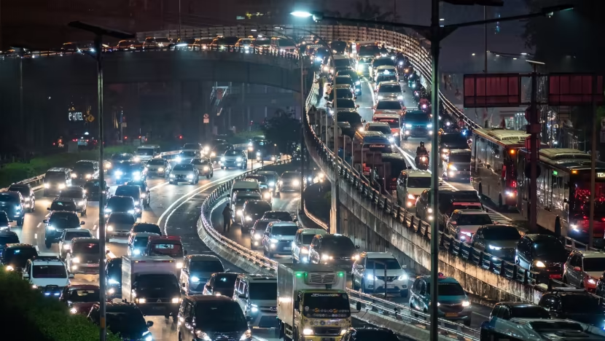Snaking traffic lines along Dewi Sartika street in Jakarta, Indonesia. (Photo: CNA/Wisnu Agung Prasetyo)

BANGKOK/JAKARTA/KUALA LUMPUR: Most people might hasten to clock out and leave for home at the end of their working hours, but not Ekaristi Lydia.
The 27-year-old hangs out with friends, goes to the gym and does whatever it takes to deliberately delay - sometimes by up to two hours - the start of her journey back to the southern suburbs of Jakarta.
Despite her best efforts to dodge the rush-hour gridlock, she will still need 90 minutes to negotiate, in her compact city car, 30km of crawling, honking, bumper-to-bumper congestion on the streets.
A journey of around the same distance, say from north to south of Singapore, would take just over half an hour’s drive off-peak.
For visitors to the Indonesian capital and other Southeast Asian cities like Bangkok and Kuala Lumpur, traffic jams are the stuff of legend and for commuters, a tolerated but no less miserable daily routine.
They suffer the chronic snarl-ups for one simple reason: An absence of other good options.

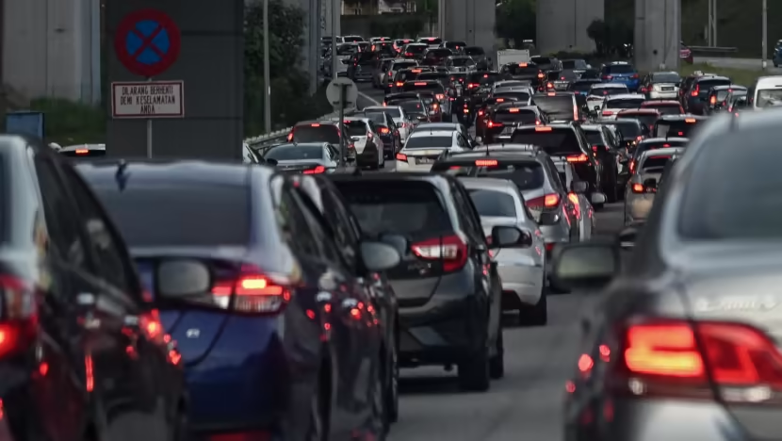A choked-up road in the Malaysian city of Petaling Jaya within the Greater Kuala Lumpur metropolitan area. (Photo: CNA/Fadza Ishak)

Take Ms Lydia, who would prefer to use public transport to get to work - except her nearest train station is 30 minutes away by motorcycle taxi; and after reaching the station closest to her office, another 45-minute bus ride awaits. It all adds up to an additional hour or so, compared to driving – and costs the same.
“When you take public transport, you are not mentally exhausted by the traffic so much because you just sit or stand there,” said the creative writer. “But it is physically tiring. Because you need to walk, switch modes of transportation and fight for seats.”
Whether it’s underinvestment in public transport infrastructure and urban planning, or booming populations leading to a corresponding rise in vehicle ownership, reasons for the persistent traffic problems faced by major cities in the region are manifold.
So too, the solutions proposed over the years, which run the gamut from the rudimentary - such as carpooling - to the bureaucratically complex like congestion charges.
But experts say no panacea exists. An approach of small, incremental steps building towards a long-term goal represents the cities’ best bet, though just as fundamental is the “political will” of local authorities, said Singapore-based transport economist Walter Theseira.
“The starting point has to be that the governments with direct responsibility for these cities want to implement the changes – and have the mandate to do so.”

HOURS AND DOLLARS WASTED

Based on an annual global traffic index by navigation specialists TomTom, Jakarta was the 29th most congested city out of 390 surveyed in 2022, ninth out of 35 in Asia, and second behind Manila in Southeast Asia. Bangkok placed 15th and Kuala Lumpur 22nd in the continent.
With some of these cities only lifting all COVID-19 activity restrictions at the end of last year, they could place even higher in the yet-to-be-released 2023 index, which rates cities by their travel speeds, fuel costs and CO2 emissions.

Source: CNA
https://www.channelnewsasia.com/asia/traffic-jams-bangkok-jakarta-kuala-lumpur-southeast-asian-cities-congestion-roads-3497091

Discussion Questions:

What are some social, environmental and environmental impacts of traffic congestion in cities?

