S$220m to go towards research in water technologies, sustainable resources
by Megan Cheah on 8 March 2022
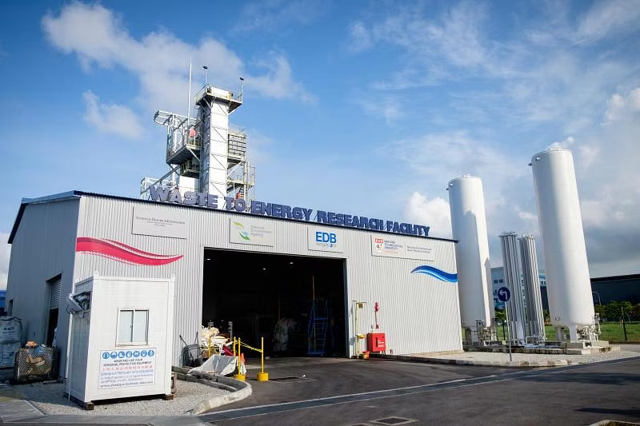Above: NTU Waste to Energy Research Facility at Tuas South. The funds will support such R&D at the Nanyang Environment and Water Research Institute (NEWRI) and the Separation Technologies Applied Research and Translation (START), both part of PUB's Centres of Excellence (CoE) programme.
THE government has allocated around S$220 million to drive new initiatives in water technologies and resource circularity - that is, reusing and recycling resources - under the urban solutions and sustainability domain of the national Research, Innovation and Enterprise 2025 plan (RIE2025).
"Our investments will go towards developing high impact solutions for our national water needs," said Minister for Sustainability and the Environment Grace Fu in Parliament on Tuesday (Mar 8), in a joint segment on the Singapore Green Plan 2030.
The S$220 million sum is drawn from the National Research Fund, under the 5-year RIE2025 tranche.
Of this, S$80 million will go towards a new Closing the Resource Loop (CTRL) funding initiative, administered by the National Environment Agency (NEA).
CTRL will fund research and development (R&D) on sustainable resource recovery solutions for key waste streams including e-waste, plastics and food, as well as finding useful and safe applications for treated waste residues.
Over the next 5 years, NEA will launch a series of competitive grant calls under CTRL, along the three R&D tracks of resource recovery, residues as resources, and rethinking energy from waste. These are aimed at institutes of higher learning, research institutes and private sector partners.
Another S$87 million was allocated for R&D in 3 water technology focus areas: desalination and water reuse; used water treatment; and waste reduction and resource recovery.
The funds will support such R&D at the Nanyang Environment and Water Research Institute (NEWRI) and the Separation Technologies Applied Research and Translation (START), both part of PUB's Centres of Excellence (CoE) programme.
The remaining amount of the S$220 million headline figure was allocated to the Competitive Funding for Water Research programme last year, said Fu.
Beyond addressing national needs, "research and innovation will also be an engine for green growth, spurring private sector R&D spending, job creation and technology spin-offs in the water industry and adjacent sectors", she said.
"For example, NEWRI has deployed technologies with local and global applications in areas such as biomimetic membranes for desalination, and anchored investments from global companies in Singapore," she added.
Under RIE2025, START will also have to commission a new desalination integrated validation plant in 2023.
This plant will "trial promising technologies to reduce the energy consumption of desalination", said Fu. If successful, it will reduce the system-level energy consumption of desalination to less than 2 kWh per cubic metre of water.
"This will pave the way for the technologies to be implemented in full-scale desalination plants," she added.

Source: https://www.businesstimes.com.sg/singapore/economy-policy/s220m-go-towards-research-water-technologies-sustainable-resources
Discussion Questions:
Do you think such a large amount of money going towards developing Singapore’s water technologies is justified?
What are some unique problems Singapore faces about its water supply?

