Singapore to raise water prices by 18% over two phases in 2024 and 2025
by Koh Wan Ting on 27 September 2023
Most households will pay 20 cents more for every 1,000 litres of water next year and another 30 cents more in 2025.
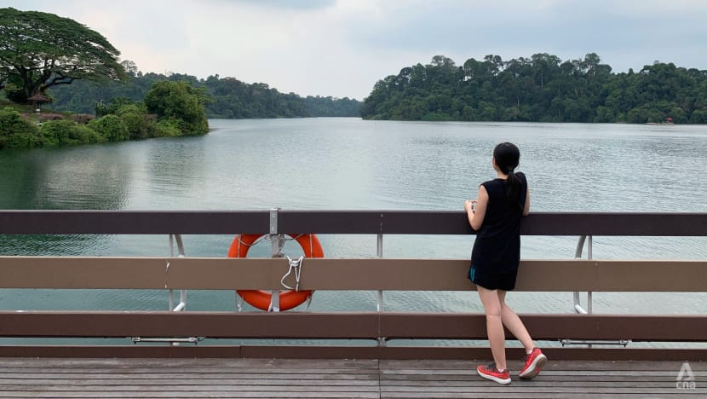A person looks out over the water at a reservoir in Singapore. (File photo: CNA/Jeremy Long)

- The price of water for most households will increase from S$2.74 for every 1,000 litres used to S$3.24 in 2025, a rise of about 18 per cent
- HDB households and non-HDB households will see an average increase of S$7 and S$8 a month respectively
- Deputy Prime Minister Lawrence Wong will announce additional cost-of-living support measures for Singaporean households on Thursday
- Increase in price to cover operating costs and long-term investments in water infrastructure, PUB says

Water prices in Singapore will rise by about 18 per cent over the next two years, national water agency PUB said on Wednesday (Sep 27).
Potable water currently costs S$2.74 (US$2.01) for every 1,000 litres, or per cubic metre, before tax for most households.
The increase translates to an additional 50 cents per cubic metre. It will be split over two phases: 20 cents on Apr 1, 2024 and 30 cents on Apr 1, 2025.
After the 2025 revision, three in four households will see a less than S$10 increase in their monthly water bills, PUB said. For businesses, three in four will see their water bills rise by less than S$25 a month while three in four hawkers will foot an increase of less than S$15 monthly.
The 4 per cent of households that consume much more water – exceeding 40 cubic metres a month – will see a higher increase in their bills. For every cubic metre of water above the threshold, the rate they pay will rise by 70 cents, from S$3.69 now to S$3.94 next year and S$4.39 the year after.
The average household consumes about 15 cubic metres of water each month.
The price of NEWater – the treated reclaimed wastewater used mainly for industrial and air-con cooling purposes – will increase by 17 cents per cubic metre; also in two stages: 8 cents on Apr 1, 2024 and 9 cents on Apr 1, 2025.
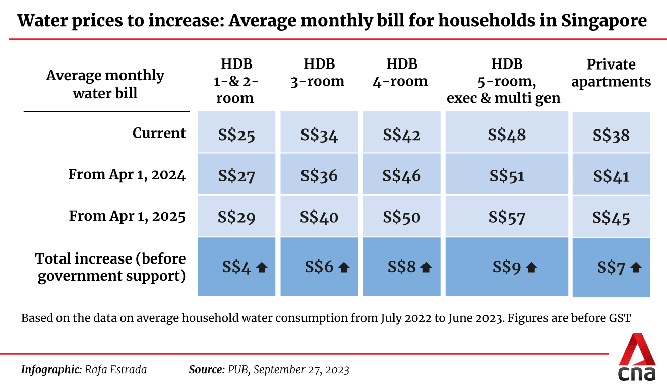
Water prices were last increased by 30 per cent in two phases from 2017, and before that in 2000.
PUB pointed to how the costs of producing and supplying water have increased "substantially" since 2017, due to external pressures.
Average electricity market tariffs have increased by about 37 per cent; construction costs have risen by 35 per cent; expenses for essential chemicals in water treatment have grown by 33 per cent; and maintenance expenses have also gone up by 18 per cent due to higher manpower costs, said PUB.
There are three components to the pricing: A tariff covering costs incurred in the water production process; a water conservation tax which is a percentage of the tariff and meant to encourage water conservation; and a waterborne tax for the cost of treating used water and maintaining the used water network.
All three components will be increased in this round for domestic and non-domestic potable water. For NEWater, only the waterborne tax component is increasing.
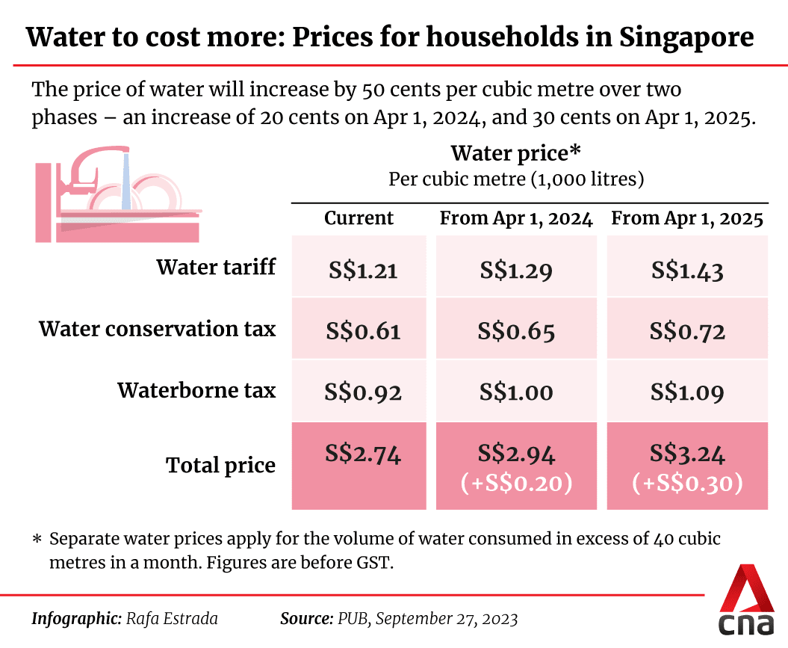

Why prices are going up
On how it arrived at the quantum of 50 cents, PUB said it took into account rising operating costs and heavy investment needs for water infrastructure. Operating costs are affected by external factors, which PUB expects to remain elevated.
During a progress update on the Tuas Water Reclamation Plant last week, PUB revealed that the second phase of the Deep Tunnel Sewerage System would cost S$6.5 billion, almost twice that of the first phase built nearly two decades ago.
With increasing water demand – projected to almost double by 2065, as the economy and population grow – PUB will also have to draw more heavily on two out of its four sources known as "national taps".
These two sources - NEWater and desalinated water - are more resilient in the face of climate change where extreme weather may affect water supply. But they are also more energy-intensive and costlier to produce.
The other national taps are water from local catchments and imported water.
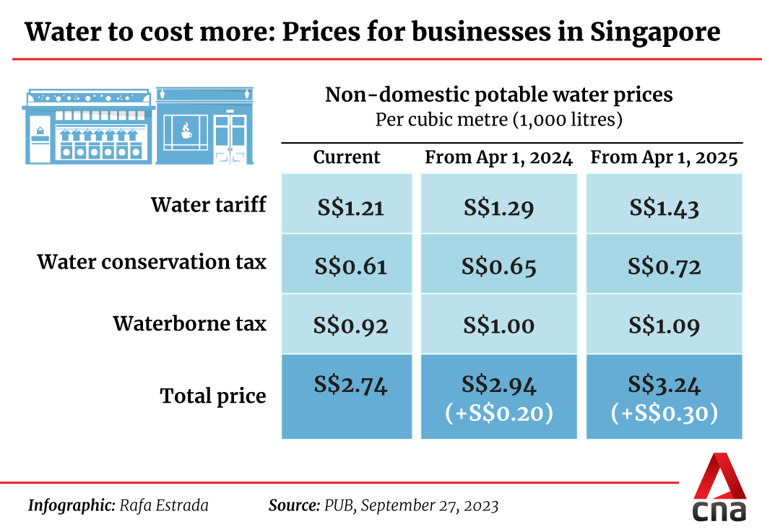
In response to whether the price increase can be deferred, PUB said that doing so will only mean higher and more significant hikes in the near future.
"The total cost of producing and supplying water already exceeds today’s water price, due to external cost pressures over the past few years. To catch up to the rising costs and support continued investments, water price needs to be increased at this point," PUB said.
It added that this latest price increase will enable PUB to "sustain its operations and maintain existing assets", to deliver high-quality and reliable water supply and used water services.
"It will also allow us to support critical investments in water infrastructure to ensure water security for Singapore, amidst the challenges of climate change and water demand growth," said the agency.
PUB has invested more than S$3 billion in the past five years to enhance infrastructure. For example, it has added three desalination plants in Tuas, Marina East and Jurong Island since 2017, and is continuing to upgrade ageing local water treatment plants.
As to whether PUB is expected to conduct more frequent reviews of water prices, the agency said it regularly reviews water prices and considers both annual operating costs and long-term investments in water infrastructure.
It added it would introduce measures to manage costs. For example, the agency is investing in the research and development of new technology.
"These efforts serve to manage the growth in long-term costs on a sustainable trajectory, even as we need to renew and expand our water system. Our long-term water infrastructure plans also affect the level of investments required," PUB said.

How bills will be affected
In its news release, PUB described the water price increase as a 2.5 per cent hike per year since the last full revision of prices in 2018.
Asked why it did not implement smaller and more frequent increases instead of a large hike over a shorter period, PUB pointed to how water prices cover operating costs year-on-year as well as future investments on a long timeline, which make it more unlikely for recurrent adjustments to prices.
Based on data of average household water consumption from July 2022 to June 2023, Housing Board one- and two-room flats currently pay S$25 a month, while five-room flats pay S$48. These are before the Goods and Services Tax (GST).
After the full price increase, they will pay S$29 and S$57 a month respectively, PUB estimated.
HDB households and non-HDB households will see an average increase of S$7 and S$8 a month respectively.
Based on the latest survey by the Department of Statistics, water bills account for less than 2 per cent of an average household's expenditure.
For most businesses - including most of the services sector - their utility bills, which also include electricity and gas, comprise less than 5 per cent of their costs, said PUB.
"The 50-cent increase over one cubic metre of water translates to an increase of 0.05 cents per litre of water (or about 0.01 cent per cup of coffee)," it added.
In recognition that businesses would eventually pass on the price hike to consumers, PUB said it would work with the Ministry of Trade of TI and relevant authorities to advise against profiteering.
With the increase in water prices along with other cost of living concerns - such as rising public transport fares – the government will provide financial support, especially for lower- and middle-income households, said PUB.
Deputy Prime Minister and Minister for Finance Lawrence Wong will also announce additional cost-of-living support measures for Singaporean households on Thursday, the Ministry of Finance said.
PUB said that one-, two- and three-room households can apply for e-vouchers under the Climate Friendly Households Programme, to offset the costs of installing water-efficient shower fittings. The programme will expand to include more water fittings in the coming year.
Companies meanwhile can tap on PUB's Water Efficiency Fund for support in implementing water conservation projects.
Source: https://www.channelnewsasia.com/singapore/water-prices-singapore-increase-two-phases-vouchers-3796726
Discussion Questions:
What alternative actions do you think could have been taken to safeguard Singapore’s water supply?
Taking into account social, economic, and environmental considerations, do you think that raising water prices is the best course of action?

