Beyond boundaries: Earth’s water cycle is being bent to breaking point
by Petro Kotzé on 21 June 2022

- The hydrological cycle is a fundamental natural process for keeping Earth’s operating system intact. Humanity and civilization are intimately dependent on the water cycle, but we have manipulated it vastly and destructively, to suit our needs.
- We don’t yet know the full global implications of human modifications to the water cycle. We do know such changes could lead to huge shifts in Earth systems, threatening life as it exists. Researchers are asking where and how they can measure change to determine if the water cycle is being pushed to the breaking point.
- Recent research has indicated that modifications to aspects of the water cycle are now causing Earth system destabilization at a scale that modern civilization might not have ever faced. That is already playing out in extreme weather events and long-term slow-onset climate alterations, with repercussions we don’t yet understand.
- There are no easy or simple solutions. To increase our chances of remaining in a “safe living space,” we need to reverse damage to the global hydrological cycle with large-scale interventions, including reductions in water use, and reversals of deforestation, land degradation, soil erosion, air pollution and climate change.

Water seems deceptively simple and is easy to take for granted. It has no color, taste or smell and is one of the most plentiful chemical compounds on Earth. Recycled endlessly through the biosphere in its various forms, it is fundamental to keeping our planet’s operating system intact, and has done so for millions of years.
Water is life. Earth’s oceans are where life likely originated, and freshwater is essential for plants and animals to persist and thrive. It is basic to all human development. But as our 21st-century world gallops ahead, we are vastly manipulating the water cycle at an unprecedented rate and scale to meet the ever-growing needs of an exploding population.
By 2030, we will have built enough dams to alter 93% of the world’s rivers. Estimates vary, but we already use around 90% of the planet’s freshwater to grow our food. More than half of us now live in cities, but by 2050 a projected 68% of the world’s nearly 8 billion people will reside in urban areas. That metropolitan lifestyle will require astronomical amounts of water — extracted, treated, and piped over large distances. Humanity also prevents much rainwater from easily infiltrating underground, reducing aquifers, as we pave over immense areas with impermeable concrete and asphalt.
But these easily visible changes are only the proverbial tip of the iceberg. Researchers are shining new light on sweeping human alterations to Earth’s water cycle, many playing out in processes largely unseen. In the Anthropocene — the unofficial name for the current human-influenced unit of geologic time — we are already pushing one of Earth’s most fundamental and foundational systems, the hydrological cycle, toward the breaking point.
Trouble is, we don’t yet know when this threshold may be reached, or what the precise consequences will be. Scientists are resolutely seeking answers.
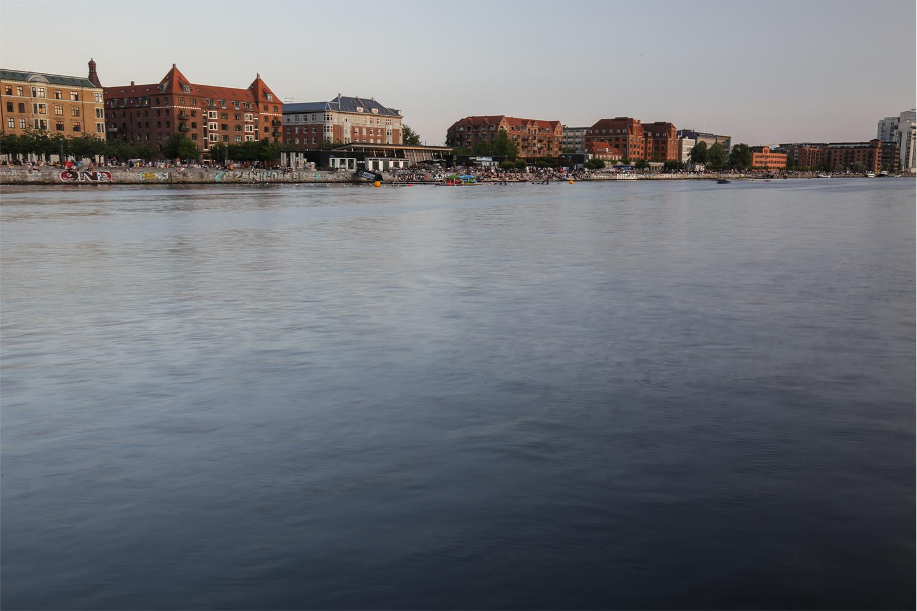Water flows past Copenhagen in Denmark. As Earth’s urban areas expand, so do population pressures on the freshwater supply and the water cycle. Image by Petro Kotzé.

Water cycle basics
The hydrological cycle is powered by the sun and flows through eternal inhalations and exhalations of water in different states, as it is exchanged between the atmosphere and the planet. Liquid water from oceans, lakes and rivers rises via evaporation into the sky, to form water vapor, an important greenhouse gas that, like carbon dioxide, helps insulate the planet to maintain that “just right” temperature to maintain life as we know it.
Atmospheric water vapor then changes to liquid, falling to earth as precipitation. It then flows as runoff again across the landscape, and what doesn’t go back into waterbodies, settles into soils, to be taken up by plants and released via transpiration as vapor skyward. A large amount of freshwater is also locked in glaciers and icecaps.
Within this cycle, there are constant complex interactions between what scientists call blue and green water. Blue water includes rivers, lakes, reservoirs and renewable groundwater stores. Green water is defined as terrestrial precipitation, evaporation and soil moisture.
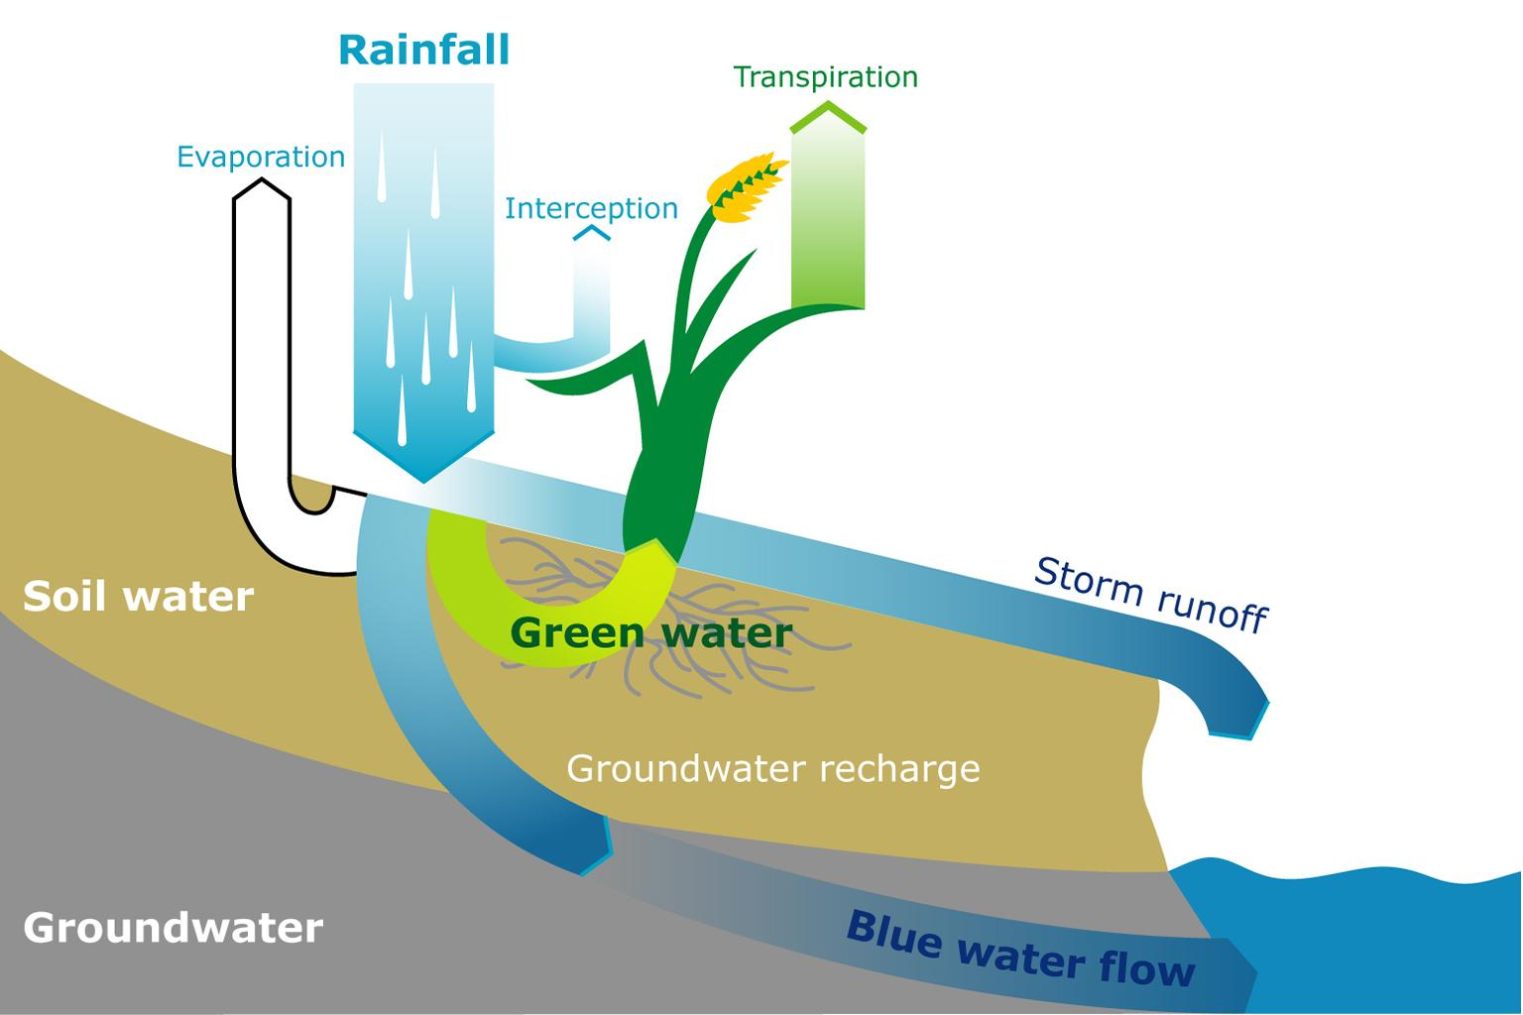Partitioning of rainwater into green and blue water flows. Image by Geertsma et al. (2009)/Baseline Review for the Pilot Programme in Kenya. Green Water Credits Report 8, ISRIC–World Soil Information, Wageningen.
A fully functioning hydrological cycle, with balanced supplies and flows of blue and green water, is essential to terrestrial and aquatic ecosystems, human food availability and production, and our energy security.
It also regulates Earth’s weather and influences climate. Atmospheric temperature, for example, is dependent on evaporation and condensation. That’s because as water evaporates, it absorbs energy and cools the local environment, and as it condenses, it releases energy and warms the world. Throughout the Holocene geological epoch, a relatively stable water cycle helped maintain balanced temperatures and conditions able to support civilization.
However, in the Anthropocene, human activity has impacted the water cycle, the climate and ecosystems. For one, as more human-produced CO2 and methane build up in the atmosphere, more solar energy is held by the planet, causing global warming. And the hotter the air, the greater the quantity of water vapor the atmosphere can hold. That’s bad news because water vapor is itself a powerful greenhouse gas, greatly increasing the warming.
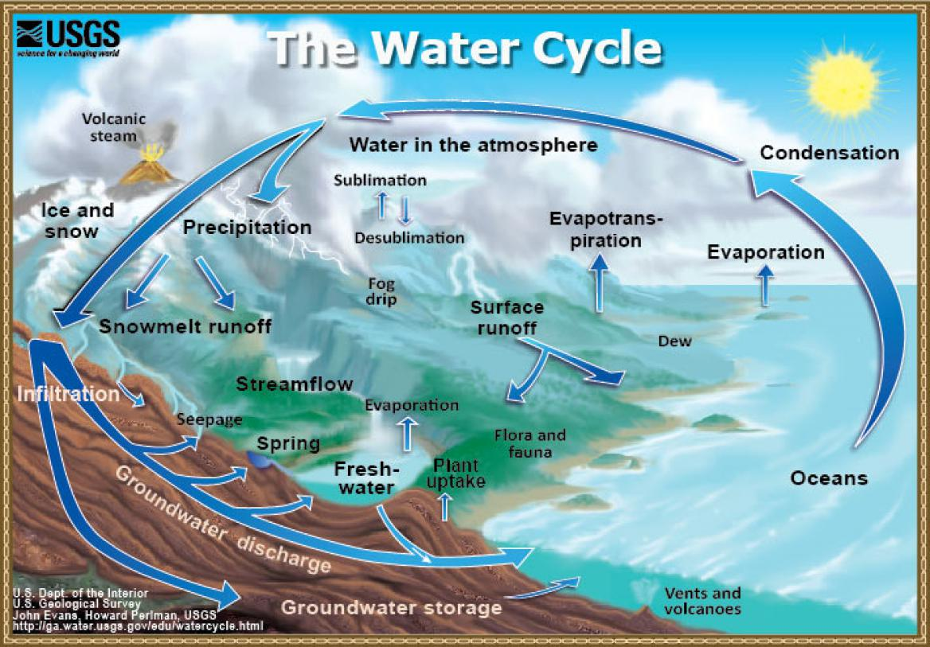Earth’s water cycle. Image courtesy of USGS.

Measuring hydrological cycle change: ‘It’s complicated’
As our anthropogenic manipulation of the water cycle escalates on a global scale, we urgently need a holistic way to monitor these modifications and understand their impacts. Yet, the topic has not received the urgent scientific attention it requires. “To the best of our knowledge, there is no study comprehensively investigating whether human modifications of the water cycle have led, could be leading, or will lead to planetary‐scale regime shifts in the Earth system,” researchers noted in a 2020 paper on the role of the water cycle in maintaining fundamental Earth functioning.
One key concern of scientists: If severe hydrological shifts occur in too many regions, or in key regions that greatly influence the water cycle or water availability (such as the Amazon), then that could provoke shifts in other regions, in a global chain reaction, says study co-author Dieter Gerten, working group leader and Earth modeling coordinator at the Potsdam Institute for Climate Impact Research in Germany.
“Conceptually we know that there must be a limit for how much we can disturb the [hydrological] system before we start feeling serious impacts on the Earth system and then, by extension, to humanity,” says one of the paper’s other co-authors, Miina Porkka, a postdoctoral researcher at the Water and Development Group at Aalto University in Finland.
International researchers under the auspices of the Stockholm Resilience Centre have been hammering away at answering these questions. They had to start with the basics. One big problem to date has been scientists’ lack of a metric for quantifying serious water cycle alterations. How do we even measure changes to the water cycle?
“It gets complicated,” says Gerten, who has been involved in the research to bring a global perspective to local water management since 2009, as conducted under the Planetary Boundaries Framework; Gerten is also a professor of global change climatology and hydrology at Humboldt University of Berlin.
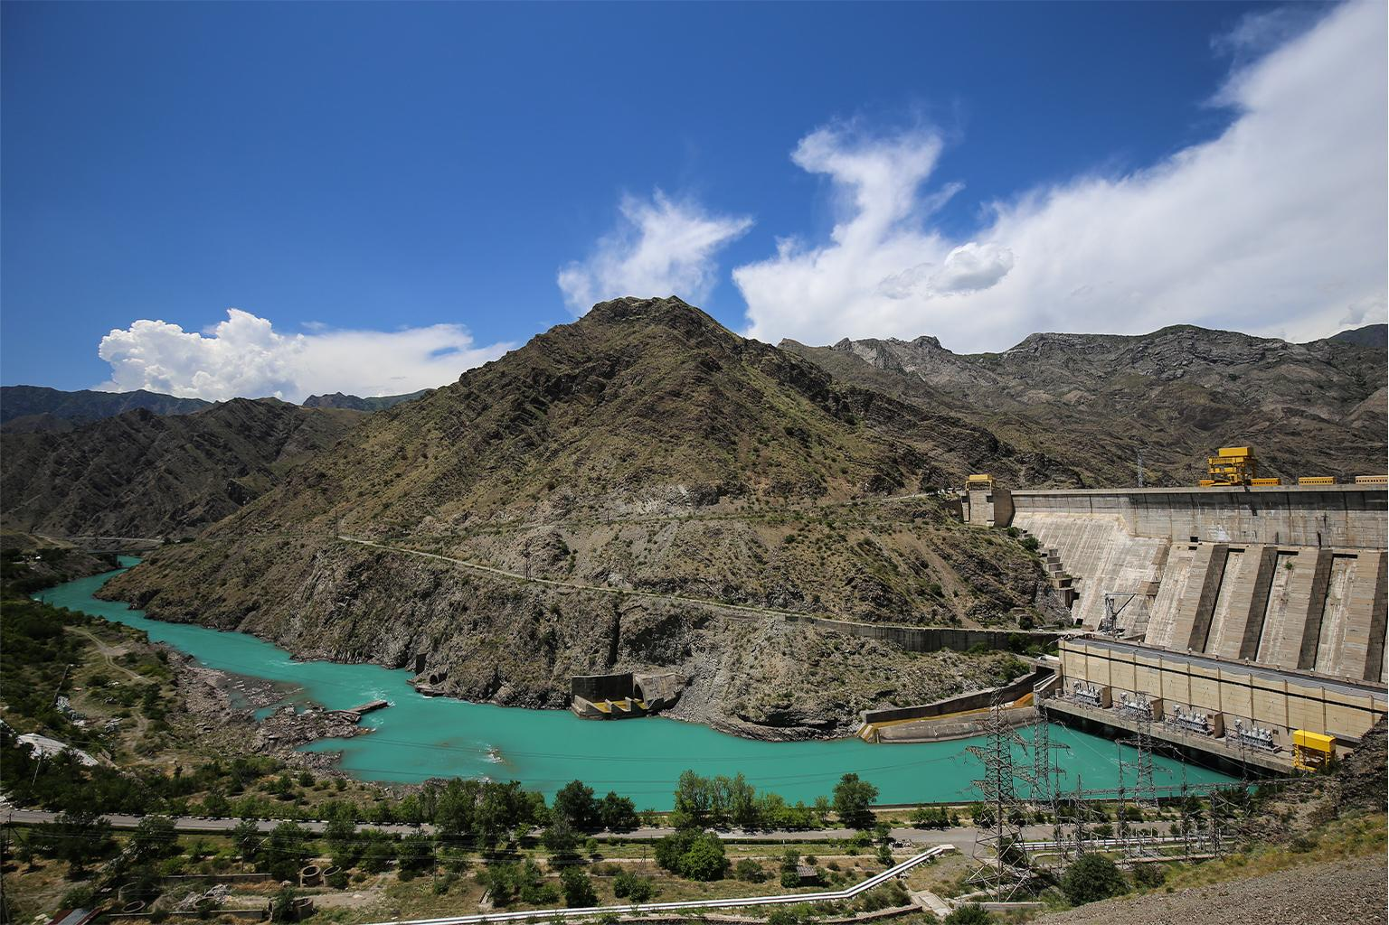The Toktogul reservoir in Kyrgyzstan. The Anthropocene is producing wholesale manipulations to Earth’s water cycle. For example, by 2030, more than 90% of the world’s rivers will likely be altered by dams. Image by Petro Kotzé.

Measuring change: Blue water
The Planetary Boundaries Framework defines a safe operating space for humanity as represented by nine natural global processes that, if severely destabilized, could disrupt Earth’s operating system and threaten life and civilization. The freshwater planetary boundary presents one such threshold, and scientists are working to define a global limit to anthropogenic water cycle modifications.
Initially, in 2009, river flow was used to try and measure the boundary threshold, Gerten explains, because blue water in all its forms was seen to integrate the three largest anthropogenic manipulations of the water cycle: human impacts on precipitation patterns, modifications of soil moisture by land use and land cover; and water withdrawals for human use.
This research used a simple calculation of the global sum of the average annual surface water flow in rivers, with an assumed 30% of that accessible water needing to be protected. This “freshwater use” boundary was set at 4,000 cubic kilometers (960 cubic miles) per year of blue water consumption. This is at the lower limit of a 4,000-6,000 km3 (960-1,440 mi3) annual range designated as a danger zone that takes us “too close to the risk of blue and green water-induced thresholds that could have deleterious or even catastrophic impacts on the Earth System,” researchers wrote in a 2020 paper that evaluated the water planetary boundary.
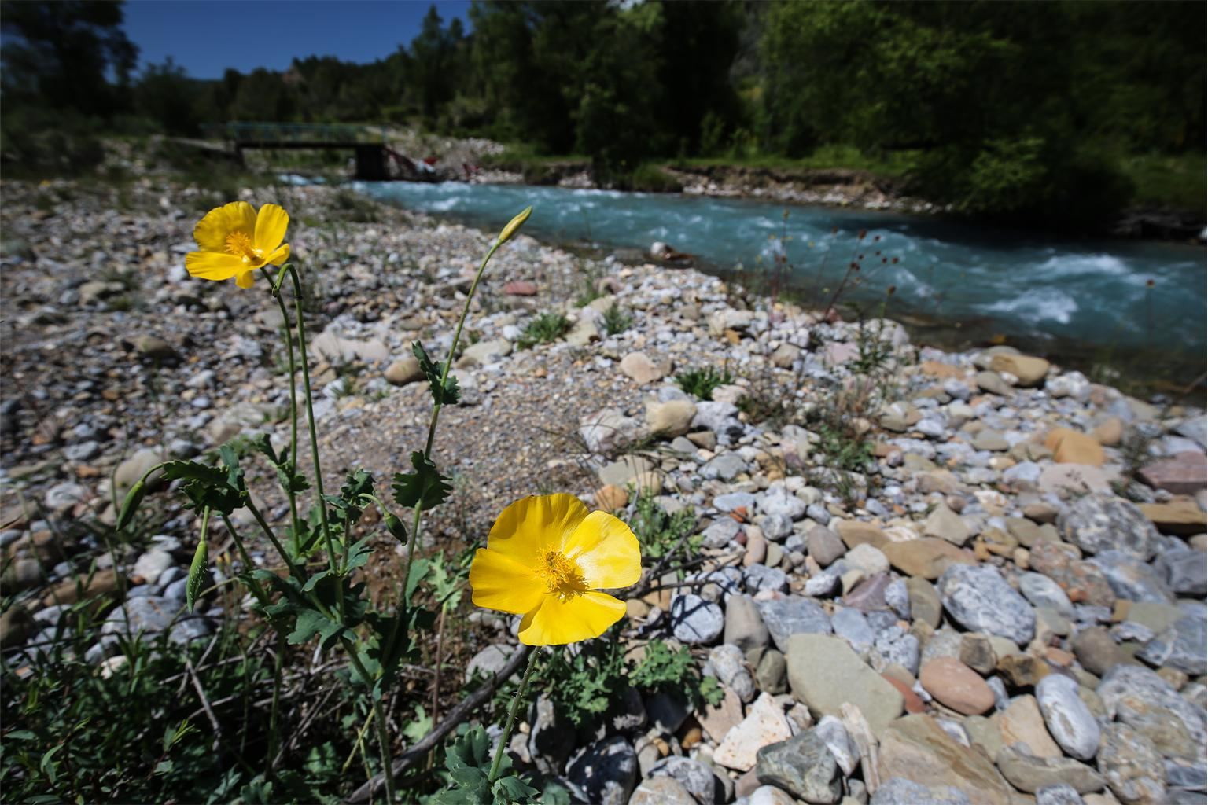The Padysha-Ata River in Kyrgyzstan. Blue water includes rivers as well as lakes, reservoirs, and renewable groundwater stores. Image by Petro Kotzé.
With only an estimated 2,600 km3 (624 mi3) of water withdrawn annually at the time of the study, scientists concluded we were still in the safe zone. However, “That [conclusion] was immediately criticized,” Gerten says, in part because scientists were already seeing ample regional water-related problems. Another criticism argued that the measure of blue water alone did not reflect all types of human interference with the water cycle and Earth system.
Gerten later led work that proposed quantifying the boundary by assessing the amount of streamflow needed to maintain environmental flow requirements in all river basins on Earth. This approach had the advantage of recognizing regionally transgressed limits and thereby deduced a global value.
According to this newer calculation, the freshwater use planetary boundary should be set much lower, at about 2,800 km3 (672 mi3), Gerten says, which means humanity is already much closer to the danger zone than previously thought. “Water is more limited on Planet Earth than we think,” Gerten cautions.
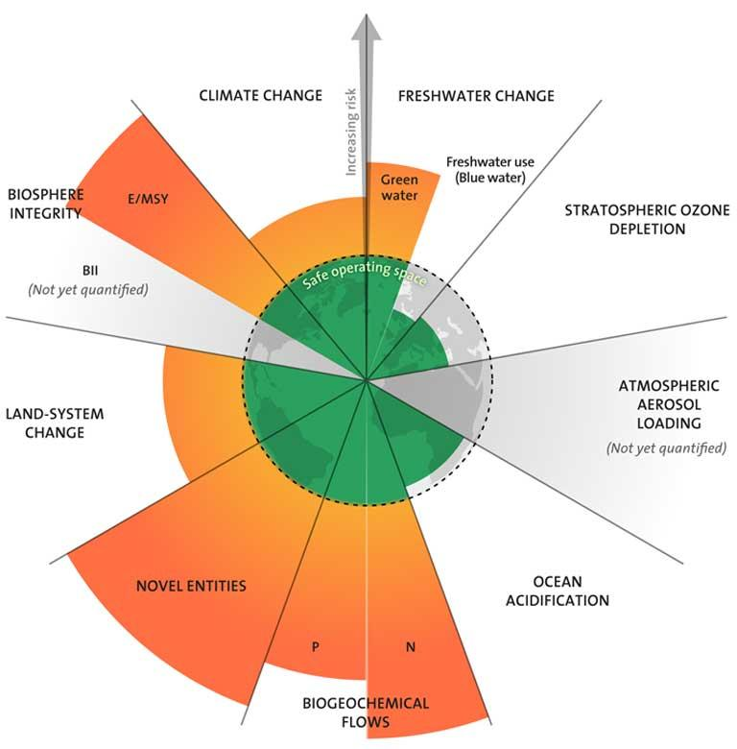The nine planetary boundaries, counterclockwise from top: climate change, biosphere integrity (functional and genetic), land-system change, freshwater change, biogeochemical flows (nitrogen and phosphorus), ocean acidification, atmospheric aerosol pollution, stratospheric ozone depletion, and release of novel chemicals. In 2022, scientists announced the transgression of both the freshwater and novel entities boundaries. Image courtesy of J. Lokrantz/Azote based on Steffen et al. (2015) via Stockholm Resilience Centre.

Redefining the freshwater boundary: Green water
Over time, a consortium of researchers was formed to deeply scrutinize the freshwater boundary. This resulted in follow-up work in 2019 and 2020 proposing that the freshwater boundary be divided into sub-boundaries related to major stores of freshwater: namely atmospheric water, frozen water, groundwater, soil moisture, and surface water.
Since then, scientists simplified their approach further. “Even though we are talking about very complex matters,” Porkka says, the boundary definition, to be useful as a metric, needed to stay “relatively simple.”
The most recent and sweeping reassessment of the freshwater planetary boundary was published in 2022. “Our suggestion is to … change the name from ‘freshwater use planetary boundary’ to ‘freshwater change planetary boundary,’” says study lead author Lan Wang-Erlandsson from the Stockholm Resilience Centre. “Then, to have two components,” she adds, “One for green water, and one for blue water.”
“Water has so many functions in the Earth system, and many of them happen invisibly via green water,” Gerten explains. “We don’t see it and we don’t feel it. That’s why [green water] has been neglected over decades. The focus has been on river flows and groundwater because we can see it, feel it, use it, and touch it. But [as a result] a big share of the water cycle has been overlooked.”
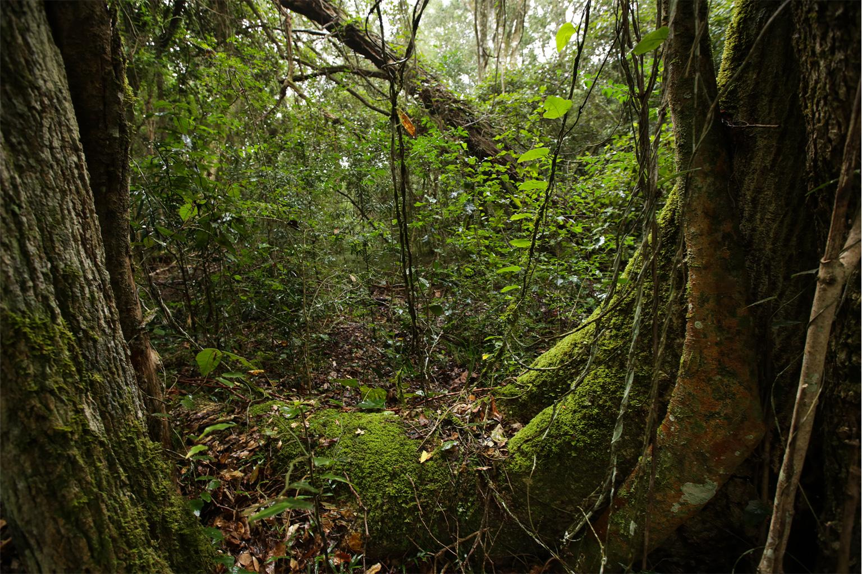The Tsitsikamma forests in South Africa’s Garden Route region. The water taken up by plants and released via transpiration as vapor skyward is an integral part of the water cycle. Image by Petro Kotzé.
The newly accepted metric for tracking green water: The soil moisture in the root zone of plants, or more technically: “the percentage of ice-free land area on which root-zone soil moisture anomalies exit the local bounds of baseline variability in any month of the year.”
This new proxy is appealing because it is directly influenced by human pressures with change over time measurable. In turn, soil moisture directly impacts a range of large-scale ecological, climatic, biogeochemical and hydrological dynamics.
Using this novel green water boundary transgression criteria, scientists detected a major hydrological departure from the baseline set during the Holocene. And the evidence for such a departure is overwhelming: Researchers found “unprecedented areas [of Earth] with root-zone soil moisture anomalies,” indicating an exit from the so-called “safe zone.”
A second criteria, Earth Systems Resilience, was also instituted. Researchers evaluated the state of regional climate systems (ranging from monsoons to land carbon sinks and large biomes) to see which have seen enhanced changes in their process rates, resulting in ripple effects that could destabilize the Earth system, Wang-Erlandsson explains.
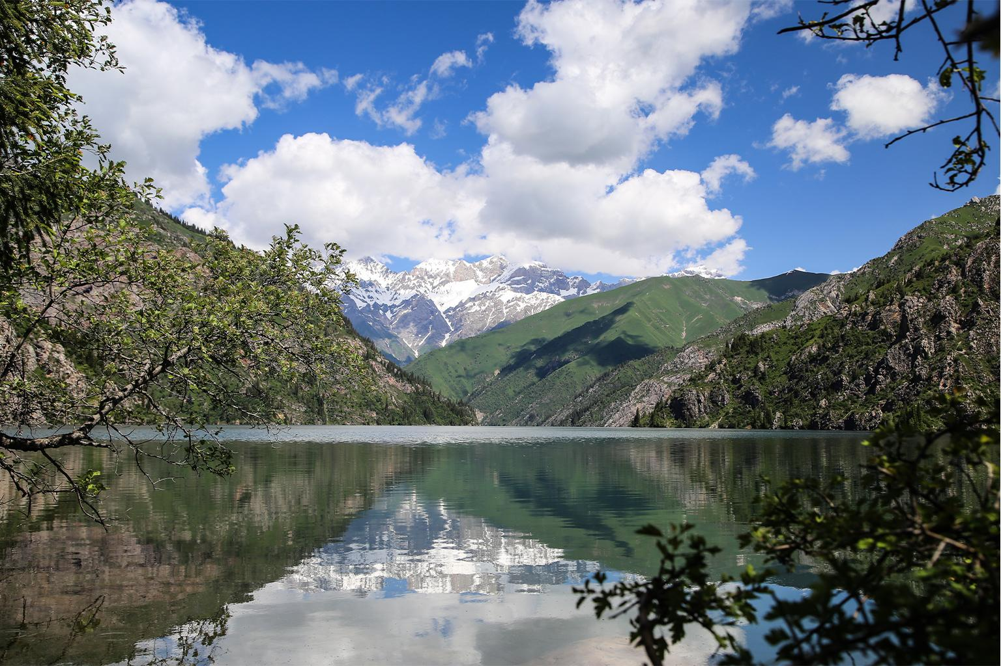Lake Sary-Chelek, part of a UNESCO Biosphere Reserve, in Kyrgyzstan. The hydrological cycle represents an eternal exchange of water in different states between the atmosphere and the planet’s surface, and it maintains the biosphere as we know it. Within this cycle, there is constant interaction between blue and green water. Image by Petro Kotzé.

A transgressed freshwater change boundary
Unfortunately, examples of compromised Earth System Resilience transgressions are rife across the planet.
Take the Amazon Rainforest, for instance. It is now understood that carbon uptake likely peaked there in the 1990s, with a sequestration decline since then driven by escalating climate change and fires, along with global demand for agricultural commodities, which spurred extensive Amazon forest clearing, bringing major land-use change. More recently, African tropical forests have passed their carbon uptake peak.
When these vast biomes and natural systems are put under extreme multiple stressors, the effects can self-amplify and lead to greater, more rapid, rates of change, Wang-Erlandsson says: In South America, this combination of stressors, particularly deforestation and climate change, is inducing intensifying drought, which is now leading to cascading perturbations in living systems. Scientists now think the rainforest biome, stable for thousands of years, is reaching a tipping point, and could quickly transition to seasonal forest, or even a degraded savanna. This shift could lead to the transformation of the South American monsoon system, and a permanent state of reduced rainfall and impoverished biodiversity.
But what starts in the Amazon won’t likely stay there: The rainforest’s destruction will release massive amounts of carbon, intensifying climate change, potentially leading to climate and ecological tipping points in other biomes.
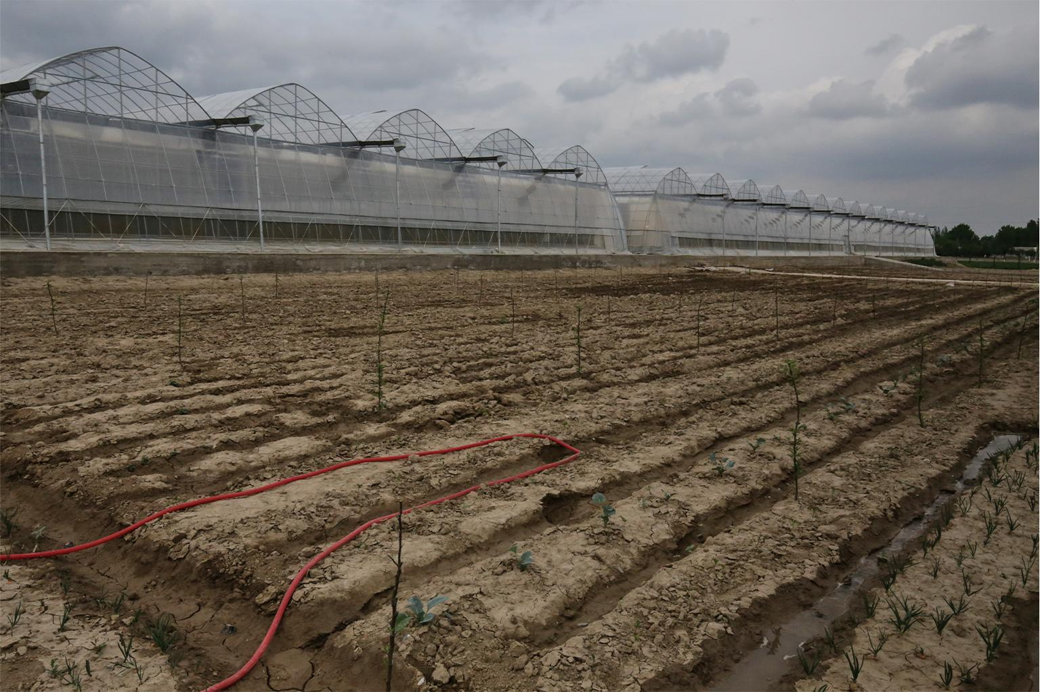Agricultural development in Uzbekistan. Global land-use change, including large-scale deforestation and irrigation, is contributing to major alterations in the water cycle, leading to a destabilized climate and major global environmental and sociopolitical disruptions. Image by Petro Kotzé.

Another concerning example (although debated) of an Earth system shift is the suggestion of a weakening carbon fertilization process, in which higher atmospheric carbon concentrations result in speeded-up photosynthesis as plants try to improve water efficiency in the face of drought. It is thought that this effect is happening already, brought on by limitations in nutrient and soil moisture availability.
In drylands, climate change and ecosystem degradation are triggering vicious cycles of infiltration capacity loss — a decrease in soil moisture and moisture recycling, resulting in increasing desertification and biodiversity loss. In polar permafrost regions, soil moisture saturation could accelerate thawing, generating dangerous methane emissions. Methane is a greenhouse gas far more powerful than carbon dioxide.
Alarmed by the water cycle’s departure from the Holocene baseline, and noting “worrying” signs of low Earth System Resilience, researchers early in 2022 declared the green water boundary to be “considerably transgressed.” The situation, they said, will likely worsen before any reversals in the trend will be observed. “Green water modifications are now causing rising Earth system risks at a scale that modern civilizations might not have ever faced,” the study states.
We don’t yet know what the planetary-scale impacts will ultimately be, but, Porkka says, we have an idea of how impacts could be felt in different parts of the world.
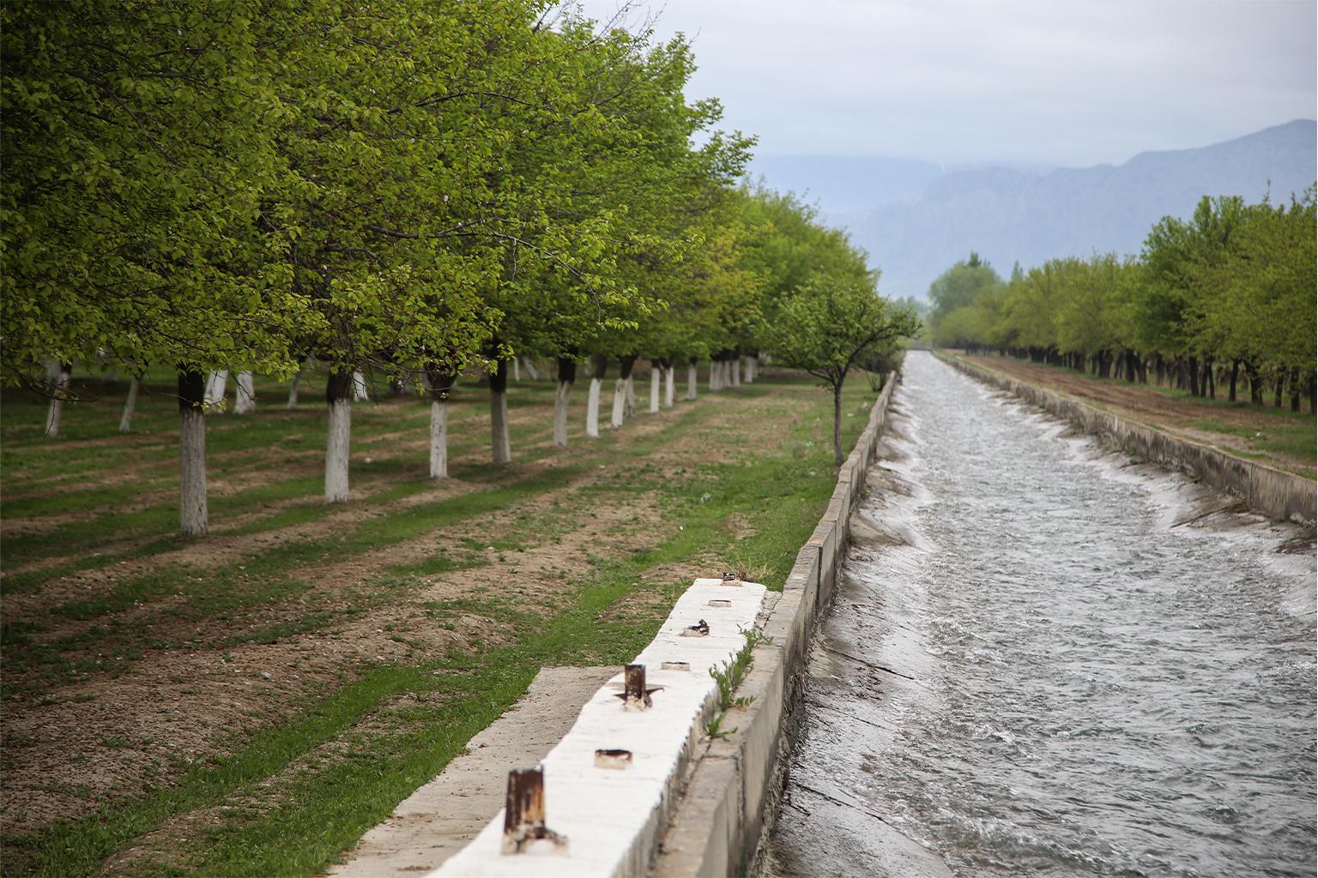An irrigation canal runs past apricot orchards in the Batken region of Kyrgyzstan. We have vastly manipulated Earth’s water cycle to suit humanity’s needs. Image by Petro Kotzé.

Disastrous extreme weather events
Regional extreme events, including floods and mega droughts, are already occurring, Porkka notes. Examples are to be found on every continent.
On Africa’s southeast coast, as just one example: the World Weather Attribution (WWA) network of scientists has found that human-induced climate change has increased the likelihood and intensity of heavy rainfall associated with tropical cyclones. The group based their findings on an analysis of tropical storms Ana and Batisrai, which battered parts of Madagascar, Mozambique, Malawi and Zimbabwe in early 2022. Both cyclonic systems brought devastating floods that caused severe humanitarian impacts, including many deaths and injuries and large-scale damage to infrastructure. These sorts of extreme weather events put great pressure on socioeconomic and political institutions, and could easily destabilize struggling developing nations.
And the situation is worsening. The number of disasters related to weather, climate or water hazards has increased fivefold over the past 50 years, according to the World Meteorological Organization. An assessment from 1970 to 2019 found more than 11,000 reported disasters attributed to such hazards globally, resulting in more than 2 million deaths and $3.64 trillion in losses. All are indicative of a careening hydrological cycle.
Of the top 10 climate disasters, those causing the largest human losses during that period were droughts (650,000 deaths), storms (577,232), floods (58,700), and extreme temperature (55,736 deaths). In economic terms, the top 10 events included storms (costing $521 billion) and floods ($115 billion).
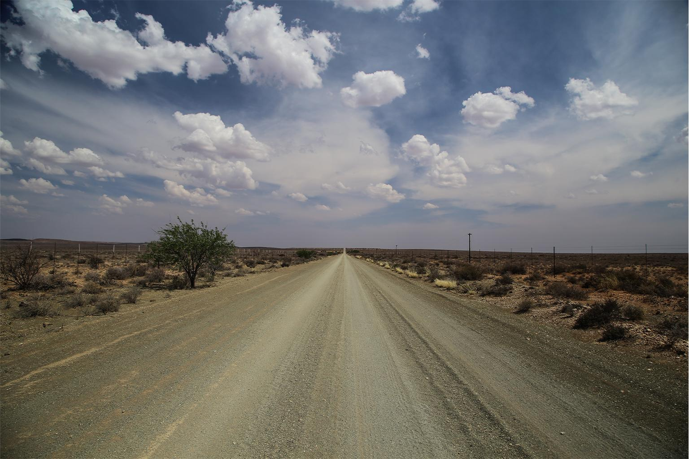Clouds above a dusty road in the Northern Cape of South Africa. The hydrological cycle is powered by the sun and is an eternal exchange of water between the atmosphere and the planet. As climate change escalates, so do extreme weather events such as droughts and intense storms. Image by Petro Kotzé.
Porkka points out, however, that freshwater system destabilization impacts can be more subtle than extreme events. Widespread irrigation of croplands, for example, can increase evaporation to such a high degree that even distant precipitation patterns are altered. Part of the problem is that we do not know if consequences like these are negative or positive.
“[W]e know that we’re changing the [hydrological] system in fundamental ways and, once we do, we don’t really know how the impacts accumulate,” says Porkka.
While many riddles remain, scientists now feel they have a reliable metric for accurately tracking transgressions of the freshwater change boundary. “The prime question was what the key variables are, and I think that is relatively solid now with soil moisture [green water] and river flows [blue water],” Gerten says. “The next questions are, where exactly to put the boundaries, and what happens if they are transgressed?”
Based on these findings, researchers are calling for urgent action: “The current global trends and trajectories of increasing water use, deforestation, land degradation, soil erosion, atmospheric pollution, and climate change need to be promptly halted and reversed to increase the chances of remaining in [Earth’s] safe operating space.”
That’s a tall order, and no matter humanity’s actions, we don’t know how things will play out. “Water is so fundamental and elemental, and at the same time, so varied,” Gerten says, and there is no silver bullet for solving our hydrological problems.
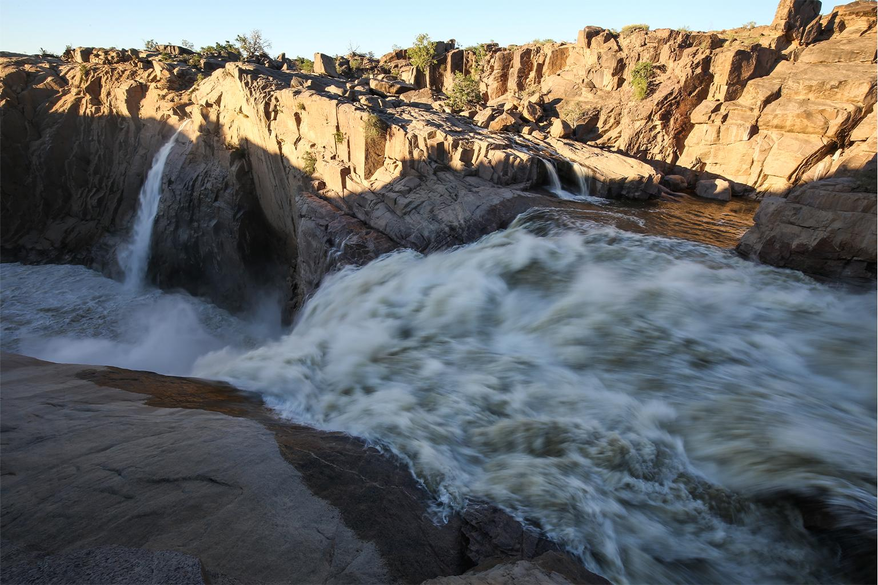South Africa’s Orange River tumbles over Augrabies Falls. Water is one of the most plentiful chemical compounds on Earth and is recycled endlessly through the biosphere in different forms. Image by Petro Kotzé.

Discussion Questions:
How do you think water in Singapore might be affected in the near future?

