Bangladesh confronts growing threat of warming-driven floods
by Md. Tahmid Zami on August 25 2023
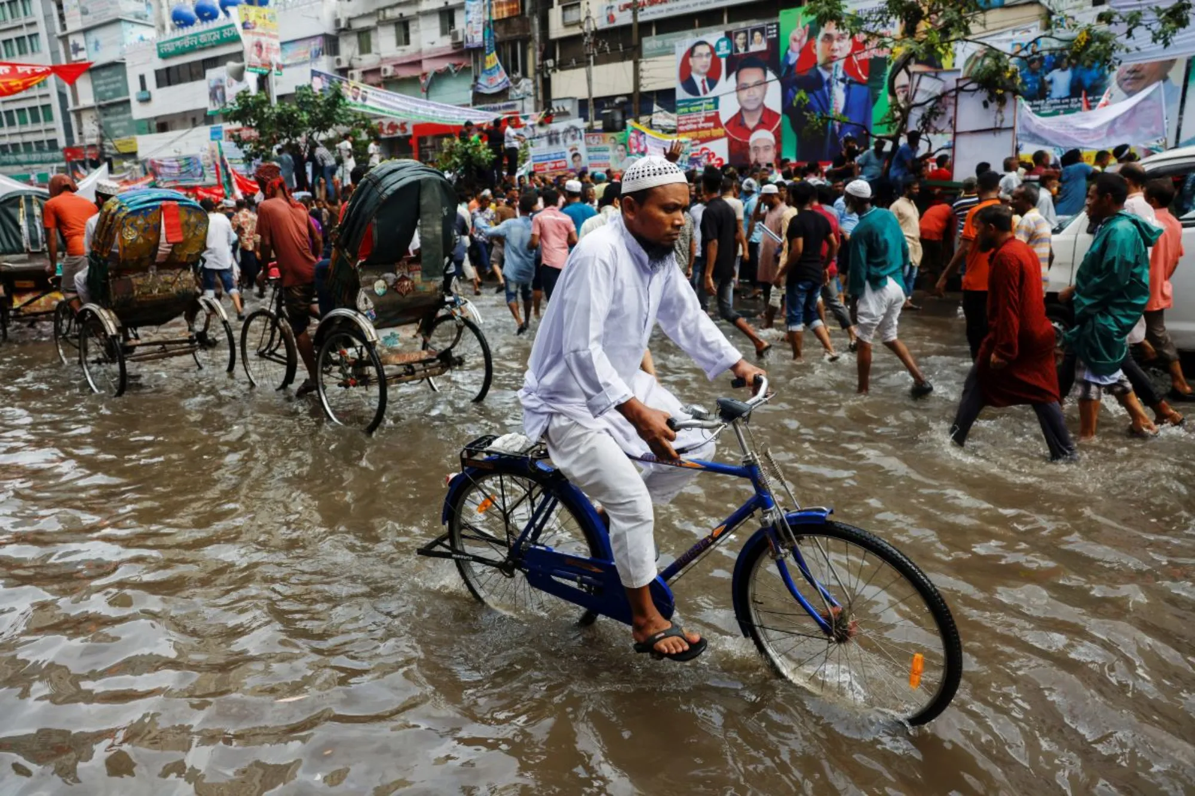A man rides a bicycle on a flooded streets after rain in Dhaka, Bangladesh, August 4, 2023. REUTERS/Mohammad Ponir Hossain
DHAKA - As Bangladesh faces fiercer floods stoked by heavy rains and melting glaciers, driven by climate change, efforts are being launched to reduce the risk.
In August, monsoon rains triggered deadly flash floods in the hilly coastal region of Chattogram - and while the government and aid agencies mobilised to help those affected, the flooding killed more than 50 people and displaced more than 200,000 after their homes were badly damaged.
A report released this week highlighted the growing threat of flooding to the vulnerable South Asian nation.
The study, from the Grantham Research Institute on Climate Change and Environment at the London School of Economics and the UK-based Centre for Climate Change Economics and Policy, called for stronger flood preparedness and community protection, combined with a transition to a low-carbon energy pathway.

Why are floods in Bangladesh getting worse?
Flooding is part of the physical make-up of low-lying Bangladesh, with flood-plains comprising about 80% its land, which is traversed by almost 700 rivers. Nearly two-thirds of the country is less than 5 metres (16.4 ft) above sea-level.
But the new report points to climate change as a major driver of rising flood risk.
Co-author Shouro Dasgupta, an environmental economist at Fondazione CMCC and visiting research fellow at the Grantham Research Institute, said a warming climate has led to more frequent heavy rainfall since the 1950s and could make rains more erratic in the future, with worsening flooding expected.
In June 2022, record-shattering monsoon rains in India's upstream Meghalaya state unleashed a flash flood in northeastern Bangladesh that killed more than 100 people and affected more than 7 million, causing economic damage of about $1 billion.
Even in a scenario with low global greenhouse gas emissions, glacial melting in the Himalaya-Tibetan plateau could increase water flow in the Ganges, Brahmaputra and Meghna rivers by 27%, 8% and 15% respectively this decade, compared to 1986–2005, the study said.
But in a high-emissions scenario, water flow during severe floods in the same rivers could grow as much as 54%, 63% and 81% by 2030, it predicted.
Flooding risks are compounded by economic activities such as unplanned infrastructure development in drainage basins.
Mohammed Moniruzzaman Khan, a professor at the Institute of Disaster Management and Vulnerability Studies at the University of Dhaka, said ad-hoc development and environmental degradation curb the ability of water catchments to absorb precipitation, leading to higher surface runoff and aggravated flood risks.
Moreover, measures to control water flow during the wet season in upstream countries like India and China - from where 54 rivers flow into Bangladesh - can have a considerable impact on flooding, said the report.

What is Bangladesh doing to tackle the risks?
As flood risks grow, the Bangladesh government and development agencies are working together to adapt to the situation and limit the negative impacts.
Traditional measures to prevent floods have focused on building embankments and polders, and improving drainage.
But Dasgupta said structural protection has not been fully effective - and in places, it may have made flood-prone areas appear safer than they are.
Recent government policies have instead adopted a "living with floods" approach using tactics such as discouraging settlements in high-risk areas and promoting types of housing and agriculture that can better withstand floods.
"Bangladesh is moving in the right direction with respect to flood management," Elizabeth Robinson, director of the Grantham Research Institute, told Context.
Disaster experts said that keeping homes out of flood zones could save many lives and properties.
Jimran Mohammad Saiak, an activist with YouthNet for Climate Justice, who worked to support Chattogram flood survivors, said large numbers of houses in Bandarban district were located in low-lying areas or on river banks and were damaged by the surge of water in the river, while those on hilltops came crashing down with landslides caused by the heavy rainfall.
The country's national adaptation plan encourages climate-resilient housing built above flood levels that can conserve water and energy through techniques like rainwater storage.
Development organisations are also expanding flood protection work. Financial institutions like BRAC Bank and the SAJIDA Foundation are using micro-credit and insurance to help vulnerable people become more resilient to repeated floods.
And agencies like ActionAid have recruited volunteers who spread early warnings issued by the government to communities.
Architects are also designing homes that can keep people safer during the frequent flash floods that are hitting sandbar islands in flood-prone northern districts, by creating settlements on elevated ground around a man-made water body that collects rainwater for safe drinking.

How can Bangladesh adapt in the longer-term?
The Grantham study recommends local solutions like tidal river management - which selectively allows tidal water through polders into low-lying areas called "beels", gradually raising the land with sediment - noting their lower financial and environmental costs.
Harnessing ecological resources like the Sundarbans mangrove forests can also be a useful defense as they already protect more than 1 million people and $1.56 billion worth of property from floods, it added.
Khan from the University of Dhaka called for better assessment of vulnerabilities, taking account of the needs of marginalised groups such as Indigenous communities.
The study authors said that besides preparing for the expected flooding, Bangladesh should also pursue decarbonisation as outlined in its national plan for reducing emissions under the Paris Agreement.
"Higher-income countries are in the main responsible for the climate crisis - but it is clear that moving forward, all countries will need to work towards global net zero (emissions) by 2050," said Robinson of the Grantham Research Institute.
Reducing Bangladesh's reliance on coal would not only bring health benefits by easing air pollution, but adopting more renewables like solar and wind could also boost energy security and economic growth, experts said.
"That can make it easier for the country to adapt to and increase its resilience to flooding," added Robinson.
Source: https://www.context.news/climate-risks/bangladesh-confronts-growing-threat-of-warming-driven-floods
Discussion Questions:
How would you adapt to living with climate change?
What has Singapore been doing to mitigate the risks of flooding?

