ANNEX A – Energy Audit Report
Date: DD/MM/YYYY

ENERGY AUDIT REPORT

for
ENTER BUILDING NAME
at
ENTER BUILDING ADDRESS
(BUILDING IMAGE)

Submitted By
Enter name of PE/Energy Auditor
Signature of PE/Energy Auditor
PE (Mech) Registration No*: Enter No.
Energy Auditor Registration No*: Enter No.
*Delete whichever is not applicable

Contents
1.0 Executive Summary & Recommendation 6
2.0 Building Information 7
3.0 Energy Audit Information For Building Cooling System 14
3.1 Chilled Water Plant Design Information* 15
3.2 Air Distribution System information* 16
3.3 Chilled Water Plant Normal Operating Hours 16
3.4 Description of Plant Control Strategy 17
4.0 Instrumentations 19
5.0 Chiller Plant Performance Analysis (1 week data) 20
5.1 Summary of Chilled-Water Plant Operating Performance 29
5.2 Summary of Air Distribution System Operating Performance 30
5.3 Determination of the Energy Efficiency of Unitary Air-Conditioning System 30
5.4 Summary of Building Cooling System Operating Performance 32
6.0 Summary of System Heat Balance (Chilled Water Plant) 33
7.0 Schedule of Space Operating Conditions 34
8.0 Schedule of AHU Operating Conditions (5 typical units) 35
9.0 Key Findings and Potential Energy Efficiency Improvement Measures 36
10.0 Summary list of potential measures and selection 40
APPENDIX B: Temperature Sensor Verification Plot (worked example) 46
APPENDIX C: Supporting documentation in relation to the audit of energy use of buildings and system 48
APPENDIX D: Supporting documentation in relation to the audit of energy efficiency level of building cooling system 49
Contents -Tables
Table 1: Building Information 6
Table 2: Building Energy Use Data 7
Table 3: Building Energy Cost Data 8
Table 4: Building Systems Inventory 9
Table 5: Building Energy Use Breakdown 11
Table 6: Energy Audit Details of Building Cooling System 12
Table 7: Chiller Information (Example) 14
Table 8: Ancillary water-side equipment Information (Example) 14
Table 9: Ancillary air distribution system equipment Information (Example) 15
Table 10: Instrumentation Table (Example) 18
Table 11: Chilled Water Plant Performance Summary (refer to raw data for details) 28
Table 12: Air Distribution System Performance Summary (refer to raw data for details) 29
Table 13: Specification of VRF Outdoor Condensing Unit 30
Table 14: Specification of Air Distribution Units 30
Table 15: Total Cooling System Efficiency (including air distribution system) 31
Table 16: Heat Balance Summary 32
Table 17: Space Condition Schedule (Example) 33
Table 18: Schedule of AHU Operating Condition (5 Typical Units) 34
Table 19: Audit Finding 38
Table 20: Summary List of Potential Measures and Selection 41
Table 21: Energy Saving Potential Matrix 41
Table 22: Checklist of Plant Operating Condition (for best practices) 42
Table 23: EUI Value 42
Table 24: List of Checks 43
Table 25: Verification of temperature sensors 45
Table 26: Supporting documentation in relation to the audit of energy use of buildings and system 46
Table 27: Supporting documentation in relation to the audit of energy efficiency level of building cooling system 48

Table of Figures
Figure 1: Super-imposed plot of 24 hr Cooling Load Profile RT (Example) 19
Figure 2: Histogram of Cooling Load Occurrences (Example) 19
Figure 3: Super-imposed plot of daily chilled water supply/return temperature ºC (Example) 20
Figure 4: Super-imposed plot of daily chilled water temperature difference ºC (Example) 20
Figure 5: Super-imposed plot of daily condenser water supply/return temperature ºC (Example) 21
Figure 6: Super-imposed plot of daily condenser water temperature difference ºC (Example) 21
Figure 7: Super-imposed plot of daily chilled water GPM/RT (Example) 22
Figure 8: Super-imposed plot of daily condenser water GPM/RT (Example) 22
*Figure 9: Cooling Tower Approach Temperature (Example) 23
Figure 10: Super-imposed plot of daily chiller efficiency kW/RT (Example) 23
Figure 11: Super-imposed plot of daily chilled water pump efficiency kW/RT (Example) 24
Figure 12: Super-imposed plot of daily condenser water pump efficiency kW/RT (Example) 24
Figure 13: Super-imposed plot of daily cooling tower efficiency kW/RT (Example) 25
Figure 14:Super-imposed plot of daily chiller plant system efficiency kW/RT (Example) 25
Figure 15: Scatter plot of chiller plant efficiency over cooling load (Example) 26
Figure 16: Scatter plot of chilled water pump efficiency over cooling load (Example) 26
Figure 17: Scatter plot of condenser water pump efficiency over cooling load (Example) 27
Figure 18: Scatter plot of cooling tower efficiency over cooling load (Example) 27
Figure 19: Super-imposed plot of daily total cooling system efficiency kW/RT (Example) 31
Figure 20: System Level Heat Balance Plot (Example) 32
Figure 21: Temperature Verification Plots for Water-Cooled Chiller Plant System (Example) 44

1.0 Executive Summary & Recommendation
(Example)
This report highlights the findings and recommendations obtained from the energy audit performed at Enter Building Name from [Enter Period of Audit] DD/MM/YYYY to DD/MM/YYYY for 24 hrs.
Corrective measures taken by PE (Mech)/ Energy Auditor to comply with MEI Notice.
- <Description of findings/ measures>
- <Description of findings/ measures>
- <Description of findings/ measures>

Recommended energy improvement measures for Building Owners :
- <Description of recommendations>
- <Description of recommendations>
- <Description of recommendations>

2.0 Building Information
Building Name : Example Building
- Building Information
Project Reference Number | Enter project reference indicated in CORENET submission
Building Address
Postal Code
Primary Building Use Type and % Use | Office (50%)
Other Building Use Type and % Use | Hotel (30%), Retail (10%)
Building Age
Typical operation hours | 9 am to 6 pm (Office), 24 hrs (Hotel), 10 am to 9 pm (Retail)
Gross Floor Area (GFA) in m²
Total Number of Blocks | 2 blocks
Number of Floors | Block 1 - Office – 15  Block 2 – Retail (3 from Level 1 to 3) Hotel (15 from level 4-18)
Air-Conditioned Areas in m²
Percentage owned (%)
Percentage leased (%)
Net Lettable Areas in m²
Carpark Areas in m²
Common Areas in m²  Note: To include all areas within the building such as lobbies, corridors, staircases, lifts, car parks, toilets, mechanical and electrical rooms, and other shared facilities that are not that are not leased to or owned by tenants. | Air-Conditioned areas in m²
 | Non-Air-Conditioned areas in m²
Number of guest rooms :
(for hotels/service apartments)
Table 1: Building Information

Building Name : Example Building
(B) Historical Energy Use Data
Monthly electricity consumption over the 3 years prior to the year of notice.
Year of MEI Audit Notice Received | 2025
Building GFA (m²) | XXXX
Month | Monthly Electricity Consumption
Month | 2022 | 2023 | 2024
Jan
Feb
Mar
Apr
May
Jun
Jul
Aug
Sep
Oct
Nov
Dec
Total Building Electricity Consumption (TBEC) (kWh/year)
Energy Use Intensity (EUI) kWh/m²/year
Average Total Building Electricity Consumption (kWh/year) | $$\frac{\sum{{\left(TBEC\right)}_{i}}}{3}$$
Average Energy Use Intensity  (EUI) (kWh/m²/year) | $\frac{Average TBEC}{GFA}$
Remarks | Please highlight any major changes in building operations, occupancy, or requirements that may have affected energy use, if applicable
Note : The average EUI will be used as the baseline to accord the percentage reduction in EUI after implementation of EEIP.
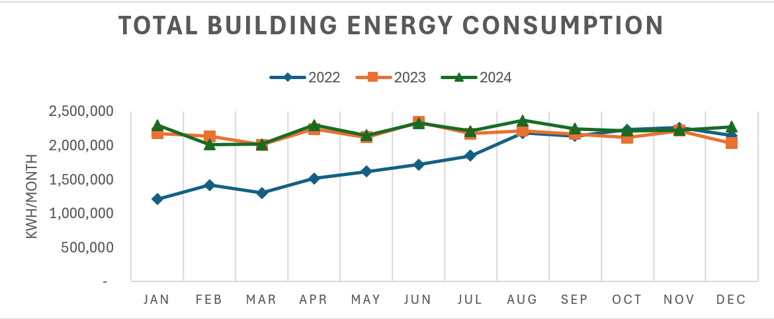
Table 2: Building Energy Use Data

Building Name : Example Building
(C) Utility Cost Arrangement
- Utility account under building owner/Landlord. Building owner will charge tenant based on tenancy lease where relevant. |  |  |  | Yes/No
- Tenants have direct account with utility provider and pay for their own electricity consumption. |  |  |  | Yes/No
- Landlord has the master utility accounts and sub-meter individual units and tenants pay for their metered usage and a share of common areas utilities. |  |  |  | Yes/No
Combination of above or others, pls specify :
(D) Utility Cost for Building Owner or Landlord
Type of Electricity Package | Pls state  Low tension supplies or High tension (small/large) supplies with contracted or uncontracted charges /reactive power charges
Year of MEI Audit Notice Received | 2025
Building GFA (m²) | XXXX
Month | Monthly Electricity Cost
Month | 2022 | 2023 | 2024
Jan
Feb
Mar
Apr
May
Jun
Jul
Aug
Sep
Oct
Nov
Dec
Total Electricity Cost
($/year)
Average Monthly Electricity Cost
($/month)
Table 3: Building Energy Cost Data

Building Name : Example Building
(E) Inventory of Major Energy-Consuming Systems and Equipment
Building cooling System : Refer to Section 3.0 – Energy Audit Information For Building Cooling System.

Centralised Hot Water System (Required, where applicable)
System/Equipment Type | Quantity | Year Installed | Rated Capacity  (kW) | Rated Power  (kW) | Control System | Location/Remarks
Electric/Gas Boiler
Heat Pump
Ancillary Equipment | Quantity | Pump Head  (m) | Flow Rate (L/S) | Rated Pump/ Fan Efficiency (%) | Rated Motor Efficiency  (%) | Location/Remarks
Primary Circulation Pump

Mechanical Ventilation System (Required, if it is in the EEIP)
System/Equipment Type | Quantity | Fan Type | Floor Areas served  (m²) | Air Changes per hour (ACH) | External Static (Pa) | Fan Motor Input Power (kW) | Fan Efficiency (W/CMH) | Location/  Remarks
Exhaust and Intake Fans for Carparks

Lighting System (Required, if it is in the EEIP)
S/No | Fitting Type | Location | Areas Covered  (m²) | Light Fitting Power  (W) | No. of Fittings | Total Power Consumption include ballast loss (W) | Operating Hours  (h) | Operating Lighting Power Budget (W/m²)

Table 4: Building Systems Inventory

Building Name : Example Building
- Breakdown of Energy Consumption by End-Use
End-Use | Energy Consumption (kWh/year) | Data Source
Building Cooling System
Chilled Water System |  | To indicate the data source for example data from BMS, sub-meter, spot measurement, spec and calculation. For others, pls specify
Unitary Air-Conditioning System
Air-Handling and Distribution System
Centralised Hot Water System
Electric/Gas Boiler |  | Ditto
Heat Pump |  | Ditto
Other Equipment and System
Lighting System |  | Ditto
Carpark Ventilation System |  | Ditto
Mechanical and Ventilation System |  | Ditto
Lifts and Escalators |  | Ditto
Receptacle load |  | Ditto
Others (pls specify) |  | Ditto
Total Energy Consumption from Building Systems | ∑ Energy Consumption from the above systems
Other Energy Use (if relevant)
Energy Consumption from Tenants |  | Electricity bills, sub-meter etc.,
Others (pls specify) |  | Ditto
Total Building Energy Consumption (TBEC) | ∑ Energy Consumption from the above systems and Tenants
On-site Renewable Energy Generation (if any) |  | Ditto
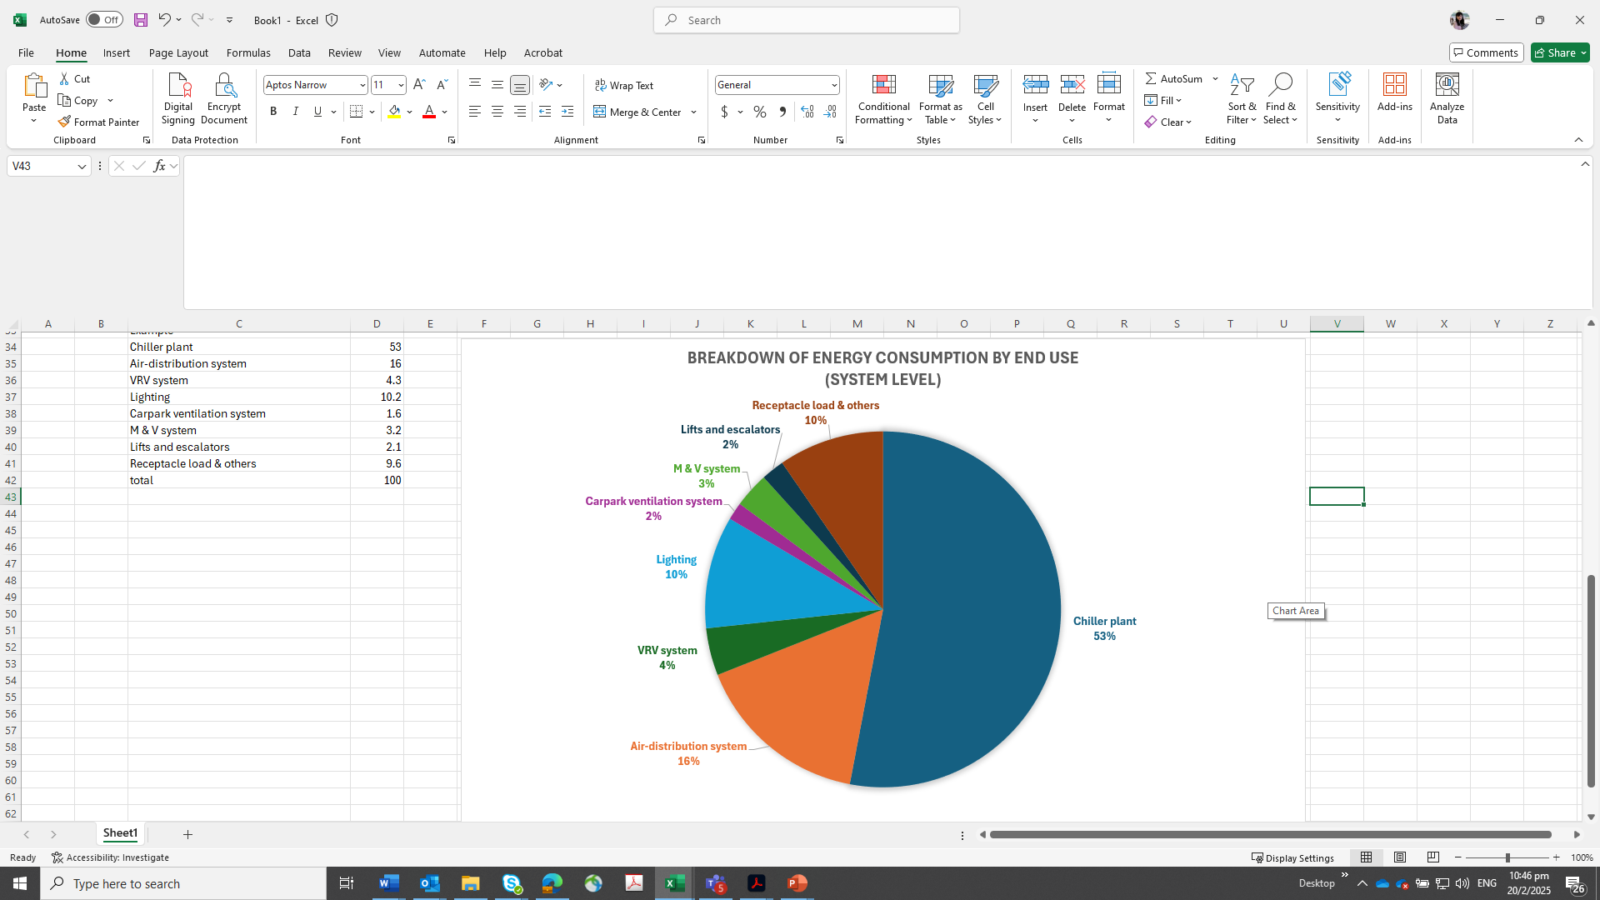
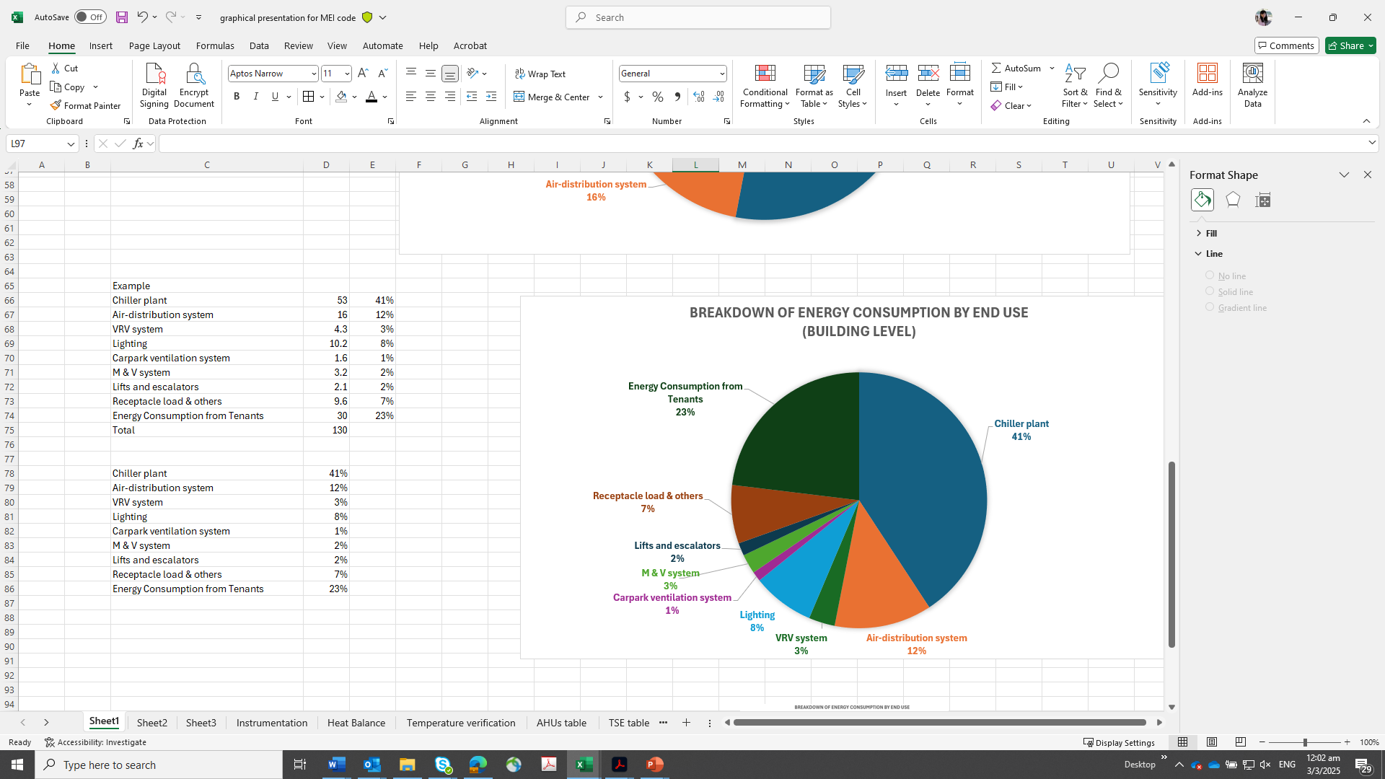
Note : The distribution of energy consumption at system level will include the operation energy demand from the Landlord. If the building is solely occupied by an owner with no other tenancy, the distribution will be the same as that for building level.
Breakdown of Energy Consumption by End-Use
(System Level)
Breakdown of Energy Consumption by End-Use
(Building Level)

Table 5: Building Energy Use Breakdown

Building Name : Example Building
(G) Energy Efficiency of Building Cooling System
Audit Information
Type of Building Cooling System | Pls state the cooling system used :  For e.g.  (a) Water-Cooled Building Cooling System comprises the following systems and components, where relevant.  • Water-Cooled Chiller  • Water-Cooled Direct-Expansion (DX) System  • Chilled Water Pump  • Condenser Water Pump  • Cooling Tower  • Air Handling and Distribution System  (b) Air-Cooled Building Cooling System comprises the following systems and components, where relevant  • Unitary Air-Conditioners (Single or combination of systems)  o Variable Refrigerant Flow (VRF) system  o Single-Split Units  o Multi-Split Units  o Air Handling and Distribution System  • Air-Cooled Chilled-Water System  o Air-Cooled Chiller  o Chilled Water Pump  o Air Handling and Distribution System  (c) District Cooling System comprises the following systems and components, where relevant  • District level - Central chilled water system with distribution networks  • Building level – Air-handling and distribution System
Location of Cooling System | Office Block Basement 2 [Indicate all locations of cooling system and respective configuration]
Energy Audit Period | DD MMM YYYY - DD MMM YYYY
Building Cooling System  Normal Operating Hours | For e.g. office  Monday to Friday : 0800 – 2000 Hrs  Saturday/Sunday : No operation
Table 6: Energy Audit Details of Building Cooling System

3.0 Energy Audit Information For Building Cooling System
Enter PE(Mechanical) / Energy Auditor Name was appointed by Enter Owner Name/ MCST, owner of Enter Building Name to be the Energy Auditor for the submission of the operating system efficiency (OSE) of the building cooling system. The report will present the OSE of the building cooling system based on the measurements from the permanent instrumentations installed on site.
Location : Enter location of Chilled Water Plant
Energy Audit Period : Enter Energy Audit period *Note: Min 1 week
Date of notice served : Enter date of notice served by BCA
Date of submission in notice : Enter submission deadline stipulated in BCA notice
OSE standard to comply (kW/RT) : Enter Min OSE standard for Chilled Water Plant

OSE standard to comply (kW/RT) : Enter Min OSE standard for Total System Efficiency

Data Logging Interval : 1 minute sampling
Trend Logged Parameters* : Chilled Water Supply main header temperature
Chilled Water Return main header temperature
Chilled Water flow rate at chilled water return main header
Condenser Water Supply main header temperature
Condenser Water Return main header temperature
Condenser water flow rate at condenser water return main header
Power input to Chiller(s)
Power input to Chilled water pump(s)
Power input to Condenser water pump(s)
Power input to Cooling tower(s)
Power input to Pre-AHU(s)/AHU(s)/FCU(s)
* Trend logged parameters are not limited to the above and may vary depending on the piping and electrical circuit design.

3.1 Chilled Water Plant Design Information*

ID | Description | Brand | Type | Name plate motor (kW) | Total Cooling Capacity (RT) | Chilled water LWT/EWT | Rated  Efficiency  kW/RT | Year Installed | Location
CH01 | Chiller 1 | Brand X | Centrifugal, water-cooled | 162.8 | 300 | 7.5 °C | 0.543 | 2017 | B2 plant room
CH02 | Chiller 2 | Brand X | Centrifugal, water-cooled | 162.8 | 300 | 7.5 °C | 0.543 | 2017 | B2 plant room
CH02 | Chiller3 | Brand X | Centrifugal, water-cooled | 162.8 | 300 | 7.5 °C | 0.543 | 2017 | B2 plant room
Table 7: Chiller Information (Example)

ID | Brand | Type | Name plate motor (kW) | Pump Head  (m) | Flow rate (L/S) | Rated Pump/ Fan efficiency | Rated Motor Efficiency
CHWP 1 | Brand X | end suction | 11 | 23 | 33.65 | 80.0% | 92.4%
CHWP 2 | Brand X | end suction | 11 | 23 | 33.65 | 80.0% | 92.4%
CHWP 3 | Brand X | end suction | 11 | 23 | 33.65 | 80.0% | 92.4%
CWP 1 | Brand Y | end suction | 15.0 | 16.0 | 56.82 | 79.0% | 92.4%
CWP 2 | Brand Y | end suction | 15.0 | 16.0 | 56.82 | 79.0% | 92.4%
CWP 3 | Brand Y | end suction | 15.0 | 16.0 | 56.82 | 79.0% | 92.4%
CT 1 | Brand Z | cross flow | 5.5 x 1 Cell | - | 66.2 | 75% | 86%
CT 2 | Brand Z | cross flow | 5.5 x 1 Cell | - | 66.2 | 75% | 86%
CT 3 | Brand Z | cross flow | 5.5 x 1 Cell | - | 66.2 | 75% | 86%
Table 8: Ancillary water-side equipment Information (Example)
*Based on equipment design specifications and name plate ratings

3.2 Air Distribution System information*
ID | Model (Serial Number) | Type (Centrifugal/ EC Centrifugal/ Axial) | Motor Power (kW) | Input Power  (kW) | Rated Airflow (m³/h) | Ext Static Pressure (Pa) | Total Static Pressure (Pa) | Cooling Capacity (Ton) | Filter Type/ Rating | Outdoor air provision
AHU 1 | Mod Xx | Centrifugal | 3.0 | 2.67 | 6523 | 205 | 768 | 10.2 | Bag/F7 | Direct opening to external/ via PAHU or FAF
AHU 2 | Mod Xx | Centrifugal | 3.0 | 2.67 | 6523 | 205 | 768 | 10.2 | Bag/F7
AHU 3 | Mod Xx | Centrifugal | 3.0 | 2.67 | 6523 | 205 | 768 | 10.2 | Bag/F7
AHU 4 | Mod Xx | Centrifugal | 3.0 | 2.67 | 6523 | 205 | 768 | 10.2 | Bag/F7
AHU 5 | Mod Xx | Centrifugal | 3.0 | 2.67 | 6523 | 205 | 768 | 10.2 | Bag/F7
AHU 6 | Mod Xx | Centrifugal | 3.0 | 2.67 | 6523 | 205 | 768 | 10.2 | Bag/F7
Pre-Cooled AHU 1 | Mod Yx | Centrifugal | 11.0 | 10.8 | 18500 | 705 | 1221 | 42 | Bag/F7
Pre-Cooled AHU 2 | Mod Yx | Centrifugal | 11.0 | 10.8 | 18500 | 705 | 1221 | 42 | Bag/F7
Summation | - | - | - | X | - | - | - | X | -
Table 9: Ancillary air distribution system equipment Information (Example)
*Based on equipment design specifications and name plate ratings

3.3 Chilled Water Plant Normal Operating Hours
Monday to Friday : 1000 – 2100 Hrs
Saturday / Sunday : No operations
Note: The operating hours should follow the table in clause 6.1.4

3.4 Description of Plant Control Strategy
Summary of the present plant control strategy adopted for the applicant’s building chiller plant systems’ operation. You may include but not limited to the following:
- Chiller sequencing
Describe how the chiller(s) operate to handle the varying building cooling load
e.g. chiller cut-in/out sequence varying with building load and addressing peak and off peak load based on (supply water temperature, and/or building load, and/or compressor current running load amps) and time delay.
- Chilled water pump (if applicable)
Describe the parameters used to control chilled water pumps
e.g. pump speed modulate based on ((differential) pressure sensor located at chiller header, or remote AHU cooling coil, or several zones of AHU cooling coil, or optimising pump pressure by critical valve control), set-point(s) and bypass valve controls to ensure chillers operate at minimum flow rate
- Condenser water pump (if applicable)
Describe the parameters used to control condenser water pumps
e.g. modulate to maintain condenser water differential temperature set point or gpm/ton and the set-point(s).
- Cooling tower (if applicable)
Describe the parameters used to control cooling towers
e.g. Modulate base on cooling tower approach temperature (difference between CT leaving water temperature and ambient wet-bulb temperature) set point (adjustable), or scheduled cooling tower leaving temperature set point, or dynamic optimized cooling tower leaving water temperature set point and the set-point(s)
- Other optimisation (if applicable)
Describe any other optimisation used
e.g. Chilled water supply temperature reset. At off-peak period, reset based on outdoor air temperature/humidity, or VPF bypass control, or predefined schedule.
(Note: Resetting CHW temperature may incur higher pump power and may compromise on space temperature and relative humidity)
(Example)
Chiller Configuration: <x> unit(s) of <x> RT chiller & <x> unit(s) of <x> RT chiller
Variable Primary Chilled Water System
Variable Condenser Pump

- Chiller sequencing
Scenario for Cut-in: Chilled water supply header temperature is above set point of <x> °C + <deadband> OR total system tonnage is above <x> RT for a period of <x> minutes.
Scenario for Cut-out: Chilled water supply header temperature is below set point of <x> °C + <deadband> AND total system tonnage is below <x> RT for a period of <x> minutes.
Time delay: Whenever any chiller cuts-in/out, there is <x> minutes delay to allow system to stabilize.

- Chilled water pump (CHWP)
Primary CHWP speed is modulated to maintain a differential pressure set point of <x> psi + <deadband>. Differential pressure sensors are installed at chilled water pipe headers. CHWP speed is limited to <x> Hz to ensure chillers running at minimum flow. When CHWP speed ramps down to minimum and differential pressure rises above set point, the bypass valve will open to maintain DP set point and minimum flow rate.

- Condenser water pump (CWP) <fixed/variable>
Minimum running speed of CWP is <x> Hz. When condenser flow rate is reduced to set point of <x> l/s or <x> gpm/ton, CWP speed would be increased and vice versa.

- Cooling Tower (CT)
CT fan speed is modulated to maintain leaving condenser water temperature set point of <x> °C which is equal to outdoor air wet-bulb temp plus <x> °C. When chiller(s) is in operation, all CTs would be turn on. When CT leaving water temperature falls below the set point, CT fan speed would be decreased until minimum speed of <x> Hz.

- Other Optimisation
Chilled water temperature set point is reset to <x> °C during off-peak period from 2000hrs to 0800hrs.

4.0 Instrumentations
The measuring instruments complying with the standards in accordance with SS591-Code of Practice for Long Term Measurement of Central Chilled Water System Energy Efficiency are to be used for this purpose.
The points of measurements are listed in the following table:
ID / Serial No. | Brand | Sensor Type | Installation Location | Measurement Uncertainty (%) | Last Calibration Date | Calibration Laboratory
EP80367 | Brand X | 10K Ω Thermistor | CHWS Header | ±0.03 °C | 09/05/2014 | XX laboratory
EP80364 | Brand X | 10K Ω Thermistor | CHWR Header | ±0.03 °C | 09/05/2014 | XX laboratory
EP80361 | Brand X | 10K Ω Thermistor | CWS Header | ±0.03 °C | 09/05/2014 | XX laboratory
EP80363 | Brand X | 10K Ω Thermistor | CWR Header | ±0.03 °C | 09/05/2014 | XX laboratory
3k67201343004 | Brand X | Magnetic Full Bore | CHWR Header | 0.5% | 29/10/2013 | factory calibration
3k67201418063 | Brand X | Magnetic Full Bore | CWR Header | 0.5% | 09/05/2014 | factory calibration
38498 | Brand X | True RMS, 3 phase | MSB Incoming 1 | 0.5% | 08/07/2014 | factory calibration
1402404 | Brand X | True RMS, 3 phase | MSB Incoming 2 | 0.5% | 08/07/2014 | factory calibration
38491 | Brand X | True RMS, 3 phase | CH/6-1 | 0.5% | 08/07/2014 | factory calibration
38487 | Brand X | True RMS, 3 phase | CHP/6-1 | 0.5% | 08/07/2014 | factory calibration
38490 | Brand X | True RMS, 3 phase | CWP/6-1 | 0.5% | 08/07/2014 | factory calibration
38499 | Brand X | True RMS, 3 phase | CT/6-1 | 0.5% | 08/07/2014 | factory calibration
38497 | Brand X | True RMS, 3 phase | CH/6-2 | 0.5% | 08/07/2014 | factory calibration
38483 | Brand X | True RMS, 3 phase | CHP/6-2 | 0.5% | 08/07/2014 | factory calibration
1402325 | Brand X | True RMS, 3 phase | CWP/6-2 | 0.5% | 08/07/2014 | factory calibration
38572 | Brand X | True RMS, 3 phase | CT/6-2 | 0.5% | 08/07/2014 | factory calibration
1402399 | Brand X | True RMS, 3 phase | CH/6-3 | 0.5% | 08/07/2014 | factory calibration
38574 | Brand X | True RMS, 3 phase | CHP/6-3 | 0.5% | 08/07/2014 | factory calibration
38485 | Brand X | True RMS, 3 phase | CWP/6-3 | 0.5% | 08/07/2014 | factory calibration
38486 | Brand X | True RMS, 3 phase | CT/6-3 | 0.5% | 08/07/2014 | factory calibration
Table 10: Instrumentation Table (Example)

5.0 Chiller Plant Performance Analysis (1 week data)

Ave (10am-9pm) = 799RT
Figure 1: Super-imposed plot of 24 hr Cooling Load Profile RT (Example)

Figure 2: Histogram of Cooling Load Occurrences (Example)

Ave (10am-9pm) = 7.5 ºC
Ave (10am-9pm) = 12.9 ºC
Figure 3: Super-imposed plot of daily chilled water supply/return temperature ºC (Example)

Ave (10am-9pm) = 5.4 ºC
Figure 4: Super-imposed plot of daily chilled water temperature difference ºC (Example)

Ave (10am-9pm) = 35.6 ºC
Ave (10am-9pm) = 29.6 ºC
Figure 5: Super-imposed plot of daily condenser water supply/return temperature ºC (Example)

Ave (10am-9pm) = 6.05 ºC
Figure 6: Super-imposed plot of daily condenser water temperature difference ºC (Example)

Ave (10am-9pm) = 2.59
Figure 7: Super-imposed plot of daily chilled water GPM/RT (Example)

Ave (10am-9pm) = 2.9
Figure 8: Super-imposed plot of daily condenser water GPM/RT (Example)

*Figure 9: Cooling Tower Approach Temperature (Example)
*required if using wet bulb temperature as set point

⁺Weighted Ave (10am-9pm) = 0.520
Figure 10: Super-imposed plot of daily chiller efficiency kW/RT (Example)
⁺Weighted average: ∑ kW-hr / ∑ RT-hr
⁺Weighted Ave (10am-9pm) = 0.037
Figure 11: Super-imposed plot of daily chilled water pump efficiency kW/RT (Example)

⁺Weighted Ave (10am-9pm) = 0.031
Figure 12: Super-imposed plot of daily condenser water pump efficiency kW/RT (Example)

⁺Weighted Ave (10am-9pm) = 0.038
Figure 13: Super-imposed plot of daily cooling tower efficiency kW/RT (Example)

⁺Weighted Ave (10am-9pm) = 0.626
Figure 14:Super-imposed plot of daily chiller plant system efficiency kW/RT (Example)

Figure 15: Scatter plot of chiller plant efficiency over cooling load (Example)

Figure 16: Scatter plot of chilled water pump efficiency over cooling load (Example)

Figure 17: Scatter plot of condenser water pump efficiency over cooling load (Example)

Figure 18: Scatter plot of cooling tower efficiency over cooling load (Example)

5.1 Summary of Chilled-Water Plant Operating Performance
Daily Average Reading | Period |  | Unit
Daily Average Reading | Daytime^ | Night-time~ | Unit
Cooling Load |  |  | RTh
Cooling Load Density (Air-con area) |  |  | m²/RT
Power Consumption |  |  | kWh
Chilled water supply temperature |  |  | ºC
Chilled water return temperature |  |  | ºC
Chilled water delta T |  |  | ºC
Chilled water flow rate |  |  | l/s
Chilled water flow rate vs cooling load |  |  | USgpm/RT
*Condenser heat rejection |  |  | HRT
*Condenser water supply temperature |  |  | ºC
*Condenser water return temperature |  |  | ºC
*Condenser water delta T |  |  | ºC
*Condenser water flow rate |  |  | l/s
*Condenser water flow rate vs cooling load |  |  | USgpm/RT
Chiller(s) efficiency |  |  | kW/RT
Chilled water pump(s) efficiency |  |  | kW/RT
*Condenser water pump(s) efficiency |  |  | kW/RT
*Cooling tower(s) efficiency |  |  | kW/RT
Overall chiller plant efficiency |  |  | kW/RT
Table 11: Chilled Water Plant Performance Summary (refer to raw data for details)
* The data in relation condenser pumps and cooling towers will not be applicable for air-cooled chilled water system.
~For hotels and other developments with 24-hour operations only; Night-time shall refer to the period from 11pm – 7am;
^ For hotels and other developments with 24-hour operations, day-time shall refer to the period from 7am – 11pm; for all other developments, daytime shall refer to the normal operating hours as below.
Building Type | Operating Hours
Office Building | Monday to Friday: 9a.m. to 6p.m.
Retail Malls | Monday to Sunday: 10a.m. to 9p.m.
Hotels/Hospital | Monday to Sunday: 24 hours
Other buildings | Building specific operating hours

5.2 Summary of Air Distribution System Operating Performance
Daily Average Reading | Period |  | Unit
Daily Average Reading | Daytime^ | Night-time~ | Unit
Air distribution system power consumption (a) |  |  | kWh
- Pre-AHU (measured) |  |  | kWh
- AHU (measured) |  |  | kWh
- FCU (nameplate or input power x op hrs) |  |  | kWh
Chiller plant cooling load (b) |  |  | RTh
Overall air distribution system efficiency (a / b) |  |  | kW/RT
Table 12: Air Distribution System Performance Summary (refer to raw data for details)

5.3 Determination of the Energy Efficiency of Unitary Air-Conditioning System
VRF System | Single-split and Multi-split Unitary Air Conditioners
IEER = (0.020 x A) + (0.617 x B) + (0.238 x C) + (0.125 x D)  where  A = EER or COP at full load  B = EER or COP at 75% load  C = EER or COP at 50% load  D = EER or COP at 25% load | COP_{weighted} = 0.4 x COP_{100%} + 0.6 x COP_{50%}  where  COP_{100%} is defined as the ratio of the cooling capacity to effective power input at full load cooling capacity  COP_{50%} is defined as the ratio of the cooling capacity to effective power input at 50% cooling capacity
Where there is a combination of unitary air-conditioning systems serving different zones, the weighted system efficiency will be determined by pro-ration according to the respective cooling capacity served and expressed as follows:

Energy efficiency  of unitary air-conditioning system | EE_{Weighted} (in kW/RT) = 3.517/ ∑(Cooling Capacity x IEER or COP_{weighted})_{i}  Total Cooling Capacity_{overall}

Outdoor Condenser Units / System | Zone | Location  Served | Specification of VRF Outdoor Condensing Unit |  |  |  |  |  | IEERi  (0.020 x A) + (0.617 x B) + (0.238 x C) + (0.125 x D)
Outdoor Condenser Units / System | Zone | Location  Served | Full  Installed Capacity (kW) | Designed  Cooling Capacity (kW) | 100% EER  (A) | 75% EER  (B) | 50% EER (C) | 25% EER  (D) | IEERi  (0.020 x A) + (0.617 x B) + (0.238 x C) + (0.125 x D)
VRF System 1 | 1 | FCC Room | 22.4 | 14.18 | 4.1 | 5.5 | 7.3 | 7.6 | 6.16
VRF System 1 | 1 | Lift lobby  Corridor
VRF System 1 | 1 | Reception
VRF System 2 | 2 | Office 1 | 44.8 | 28.36 | 3.90 | 5.20 | 7.10 | 7.90 | 5.96
VRF System 2 | 3 | Office 2 | 44.8 | 28.36 | 3.90 | 5.20 | 7.10 | 7.90 | 5.96
VRF System 2 | 4 | Office 3 | 44.8 | 28.36 | 3.90 | 5.20 | 7.10 | 7.90 | 5.96
Total cooling capacity : |  |  | 156.8 | 99.26 | - | - | - | - | -
Table 13: Specification of VRF Outdoor Condensing Unit
Indoor Unit / System | Zone | Location Served | Specification of Air Distribution Units |  |  |  | Air Distribution  System efficiency based on design cooling capacity ƞa in kW/RT
Indoor Unit / System | Zone | Location Served | Unit Type | Installed Capacity (kW) | Design cooling Capacity (kW) | Nameplate Motor Power (kW)
VRF System 1 | 1 | FCC Room | Ceiling Cassette (FCUs) | 4.2 | 2.67 | 0.043 | 0.0569
VRF System 1 | 1 | Lift lobby  Corridor | Ceiling Cassette (FCUs) | 9.0 | 5.70 | 0.092 | 0.0568
VRF System 1 | 1 | Reception | Ceiling Cassette (FCUs) | 9.0 | 5.70 | 0.092 | 0.0568
VRF System 2 | 2 | Office 1 | Ducted FCUs | 44.0 | 27.85 | 1.8 | 0.2273
VRF System 2 | 3 | Office 2 | Ducted FCUs | 44.0 | 27.85 | 1.8 | 0.2273
VRF System 2 | 4 | Office 3 | VAV AHUs | 44.8 | 28.36 | 5.2 | 0.6449
VRF System 2 |  |  | Total | 155 | 98.13 | 9.027 | –
Table 14: Specification of Air Distribution Units
Compute Weighted Design System Efficiency of outdoor condenser units, Ƞ_{c (Overall)} (kW/RT) and Weighted System Efficiency of air-distribution system, Ƞ_{a (overall)} (in kW/RT)
Total system efficiency, TSE (in kW/RT) = ƞc (overall) + ƞa (overall)
= 0.668 + 0.324 = 0.992 kW/RT

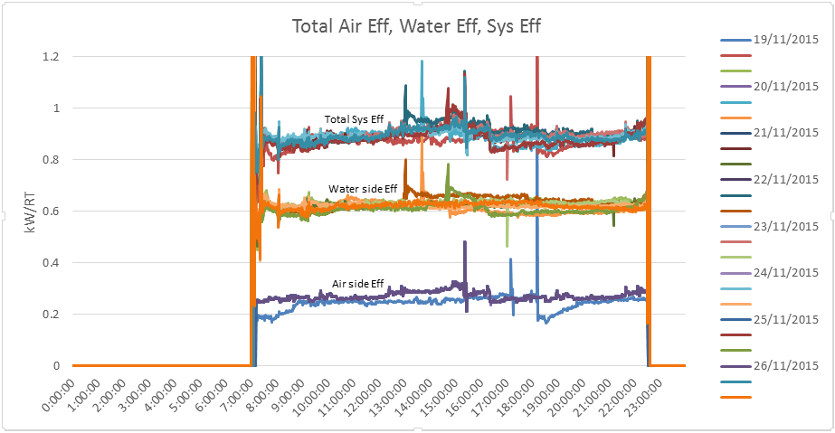
Figure 19: Super-imposed plot of daily total cooling system efficiency kW/RT (Example)

5.4 Summary of Building Cooling System Operating Performance

Daily Average reading | Period |  | Unit
Daily Average reading | Daytime^ | Night-time~ | Unit
Overall air distribution efficiency |  |  | kW/RT
Overall Chilled Water Plant/AC System efficiency |  |  | kW/RT
Total System Efficiency (TSE) of Building Cooling System |  |  | kW/RT
Table 15: Total Cooling System Efficiency (including air distribution system)

6.0 Summary of System Heat Balance (Chilled Water Plant)
± 5%
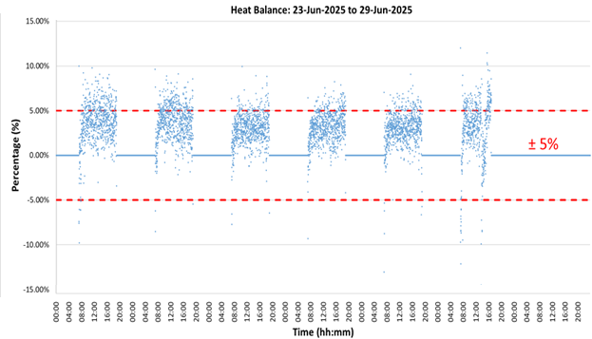
Figure 20: System Level Heat Balance Plot (Example)
Parameters | Quantity | Unit | Formula
Sum of total electrical energy used |  | kWh | (A)
Sum of total cooling produced |  | RTh | (B)
Sum of total heat rejected |  | RTh | (C)
Chiller Plant Efficiency |  | kW/RT | (A) / (B)
Total Heat Balance Data Count |  | - | (D)
Data Count > + 5% error |  | - | (E)
Data Count < - 5% error |  | - | (F)
Data Count within ±5% error |  | - | (G) = (D) – (E) – (F)
% Heat Balance within ±5% error |  | % | 100 x (G) / (D)
Table 16: Heat Balance Summary

7.0 Schedule of Space Operating Conditions
(Minimum of 10 points Spot measurements)
S/No | Room name  (i.e. Air conditioned occupied/ common Spaces) | Normal operating room conditions |  | Measured
S/No | Room name  (i.e. Air conditioned occupied/ common Spaces) | Dry Bulb Temperature (ºC) | Relative Humidity (%) | *Dry Bulb Temperature (ºC) | *Relative Humidity (%) | *CO2 Concentration (ppm)
1 | i.e. Office 1
2 | i.e. Office 2
3 | i.e. Meeting Room 1
4 | i.e. Meeting Room 2
5
6
7
8
9
10
Table 17: Space Condition Schedule (Example)
* Any observation on over-cooling/ under-cooling and ventilating of space conditions should first be investigated and corrected before the energy audit is carry out. Refer to recommended limits of SS553 and SS 554.

8.0 Schedule of AHU Operating Conditions (5 typical units)
(Spot Measurements)
AHU no. | Parameters | Pre-Cooled AHU #1 | Pre-Cooled AHU #2 | AHU #1 | AHU #2 | AHU #3
1 | Return Air Temp Setpoint (ºC) | - | -
2 | Return Air Temp (ºC) | - | -
3 | Supply Air Temp Setpoint ( ºC) | - | -
4 | Supply Air Temp (ºC)
5 | Fan Speed Setpoint (Hz/%)
6 | Fan Speed (Hz /%)
7 | Rated (kW)
8 | Running (kW)
9 | Nameplate Airflow (CMH) | - | -
10 | Nameplate W/CMH | - | -
11 | CO₂ Setpoint (ppm) | - | -
12 | CO₂ (ppm)
13 | Outdoor Air Damper Opening (%)
14 | Outdoor Air Provision (Direct opening to external/ via PAHU or FAF)
15 | Filter Type/ Rating (Bag/ F7)
Table 18: Schedule of AHU Operating Condition (5 Typical Units)

9.0 Key Findings and Potential Energy Efficiency Improvement Measures
Audit Finding (1) [Example]
Focus Area |  | Chilled water system efficiency
Key Observations |  | - Two 500-ton centrifugal chillers of about 10 years old  - Serving a 25,000 m² office complex  - Current chilled water system efficiency : 0.85 kW/RT  - Industry benchmark: 0.60 kW/ton for similar systems  - System is operating in bottom 30% of efficiency range  - Current chilled water system efficiency averages 0.85 kW/ton, about 30% below industry benchmark. Trend logs show frequent cycling at low loads and suboptimal sequencing. The main chillers are operating significantly below the designed efficiency levels, resulting in an estimate increase in energy consumption and operating costs by 30%. It was observed to have some potential issues with maintenance, control settings, and component degradation.
Potential Measures |  | - Conduct a comprehensive maintenance, including tube cleaning, refrigerant charge optimisation.  - Chiller system optimisation, including upgrading control system for improved sequencing and load management.  - Complement with installation of smaller capacity chiller to cater to low load conditions
Audit Finding (2) [Example]
Focus Area | Air Distribution System Operation
Key Observations | - Existing AC fan motors in the AHUs are standard efficiency type, operating at constant speed regardless of load variations though they are equipped with VSDs. There are some signs of aging with reduced efficiency. Current fan system efficiency is below optimal levels, with higher energy consumption and maintenance requirements.  - The supply air temperature setpoint remains constant at 13°C regardless of building load conditions.  - Dirty cooling coils and blocked filters causing reduced heat transfer and increased fan power.
Potential Measures | (1) Optimise existing system:  - Implement proper VSD control strategies based on demand  - Service/repair existing motors and drives  - Review and calibrate pressure sensors  - Commission proper control sequences  (2) Consideration to replace existing AC motors with electronically commutated (EC) fans which come with higher motor efficiency (about 30% energy savings compared to AC motors) and better part-load performance  (3) Establish regular cleaning schedule and preventive maintenance programme for cooling coils along with filter differential pressure monitoring.
Audit Finding (3) [Example]
Focus Area |  | Lighting system efficiency and use
Key Observations |  | - Current lighting using T8 fluorescent tubes (32 W) with magnetic ballasts for all office spaces of 20,000 m²  - No occupancy sensors or daylight harvesting systems  - Lighting accounts for 15% of the total building energy consumption  - Current lighting system operates at an average efficacy of 60 lumens/watt, significantly below modern standards. Light level measurements show over-illumination in 50% of the office space, with an average of 650 lux at desk level. Energy monitoring reveals that 30% of lighting energy is consumed outside of standard operating hours. Estimated annual lighting energy consumption: 1,200,000 kWh Calculated lighting power density: 12 W/m², compared to best practice of 5-7 W/m²
Potential Measures |  |  | - Replace existing fixtures with LED panels (efficacy >120 lumens/watt)  - Install occupancy sensors in less frequently accessed areas  - Use time scheduling for open office areas, with manual override capability  - Integrate lighting control with the building management system upgrade
Audit Finding (4) [Example]
Focus Area |  |  | Carpark ventilation system
Key Observations |  |  | - Conventional carpark ventilation system for all zones.  - It was observed that the carpark ventilation system is operating at full speed with fixed air changes per hour. It is expected to have higher energy consumption due to constant operation.
Potential Measures |  |  | - Upgrade to facilitate demand-controlled ventilation with CO sensors to monitor the air quality and modulate the fan speeds of the supply and exhaust fans based on CO level  - Reduction in energy consumption by way of operational scheduling. For e.g. to align ventilation with peak usage patterns, to reduce ventilation during low occupancy period and have such interface with carpark management system to facilitate such monitoring.
Audit Finding (5) [Example]
Focus |  |  | Excessive air leakage via door openings at entrance A & B
Key Observations |  |  | - Door openings and lobby areas leading to building XYZ are not enclosed.  - Excessive infiltration of hot/humid outdoor air and loss of conditioned air was observed. This may have attributed to higher cooling load and energy consumption.
Potential Measures |  |  | - Adjustment of pressure control by optimising the AHU settings for proper pressurisation and balance the air distribution.  - Install automated self-closing doors to minimise excessive air leakage
Audit Finding (6) [Example]
Focus Area |  |  | Centralised hot water system operation (electric boilers)
Key Observations |  |  | - The hot water system was operating on a high operating temperature (65°C) maintained throughout the day regardless of demand.  - Circulation pumps operating at constant speed 24/7  - Significant heat loss from poorly insulated distribution pipes
Potential Measures |  |  | - System Optimisation by implementing demand-based temperature control.  - Install VSD for circulation pumps and demand-based circulation control  - Improve on system insulation  - Replace with high efficiency boiler  - Tap on heat recovery from chiller condensers
Audit Finding (7) [Example]
Focus Area |  |  |  | Partnership with Tenants and Users
Key Observations |  |  |  | - Lack of structured tenant/user engagement in reducing energy consumption.  - Energy saving efforts are fragmented, with no clear framework for tenant participation or incentives for energy-saving behaviors
Potential Measures |  |  |  | - Energy performance requirements in lease agreements  - Guidelines for fit out works  - Protocol for air-conditioning usage during off-peak hours  - Cost-sharing mechanism for energy efficiency improvements  - Tenant energy management programme  - Performance-linked rental rebates
Table 19: Audit Finding

10.0 Summary list of potential measures and selection
Summary List of Potential Measures and Selection [Example]
S/No. | List of Potential Measures | Building System/ Initiative | Energy Saving Potential (High/Medium/Low) |  | Potential Cost (High/ Medium/ Low) | Selection (Y/N) | Remarks/ Reasons (if not implementing)
S/No. | List of Potential Measures | Building System/ Initiative | System Level | Building Level | Potential Cost (High/ Medium/ Low) | Selection (Y/N) | Remarks/ Reasons (if not implementing)
1 | Conduct comprehensive maintenance including tube cleaning and refrigerant charge optimisation | Chiller system | Low | Low | Low | Yes
2 | Chiller optimisation including upgrading of control system | Chiller system | High | High | Medium | Yes
3 | Installation of smaller capacity chiller | Chiller system | High | High | High | Yes
4 | AHUs system optimisation | AHUs | Medium | Medium | Medium | Yes
5 | Replacement with EC fans | AHUs | High | Medium | Medium | No | To be considered at later stage as existing systems are within service life.
6 | Regular cleaning schedule and preventive maintenance programme for cooling coils along with filter differential pressure monitoring | AHUs | Low | Low | Low | Yes
7 | Replacement of existing fixtures with LED panels | Lighting system | Low | Low | Low | Yes
8 | Install occupancy sensors in less frequently accessed areas | Lighting system | Low | Low | Low | Yes
9 | Use time scheduling for open office areas, with manual override capability | Lighting system | Low | Low | Low | Yes
10 | Integrate lighting control with the building management system upgrade | Lighting system | Medium | Low | Medium | No | Incompatible existing lighting circuits/systems
11 | Upgrade with demand-controlled ventilation with CO sensors to monitor the air quality and modulate the fan speeds of the supply and exhaust fans based on CO level | Carpark ventilation System | Medium | Low | Medium | No | Limited BMS integration capability for carpark systems
12 | Change operational scheduling by aligning ventilation with peak usage patterns, to reduce ventilation during low occupancy period | Carpark  ventilation System | Medium | Low | Low | Yes
13 | Adjustment of pressure control by optimising the AHU settings for proper pressurisation and balance the air distribution. | AHUs in relation to air leakage | Medium | Low | Low | Yes
14 | Install automated self-closing doors to minimise excessive air leakage | Door provision | Medium | Low | Low | Yes
15 | System Optimisation by implementing demand-based temperature control. | Centralised hot water system | High | Medium | Medium | No | Plan for boiler replacement
16 | Install VSD for circulation pumps and demand-based circulation control | Centralised hot water system | High | Medium | Medium | No | Plan for boiler replacement
17 | Improve on existing hot water system insulation | Centralised hot water system | Low | Low | Low | No | Plan for boiler replacement
18 | Replace with high efficiency heat pump | Centralised hot water system | High | High | High | Yes
19 | Tap on heat recovery from chiller condensers | Centralised hot water system | Medium | Medium | Medium | Yes | Complement boiler replacement
20 | Energy performance requirements in lease agreements | Tenant partnership programme | NA | Medium | Low | Yes | Limit to new tenants or at lease renewal stage
20 | Guidelines for fit out works to required energy efficient equipment | Tenant partnership programme | NA | Medium | Low | Yes | Limit to new tenants or at lease renewal stage
21 | Protocol for air-conditioning usage during off-peak hours | Tenant partnership programme | NA | Low | Low | Yes
22 | Cost-sharing mechanism for energy efficiency improvements | Tenant partnership programme | NA | High | Medium | Yes | Subject to tenants’ agreement to terms like energy data sharing
23 | Tenant energy management programme | Tenant partnership programme | NA | Medium | Low | Yes
24 | Performance-linked rental rebates | Tenant partnership programme | High | High | Medium | No | Subject to tenants’ agreement to terms like energy data sharing
Table 20: Summary List of Potential Measures and Selection
<Explain and provide the basis on how the energy saving potential and implementation cost are classified as High, Medium, or Low.>
Energy Saving Potential (example) |  | Potential Implementation Cost (example)
System Level | Building Level | Potential Implementation Cost (example)
High: > 20%  Medium: 5% to 20%  Low: <5 % | High: > 1%  Medium: 0.5% to 1%  Low: <0.5 % | High: > $1 million  Medium: $300,000 to $1 million  Low: < $ 300,000
Table 21: Energy Saving Potential Matrix

APPENDIX A: Checklist of Plant Operating Condition (for best practices)

Best Practices | Yes | No | Actual value
Is the air distribution system efficiency ≤ 0.20 kW/RT?
Is Chilled water delta T >5.5 ºC?
Is the cooling tower approach temperature ≤ 2.0 ºC as compared with outdoor wet bulb temperature?
Is the Chilled water pump efficiency ≤ 0.03 kW/RT?
Is the Condenser water pump efficiency ≤ 0.035 kW/RT?
Is the Cooling Tower efficiency ≤ 0.03 kW/RT?
Is Refrigerant Condenser approach ≤1.5 ºC?
Is Refrigerant Evaporator approach ≤ 1.5 ºC?
Table 22: Checklist of Plant Operating Condition (for best practices)

Parameter | Before Retrofit | After Retrofit* | Remark
EUI  (kWh/m²/yr) |  |  | XX% Office  XX% Retail  XX% Hotel
* Estimated value during design stage. Measured value at operation stage.
Supporting documentation on computation to be provided.
Table 23: EUI Value

Checks
BMS Check  - Temperature sensors’ ABC coefficient constants input as reflected in the calibration certificate | ☐
Power Meter (Consistency Check)  - Check power meter and BMS readings are the same  - Check power meter reading and chiller panel or pump VSD display reading is ≤ 3%  - Check current transformer ratio tally with power meter setting | ☐  ☐  ☐
Flow Meter  - Check the sum of branch flowmeters matches with header flow meter header readings (if flow meters exist at header and individual chillers)  - Check flow meters and BMS readings are the same  - Check flow meters do not have any correction factor or offset factor input | ☐  ☐  ☐
Verified Temperature Sensor Accuracy  - Use calibrated reference temperature sensor with end-to-end uncertainty of ≤ 0.05 ºC  - Synchronise the reference temperature sensor device timing with BMS  - Collect at least 20 sets of readings from reference temperature sensor device (after insertion to the available test plug) and BMS  - Compare the difference between both set of readings, with average of absolute difference to be ≤ 0.07 ºC  - Temperature verification data and plots are to be provided (see example below) | ☐  ☐  ☐  ☐  ☐
Table 24: List of Checks

APPENDIX B: Temperature Sensor Verification Plot (worked example)

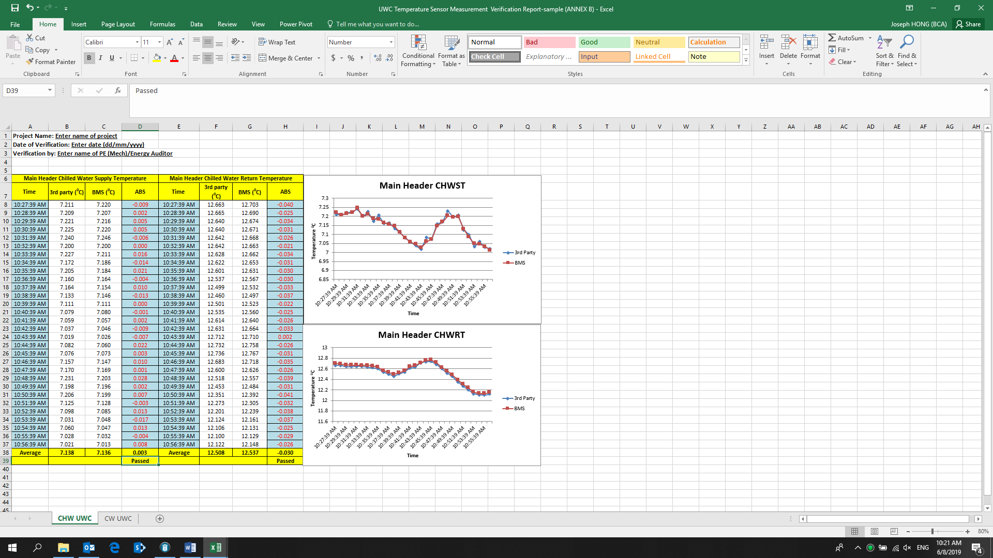 | 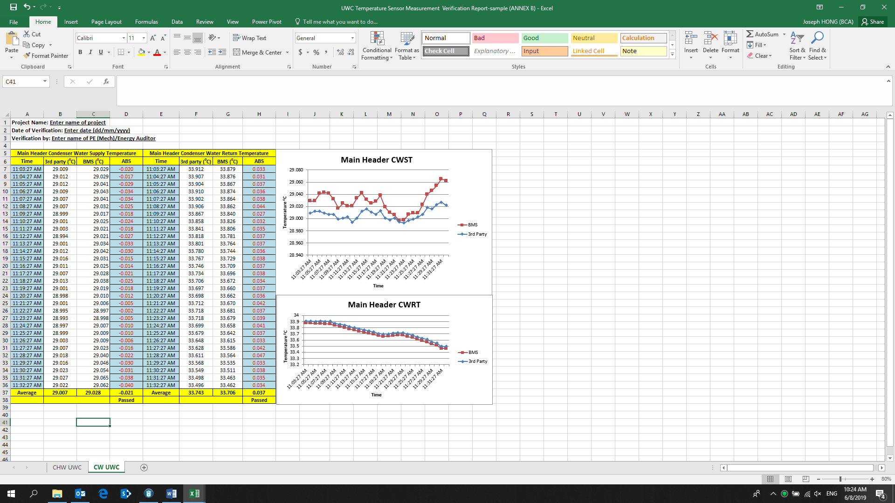
Figure 21: Temperature Verification Plots for Water-Cooled Chiller Plant System (Example)

Table 25: Verification of temperature sensors

APPENDIX C: Supporting documentation in relation to the audit of energy use of buildings and system

S/No. | Supporting documents to be provided | Related Sections under Energy Audit Report
C.1 | Past energy use data:  - Monthly utility bills over the 3 years prior to year of notice  - On-site renewable energy generation over the same period (where relevant) | 2(B) Historical energy use data  2(D) Utility cost for building owner or landlord
C.2 | As-built schematic drawings indicating the location of the major energy-consuming systems:  - Building cooling system  - Unitary air conditioners  - Centralised hot water system (Required, where applicable)  - Mechanical ventilation system for carparks (Required, if in EEIP)  - Lighting system (Required, if in EEIP) | 2(E) Inventory of major energy-consuming systems and equipment
C.3 | Photographic evidence :  - Major energy-consuming systems and equipment  - Areas identified with energy wastage and inefficiencies
C.4 | Energy use records:  - Submetering data or energy consumption measurements for:  - Building cooling system  - Unitary air-conditioners  - Centralised hot water system (where relevant) | 2(F) Breakdown of Energy Consumption by End-use
C.5 | Energy consumption calculations and estimates (where relevant), including the following:  - Equipment specifications and performance data  - Building Management System (BMS) data  - System operating schedules  - Derivation of energy consumption from tenants  - Any other relevant supporting basis | 2(F) Breakdown of Energy Consumption by End-use
Table 26: Supporting documentation in relation to the audit of energy use of buildings and system

APPENDIX D: Supporting documentation in relation to the audit of energy efficiency level of building cooling system
S/No. | Supporting documents to be provided | Related Sections under Energy Audit Report
D.1 | Chilled Water System:  - As-built schematic drawings of the chiller plant configuration.  - As-built drawings of chiller plant room plan layout and locations of the measurement and verification instrumentation.  - Data points in file format that are supported in Excel and to be presented with date and time stamp; chilled water supply temperature (°C); chilled water return temperature (°C); condenser water supply temperature (°C); condenser water return temperature (°C); chilled water flow rate (l/s); condenser water flow rate (l/s); electrical power of chiller(s), chilled water 1 week raw data of the pump(s), condenser water pump(s) and cooling tower(s) (kW). The excel file should include all the chart plots specified in Annex B.  - Instruments’ calibration certificates from the accredited laboratories and their factory calibration certificates from manufacturers.  - Calculation of the overall uncertainty of measurement of the resultant chiller plant in kW/RT to be within ±5% of the true value based on instrumentation specifications and calibration certificates for (a) central chilled water system; and (b) for individual chillers (if the permanent measuring instruments or devices are installed at individual chillers and header/risers).  - Chiller(s) part load performance (at 10% interval from 100% to minimum value) from equipment supplier at operating conditions. | 2(G) Energy Efficiency of Building Cooling System
D.2 | Air Handling and Distribution System:  - As-built schematic drawings of the air distribution system (AHUs / FCUs).  - 1-week raw data of the following data points if trended from BMS/EMS in file format that are supported in Excel and to be presented with date and time stamp: electrical power of air distribution system (kW) (AHUs / FCUs). Refer to ANNEX C for more details of the data points, type of instrumentation, measurement uncertainty, and sampling size and interval. | 2(G) Energy Efficiency of Building Cooling System
D.3 | Unitary Air-conditioning System:  - As-built plan showing the location of the unitary air-conditioners and VRF system  - Records of the energy efficiency data collected from the VRF system’s built-in monitoring tools for a period of 1 week  - Energy Efficiency calculations and estimates (where relevant) including the technical specification or basis. | 2(G) Energy Efficiency of Building Cooling System
Table 27: Supporting documentation in relation to the audit of energy efficiency level of building cooling system

