Date: DD/MM/YYYY

ENERGY AUDIT REPORT
FOR BUILDING COOLING SYSTEM
for
ENTER BUILDING NAME
at
ENTER BUILDING ADDRESS
(BUILDING IMAGE)

Submitted By
Enter name of PE/Energy Auditor
Signature of PE/Energy Auditor
PE (Mech) Registration No*: Enter No.
Energy Auditor Registration No*: Enter No.
*Delete whichever is not applicable

Content
1.0 Executive Summary & Recommendation 5
2.0 Report Applicability and Compliance Route 6
3.0 Building Information 6
4.0 Energy Audit Information for Building Cooling System 7
4.1 Chilled Water Plant Design Information* 8
4.2 Air Distribution System information* 9
4.3 Chilled Water Plant Normal Operating Hours 9
4.4 Description of Plant Control Strategy 10
5.0 Measurement and Instrumentation 12
6.0 Chiller Plant Performance Analysis (1 week data) 13
6.1 Summary of Chilled-Water Plant Operating Performance 22
6.2 Summary of Air Distribution System Operating Performance 23
6.3 Summary of Building Cooling System Operating Performance 24
7.0 Summary of System Heat Balance (Chilled Water Plant) 25
8.0 Space Operating Conditions 26
9.0 AHU Operating Conditions (5 typical units) 27
APPENDIX A: Chilled-Water Plant Operating Best-Practice Checklist 28
APPENDIX B: Temperature Sensor Verification Plot-Worked example 30

Tables
Table 1: Chiller Information (Example) 8
Table 2: Ancillary water-side equipment Information (Example) 8
Table 3: Ancillary air distribution system equipment Information (Example) 9
Table 4: Instrumentation Table (Example) 12
Table 5: Chilled Water Plant Performance Summary (refer to raw data for details) 22
Table 6: Air Distribution System Performance Summary (refer to raw data for details) 23
Table 7: Total Cooling System Efficiency (including air distribution system) 24
Table 8: Heat Balance Summary 26
Table 9: Space Condition Schedule (Example) 26
Table 10: Schedule of AHU Operating Condition (5 Typical Units) 27
Table 11: Checklist of Plant Operating Condition (for best practices) 28
Table 12: EUI Value (where applicable – including Major Energy Use Change submissions) 28
Table 13: Measurement, BMS and Instrument Verification Checks 29
Table 14: Verification of Temperature Sensors (worked example) 31

Figures
Figure 1: Super-imposed plot of 24 hr Cooling Load Profile RT (Example) 13
Figure 2: Histogram of Cooling Load Occurrences (Example) 13
Figure 3: Super-imposed plot of daily chilled water supply/return temperature ºC (Example) 14
Figure 4: Super-imposed plot of daily chilled water temperature difference ºC (Example) 14
Figure 5: Super-imposed plot of daily condenser water supply/return temperature ºC (Example) 15
Figure 6: Super-imposed plot of daily condenser water temperature difference ºC (Example) 15
Figure 7: Super-imposed plot of daily chilled water GPM/RT (Example) 16
Figure 8: Super-imposed plot of daily condenser water GPM/RT (Example) 16
*Figure 9: Cooling Tower Approach Temperature (Example) 17
Figure 10: Super-imposed plot of daily chiller efficiency kW/RT (Example) 17
Figure 11: Super-imposed plot of daily chilled water pump efficiency kW/RT (Example) 18
Figure 12: Super-imposed plot of daily condenser water pump efficiency kW/RT (Example) 18
Figure 13: Super-imposed plot of daily cooling tower efficiency kW/RT (Example) 19
Figure 14: Super-imposed plot of daily chiller plant system efficiency kW/RT (Example) 19
Figure 15: Scatter plot of chiller plant efficiency over cooling load (Example) 20
Figure 16: Scatter plot of chilled water pump efficiency over cooling load (Example) 20
Figure 17: Scatter plot of condenser water pump efficiency over cooling load (Example) 21
Figure 18: Scatter plot of cooling tower efficiency over cooling load (Example) 21
Figure 19: Super-imposed plot of daily total cooling system efficiency kW/RT (Example) 23
Figure 20: System Level Heat Balance Plot (Example) 25
Figure 21: Temperature Verification Plots for Water-Cooled Chiller Plant System (Example) 30

1.0 Executive Summary & Recommendation
(Example)
This report highlights the findings and recommendations obtained from the energy audit performed at Enter Building Name from [Enter Period of Audit] DD/MM/YYYY to DD/MM/YYYY for 24 hrs. For as-built submission, indicate the work done including % of air distribution equipment replaced, where applicable.
Corrective measures taken by PE (Mech)/ Energy Auditor to comply with PEA Notice.
- <Description of findings/ measures>
- <Description of findings/ measures>
- <Description of findings/ measures>

Recommended energy improvement measures for Building Owners :
- <Description of recommendations>
- <Description of recommendations>
- <Description of recommendations>

2.0 Report Applicability and Compliance Route
Complete the fields and sections applicable to the submission purpose. Where the report is used for both Green Mark assessment and ES regulatory submission, complete all applicable requirements.
Submission purpose | ☐ ES regulatory (Ref no._______)  ☐ Green Mark assessment (Ref no._______)
Chilled Water Plant OSE requirement  (Min requirement is stipulated in the PEA notice) | Enter applicable minimum OSE requirement (kW/RT)
Total System Efficiency (TSE) requirement  (Min requirement is stipulated in the PEA notice) or  (Green mark rating requirement) | Enter applicable minimum TSE requirement (kW/RT), where applicable

3.0 Building Information
Enter a brief description of the building here.
Building Name :
Building Owner :
Building Address :
Postal Code :
Building Type :
Building Age :
Date of last Energy Audit Submission :
Gross floor area (GFA), m² :
Air conditioned area, m² :
Number of guest rooms :
(for hotels/service apartments)

4.0 Energy Audit Information for Building Cooling System
This report presents the operating system efficiency (OSE) of the building cooling system based on measurements from permanent instrumentation installed on site. Complete the submission-specific information below for the applicable Green Mark and/or ES regulatory requirements.
Location : Enter location of Chilled Water Plant
Energy Audit Period : Enter Energy Audit period *Note: Min 1 week
Date of notice served : Enter date of notice served by BCA
Date of submission in notice : Enter submission deadline stipulated in BCA notice

Data Logging Interval : 1 minute sampling for one week
Trend Logged Parameters* : Chilled Water Supply main header temperature
Chilled Water Return main header temperature
Chilled Water flow rate at chilled water return main header
Condenser Water Supply main header temperature
Condenser Water Return main header temperature
Condenser water flow rate at condenser water return main header
Power input to Chiller(s)
Power input to Chilled water pump(s)
Power input to Condenser water pump(s)
Power input to Cooling tower(s)
Power input to Pre-AHU(s) / AHU(s) / FCU(s) / air distribution system(s), as applicable
* Trend logged parameters are not limited to the above and may vary depending on the piping and electrical circuit design.

4.1 Chilled Water Plant Design Information*

ID | Description | Brand | Type | Name plate motor (kW) | Total Cooling Capacity (RT) | Chilled water LWT/EWT | Rated  Efficiency  kW/RT | Year Installed | Location
CH01 | Chiller 1 | Brand X | Centrifugal, water-cooled | 162.8 | 300 | 7.5 °C | 0.543 | 2017 | B2 plant room
CH02 | Chiller 2 | Brand X | Centrifugal, water-cooled | 162.8 | 300 | 7.5 °C | 0.543 | 2017 | B2 plant room
CH02 | Chiller3 | Brand X | Centrifugal, water-cooled | 162.8 | 300 | 7.5 °C | 0.543 | 2017 | B2 plant room
Table 1: Chiller Information (Example)

ID | Brand | Type | Name plate motor (kW) | Pump Head  (m) | Flow rate (L/S) | Rated Pump/ Fan efficiency | Rated Motor Efficiency
CHWP 1 | Brand X | end suction | 11 | 23 | 33.65 | 80.0% | 92.4%
CHWP 2 | Brand X | end suction | 11 | 23 | 33.65 | 80.0% | 92.4%
CHWP 3 | Brand X | end suction | 11 | 23 | 33.65 | 80.0% | 92.4%
CWP 1 | Brand Y | end suction | 15.0 | 16.0 | 56.82 | 79.0% | 92.4%
CWP 2 | Brand Y | end suction | 15.0 | 16.0 | 56.82 | 79.0% | 92.4%
CWP 3 | Brand Y | end suction | 15.0 | 16.0 | 56.82 | 79.0% | 92.4%
CT 1 | Brand Z | cross flow | 5.5 x 1 Cell | - | 66.2 | 75% | 86%
CT 2 | Brand Z | cross flow | 5.5 x 1 Cell | - | 66.2 | 75% | 86%
CT 3 | Brand Z | cross flow | 5.5 x 1 Cell | - | 66.2 | 75% | 86%
Table 2: Ancillary water-side equipment Information (Example)
*Based on equipment design specifications and name plate ratings

4.2 Air Distribution System information*
ID | Model (Serial Number) | Type (Centrifugal/ EC Centrifugal/ Axial) | Motor Power (kW) | Input Power  (kW) | Rated Airflow (m³/h) | Ext Static Pressure (Pa) | Total Static Pressure (Pa) | Cooling Capacity (Ton) | Filter Type/ Rating | Outdoor air provision
AHU 1 | Mod Xx | Centrifugal | 3.0 | 2.67 | 6523 | 205 | 768 | 10.2 | Bag/F7 | Direct opening to external/ via PAHU or FAF
AHU 2 | Mod Xx | Centrifugal | 3.0 | 2.67 | 6523 | 205 | 768 | 10.2 | Bag/F7
AHU 3 | Mod Xx | Centrifugal | 3.0 | 2.67 | 6523 | 205 | 768 | 10.2 | Bag/F7
AHU 4 | Mod Xx | Centrifugal | 3.0 | 2.67 | 6523 | 205 | 768 | 10.2 | Bag/F7
AHU 5 | Mod Xx | Centrifugal | 3.0 | 2.67 | 6523 | 205 | 768 | 10.2 | Bag/F7
AHU 6 | Mod Xx | Centrifugal | 3.0 | 2.67 | 6523 | 205 | 768 | 10.2 | Bag/F7
Pre-Cooled AHU 1 | Mod Yx | Centrifugal | 11.0 | 10.8 | 18500 | 705 | 1221 | 42 | Bag/F7
Pre-Cooled AHU 2 | Mod Yx | Centrifugal | 11.0 | 10.8 | 18500 | 705 | 1221 | 42 | Bag/F7
Summation | - | - | - | X | - | - | - | X | -
Table 3: Ancillary air distribution system equipment Information (Example)
*Based on equipment design specifications and name plate ratings

4.3 Chilled Water Plant Normal Operating Hours
Monday to Friday : 1000 – 2100 Hrs
Saturday / Sunday : Enter actual operational hours / No operations
Note: please refer to the operating hours in this table.
Building Type | Operating Hours
Office Building | Monday to Friday: 9a.m. to 6p.m.
Retail Malls | Monday to Sunday: 10a.m. to 9p.m.
Hotels/Hospital | Monday to Sunday: 24 hours
Other buildings | Building specific operating hours

4.4 Description of Plant Control Strategy
Summary of the present plant control strategy adopted for the applicant’s building chiller plant systems’ operation. You may include but not limited to the following:
- Chiller sequencing
Describe how the chiller(s) operate to handle the varying building cooling load
e.g. chiller cut-in/out sequence varying with building load and addressing peak and off peak load based on (supply water temperature, and/or building load, and/or compressor current running load amps) and time delay.
- Chilled water pump (if applicable)
Describe the parameters used to control chilled water pumps
e.g. pump speed modulate based on ((differential) pressure sensor located at chiller header, or remote AHU cooling coil, or several zones of AHU cooling coil, or optimising pump pressure by critical valve control), set-point(s) and bypass valve controls to ensure chillers operate at minimum flow rate
- Condenser water pump (if applicable)
Describe the parameters used to control condenser water pumps
e.g. modulate to maintain condenser water differential temperature set point or gpm/ton and the set-point(s).
- Cooling tower (if applicable)
Describe the parameters used to control cooling towers
e.g. Modulate base on cooling tower approach temperature (difference between CT leaving water temperature and ambient wet-bulb temperature) set point (adjustable), or scheduled cooling tower leaving temperature set point, or dynamic optimized cooling tower leaving water temperature set point and the set-point(s)
- Other optimisation (if applicable)
Describe any other optimisation used
e.g. Chilled water supply temperature reset. At off-peak period, reset based on outdoor air temperature/humidity, or VPF bypass control, or predefined schedule.
(Note: Resetting CHW temperature may incur higher pump power and may compromise on space temperature and relative humidity)
(Example)
Chiller Configuration: <x> unit(s) of <x> RT chiller & <x> unit(s) of <x> RT chiller
Variable Primary Chilled Water System
Variable Condenser Pump

- Chiller sequencing
Scenario for Cut-in: Chilled water supply header temperature is above set point of <x> °C + <deadband> OR total system tonnage is above <x> RT for a period of <x> minutes.
Scenario for Cut-out: Chilled water supply header temperature is below set point of <x> °C + <deadband> AND total system tonnage is below <x> RT for a period of <x> minutes.
Time delay: Whenever any chiller cuts-in/out, there is <x> minutes delay to allow system to stabilize.

- Chilled water pump (CHWP)
Primary CHWP speed is modulated to maintain a differential pressure set point of <x> psi + <deadband>. Differential pressure sensors are installed at chilled water pipe headers. CHWP speed is limited to <x> Hz to ensure chillers running at minimum flow. When CHWP speed ramps down to minimum and differential pressure rises above set point, the bypass valve will open to maintain DP set point and minimum flow rate.

- Condenser water pump (CWP) <fixed/variable>
Minimum running speed of CWP is <x> Hz. When condenser flow rate is reduced to set point of <x> l/s or <x> gpm/ton, CWP speed would be increased and vice versa.

- Cooling Tower (CT)
CT fan speed is modulated to maintain leaving condenser water temperature set point of <x> °C which is equal to outdoor air wet-bulb temp plus <x> °C. When chiller(s) is in operation, all CTs would be turn on. When CT leaving water temperature falls below the set point, CT fan speed would be decreased until minimum speed of <x> Hz.

- Other Optimisation
Chilled water temperature set point is reset to <x> °C during off-peak period from 2000hrs to 0800hrs.

5.0 Measurement and Instrumentation
Accurate measuring instruments complying with the applicable prevailing requirements were used during the audit to gather information on power consumption including air distribution system, temperatures and flow rate. Include the measurement / calibration range, measurement uncertainty, last calibration date and calibration laboratory for each instrument.
The points of measurements are listed in the following table:
ID / Serial No. | Brand | Sensor Type | Installation Location | Measurement Uncertainty (%) | Last Calibration Date | Calibration Laboratory
EP80367 | Brand X | 10K Ω Thermistor | CHWS Header | ±0.03 °C | 09/05/2026 | XX laboratory
EP80364 | Brand X | 10K Ω Thermistor | CHWR Header | ±0.03 °C | 09/05/2026 | XX laboratory
EP80361 | Brand X | 10K Ω Thermistor | CWS Header | ±0.03 °C | 09/05/2026 | XX laboratory
EP80363 | Brand X | 10K Ω Thermistor | CWR Header | ±0.03 °C | 09/05/2026 | XX laboratory
3k67201343004 | Brand X | Magnetic Full Bore | CHWR Header | 0.5% | 29/10/2025 | factory calibration
3k67201418063 | Brand X | Magnetic Full Bore | CWR Header | 0.5% | 09/05/2026 | factory calibration
38498 | Brand X | True RMS, 3 phase | MSB Incoming 1 | 0.5% | 08/07/2026 | factory calibration
1402404 | Brand X | True RMS, 3 phase | MSB Incoming 2 | 0.5% | 08/07/2026 | factory calibration
38491 | Brand X | True RMS, 3 phase | CH/6-1 | 0.5% | 08/07/2026 | factory calibration
38487 | Brand X | True RMS, 3 phase | CHP/6-1 | 0.5% | 08/07/2026 | factory calibration
38490 | Brand X | True RMS, 3 phase | CWP/6-1 | 0.5% | 08/07/2026 | factory calibration
38499 | Brand X | True RMS, 3 phase | CT/6-1 | 0.5% | 08/07/2026 | factory calibration
38497 | Brand X | True RMS, 3 phase | CH/6-2 | 0.5% | 08/07/2026 | factory calibration
38483 | Brand X | True RMS, 3 phase | CHP/6-2 | 0.5% | 08/07/2026 | factory calibration
1402325 | Brand X | True RMS, 3 phase | CWP/6-2 | 0.5% | 08/07/2026 | factory calibration
38572 | Brand X | True RMS, 3 phase | CT/6-2 | 0.5% | 08/07/2026 | factory calibration
1402399 | Brand X | True RMS, 3 phase | CH/6-3 | 0.5% | 08/07/2026 | factory calibration
38574 | Brand X | True RMS, 3 phase | CHP/6-3 | 0.5% | 08/07/2026 | factory calibration
38485 | Brand X | True RMS, 3 phase | CWP/6-3 | 0.5% | 08/07/2026 | factory calibration
38486 | Brand X | True RMS, 3 phase | CT/6-3 | 0.5% | 08/07/2026 | factory calibration
Table 4: Instrumentation Table (Example)

6.0 Chiller Plant Performance Analysis (1 week data)

Ave (10am-9pm) = 799RT
Figure 1: Super-imposed plot of 24 hr Cooling Load Profile RT (Example)

Figure 2: Histogram of Cooling Load Occurrences (Example)

Ave (10am-9pm) = 7.5 ºC
Ave (10am-9pm) = 12.9 ºC
Figure 3: Super-imposed plot of daily chilled water supply/return temperature ºC (Example)

Ave (10am-9pm) = 5.4 ºC
Figure 4: Super-imposed plot of daily chilled water temperature difference ºC (Example)

Ave (10am-9pm) = 35.6 ºC
Ave (10am-9pm) = 29.6 ºC
Figure 5: Super-imposed plot of daily condenser water supply/return temperature ºC (Example)

Ave (10am-9pm) = 6.05 ºC
Figure 6: Super-imposed plot of daily condenser water temperature difference ºC (Example)

Ave (10am-9pm) = 2.59
Figure 7: Super-imposed plot of daily chilled water GPM/RT (Example)

Ave (10am-9pm) = 2.9
Figure 8: Super-imposed plot of daily condenser water GPM/RT (Example)

*Figure 9: Cooling Tower Approach Temperature (Example)
*required if using wet bulb temperature as set point

⁺Weighted Ave (10am-9pm) = 0.520
Figure 10: Super-imposed plot of daily chiller efficiency kW/RT (Example)
⁺Weighted average: ∑ kW-hr / ∑ RT-hr
⁺Weighted Ave (10am-9pm) = 0.037
Figure 11: Super-imposed plot of daily chilled water pump efficiency kW/RT (Example)

⁺Weighted Ave (10am-9pm) = 0.031
Figure 12: Super-imposed plot of daily condenser water pump efficiency kW/RT (Example)

⁺Weighted Ave (10am-9pm) = 0.038
Figure 13: Super-imposed plot of daily cooling tower efficiency kW/RT (Example)

⁺Weighted Ave (10am-9pm) = 0.626
Figure 14: Super-imposed plot of daily chiller plant system efficiency kW/RT (Example)

Figure 15: Scatter plot of chiller plant efficiency over cooling load (Example)

Figure 16: Scatter plot of chilled water pump efficiency over cooling load (Example)

Figure 17: Scatter plot of condenser water pump efficiency over cooling load (Example)

Figure 18: Scatter plot of cooling tower efficiency over cooling load (Example)

6.1 Summary of Chilled-Water Plant Operating Performance
Daily Average Reading | Period |  | Unit
Daily Average Reading | Daytime^ | Night-time~ | Unit
Cooling Load |  |  | RTh
Cooling Load Density (Air-con area) |  |  | m²/RT
Power Consumption |  |  | kWh
Chilled water supply temperature |  |  | ºC
Chilled water return temperature |  |  | ºC
Chilled water delta T |  |  | ºC
Chilled water flow rate |  |  | l/s
Chilled water flow rate vs cooling load |  |  | USgpm/RT
*Condenser heat rejection |  |  | HRT
*Condenser water supply temperature |  |  | ºC
*Condenser water return temperature |  |  | ºC
*Condenser water delta T |  |  | ºC
*Condenser water flow rate |  |  | l/s
*Condenser water flow rate vs cooling load |  |  | USgpm/RT
Chiller(s) efficiency |  |  | kW/RT
Chilled water pump(s) efficiency |  |  | kW/RT
*Condenser water pump(s) efficiency |  |  | kW/RT
*Cooling tower(s) efficiency |  |  | kW/RT
Overall chiller plant efficiency |  |  | kW/RT
Table 5: Chilled Water Plant Performance Summary (refer to raw data for details)
* The data in relation condenser pumps and cooling towers will not be applicable for air-cooled chilled water system.
~For hotels and other developments with 24-hour operations only; Night-time shall refer to the period from 11pm – 7am;
^ For hotels and other developments with 24-hour operations, day-time shall refer to the period from 7am – 11pm; for all other developments, daytime shall refer to the normal operating hours as stated in 3.3 Chilled Water Plant Normal Operating Hours.

6.2 Summary of Air Distribution System Operating Performance
Daily Average Reading | Period |  | Unit
Daily Average Reading | Daytime^ | Night-time~ | Unit
Air distribution system power consumption (a) |  |  | kWh
- Pre-AHU (measured) |  |  | kWh
- AHU (measured) |  |  | kWh
- FCU (nameplate or input power x op hrs) |  |  | kWh
Chiller plant cooling load (b) |  |  | RTh
Overall air distribution system efficiency (a / b) |  |  | kW/RT
Table 6: Air Distribution System Performance Summary (refer to raw data for details)

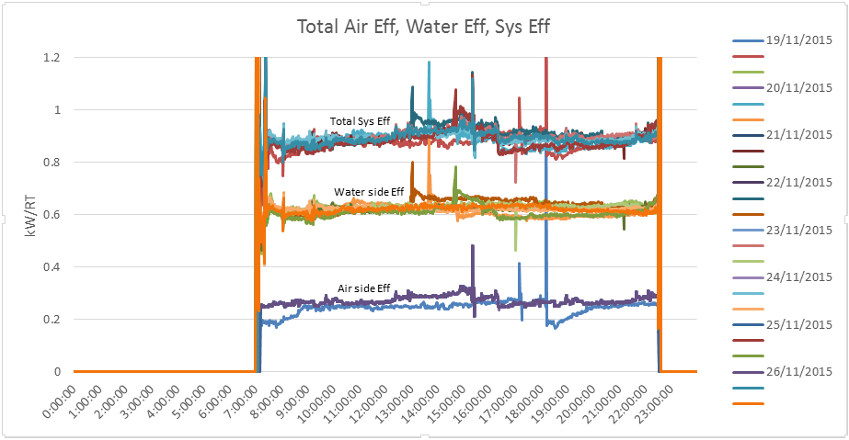
Figure 19: Super-imposed plot of daily total cooling system efficiency kW/RT (Example)

6.3 Summary of Building Cooling System Operating Performance

Daily Average reading | Period |  | Unit
Daily Average reading | Daytime^ | Night-time~ | Unit
Overall air distribution system efficiency |  |  | kW/RT
Overall Chilled Water Plant/AC System efficiency |  |  | kW/RT
Total System Efficiency (TSE) of Building Cooling System |  |  | kW/RT
Table 7: Total Cooling System Efficiency (including air distribution system)

7.0 Summary of System Heat Balance (Chilled Water Plant)

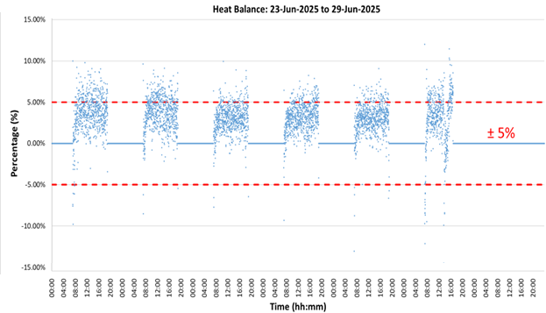
± 5%
Figure 20: System Level Heat Balance Plot (Example)
Parameters | Quantity | Unit | Formula
Sum of total electrical energy used |  | kWh | (A)
Sum of total cooling produced |  | RTh | (B)
Sum of total heat rejected |  | RTh | (C)
Chiller Plant Efficiency |  | kW/RT | (A) / (B)
Total Heat Balance Data Count |  | - | (D)
Data Count > + 5% error |  | - | (E)
Data Count < - 5% error |  | - | (F)
Data Count within ±5% error |  | - | (G) = (D) – (E) – (F)
% Heat Balance within ±5% error |  | % | 100 x (G) / (D)
Table 8: Heat Balance Summary

8.0 Space Operating Conditions
(Minimum of 10 points Spot measurements)
S/No | Room name  (i.e. Air conditioned occupied/ common Spaces) | Normal operating room conditions |  | Measured
S/No | Room name  (i.e. Air conditioned occupied/ common Spaces) | Dry Bulb Temperature (ºC) | Relative Humidity (%) | *Dry Bulb Temperature (ºC) | *Relative Humidity (%) | *CO2 Concentration (ppm)
1 | i.e. Office 1
2 | i.e. Office 2
3 | i.e. Meeting Room 1
4 | i.e. Meeting Room 2
5
6
7
8
9
10
Table 9: Space Condition Schedule (Example)
* Any observation on over-cooling/ under-cooling and ventilating of space conditions should first be investigated and corrected before the energy audit is carry out. Refer to recommended limits of SS553 and SS 554.

9.0 AHU Operating Conditions (5 typical units)
(Spot Measurements)
AHU no. | Parameters | Pre-Cooled AHU #1 | Pre-Cooled AHU #2 | AHU #1 | AHU #2 | AHU #3
1 | Return Air Temp Setpoint (ºC) | - | -
2 | Return Air Temp (ºC) | - | -
3 | Supply Air Temp Setpoint ( ºC) | - | -
4 | Supply Air Temp (ºC)
5 | Fan Speed Setpoint (Hz/%)
6 | Fan Speed (Hz /%)
7 | Rated (kW)
8 | Running (kW)
9 | Nameplate Airflow (CMH) | - | -
10 | Nameplate W/CMH | - | -
11 | CO₂ Setpoint (ppm) | - | -
12 | CO₂ (ppm)
13 | Outdoor Air Damper Opening (%)
14 | Outdoor Air Provision (Direct opening to external/ via PAHU or FAF)
15 | Filter Type/ Rating (Bag/ F7)
Table 10: Schedule of AHU Operating Condition (5 Typical Units)

APPENDIX A: Chilled-Water Plant Operating Best-Practice Checklist
Best Practices | Yes | No | Actual value
Is the air distribution system efficiency ≤ 0.20 kW/RT?
Is Chilled water delta T >5.5 ºC?
Is the cooling tower approach temperature ≤ 2.0 ºC as compared with outdoor wet bulb temperature?
Is the Chilled water pump efficiency ≤ 0.03 kW/RT?
Is the Condenser water pump efficiency ≤ 0.035 kW/RT?
Is the Cooling Tower efficiency ≤ 0.03 kW/RT?
Is Refrigerant Condenser approach ≤1.5 ºC?
Is Refrigerant Evaporator approach ≤ 1.5 ºC?
Table 11: Checklist of Plant Operating Condition (for best practices)

For Design/As-built submission for Major Energy Use Change only
Parameter | Before Retrofit | After Retrofit* | Remark
EUI  (kWh/m²/yr) |  |  | XX% Office  XX% Retail  XX% Hotel
* Estimated value during design stage. Measured value at operation stage.
Supporting documentation on computation to be provided.
Table 12: EUI Value (where applicable – including Major Energy Use Change submissions)

Checks and photographic evidence
BMS Check  - Temperature sensors’ ABC coefficient constants input as reflected in the calibration certificate | ☐
Power Meter (Consistency Check)  - Check power meter and BMS readings are the same  - Check power meter reading and chiller panel or pump VSD display reading is ≤ 3%  - Check current transformer ratio tally with power meter setting | ☐  ☐  ☐
Flow Meter  - Check the sum of branch flowmeters matches with header flow meter header readings (if flow meters exist at header and individual chillers)  - Check flow meters and BMS readings are the same  - Check flow meters do not have any correction factor or offset factor input | ☐  ☐  ☐
Verified Temperature Sensor Accuracy  - Use calibrated reference temperature sensor with end-to-end uncertainty of ≤ 0.05 ºC  - Synchronise the reference temperature sensor device timing with BMS  - Collect at least 20 sets of readings from reference temperature sensor device (after insertion to the available test plug) and BMS  - Compare the difference between both set of readings, with average of absolute difference to be ≤ 0.07 ºC  - Temperature verification data and plots are to be provided (see example in Appendix B) | ☐  ☐  ☐  ☐  ☐
Photographic Evidence
BMS Screenshot of chilled water plant
[attach photo here]
Current Transformer Ratio for chillers in chiller power meter and specifications
[attach photo here]
Flow meter correction factor setting shown in flow meter display unit
[attach photo here]
Temperature sensors coefficient setting shown in BMS configuration and calibration cert
[attach photo here]
Table 13: Measurement, BMS and Instrument Verification Checks

APPENDIX B: Temperature Sensor Verification Plot-Worked example

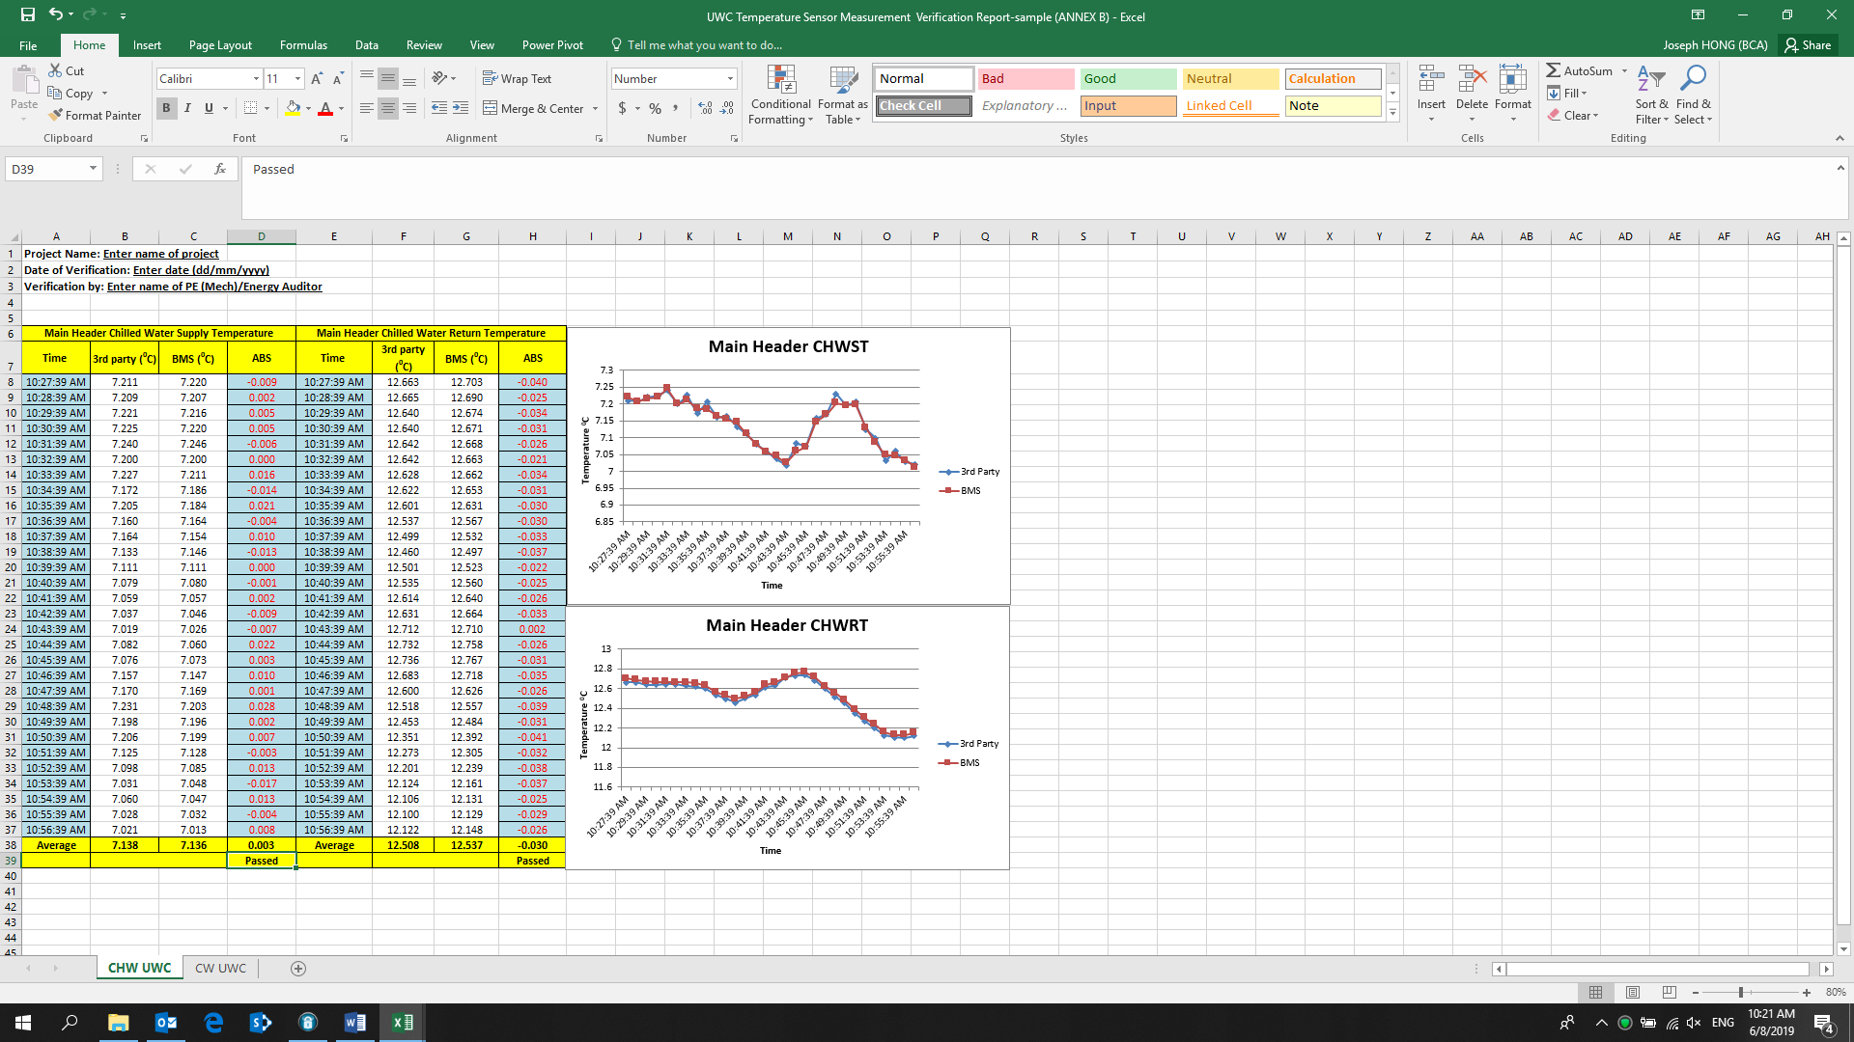 | 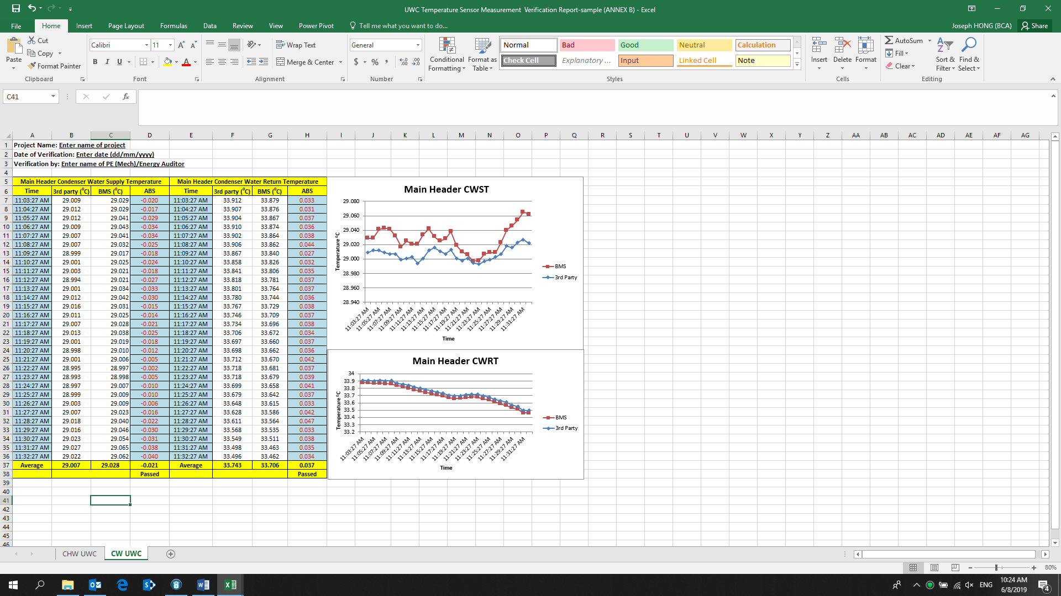
Figure 21: Temperature Verification Plots for Water-Cooled Chiller Plant System (Example)

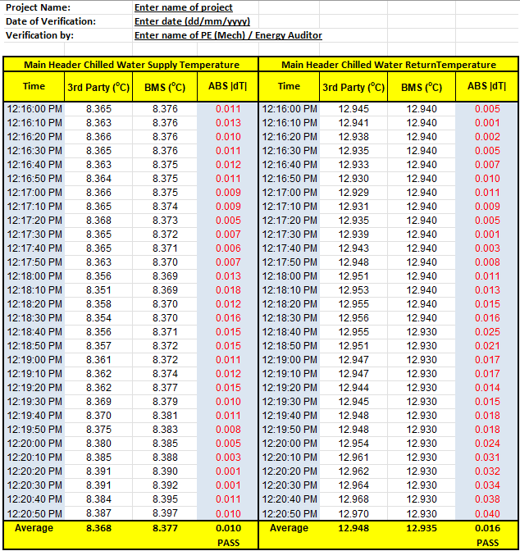

Table 14: Verification of Temperature Sensors (worked example)

