
go.gov.sg/otg

Frequently Asked Questions
To view answers, click on the arrow at the start of the question

Updated Apr 2023

General

Why is PSD introducing One Talent Gateway (OTG) across the Public Service?

OTG is a platform which supports and catalyses your growth and development. OTG:
- Allows you to identify and assess your skills and chart your career journey.
- Recommends relevant training and development opportunities for you.
- Provides assessment and tools to support your growth, including starting your own gigs, seeking out kakis and many more.

How can I use OTG for my growth and development?

Based on your profile, you can receive personalised recommendations on developmental opportunities that address identified competency growth areas and career goals. You can:
- Find Short-term Immersion Programme (STiP) and Gig projects that enable experiential learning. Find out more about STIPs and gigs here.
- Find relevant training courses from the Civil Service College and The Digital Academy to start.
- Connect with other officers for social learning opportunities (Connect with a Kaki feature).
- Self-initiate social learning opportunities by initiating a gig project.
- Validate your competency self-assessment by requesting feedback from your supervisors and/or peers.

How is OTG different from Careers@Gov?

Careers@Gov is a job portal that shows the job vacancies within Public Service and is available to all public jobseekers. Job seekers may apply for available jobs via Careers@Gov.

OTG is a Whole-of-Government (WOG) internal talent marketplace accessible only by existing public officers. It is primarily intended to equip and empower you to chart your own growth and development in the Public Service. You can build your competency profile and receive recommendations on relevant developmental opportunities such as attachments, gig work and training courses; hence, OTG is not only for officers looking to change jobs. Should you wish to apply for any jobs in the Public Service, you should continue to submit your application via Careers@Gov.

How is OTG different from my agency’s HR system (e.g. HRPS, Workday, ACE)?

OTG is a WOG internal talent marketplace platform meant to support your growth and development. It allows you to profile your competencies, receive feedback, explore different career pathways, and receive personalised recommendations on developmental opportunities. The ratings and feedback on OTG provide you with a more comprehensive picture of your competencies to help you better understand and grow your skills.

Performance management and other HR processes will continue to be conducted via your agency’s respective HR system.

I already am active on LinkedIn. Why should I still use OTG?

LinkedIn is a great tool for anyone seeking to build their professional network.

OTG is meant to be a career buddy and companion accessible only by public officers to complement your efforts to build your professional network and visibility across the Public Service. It provides a more curated and personalised set of developmental recommendations available within the Public Service based on your competency gaps. It also considers your preferences and interests to help you realise your career aspirations in the Public Service.

Can I link my LinkedIn account to OTG? How can I do so?

You can upload your LinkedIn profile onto OTG. This will help you develop a more comprehensive personal profile and increase the accuracy of recommendations on developmental opportunities.

To do so, you can export Competencies from LinkedIn as a PDF and upload it via the “Upload CV” button available on the “Competencies” tab under the profile page. See screenshot below.
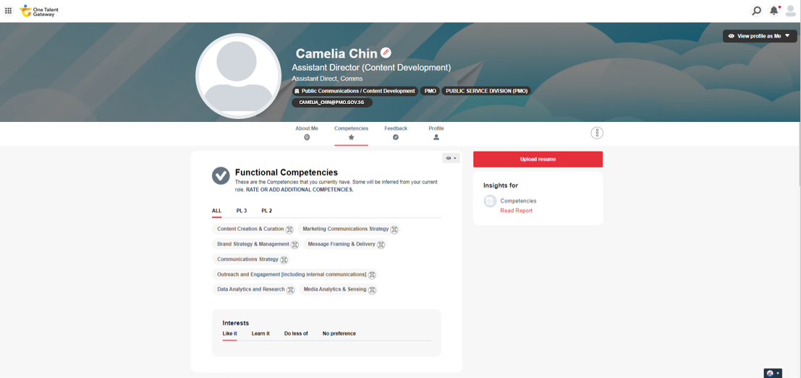

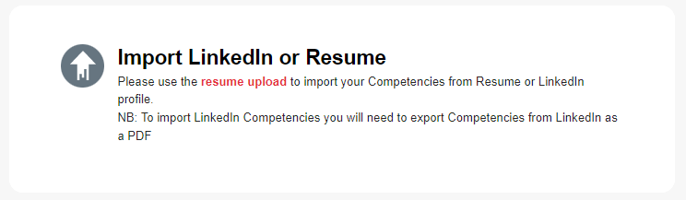

I heard of OTG from my other colleagues (from other job families) but nobody has reached out to me to use OTG. Why is this so? When can I use OTG?

Job families are being progressively onboarded to OTG in waves between 2022 and 2023. Your job family may have been scheduled to be onboarded in a subsequent wave. You will be notified via email once your OTG account has been created and is ready for use.

Do I need Internet access for OTG?

As we are just piloting OTG, it is currently only available on the Internet (we will explore making it available via mobile app in later phases). For a better experience, we strongly recommend that you use an Internet enabled laptop or tablet. Follow the guide below for a smooth login process onto OTG.

- If you are not a S-User (i.e. you do not use a black card to access your work laptop; you are able to use the internet on your work laptop):

You do not have to download Microsoft Authenticator (MFA) for 2FA authentication if you are accessing OTG via your GSIB laptop. Once OTG goes live, you will be able to access the platform directly via an URL.

However, if you foresee yourself accessing OTG via your mobile device in the future, please follow the guide below to install MFA for 2FA authentication before you can log onto OTG on your internet-enabled devices.

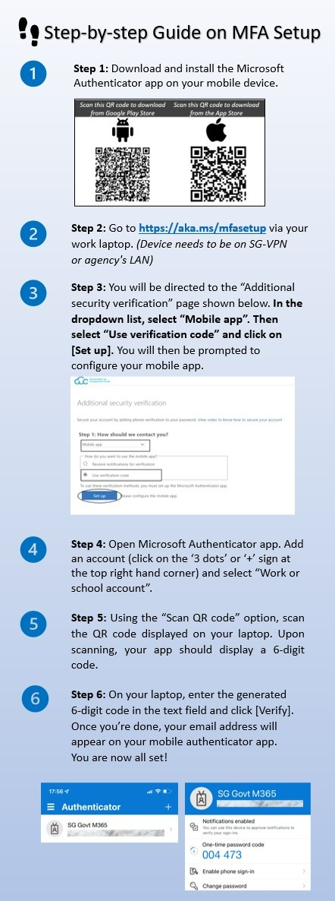
- If you are a S-User (i.e. you use a black card to access your work laptop; you are not able to use the internet on your work laptop) and have downloaded the “Microsoft Authenticator” app before:

You should see SG Govt M365 and your current work email reflected at the top.
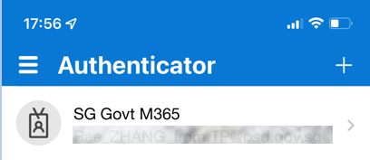

  - Do you still have the “Microsoft Authenticator” app available on your mobile device?

    - If yes, you are all ready to start using OTG. You will be able to access OTG directly via an URL.
    - If no, please contact your IT helpdesk to assist you with the resetting of your MFA before proceeding with the MFA setup. You may refer to the diagram above.

- If you are a S-User (i.e. you use a black card to access your work laptop; you are not able to use the internet on your work laptop) and have not downloaded the “Microsoft Authenticator” app before:

You will need to install MFA on your mobile device for 2FA authentication before you can log onto OTG on your internet-enabled devices.

Privacy

Is the information on OTG private? Will my Reporting Officer and Agency know what I have posted or signed up for?

Profile: You can control access to your profile by adjusting the privacy setting on each tab under your profile. See screenshot below.
  - Selecting Public means anyone on OTG can see that information.
  - Selecting Supervisors means only your direct supervisor can see it.
  - Selecting Kaki means only your Kaki(s) can see it

You are encouraged to provide your supervisors and/or Kakis access to view your profile information so that they can better support your growth and development.
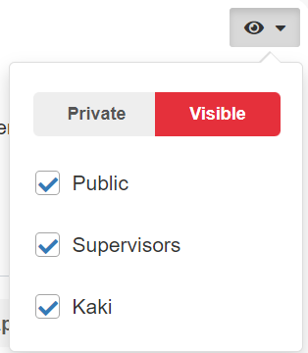

Opportunities:
- As an applicant: Only the opportunity owner will be able to see what you have applied for.
- As an owner: Your opportunity will be made available to all public officers who have access to OTG and everyone can see it.

Why is the default privacy setting for most features set as visible to Public, Supervisors and Kaki?

In the spirit of building connections and promoting visibility of officers, OTG allows the community to view each other’s profiles. Features like Kakis and Opportunities work better when data like competencies are open. Personal info like Feedback are private by default. You can also switch certain fields to private if you wish. So do not worry!

Account Related

How do I create an account on OTG?

You do not need to create an account on OTG. You will be notified via email when your account has been created by PSD and is ready for use.

How often do I need to go into my OTG account? Will my account be disabled if I stop accessing it?

Your OTG account will not be disabled, even if you do not access it for a while. However, you are highly encouraged to regularly log into OTG to browse the available developmental opportunities and update your competencies, skills, and achievements.

I did not receive notification email that my OTG account have been created, but my colleagues have received theirs. What should I do?

Do check if the notification email is in your email junk box. You can also try to access OTG via the following URL: https://go.gov.sg/otg. If you still face issues accessing OTG, you may contact our Technical Support at afm_ncs_servicedesk@support.gov.sg.

I was not able to login into my OTG account using the links/ information provided in the welcome email. What should I do?

Please contact your IT helpdesk and/or email afm_ncs_servicedesk@support.gov.sg and provide screenshots of any error messages you received (if any).

Setting Up Your Profile

Why is it important to set up my profile?

Setting up and completing your profile allows OTG to better recommend career pathways, developmental opportunities and suitable courses that would be personalised to you and address your career competencies, interests, and values.

If you do not update your profile, the competencies and corresponding proficiency levels that appears on your profile will be based on the general role profile you have been tagged to. Based on your job grade and job function, these pre-populated competencies and proficiency levels provide a sense of what an officer in that job role is typically expected to possess. To better reflect your current competencies and skills as well as your career interests and goals, you are strongly encouraged to update your profile. Updating your profile will enhance your chances to be connected to the relevant opportunities.

How often should I update my profile?

It is recommended that you re-assess your Core and Functional Competency proficiency levels ratings and add new competencies whenever you strengthen existing skills and/or gain new ones. You should also update your qualifications as you achieve them and ensure your “About Me” insights remain current.

Why is my profile ‘empty’ (e.g. functional competencies are not pre-populated)?

The OTG profile for most officers will include pre-populated competencies and corresponding proficiency levels based on the general role profile that officers have been tagged to. Based on the job grade and job function, these pre-populated competencies and proficiency levels provides a sense of what an officer in that job role is typically expected to possess.

If you do not see any pre-populated competencies, there may be incomplete information (e.g. missing job grade/ job function) in your agency HR system that resulted in you not being tagged to a generic role profile on OTG. In this case, you may select a suitable role yourself by clicking on the pencil icon beside your name. See screenshots below.

Click on the pencil icon to edit the role profile you have been pre-tagged to or add your own role profile
This is the role profile that you have been pre-tagged to base on your job function/job grade.

How do I make information on my profile private? What is the difference between “Me,” “Supervisor”, and “Public” profile view settings?

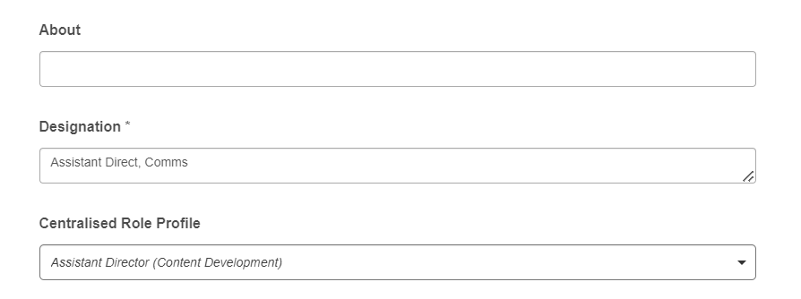
This is a drop-down field for you to select your own role profile/ switch to another role profile.

You can change the visibility settings for many of your career insights and preferences data at any time. Simply click on the “eye” icon below and select the user groups to which you would like to give or remove visibility.

These options allow you to view your profile through different user personas. Viewing your profile as your Kaki, Supervisor, or Public will show you what the respective group(s) can see when they view your profile on OTG. This allows you to verify and check that your privacy settings are accurate.
- Selecting Public means anyone on OTG can see that information.
- Selecting Supervisors means only your direct supervisor can see it.
- Selecting Kaki means only your Kaki(s) can see it.

Note: Most information will be set as visible to “Public” other than feedback, which is set as “Private” by default.

Personal Information

My personal information (e.g. name) is wrongly reflected on OTG but I cannot correct it. What should I do?

For personal information pulled from your agency’s HR management system, most of the fields are non-editable except for your agency-specific job designation and the general role profile that you have been tagged to.

For non-editable fields, please approach your agency’s HR to edit your information on your HR management system. After the information has been edited on the HR management system, it can take up to 3 weeks for the information to be updated and refreshed on OTG.

You may amend your designation and role by clicking on the pencil icon beside your name. See screenshot below.

Designation

Why is my pre-populated designation different from what I am using in my current agency? How can I change it?

Your pre-populated designation was imported from your agency’s HR management system and it may not be the most updated designation in use due to some system limitations and/or data availability.

If your current designation is not reflected properly, you can edit the information by clicking on the pencil icon beside your name and input your designation under ‘Designation*’.

CENTRAL ROLE PROFILE
DESIGNATION

Competencies

The competencies tagged to my profile are different from what my agency has communicated to me. Why is there a difference and should I update my profile with what my agency has tagged for me?

The pre-populated competencies and corresponding proficiency levels in your profile are based on role profiles derived from the WOG functional competency frameworks (including Our Core Competencies). Based on your job grade and job function, the pre-populated competencies and proficiency levels provide a sense of what an officer in that job role is typically expected to possess. Hence, the pre-populated competencies on OTG could be different from what your agency has communicated (e.g., your agency has yet to fully align with WOG competency frameworks and/or job role has agency-specific requirements).

You are strongly encouraged to update your pre-populated personal profile (e.g., remove competencies that are not applicable, adjust proficiency levels based on your self-assessment) for more accurate platform recommendations. You may also add on additional competencies manually or by uploading a CV, Resume or LinkedIn profile.

Why can’t OTG just pull my competency ratings from my agency’s HR system?

We are working towards integrating competency ratings in HR systems into OTG in the longer term. As OTG is primarily meant to be a growth and development career buddy for officers, you are strongly encouraged to update your competency ratings as you pick up new skills or deepen existing competencies in your career journey.

You can also seek feedback from your peers and supervisors on OTG at any time throughout the year. A combination of self-assessed, peer assessed and supervisor assessed competency ratings on OTG may provide a more comprehensive view of your competency profile that can supplement and complement what is available in your agency’s HR system.

Are the competencies and their corresponding ratings validated by anyone or are these based on self-declaration?

The pre-populated competencies and corresponding proficiency levels in your profile come from role profiles derived from the WOG functional competency frameworks (including Our Core Competencies). You are tagged to a general role profile based on your job grade and job function, with the pre-populated competencies and proficiency levels providing a sense of what an officer in that job role is typically expected to possess.

You are strongly encouraged to add/remove competencies and self-asses your proficiency level for each competency to better reflect your current skills. You can then invite your peers and supervisor to validate your competencies on OTG too.

Personalisation Features

How important is it to complete the personalisation exercises? How will the data be used by the OTG?

The data collected from your personalisation exercise will be used to recommend suitable developmental opportunities for you.
- “Assessed Competencies” is used when suggesting roles that might be a good fit for you and recommending competencies to prioritise for development based on your roles of interest.
- Additional indicators such as “I’d like to advance it” influences suggested developmental goals and learning content.
- The “Fit Exercise” is taken into consideration when calculating your % match to a suggested role based on inputs regarding the type of work most naturally engaging and of interest to you.

I do not have an updated CV to upload on OTG; how does it affect my experience on OTG?

The pre-populated competencies and corresponding proficiency levels in your personal profile come from role profiles derived from WOG functional competency frameworks (including Our Core Competencies). Based on your current job grade and job function, the pre-populated competencies and proficiency levels provide a sense of what an officer in that job role is typically expected to possess.

However, you may have also acquired additional competencies in previous job roles that you may like to assess and reflect on your profile. The “Resume Uploader” feature allows you to upload your resume and OTG will extract these competencies. See screenshot below. You can then complete a self-assessment of your proficiency rating for each of the competencies.

A more comprehensive competency profile improves the likelihood that you may be matched to more job roles and developmental opportunities. If you do not have an updated CV, you may also manually add competencies by clicking on the “Rate or Add Additional Competencies”. See screenshot below.

Do my self-assessment ratings on OTG have to correspond to my ratings in my most recent appraisal cycle? What happens if they do not?

Your self-assessment ratings on OTG do not need to correspond with your ratings in the most recent appraisal cycle.

OTG is a tool to help with your career development and growth and you are encouraged to regularly update your self-assessed ratings, which can change according to the types of developmental opportunities you take up and your work portfolio which can shift across the years.

The self-assessed competency ratings on OTG will not be used for R&P by your agency. However, we encourage you to share your competency ratings and participation in developmental opportunities via OTG with your supervisors during developmental and appraisal conversations as additional data points for consideration.

Career Journey

What is the “career journey” feature about? How does it benefit me?

OTG recommends career pathways, and helps you understand what your competencies gaps are relative to your aspired role(s) and what actions you can take to close the gaps.

If you are unsure of possible career pathways for yourself based on your competency profile, OTG provides starting recommendations for your reference. You are encouraged to share them with your supervisor and/or career coach where relevant, for more in-depth discussion on what is most appropriate for you.

How does OTG determine the recommended steps to my aspired role(s)?

OTG considers the competency gaps between your current role vis-à-vis your aspired role(s) and assesses the extent of upskilling needed to acquire all the competencies of the aspired role(s). The number of recommended steps depends on the competency gaps between your current and aspired role, with OTG recommending a career path with the least amount of upskilling required for your aspired role.

Why do the recommended career pathways appear ‘unrealistic’ or ‘surprising’ at times?

The recommended career pathways in OTG provide a range of options and references that you may take into consideration when exploring different career pathways. These pathways do not factor in agency-specific requirements as they cater to officers across Whole-of-Government. You are strongly encouraged to complete your profile and assess your competencies for sharper recommendations and to discuss these various options with your supervisor. You are advised to additionally refer to specific role requirements of actual job vacancies when assessing your readiness for a career move.

Why do the recommended steps not represent actual job opportunities? How can I find actual jobs based on the recommended steps?

OTG recommends possible job roles to provide you potential career pathways to your aspired role(s). Actual job opportunities are dependent on availability and vacancies and there may be multiple similar roles across Public Service. We are working on including this as part of the suite of OTG enhancements. In the meantime, you may refer to job opportunities via Careers@Gov that are similar to the recommended steps on the OTG-recommended career paths.

If the AI recommendation indicates a high % match for the next larger role for me, can it be used as justification of my promotion readiness?

OTG is primarily meant as a career development tool for you to access more targeted developmental opportunities for your growth and development. You are encouraged to share your competency ratings and participation in developmental opportunities via OTG with your supervisors during developmental and appraisal conversations as additional data points for consideration. However, promotion readiness continues to be based on “best man for the job”, and considers other critical factors such as work outcomes and availability of roles.

I would like to try out career paths outside of my current job families. How can OTG help me in this case?

OTG will be able to recommend suitable career pathways outside of your current job family based on your interests and competencies. You can also manually select your aspired role outside of your current job family.

As more job families will be progressively onboarded to OTG over the next 2-3 years, do access OTG regularly to stay updated on the latest job roles and developmental opportunities available.

What if I am interested and/or someone reached out to me to find out more about a role that was recommended by OTG, are there any guidelines that I should adhere to?

 | Dos | Don’ts
Scenario 1  - Officer is keen to explore a role recommendation on career journey - officer reaches out to incumbent sitting in the role / Kaki to find out more | Kaki/ Incumbent  - Share openly about the nature of the job, expectations, possible challenges and recommendations on how to ready oneself for the role (aim: to give mentee/ officer a grounded sense of the role)  Officer  - May apply for the role/ gig directly; officers are strongly encouraged to keep RO informed early on in the process. | Kaki/ Incumbent  - Try to convince officer/ mentee to leave current role  - Submit officer’s name to HR directly. Officer should apply for role through the official channel
Scenario 2  - Kaki is approached by an officer for a potential role referral | Kaki/ Incumbent  - Accede to request only if personally comfortable based on how well they know mentee/ officer (i.e. there is no obligation to do so)

Applying &/or Putting Up Opportunities

What is the feature on “applying and putting up opportunities” about? How does it benefit me?

The feature allows you to apply for opportunities (i.e., Short-term Immersion Programmes (STIPs) or Gig projects) that are available within the Public Service or to put up opportunities for other officers to join. Find out more about STIPs and Gigs here.
- Applying for Opportunity: You can deepen your competencies by applying them in a different context and gaining professional visibility outside of your parent agency. Upon completion of the opportunity, you should request for feedback from the host for your development.
- Putting up Opportunity: By offering opportunities related to your team’s core work, your agency will have access to a broader Public Service wide talent pool to augment your project’s manpower needs and benefit from fresh perspectives from other public officers. You may also put up opportunities that are self-initiated and related to your personal interest (e.g., form a Community of Practice for officers interested in volunteering, leisure pursuits, hobbies, professional skills etc).

Do I need to get my supervisor and/or agency HR approval to apply or put up an opportunity?

When applying for an opportunity, you are required to minimally seek your supervisor’s approval and keep your agency HR informed as you will likely be using some of your working hours for your project. As you are expected to remain accountable for your core work when undertaking gig work, do engage your supervisors on a mutually acceptable arrangement (as a general rule-of-thumb, we recommend that time spent on gig work should not be more than 30% of the work week or said duration of project, and there should be temporary job sharing to ease workload).

When putting up opportunity related to your core work, you should also seek your supervisor’s support and keep your agency HR informed on potential short-term additions to the project team.

If the opportunity is related more to your personal interest, you may exercise your own discretion on whether to seek approval prior. However, do take note that you are expected to remain accountable for your core work responsibilities.

If there are too few applicants for my opportunity, can I repost or extend the duration of my opportunity?

You can edit the opportunity’s posting application end date if you need more time for applicants to respond. Once the opportunity posting is closed, it cannot be re-opened. You will have to recreate it as a new opportunity posting.

You may also explore searching for officers on OTG who have suitable competencies for your opportunity and contact them.

How can I find officers who are a good match for my opportunity? Can I reach out to them?

The system will show you the officers who have applied for the opportunity. You may also explore searching for officers on OTG who have suitable competencies for your opportunity and contact them.

Tips to attract more applicants for your opportunity: Provide all the required information, highlighting the impact which the gig will make and how it can benefit participating officers. Ensure you also specify the required competencies – this way your opportunity will be recommended as a suggestion to others wanting to develop those skills. You can also upload an intro video to add to your posting appeal.

How will I know if there are applicants for my opportunity? Is there any system notification?

Yes, you will receive a notification for each application. You will also be able to see the responses to the application questions from each applicant.

How will I know if I am successful in my opportunity application? Is there any system notification?

Yes, you will receive a notification on the outcome of your application.

Kaki

What is the “Kaki” feature about?

The “Kaki” feature allows you to find and connect with colleagues with similar interests, and even sign up to be a kaki.

What are the criteria to be a Kaki? Is there any quality check over the Kaki on OTG?

To encourage greater sharing and learning amongst officers, anyone on OTG can volunteer to be a Kaki and there is no selection process. If you are interested to be a Kaki, you are encouraged to update your profile with as much information as possible to enable prospective colleagues to determine potential fit.

What is the time commitment like? Do I need supervisory &/or HR approval to be a Kaki on OTG?

There is no minimum time commitment to be a Kaki. Unless otherwise communicated by your agency, it is not mandatory to seek approval from your supervisor or agency HR to be a Kaki.

Feedback

What is the “Feedback” feature about? How does it benefit me?

You may invite your supervisors or peers to rate you on your competencies and obtain qualitative feedback for your development.

How do I track the feedback that I have received?

Deep dive into your competencies and keep track of all the feedback that you have received through the feedback module. Select “Feedback” from the icon at the top left-hand corner to review the feedback you have received and/or pending. Click on “Dive deeper into any Competency” to see how much you have progressed.

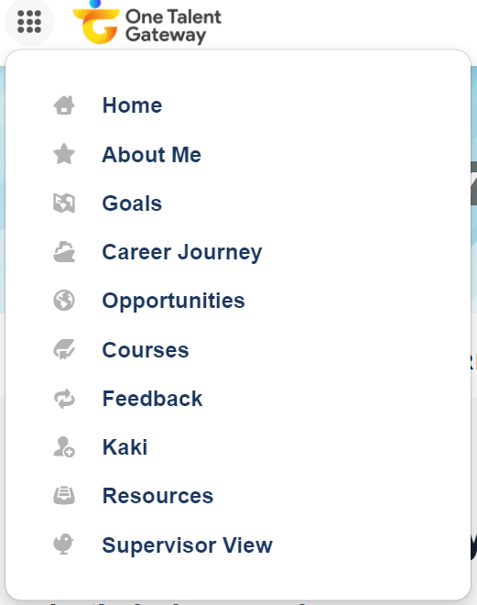

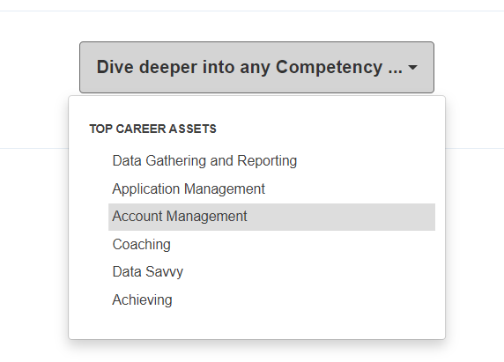

Is there a minimum or maximum number of people I can request for feedback from through OTG?

There is no minimum or maximum number of people you can request feedback from. However, it is important that you request feedback from individuals who are sufficiently familiar with how you work and/or your work deliverables for them to provide meaningful feedback for you.

A good practice is for you to request feedback from three colleagues (plus your supervisor) for up to three competencies per quarter. This will minimise the chances of people getting overwhelmed with feedback requests and have time to give you thoughtful, quality feedback.

Is the feedback I provide to other users anonymous?

Yes, the individual requesting your feedback needs at least two ratings from two different users before they will get to see their aggregated ratings. So, when you rate your peers or your supervisor, your rating(s) will also appear as part of an aggregate score.

I have sent requests for feedback, but no responses appear. What should I do?

You may re-send the request or speak directly to your colleagues, asking them for feedback through OTG. They will also receive email reminders that your feedback requests are pending completion.

How will the feedback ratings I received be used by OTG? Does it affect the types of recommendations I get?

Feedback ratings you receive will not influence your personalised recommendations. However, these ratings may serve as validation of your self-assessed competencies for other officers looking for individuals with a certain set of competencies e.g., shortlisting for opportunities. Having validated competencies and endorsements from others increases your match score for the competency cluster or roles with similar competencies.

Do others see feedback I have received/sent? Can the public view feedback provided about me?

If you receive feedback comments, you have the option of making selected comments visible on your Profile. You may change the visibility settings for each comment at any time.

You will also be able to see your ratings for each competency on a grid. Additionally, you will see the aggregated rating from your supervisor or peer/colleague for specific competencies.

Your supervisor will also have visibility of this perception gap grid. Depending on your privacy setting in the Competencies feature, he/she will or will not be able to see your self-assessment on the grid (private vs supervisor/public setting, respectively).

Will OTG feedback ratings have any impact on my performance appraisal?

OTG feedback ratings will not be automatically included within the ADP form as part of your performance appraisal. However, you are encouraged to share your competency ratings and participation in developmental opportunities via OTG with your supervisors during developmental and appraisal conversations as additional data points for consideration.

How often should I ask for feedback?

A good practice is for you to seek feedback on a quarterly basis or after every project.

Succession Pipe

What is the “Succession Pipe” feature about? How can I use it?

Supervisors are able to view and manage their Succession Pipes from Supervisor View. Succession Pipes enables Supervisors to tap into the entire pool of talent across the organization for any of the roles that roll-up to them. With this tool, Supervisors are able to be continuously curating a bench of qualified internal talent that can step into critical roles on their team, even when a vacancy is unexpected.

Note: The Supervisor sees all of the roles that report through to them, regardless of whether they are vacant or not.

If I am interested to recruit one of the officers recommended to me by the succession pipeline, are there any guidelines that I must adhere to?

 | Dos | Don’ts
Scenario 1  Agency HR/ Supervisor is keen to approach officer outside of agency for a vacant role | Agency HR/ Supervisor  - Agency HR/supervisor can reach out to an officer to inform him of a role/opportunity for SJR/secondment à keep officer’s HR cc-ed  Guidelines for non-SJR permanent job applications/sourcing  - Agency HR/supervisor can reach out to an officer to inform him of a vacancy for a permanent job à keep officer’s HR cc-ed. Then agency should ask officer to apply for the job and officer should undergo the usual recruitment and selection process, similar to an applicant in the open market and the officer should be considered with all other applicants for the job and be assessed if he is the best person for the job à keep officer’s HR cc-ed in the process.  - If the Agency HR/supervisor wishes to offer the officer a job after the interview à Officer’s HR will be kept cc-ed. Agency HR/supervisor does not need to seek approval from officer’s parent agency to offer the officer a job. The Agency HR/supervisor must offer the job based on Transfer or Movement Policy terms. | Agency HR/ Supervisor  - Should not try to convince officer/ mentee to leave current role  - Agency HR/supervisor must not offer higher salary/more senior position/ higher sub grab. Terms of offer must be based on Transfer or Movement Policy.
Scenario 2  Officer is keen to take on opportunity | Officer  - Officer to apply via C@G or the agency’s usual recruitment channel as per norm  - Inform RO early on application  - Update RO and/or HR on application status and discuss work arrangements as needed

