Risk Mitigation
1. When implementing electronic signing, Agencies should:
  - Take practical measures to enable subsequent proof of authenticity of the signature in the document. These include keeping good records of the transactions and making sure that the complete electronic trail is retrievable for as long as required.
  - Ensure that the receiving email address is valid and used by the intended recipient. Where possible, Agencies should have an independent way of confirming receipt, e.g. by calling the recipient, requesting a read receipt, or requesting an email reply of acknowledgement.
2. For external transactions in particular, Agencies should also:
- Communicate with external parties on the method they will be using in place of wet-ink signatures, and secure the external party’s acceptance prior to the transaction, in order to mitigate the risk of repudiation or dispute.
e.g. 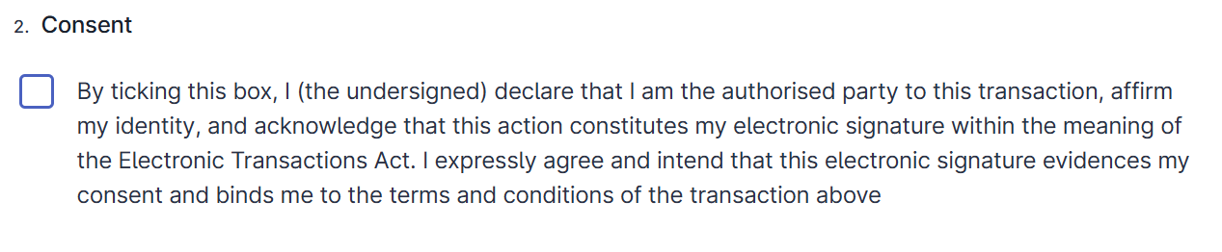

3. For transactions originating from Government, ensure that the electronically signed documents are sent through an official email account, to make clear to the recipient that this is a genuine Government notice.

4. For transactions received by Government (i.e. sent by the external party), ensure that there is clear and unambiguous language in the emails and documents from the authorised signatories to demonstrate the party’s intention. If using the OES Email Method, Agencies should ensure that the relevant emails are sent by the external party’s authorised signatories themselves, and not sent on their behalf by another person, regardless of whether the signatories are copied. Ideally, the emails should be sent from each signatories’ own email addresses which can be clearly attributed to them and, where the signatories are executing on behalf of an entity, the email domain should clearly be that of the entity. In these situations, there should be evidence that the officer has been authorised to act on behalf of the entity, such as an email from another officer from the entity stating that the signatory is authorised to act on the entity’s behalf.
5. Risk mitigation when using OES. Agencies implementing OES should adopt safeguards to ensure authenticity and mitigate disputes.
- Identity Verification
    - Ensure the signer logs in or submits via a verifiable identity (e.g. official email, system login, phone number).
    - Where possible, display the signer’s name as a non-editable field (e.g. enabling the Singpass option on FormSG and enabling the “Name” field under myInfo).
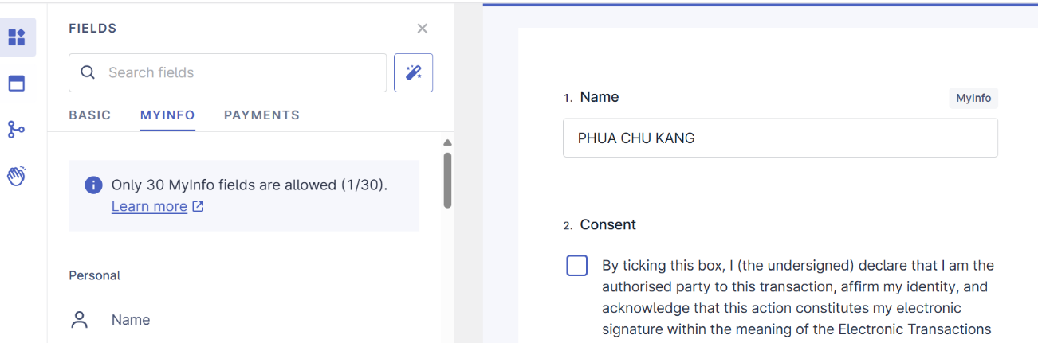
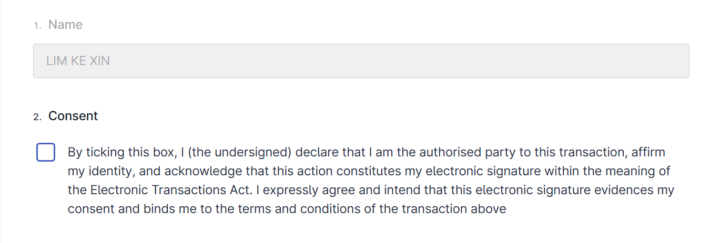
- Explicit Consent & Intent
- Include a clear checkbox option requiring the signer to confirm their identity and acknowledge that ticking the box constitutes their electronic signature.
- Checkbox must be mandatory before submission.

- Secure Transmission
- Use official government systems or email accounts for sending/receiving signed documents.
- Counterparty Acceptance
- For external transactions, obtain confirmation that the counterparty accepts the use of OES.
- Record-Keeping
- Retain the full audit trail: name (preferably non-editable), user ID/email, timestamp, form reference, checkbox status, and system metadata (e.g. IP/device info).
- Retention
- Keep records in accordance with the IM on Office Admin (Management of Public Records), and taking reference from current practices for the non-electronic equivalent as a starting point.
Note: When these steps are applied and documented, OES is legally valid and defensible under the ETA.

This applies where it makes sense to do so. An example where it does not make sense to do so is when regulatory Agencies issue warnings to individuals or businesses.

