INSTRUCTIONS

The QP for the building works for landed house built for owner’s own use no longer need to book a TOP inspection. When the project is ready for application of TOP/CSC, the QP shall submit his/her inspection report/checklist as part of the supporting documents for the application of TOP/CSC. QP can submit the TOP/CSC application via e-CORENET directly, instead of via the TOP Portal.

This QP shall use this document to prepare his/her inspection report/checklist as part of the supporting documents for the application of TOP/CSC.

We have also prepared three appendices for guidance.
- Appendix A: Guideline and sample of Site Inspection Report for Residential Landed House (Built for The Owner’s Own Use)
- Appendix B: Guideline for Supervising PE (Electrical) to provide photographs for lightning protection system
- Appendix C: Supporting documents for the application of TOP/CSC

The Supervising Professional Engineer (Electrical) for the lightning protection system shall provide the photographs as part of his submission to the QP for building works as part of the overall TOP/CSC submission. See Appendix B as a guide.

The Professional Engineer (Mechanical) shall submit the Certificate of Supervision of Air-conditioning/Mechanical Ventilation System for any installation indicated on the building plans.

The owner of lift shall apply for PTO via the Online Permit to Operate (OPTO) system.

This document is for QP’s use

PROJECT INFORMATION

1 | Project Reference No.
2 | Project Title

CLAUSES IN APPROVED DOCUMENT

The QP shall indicate the clauses that are applicable for the building works and the status of compliance. For clauses that obtained waiver approval (or owner’s undertaking), QP may indicate under remarks column. The QP may also provide further information (e.g. material specifications) if deemed necessary.

S/N | Clauses in the Approved Document | Status of compliance (Yes/No/Not applicable) | Remarks, if any
1 | C - Headroom and Ceiling Height
2 | E - Staircases
3 | F -Lighting
4 | G - Ventilation
5 | H - Safety from Falling
6 | J - Roof
7 | K - Lift and Escalators
8 | L - Lightning Protection
9 | M - Safety of Windows
10 | N - Use of Glass at Height
11 | P -Daylight Reflectance

This document is for QP’s use

SITE INSPECTION REPORT

- The submission of site inspection report is in lieu of the physical joint TOP inspection.
- The QP shall compile the photos/measurements for the items listed in Sections 1 and 2 below.
- QP is required to annotate the locations of photos on site/floor plan clearly. The QP shall refer to Appendix A as a guide to complete Sections 1 and 2 below.

SECTION 1A: GENERAL OVERVIEW OF COMPLETED BUILDING AND
SECTION 1B: GENERAL LAYOUT OF ALL FLOORS TO SHOW COMPLETION (BASEMENT TO ATTIC)
Front Elevation | Rear elevation | Side elevation
Basement | 1st Storey | 2nd Storey
3rd storey | Attic | Mezzanine (If applicable)

SECTION 2: COMPLIANCE OF CLAUSES
Clauses in Approved Document | Photographs/ Location/Measurments | Remark (if any)
Headroom and Ceiling Height
Staircases
Safety From Falling

QP can insert more rows and insert photos

I certify that the site has been inspected and complies with the requirements of the Building Control Act and Regulation, and the relevant Singapore Standard Code of Practice.

Submitted by:

__________________________________ ______________
Name and Signature of QP Date

GUIDELINE TO FILL IN SITE INSPECTION REPORT/CHECKLIST FOR RESIDENTIAL LANDED HOUSE (BUILT FOR THE OWNER’S OWN USE)

OBJECTIVE

1. Simplified Submission- Photos of ONLY critical Clauses to be submitted.
2. Consistency of submission in the industry
3. Evidence based inspection by QP

Submission Guideline

- Targeted photo evidence i.e., headroom, barrier, climbability etc. Please refer to the checklist.
- Each Photos shall be less than 250kb.
- Provide photo for each typical Clause type e.g. photo to show headroom at staircase
- To ensure resolution of photos and dimensions to be annotated clearly.
- To reference approved building plans to show location of photograph taken
- Owner undertaking letters - reference shall be clearly indicated, e.g., Refer to attached LOU(a) etc.

EXAMPLE OF SUBMISSION FOR SECTIONS 1 AND 2

- General Layout of completed building e.g. Photos of the front, rear and side elevation

SECTION 1A: GENERAL OVERVIEW OF COMPLETED BUILDING
Photos | Photos
Front Elevational  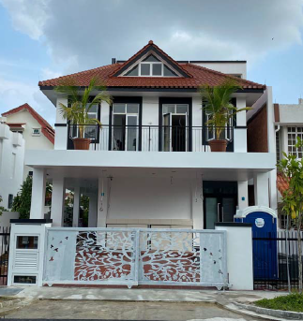 | Rear Elevation  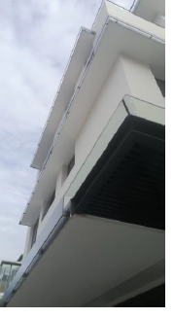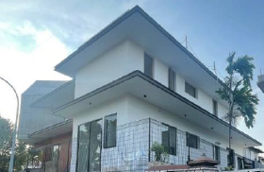
Side Elevation 1  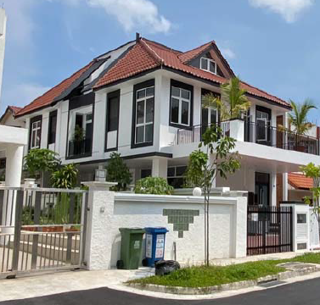 | Side Elevation 2  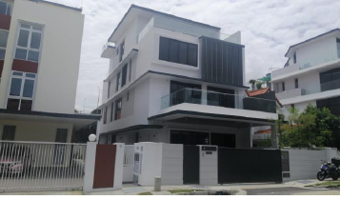
Swimming Pool (if any)
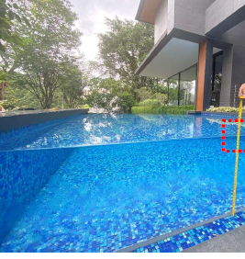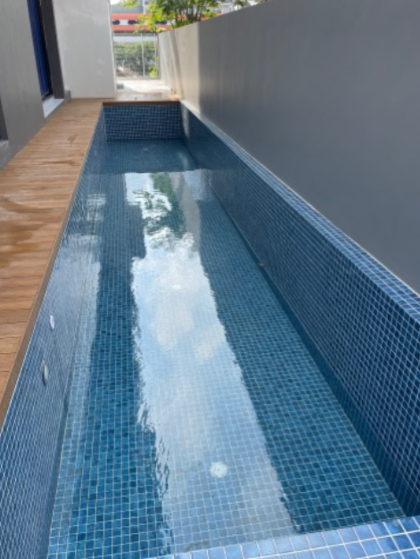

SECTION 1B: GENERAL LAYOUT OF ALL FLOORS TO SHOW COMPLETION (BASEMENT TO ATTIC)
Basement  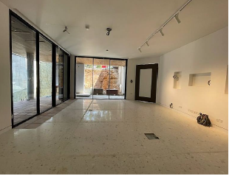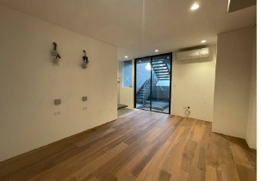 | 1st storey  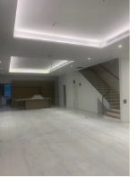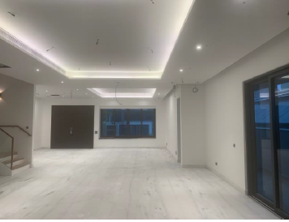
2nd storey  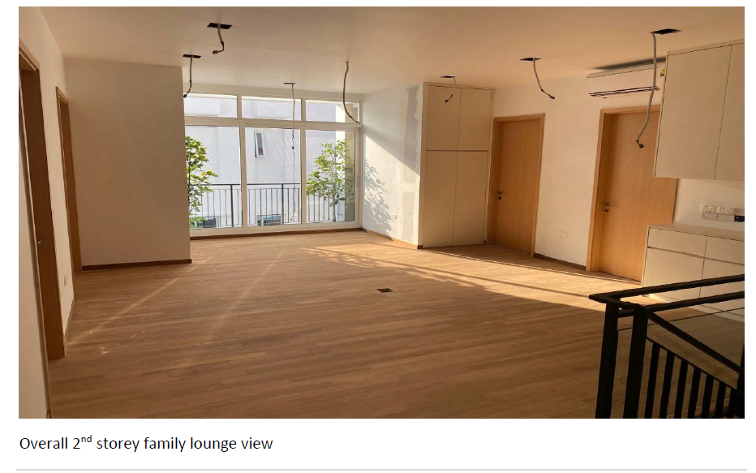 | 3rd storey  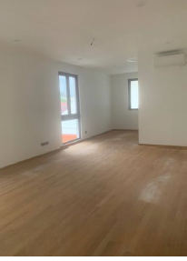
Attic  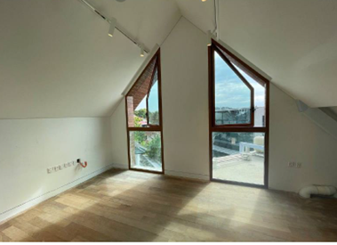 | Balcony or terrace for every storey  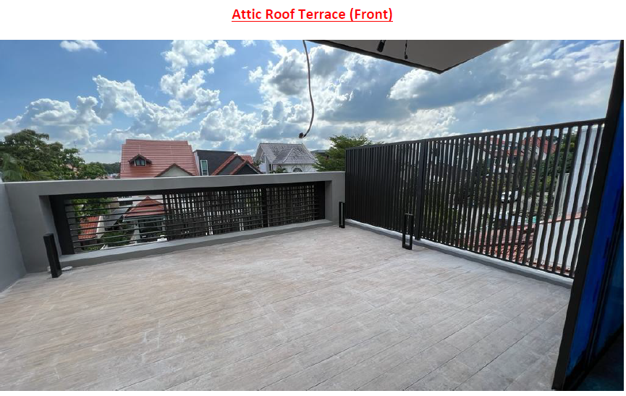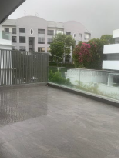

Status of compliance - Y: comply N: does not comply NA: not applicable

Note: For locations that obtained waiver approval (or owner’s undertaking), QP may indicate under remark.

SECTION 2: COMPLIANCE OF CLAUSES
 | Clauses in Approved Document | Status of compliance  (Y/N/NA) | Location / measurement of non-compliance | Remark (if any)
C | Headroom and Ceiling Height  General layout of all floors with site measurements of ceiling height (typical & worst-case scenario for each room/space) | Y | Typical room  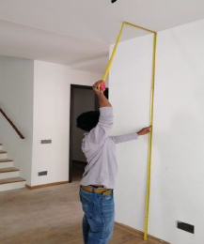  The ceiling height is 2.4m
Attic photos
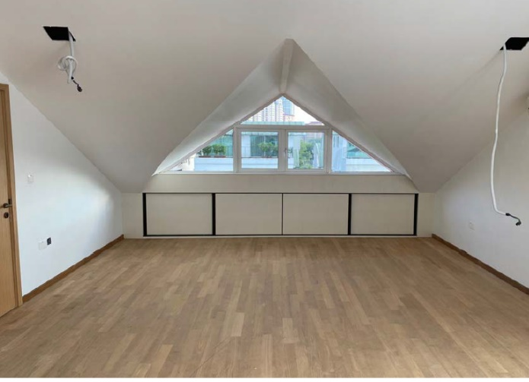
The lowest headroom is 1.5m
Staircase
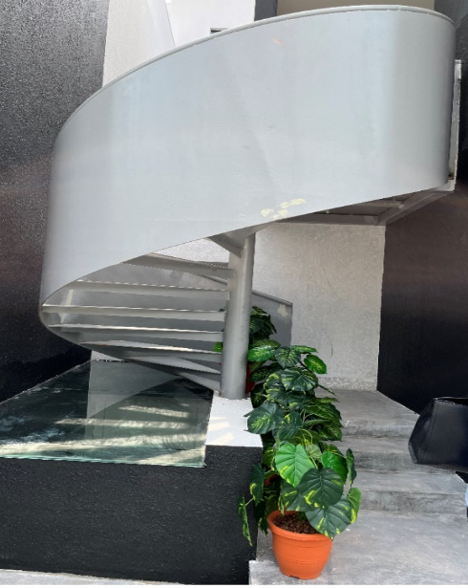
The headroom is 2.0m
E | Staircases  Typical staircase (1st /one intermediate/ last landing for each stairs) with site measurements (tread & riser, clear width, handrail)  - tread & riser - measurement at the centre of every step  - clear width (typical & worst-case scenario for every flight)  - handrail (height, opening) |  | To indicate the location of typical staircase design  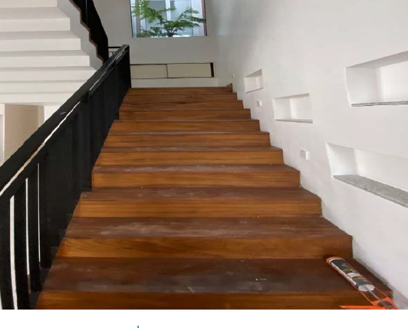  Internal staircase  a. Riser : 175mm  b. Thread: 275mm 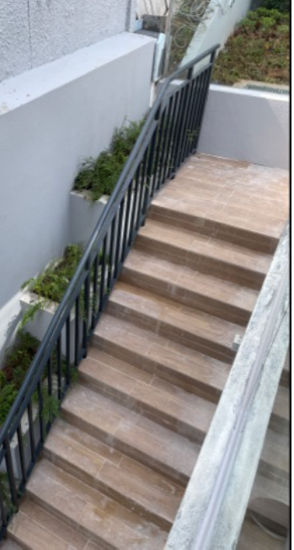  External staircase  a. Riser : 175mm  b. Thread: 275mm
H | Safety From Falling  Typical safety barriers on all floors (close-up view) with site measurements (height, opening) (typical & worst-case scenario/locations)  - Glass material label for laminated glass (one for each type) |  | Typical design glass barrier at 2nd storey between Grid XX-XX  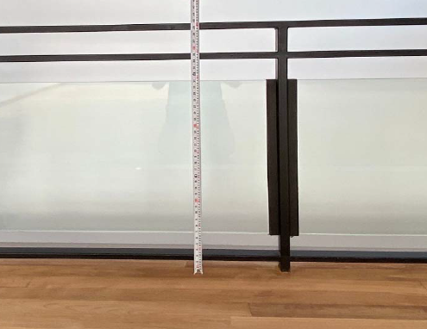  Barrier height 1m
Typical design window glass barrier at Master bedroom, Bedroom 2 and 3.

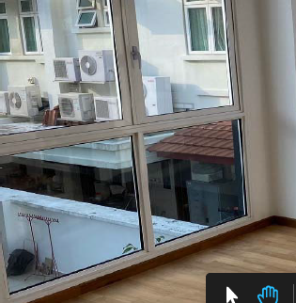
Barrier height 900mm

Typical steel barriers

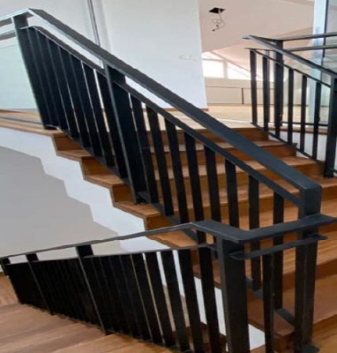
Internal staircase
Barrier height: 1000m
Gap size: 100mm

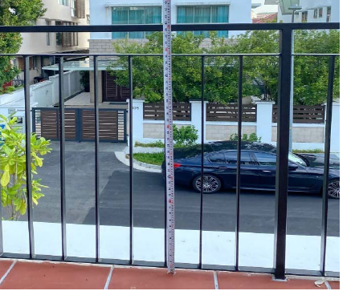
Balcony at L2
Barrier height: 1000m
Gap size: 100mm

GUIDELINE TO PROVIDE PHOTOGRAPHS FOR LIGHTNING PROTECTION SYSTEM

The PE(Electrical) shall submit the following documents during TOP/CSC applications.
- Certificate of Design & Supervision of Lightning Protection System (CSC 03)
- Earth Resistance & Electrical Continuity Test Form (Test Form shall be provided for each building)
- LPS As-built Plans should include air-termination system, down conductor system, earth termination system, details of equipotential bonding, zones of lightning protection provided by rolling sphere and/or protection angle.
Please refer to Circular dated 31 Oct 2018 for details

SITE INSPECTION REPORT

- The submission of site inspection report is in lieu of joint inspection.
- The Supervising Professional Engineer (Electrical) for the lightning protection system shall provide the following photographs as part of the report.

L | Lightning Protection (to be completed by the Professional Engineer (Electrical) for the lightning protection system)
 | Part 1 : Air Termination System
 | SS555:2018  BP submitted on or after 1 May 2019 | - Air-finials are provided at exposed corners of roof
 | SS555:2018  BP submitted on or after 1 May 2019 | - Lightning tapes shall be located not more than 100mm from the corners, exposed points, edges of parapet wall and roof
 | SS555:2018  BP submitted on or after 1 May 2019 | - LPS warning sign is provided at entrances to habitable and non-habitable roof spaces
 | SS555:2018  BP submitted on or after 1 May 2019
  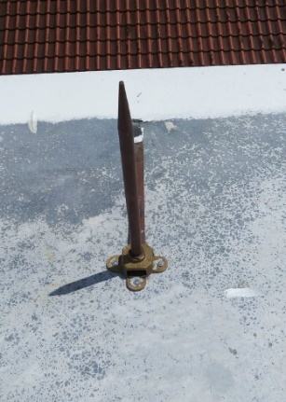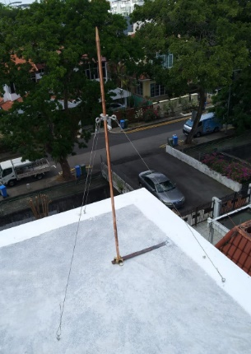 | 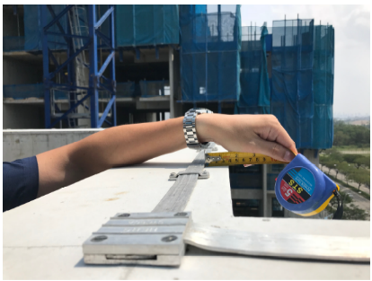 | 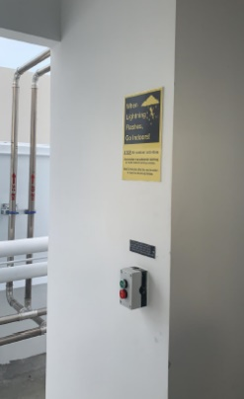
  Air-Finials | Tape ≤ 100mm | LPS Sign
 | Part 2 : Down Conductor System
 | SS555:2018  BP submitted on or after 1 May 2019 | Test links are installed at 2.5m (min) for exposed down conductor or 1.5m for natural down conductor with flushed mounted test links. Insulation of any exposed down conductor below 2.5m is required to meet a 100KV, 1.2/50µs impulse voltage e.g at least 3mm cross-linked polyethylene.
  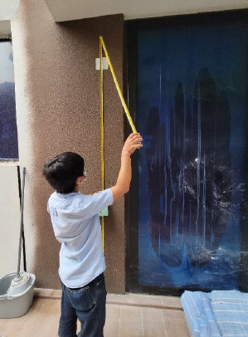 | 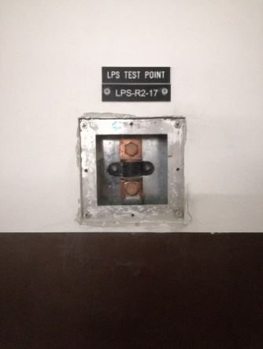
  Height of Test Link | BI Connector
 | Part 3 : Earth System
 | SS555:2018  BP submitted on or after 1 May 2019 | Earth Pits shall be located at areas where the risk of exposure of a person to step voltage is low. Example is landscape area where there is no person during normal time. Otherwise, equipotential mesh has to be provided around the earth pit.
  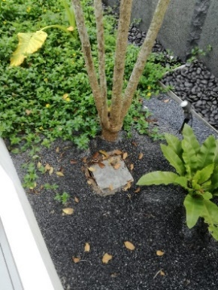 | 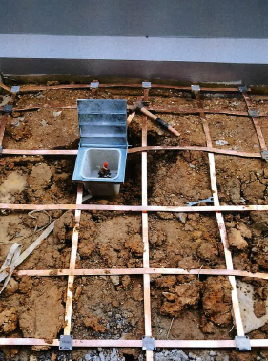
  Earth Pits at Landscape Area | Buried BRC mesh creating an equipotential zone around earth pit
 | Part 4 : Equipotential Bonding
 | SS555:2018  BP submitted on or after 1 May 2019 | Equipotential bonding between lightning tapes and any exposed metallic fixtures (trellis, railing, etc) including concealed steel rebars of concrete parapet wall or BRC mesh of concrete floor slab.
  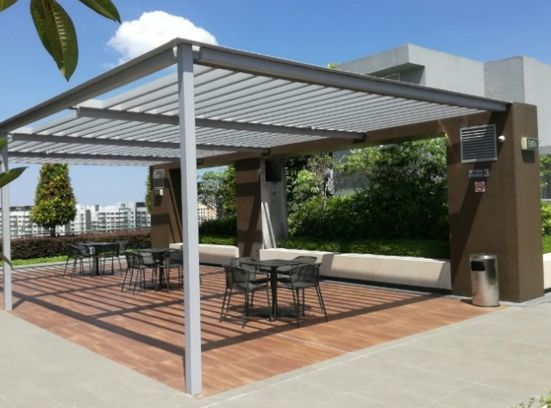 | 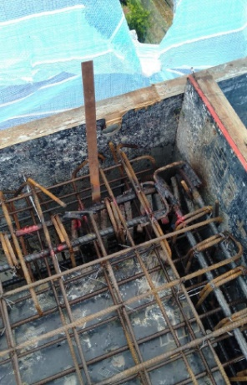 | 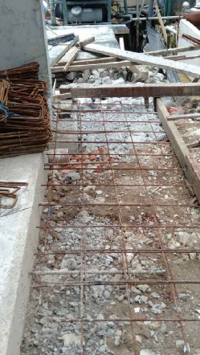
  Bonding to exposed metallic trellis | Bonding to concealed rebars of concrete parapet wall | Bonding to concealed BRC mesh inside floor slab

- UNDERTAKING CLAUSES IN APPROVED DOCUMENT

The requirements below do not apply in any house built for the owner’s own use. QP may submit owner’s undertaking letter for non-compliances of the following clauses:

Approved Document Clauses | Description
E.3.3, E.3.4, E.3.5 | Width of staircase, Risers and Treads and landing
E.3.6 | Handrails of staircase
G.2.2 | Ventilation
H.3.2.1 | Safety barrier height
H.3.4 | Size of opening of barrier
H.3.4A | Climbing issue

- How to apply

Submit the following documents via CORENET e-Submission System:
- Site Inspection Report/Checklist for Residential Landed House (Built for the Owner’s Own Use)
- Certificate of Supervision of Building Works (Form BCA-CSC-CSPBW)
- Declaration by Qualified Person (Form BCA-CSC-TOPCSCDQP)
- As-built Plans, Test Reports, Site Inspection Report and Certificate of Supervision of Lightning Protection System (Form BCA-CSC-CSPLP or BPD_CSC03). Refer to Circular dated 31 Oct 2018
- Certificate of Supervision of Installation of Escalators/ Lifts/ Stair lift/ Platform lift (Form BCA-CSC-CSPLE or BPD_CSC04) and Permit to Operate (PTO) in development
- Certificate of Supervision of Air-conditioning/Mechanical Ventilation System (Form BCA-CSC-CSPACMVS or BPD_CSC05)
- Certificate of Supervision of Piling Works and Notice of Completion (Form BCA-BE-QPCTPW or BEV C1)
- Certificate of Supervision of Structural Works (Form BCA-BE-QPCTSSW or BEV C2)
- Certificate of Record Structural Plans/Calculations (Form BCA-BE-CTASST or BEV C3)
- Builder's Certificate of Completion of Building Works (Form BCA-BE-BRCTBW or BC/BC)
- Commissioning approval for the CD shelters (Form BCA-CD-COMM01)

- TECHNICAL AGENCIES CLEARANCES

Please submit the following clearances from Technical Agencies where applicable.

1 | SCDF TFP/FSC
2 | NEA TOP/CSC
3 | PUB TOP/CSC
4 | URA TOP/CSC
5 | NParks BP/CSC (Internal & External)
6 | LTA BP/CSC (e.g. Road & Transportation, Vehicle Parking, Rails)

