WBA Forms & Template – Direct Patient Care
1 | (PA1 & PA3) Mini-CEX Extended Discussion | 
2 | (PA1 & PA3) SOAP template | 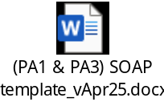
3 | (PA1) Case Based Extended Discussion | 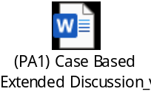
4 | (PA1) Case Review | 
5 | (PA1) Interventions | 
6 | (PA3) Dispensed Prescriptions | 
7 | (PA4) Drug Information | 
8 | (PA5) MSF_Direct | 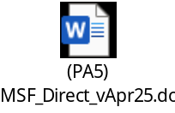
9 | (PA6) CPD_template_example | 